1. Pick any one app you use daily (like Instagram, Zomato, or Myntra) and list 3 ways that app increases its visibility online (for example: trending hashtags, Google search results, influencer posts).

1. Instagram – Online Visibility
App: Instagram
- Trending Hashtags – Instagram uses trending hashtags to help posts reach a larger audience.
- Influencer Posts – Influencer collaborations help Instagram content reach new users and increase visibility.
- Google Search Results – Popular public Instagram profiles and content can appear in Google search results, bringing more visitors to Instagram.
2. Visit the homepage of Flipkart or BookMyShow and note down 3 features or sections that are clearly designed to boost user engagement (for example: flash sales banners, trending movies carousel, or personalized recommendations).
Three features on the Flipkart homepage that are designed to increase user engagement:
- Flash Sales and Discount Banners – Attractive offers encourage users to click and shop immediately.
- Product Categories – Categories such as Mobiles, Fashion, Electronics, and Grocery help users easily find products
- Personalized Recommendations – Flipkart shows products based on users’ interests and previous browsing or shopping activity.

3. Use Google Trends (https://trends.google.com) to compare the search interest for 'IPL', 'World Cup', and 'K-pop' in India over the last 12 months. Take a screenshot of the graph and write 2 lines on which topic has the highest visibility and why.
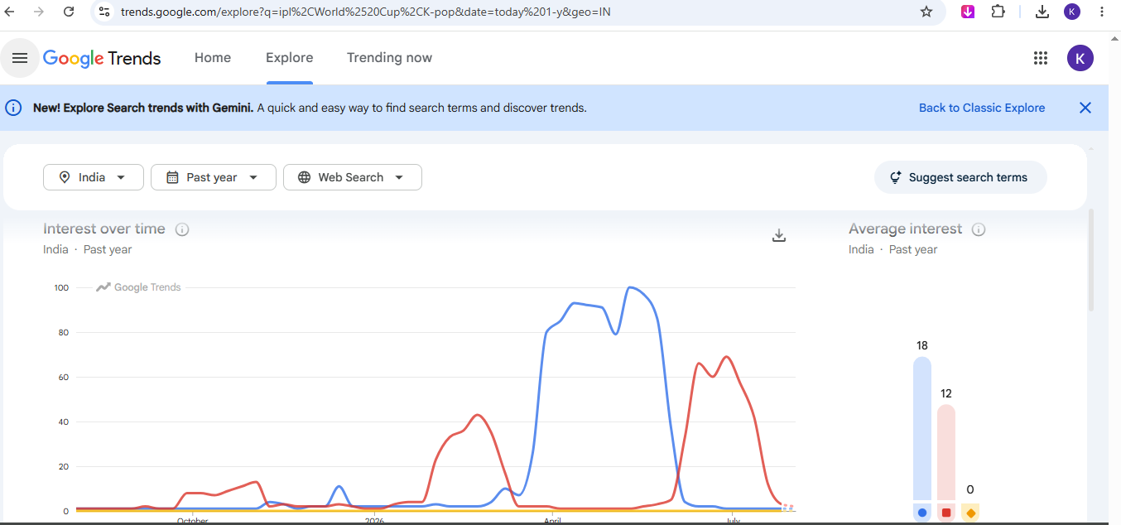

- IPL has the highest search visibility in India over the past 12 months.
- This is because cricket is extremely popular in India, and IPL matches generate a very high level of public interest and online searches.
4. Imagine you are running a food blog on Instagram. Write a sample post caption and 5 hashtags you would use to increase your post's visibility and drive more traffic to your page.Hint: Think about what keywords or trends people are searching for when they want food recommendations.
