1.Open Google, Bing, and DuckDuckGo in your browser and search for 'best budget smartphones 2024'. Take screenshots of the first page of results for each search engine and note any differences in the top 3 results.
- Google
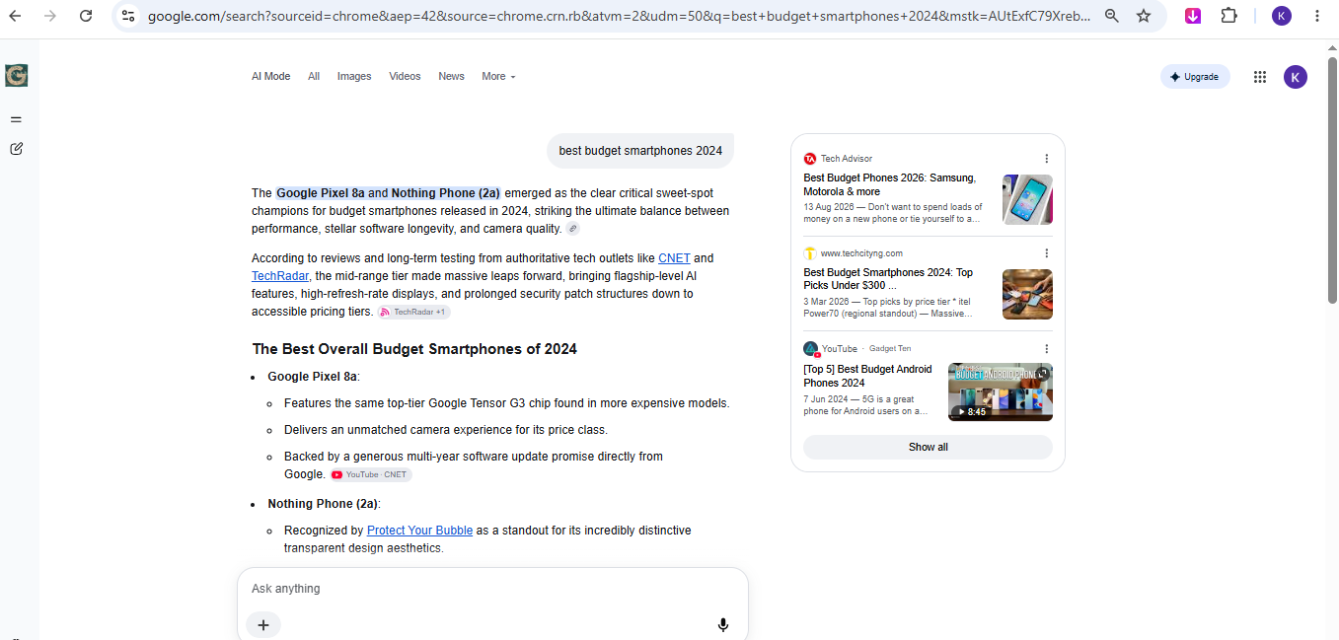

- Bing
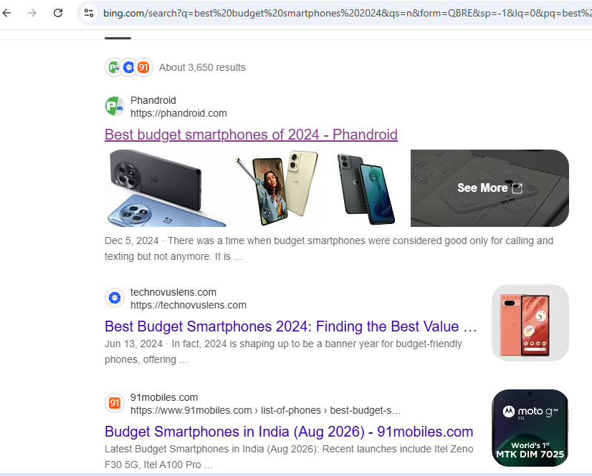
- DuckDuckGo

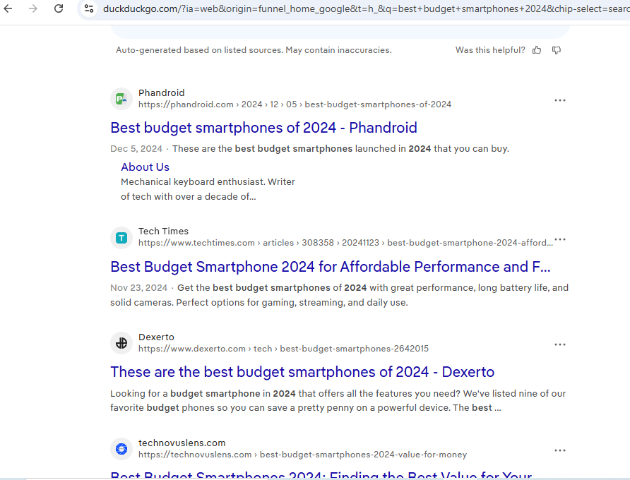

2. Create a simple table in a Google Doc or Excel listing 5 popular search engines. For each, write one unique feature or reason why a user might choose it over Google.
No. | Search Engine | Unique Feature / Reason
1 | Google | Provides fast and relevant search results.
2 | Bing | Well integrated with Microsoft services.
3 | DuckDuckGo | Focuses more on user privacy.
4 | Yahoo | Provides Search, News, and Email services.
5 | Baidu | Very popular search engine in China.

3. Write a short paragraph (4-5 lines) explaining in your own words the difference between organic results and paid results on a Google search results page. Include an example of each from a recent search you performed.
Organic results are webpages that appear naturally on Google based on their relevance and quality. Paid results are advertisements that businesses pay Google to display at the top or bottom of the search page. Paid results usually have an “Ad” or “Sponsored” label. For example, in my recent search for “best budget smartphones 2024,” a result marked “Ad” was a paid result, while a normal smartphone review webpage without an “Ad” label was an organic result.
4. Draw a flowchart (on paper or using any online tool) that shows the 3-stage process Google uses for search: crawling, indexing, and ranking. For each stage, write 1-2 lines describing what happens.
┌─────────────────┐
│ CRAWLING │
│ Google crawlers │
│ find and read │
│ web pages. │
└────────┬────────┘
↓
┌─────────────────┐
│ INDEXING │
│ Google stores │
│ and organizes │
│ page information.│
└────────┬────────┘
↓
┌─────────────────┐
│ RANKING │
│ Google selects │
│ the most relevant│
│ pages for a query.│
└────────┬────────┘
↓
┌─────────────────┐
│ SEARCH RESULTS │
└─────────────────┘
1. Crawling:
Google uses crawlers to discover webpages and read their content.
2. Indexing:
Google stores and organizes the information from webpages in its index.
3. Ranking:
When a user searches, Google ranks webpages based on relevance and usefulness and shows the best results first.
5. Pick any trending topic (like IPL, new movie release, or a gadget launch) and search it on Google. Identify at least 2 organic results and 2 paid results from the first page, then explain how you recognized which was which.<br><br><em><strong>Hint:</strong> Look for labels like 'Ad' or 'Sponsored' and compare their placement on the page.</em>
- Trending Topic: iPhone 17 Launch

Results from the First Page
Result Type | Example Result | How I Recognized It
Paid Result 1 | Amazon – iPhone 17 Deals | It had the “Sponsored” label at the top of the page.
Paid Result 2 | Flipkart – Buy iPhone 17 | It was marked as “Ad” and appeared before most results.
Organic Result 1 | Apple Official – iPhone 17 | It had no Ad/Sponsored label and appeared as a normal result.
Organic Result 2 | GSMArena – iPhone 17 Review | It was a regular search result without any advertisement label.

Explanation (4–5 lines)
I searched “iPhone 17 Launch” on Google. The paid results were easy to identify because they had “Ad” or “Sponsored” labels and appeared at the top of the search page. The organic results did not have these labels and were ranked naturally based on their relevance and quality. This helped me clearly distinguish between paid advertisements and normal search results.

