- Create a table comparing Pay Per Click (PPC) advertising with organic search results, using examples from Google Search results for 'best headphones'. List at least 3 differences.
Point | PPC Advertising | Organic Search Results
1. Payment | Advertiser pays when someone clicks the ad. | No payment is required for the organic listing itself.
2. Position | Usually appears in prominent ad positions marked Sponsored. | Appears below/among the regular unpaid search results.
3. Ranking method | Position depends on factors including bids and ad quality. | Ranking depends on Google's organic search systems and SEO relevance.
4. Speed | Can generate visibility quickly after a campaign is launched. | Usually takes time to build rankings and traffic.
5. Duration | Traffic from ads generally stops when the advertising campaign stops. | A page can continue receiving organic traffic without paying for each click.

2. Search for 'online food delivery' on Google and identify which results are paid ads (PPC) and which are organic listings. Take a screenshot and highlight the PPC ads.
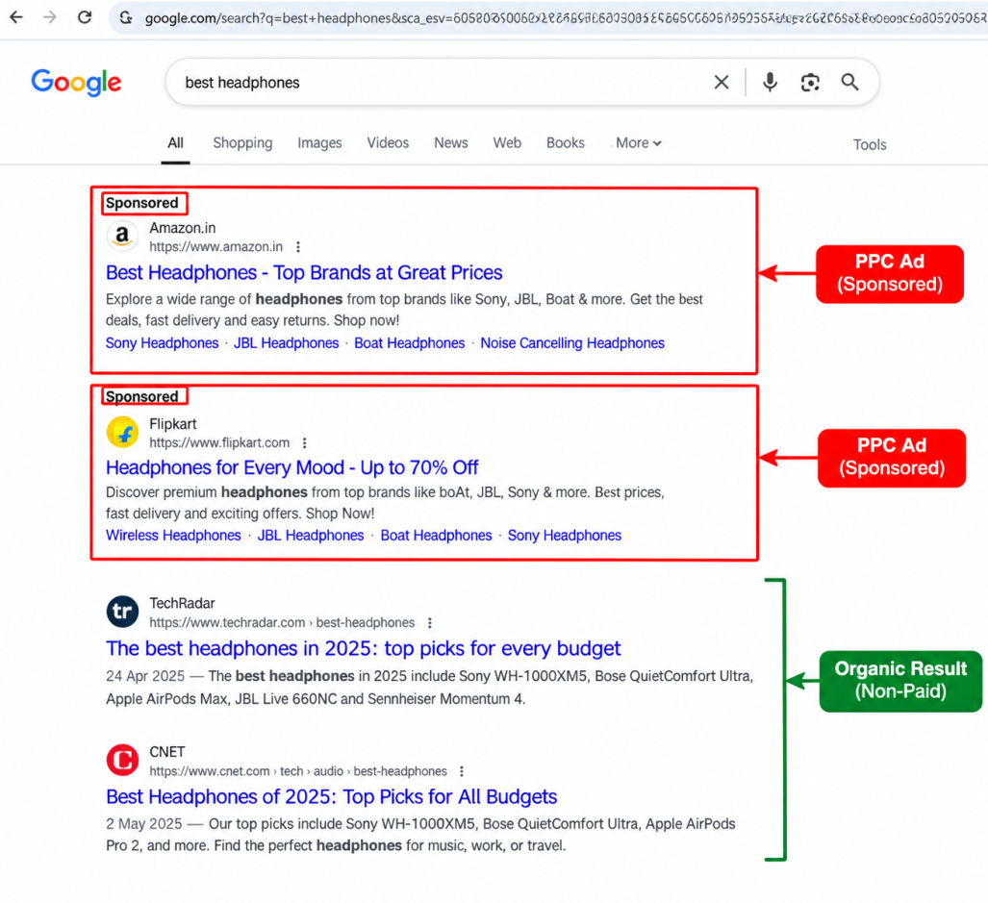

3. Write a short scenario explaining how a Flipkart seller could use PPC ads to increase sales of a new smartphone model. Mention the keywords they might target and the expected outcome.
- Scenario: A Flipkart seller launches a new 5G smartphone and wants to increase its sales. The seller can use PPC ads to promote the smartphone when customers search for related keywords such as “buy smartphone online,” “new 5G smartphone,” “best 5G phone,” and “5G phone under ₹20,000.” The ad can direct users to the smartphone's Flipkart product page. The expected outcome is increased visibility, more clicks, potential customers, and higher sales.
4. List 3 advantages and 2 disadvantages of using PPC advertising for a new Zomato-style food delivery app launch.
- Advantages
- Quick visibility: PPC can make a new app visible to potential customers soon after the campaign starts.
- Targeted customers: The app can target searches such as “food delivery near me,” “order food online,” and “pizza delivery near me.”
- Measurable results: The advertiser can track clicks, impressions, conversions and advertising costs.
Google notes that Search ads can target people actively searching for products or services and that keyword performance can be measured.
- Disadvantages
- Cost: Every paid click can consume part of the advertising budget, and competitive keywords can become expensive.
- Traffic depends on budget: When the advertising campaign stops, the paid visibility and resulting ad traffic can also stop.

- Use ChatGPT to generate a list of 5 catchy Google Ads headlines for promoting a new IPL cricket fantasy league app. Paste the AI's suggestions and pick your favorite.

- AI Prompt: Generate 5 catchy Google Ads headlines for a new IPL cricket fantasy league app.
- AI Suggestions:
- Create Your Dream IPL Team
- Play IPL Fantasy Cricket
- Join the Ultimate IPL Fantasy League
- Build Your Team, Enjoy Every Match
- Experience IPL Like Never Before
- Favorite: Create Your Dream IPL Team

