SMARTBRANCH 360
Secure Branch Office Network using Cisco Packet Tracer
Project Documentation
Final Packet Tracer Project: smartbranch.pkt

1. Aim
To design and implement a branch office network in Cisco Packet Tracer with separate Employee, Guest, Server, and Management VLANs, wireless guest connectivity, inter-VLAN routing, and connectivity testing.

2. Objectives
- Design a branch-office network using one router, two switches, a wireless access point, a server, and multiple endpoints.
- Create separate VLANs for Employee, Guest, Server, and Management traffic.
- Configure trunk links and Router-on-a-Stick inter-VLAN routing.
- Configure wired employees, a server, a management workstation, and guest wireless clients.
- Verify network connectivity using ping tests.

3. Software and Requirements
Item | Requirement
Simulation Tool | Cisco Packet Tracer
Network Devices | 1 Router, 2 Switches, 1 Wireless AP
End Devices | 8 Employee PCs, 1 Management PC, 1 Server, 2 Guest Laptops
Final Project File | smartbranch.pkt

4. Network Topology
The topology contains R1, SW1, SW2, SERVER1, MGMT-PC, eight employee PCs, AP1, and two guest laptops. R1 connects to SW1; SW1 connects to SW2, SERVER1, MGMT-PC, and AP1; AP1 provides wireless access to the guest laptops.
Topology structure:
R1 → SW1 → SW2 → Employee PCs
SW1 → SERVER1
SW1 → MGMT-PC
SW1 → AP1 → Guest Laptops

5. VLAN and IP Address Plan
VLAN | Name | Network | Gateway | Purpose
10 | EMPLOYEE | 192.168.10.0/24 | 192.168.10.1 | Employee wired devices
20 | GUEST | 192.168.20.0/24 | 192.168.20.1 | Guest wireless devices
30 | SERVER | 192.168.30.0/24 | 192.168.30.1 | Internal server
99 | MANAGEMENT | 192.168.99.0/24 | 192.168.99.1 | Network management

6. Device IP Addressing
Device | IP Address | Subnet Mask | Default Gateway
R1 Gi0/0.10 | 192.168.10.1 | 255.255.255.0 | —
R1 Gi0/0.20 | 192.168.20.1 | 255.255.255.0 | —
R1 Gi0/0.30 | 192.168.30.1 | 255.255.255.0 | —
R1 Gi0/0.99 | 192.168.99.1 | 255.255.255.0 | —
SW1 VLAN 99 | 192.168.99.2 | 255.255.255.0 | 192.168.99.1
SERVER1 | 192.168.30.10 | 255.255.255.0 | 192.168.30.1
MGMT-PC | 192.168.99.10 | 255.255.255.0 | 192.168.99.1
GUEST-LAP1 | 192.168.20.11 | 255.255.255.0 | 192.168.20.1
GUEST-LAP2 | 192.168.20.12 | 255.255.255.0 | 192.168.20.1
EMP-PC1 | 192.168.10.11 | 255.255.255.0 | 192.168.10.1
EMP-PC2 | 192.168.10.12 | 255.255.255.0 | 192.168.10.1
EMP-PC3 | 192.168.10.13 | 255.255.255.0 | 192.168.10.1
EMP-PC4 | 192.168.10.14 | 255.255.255.0 | 192.168.10.1
EMP-PC5 | 192.168.10.15 | 255.255.255.0 | 192.168.10.1
EMP-PC6 | 192.168.10.16 | 255.255.255.0 | 192.168.10.1
EMP-PC7 | 192.168.10.17 | 255.255.255.0 | 192.168.10.1

7. Configuration Procedure

7.1 Physical Connections
- R1 Gi0/0 → SW1 Fa0/1 using Copper Straight-Through.
- SW1 Fa0/2 → SW2 Fa0/1.
- EMP-PC1–EMP-PC8 → SW2 Fa0/2–Fa0/9.
- MGMT-PC → SW1 Fa0/10.
- SERVER1 → SW1 Fa0/11.
- AP1 → SW1 Fa0/12.
- WPC300N wireless adapters installed in guest laptops and associated with AP1.

7.2 VLAN Configuration
- VLAN 10 – EMPLOYEE
- VLAN 20 – GUEST
- VLAN 30 – SERVER
- VLAN 99 – MANAGEMENT

7.3 Trunk Configuration
Trunking was configured on SW1 Fa0/1 toward R1, SW1 Fa0/2 toward SW2, and SW2 Fa0/1 toward SW1. VLANs 10, 20, 30, and 99 were carried across the trunk links.

7.4 Router-on-a-Stick
Subinterface | VLAN | Gateway
Gi0/0.10 | 10 | 192.168.10.1
Gi0/0.20 | 20 | 192.168.20.1
Gi0/0.30 | 30 | 192.168.30.1
Gi0/0.99 | 99 | 192.168.99.1

7.5 Switch Port Assignment
Switch | Port(s) | Assignment
SW1 | Fa0/1 | Trunk to R1
SW1 | Fa0/2 | Trunk to SW2
SW1 | Fa0/10 | Management VLAN 99
SW1 | Fa0/11 | Server VLAN 30
SW1 | Fa0/12 | Guest VLAN 20 / AP1
SW2 | Fa0/1 | Trunk to SW1
SW2 | Fa0/2–Fa0/9 | Employee VLAN 10

7.6 Wireless Configuration
Setting | Value
SSID | GUEST_WIFI
Authentication | WPA2-PSK
Encryption | AES
Channel | 6
Password | Guest@12345

8. Testing and Verification
Connectivity was tested from EMP-PC1. The tests demonstrated connectivity to the router, server, guest network, and management host.
Test | Destination | Result
Employee → Router | 192.168.10.1 | Successful replies
Employee → Server | 192.168.30.10 | Successful replies
Employee → Guest | 192.168.20.11 | Successful replies
Employee → Management | 192.168.99.10 | Successful replies
The first ping can time out while ARP resolution occurs; subsequent replies confirmed the paths were operational.

9. Screenshots
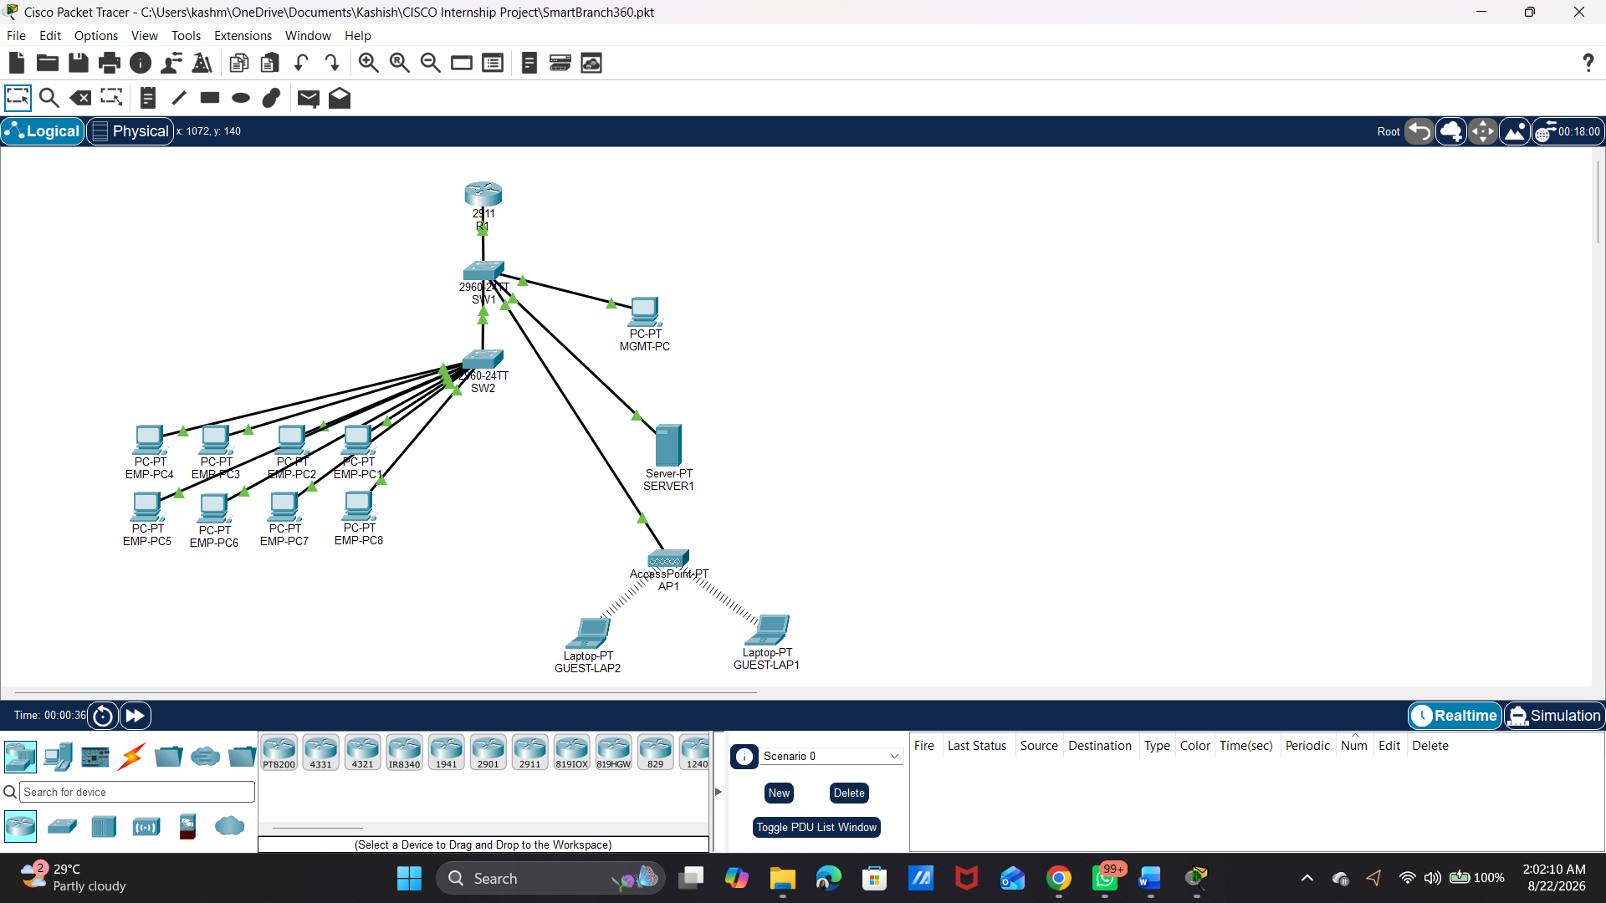
Figure1: Final SmartBranch 360 topology.
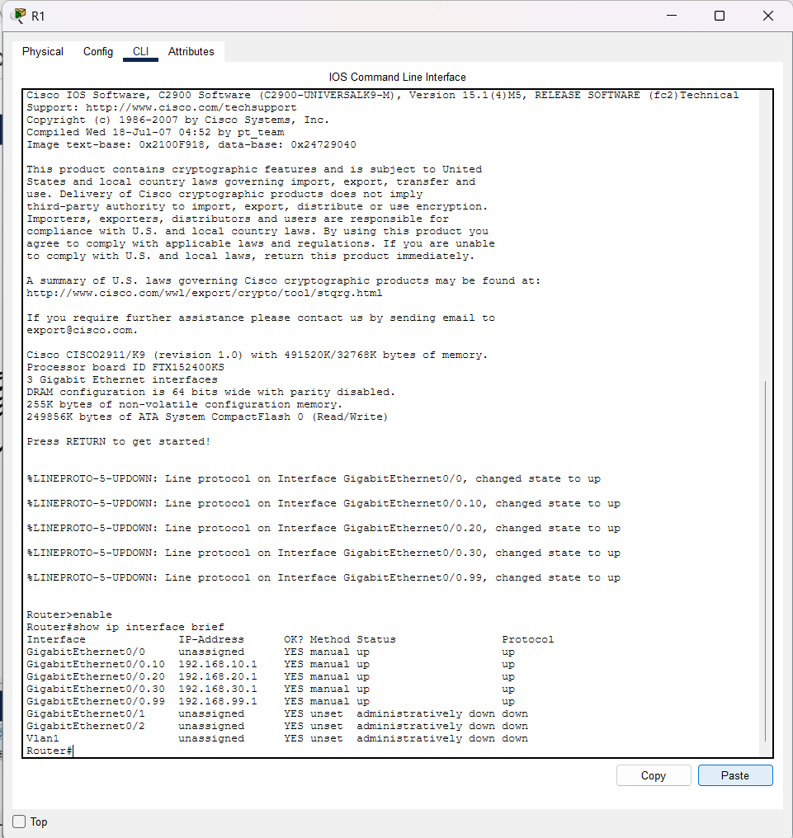
Figure 2: R1 show ip interface brief showing subinterfaces.
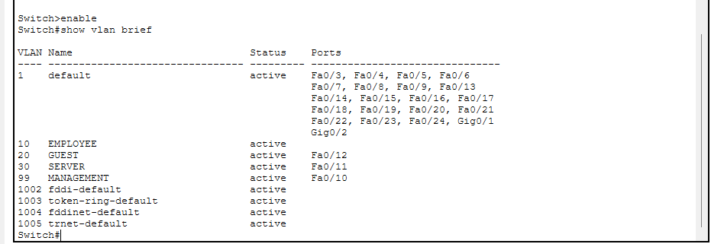
Figure 3: SW1 show vlan brief.
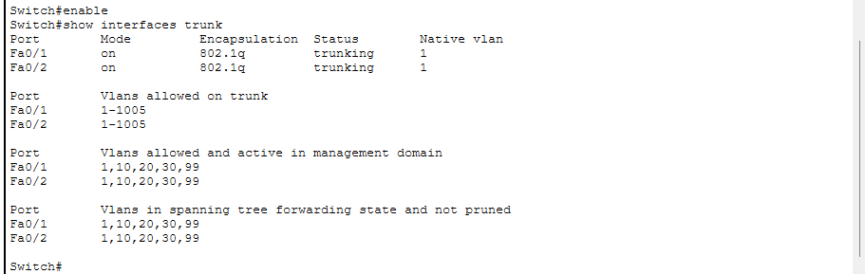
Figure 4: SW1 show interfaces trunk.
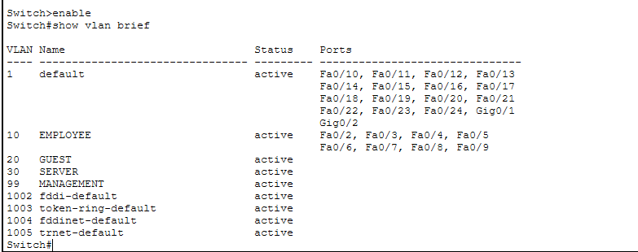
Figure 5: SW2 VLAN 10 employee port assignment.
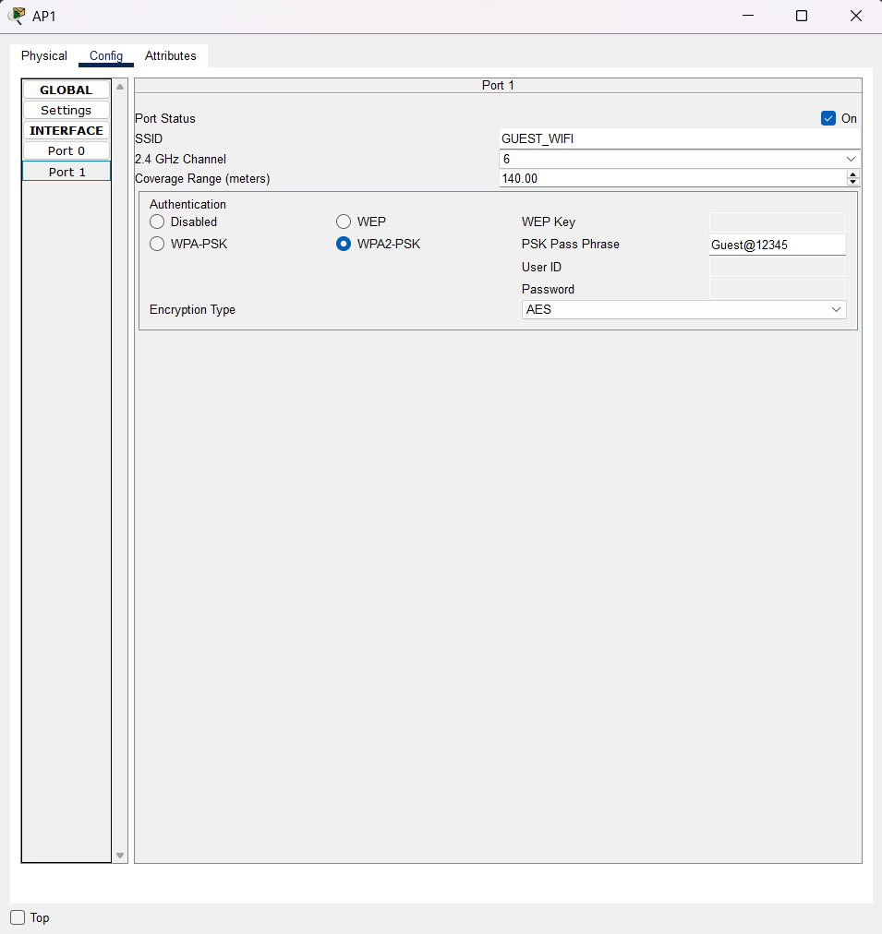
Figure 6: AP1 GUEST_WIFI configuration.
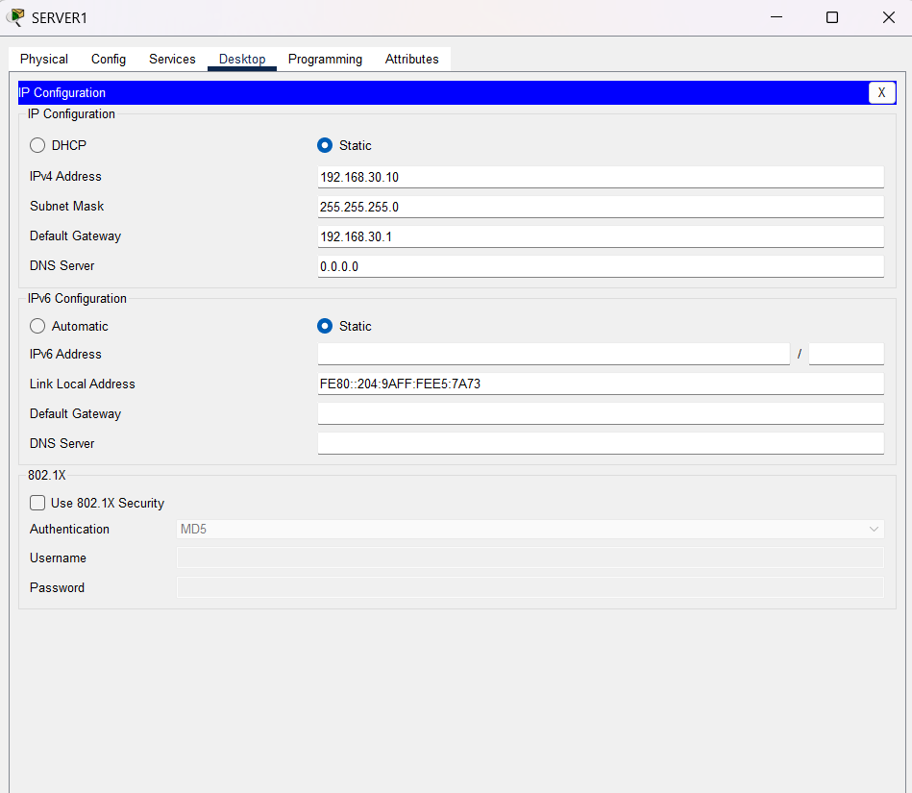
Figure 7: SERVER1 IP configuration.
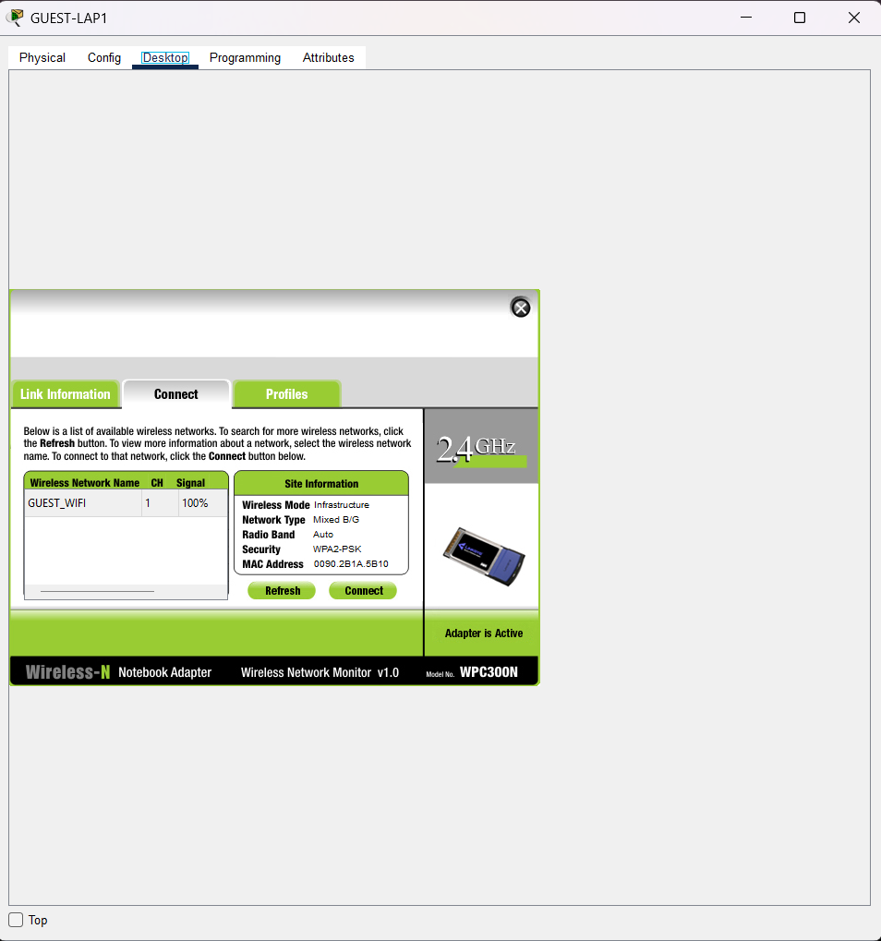
Figure 8: Guest laptop wireless association.
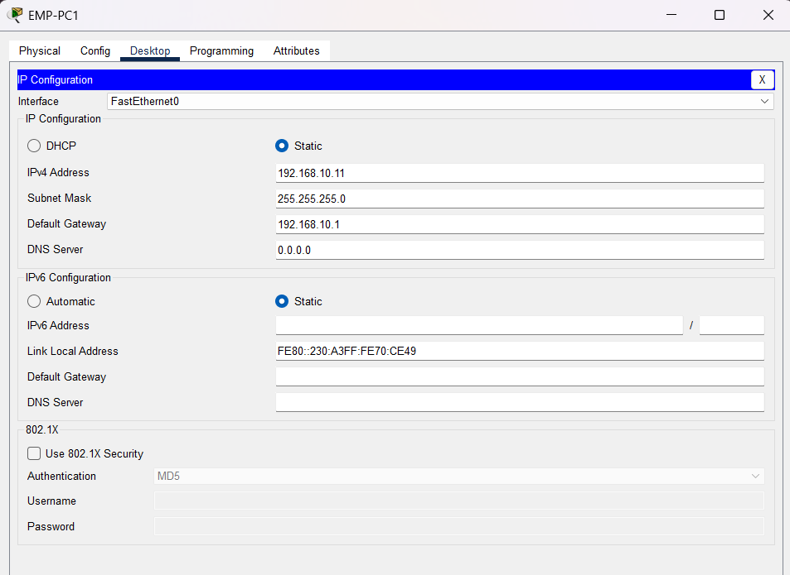
Figure 9: EMP-PC1 IP configuration.
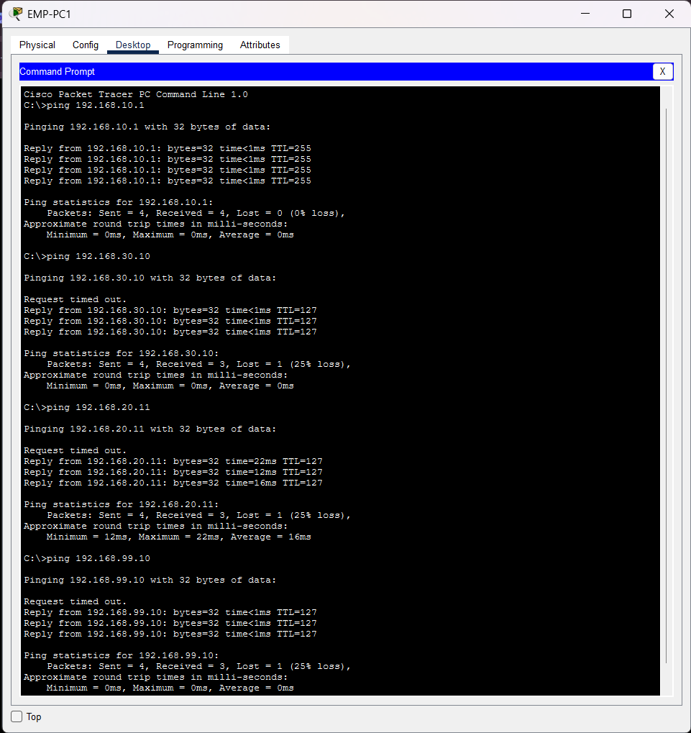
Figure 10 : Final ping results.

10. Result
The SmartBranch 360 network was successfully designed and implemented in Cisco Packet Tracer. Employee, Guest, Server, and Management VLANs were created; trunking and Router-on-a-Stick routing were configured; wireless guest connectivity was established; and connectivity was verified through ping tests.

11. Conclusion
The project demonstrates practical VLAN segmentation, trunking, wireless access, IP addressing, and inter-VLAN routing in a branch-office environment. The working Packet Tracer project was saved as smartbranch.pkt.

