**Software Requirements**

**Specification**

**Resource Management**

**System**

**Prepared by:**

**HCL Innovation Geeks**

**Kashish Agarwal**

**Sanskriti Agarwal**

**Anmol Jain**

**Saksham Jain**

**Aditya Joshi**

# 1 Introduction

This document is a software requirement specification for the HR Management System Project. After giving information about the definition of the project at the beginning part of the document, we will give complete description for overview and list the requirements which meet the needs of the company roughly.

## 1.1 Problem Definition

Nowadays, companies try to enhance their management and have a better control over their employees. In order to fulfil these requirements in a more efficient way they need software called Human Resource Management System.

HR Management System is software which satisfies the needs of the Human Resources Department of a company to manage employees' personal data (citizen identity number, name, surname, birthdate, birthplace, educational information etc.), annual leaves, payroll, trainings, skills, performance evaluation and so on. Our HR Management System will meet the needs for managing the personal data, system authentication and authorization of an employee.

Our HRMS project is being developed for HCL who wants to control and manage their employee’s data in a more appropriate and neat way. With the help of our project they will have better software to manage their personal data, control mechanism to authorize and authenticate for the employees’ entry.

## 1.2 Purpose

This document aims to give a brief description about the HR Management System Project. With the help of this document the needs of the company and the solution that will be provided to that needs will be clearly presented. In other words, this document will provide a basis for validation and verification.

## 1.3 Scope

This document covers the whole definition of the HR Management System (HRMS) project. It basically includes the requirements for managing the personal data, controlling authentication and authorization mechanism, and evaluating of employees’ performance. After creating the new HRMS we have to accomplish data migration from their existing system to our new one.

More specifically, our HRMS (HR Management System) controls and manages the personal database such that any user with different role types as manager, admin, employee, and human resource will be able to manipulate their personal data.

In addition to manipulating the personal data, our HRMS will provide authentication and authorization mechanism. Every user with any role type can be able to login to the system with his/her username and password.

## 1.4 User and Literature Survey

Although most of the companies of the world have been using HRMS for a long time as a result of a need for reaching and managing the data of employees, HRMS projects are developed without the required properties they to be well-formed. Due to the rapid progress in companies like increase number of the employees, the increase in the expectations in employees' skills and the variations of the employee types, the existing HRMS becomes inadequate to meet these required needs.

We aim to develop a HRMS in such a manner that it would be able to fulfil the upcoming changes in the needs of HCL Company. In other words, our HRMS will be a flexible system such that it could be improved according to the future needs of HCL Company.

## 1.5 Definitions and Abbreviations

* SRS: Software Requirements Specification
* HRMS: Human Resource Management System
* HR: Human Resource

## 1.7 Overview

This SRS is organized in a way that any user of the HCL can easily understand and use the HRMS. In other words, it constitutes a user guideline for HRMS.

Basically, this document starts with a brief explanation of the problem. Later on, it continues with a detailed solution we proposed. Also block diagrams of our solution to visualize the solution and system better, specific and functional requirements, interface requirements, constraints that may be confronted while developing the software, relationship between user types each of which is a data object. This document ends with the planning and estimating the basic schedule of our process.

# 2 Overall Description

The overall description of our project can be stated as creating and managing the database, developing a friendly user interface to manipulate the database, provide an authentication mechanism to safely accomplish tasks mentioned above.

## 2.1 Product Perspective

Currently, HCL has an HRMS already in use. However, with the HRMS we will provide them with additional capabilities and properties organized neatly.

HRMS which is an online intranet System will be used by four types of employees of HCL. These types who have different roles can be stated as; admin, manager, HR, employee. Every user enters the main authentication page and after that, system will grant them authorization. After being authorized according to their permissions (role type) users will basically query and edit the database via HRMS.

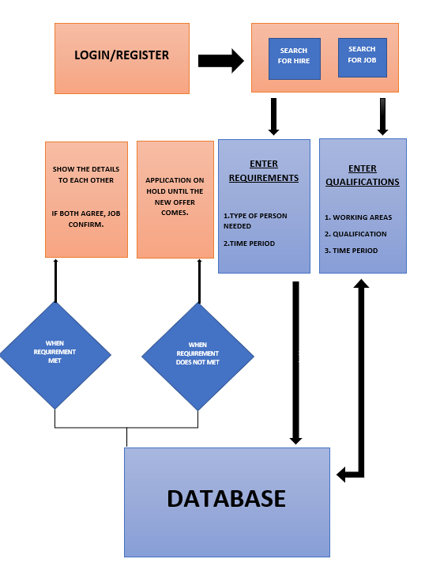

## 2.2 Product Functions

HRMS implements some major functions in order to accomplish required tasks. These functions constitute a basis for the whole system. These functions can be stated as:

### 2.2.1) Authentication and Authorization

Being connected to internet, users will be able to get into the system. In order to see the interface related to his/her role type, the users account should be authorized and also his/her user name and password should be authenticated. These tasks are basically held by the functions implemented under the header of Authentication and Authorization major function.

### 2.2.2) Process Data

These functions which can be examined in that process data major function are basically provides user to manage the database according to the desired task. These management tasks constitute the major feature of the HRMS. With the help of these functions a user can update some basic personal data like contact information, marital status etc. In addition to update data, a user can also search the database in order to obtain the list of the users' which has the properties desired. Also, a user may also see the specific information about a user or all users which can be named as report. In other words, searching is the operation with rows of the database while reporting is operation with columns of the database.

### 2.2.3) Recruitment

Recruitment of a new person which means introducing a new user to the system can be accomplished in two steps. When it is needed to add a new user to the system, firstly, HR must create an employee account, by the way at this step HRMS automatically gives an id to that user. At the second step, admin creates a user related to that user id.

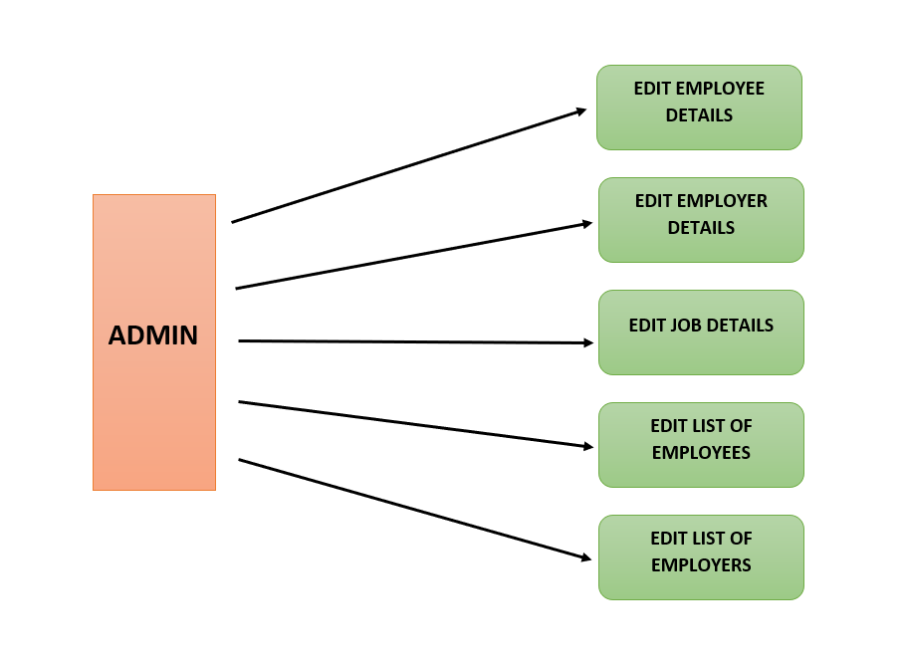

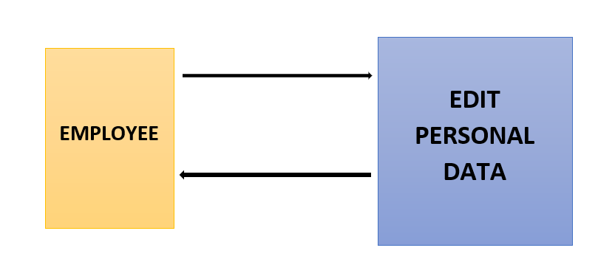

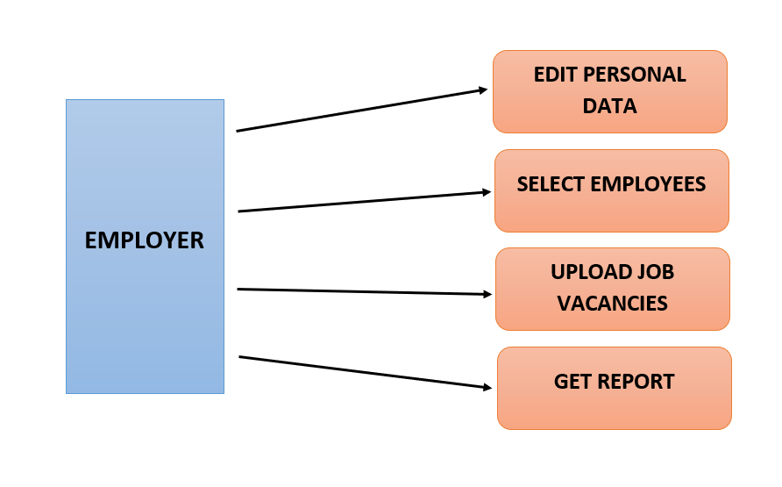

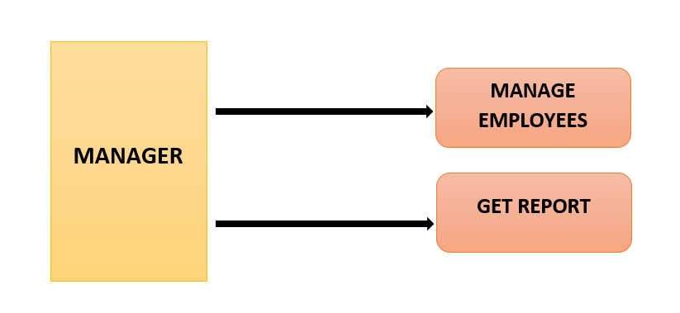

# 3 Specific Requirements

## 3.1 Interface Requirements

All the users will see the same page when they enter SERENE JOB Portal. This page asks the users either to register or if they already have an account then to login.

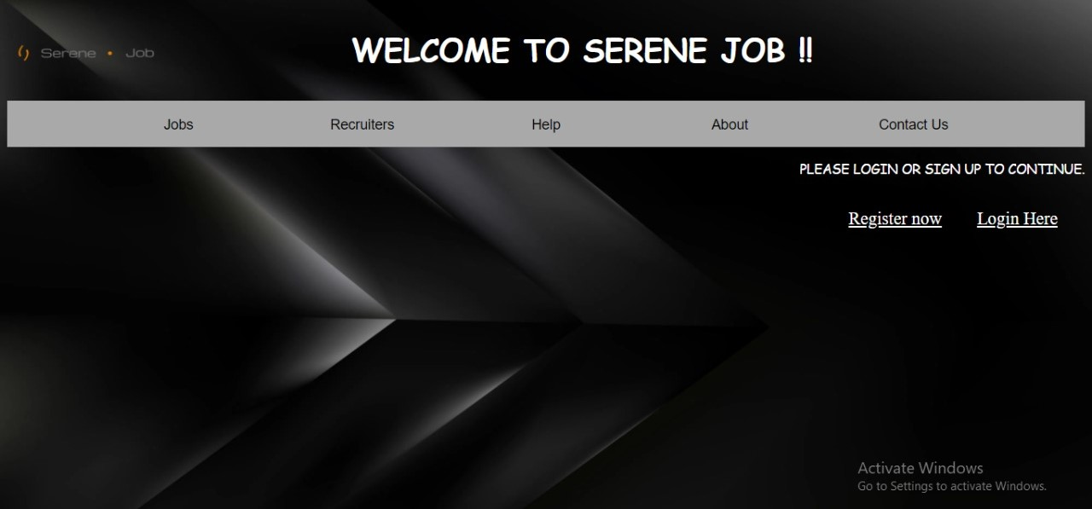

After this page if the user clicked on register then a page will be displayed which will ask for their details and then the user will submit its details according to the page.

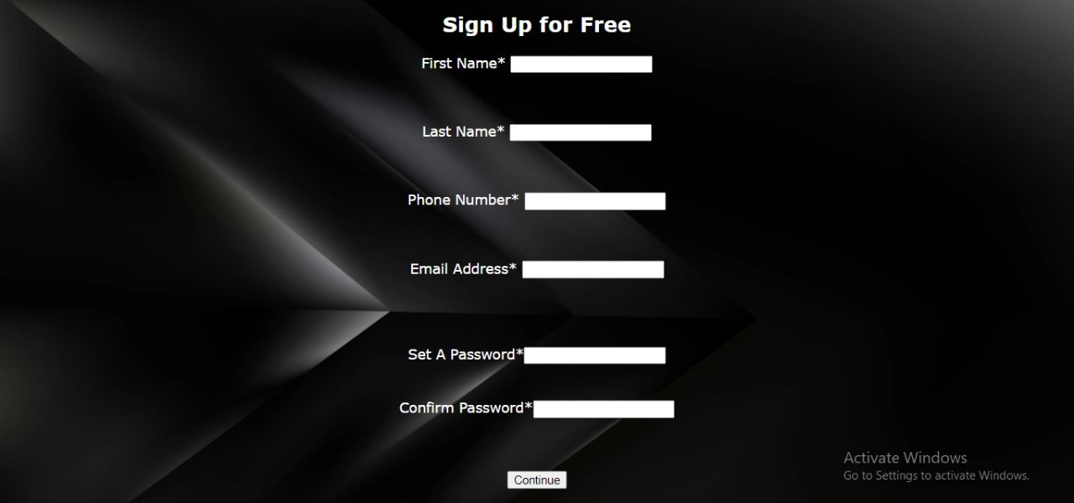

After this page if the user clicked on login then a page will be displayed which will ask for their username/email id and password, password is that one which is already confirmed in the register page.

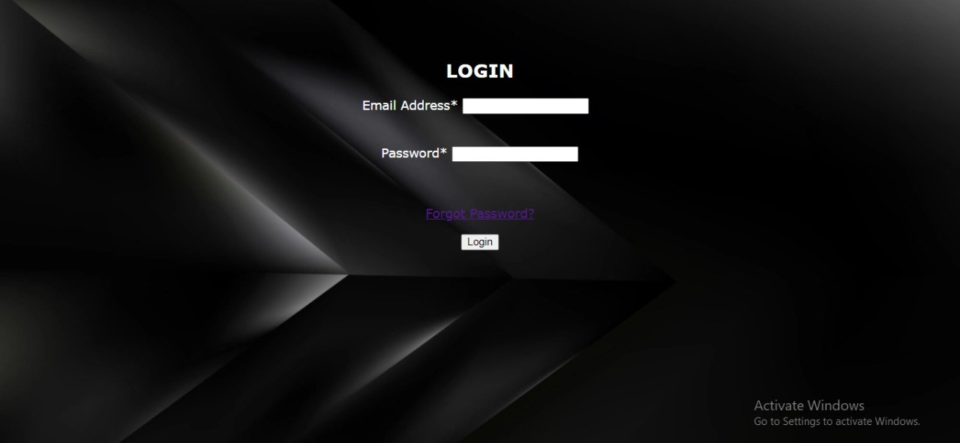

After this page one more page will be shown in which the user has to select either they want a job or they want to provide a jo and then submit.

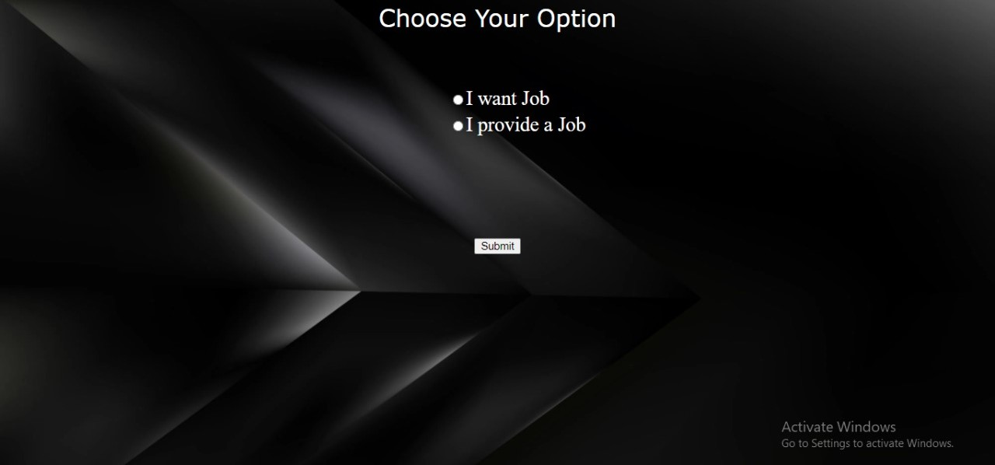

After selecting an option(I want Job ) a page will open which will ask for personal details of employee and in the form the details will be filled.

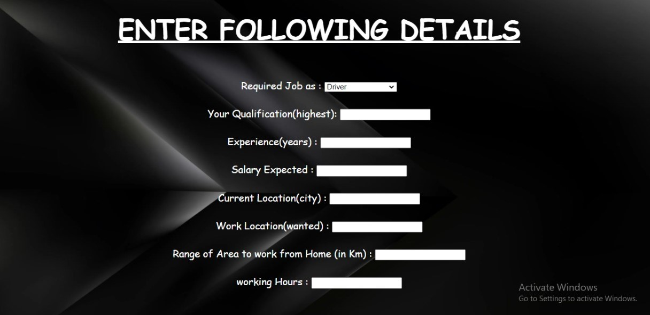

After the option is selected (I provide Job) a page will be opened in which the details of the employer will be filled those are optional in case of employer.

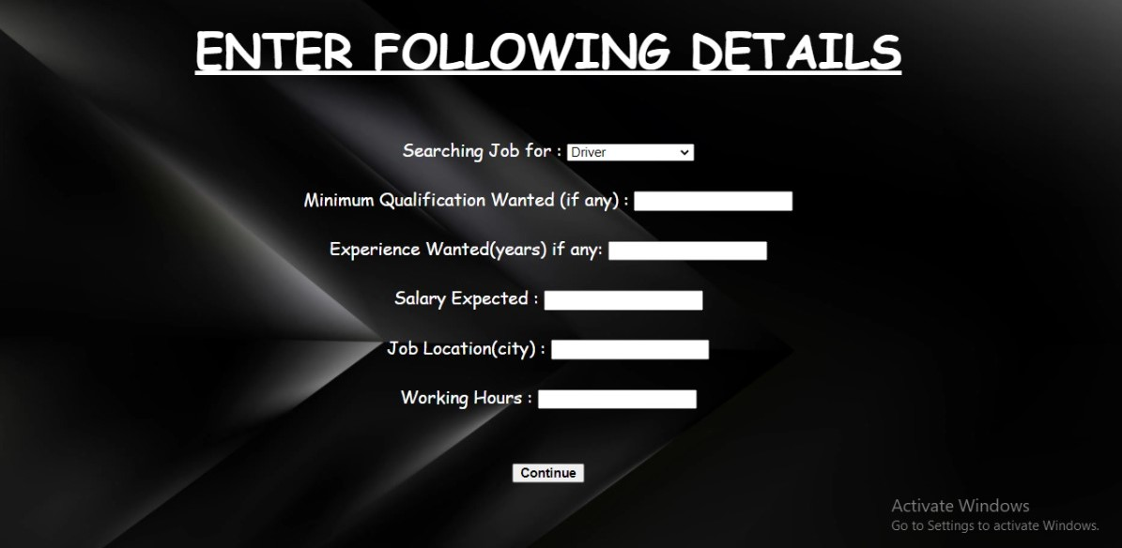

These tabs can be explained detailed as:

#### 3.1.1 Homepage Tab

With the help of this tab, the user is able to register or login on the website and can save his/her details for the further process. In the homepage tab the user is able to see what he/she can do on this website and if he/she is interested in this then they can register or if they already have an account on this website then they can directly login from this page.

#### 3.1.2 Register Tab

This tab is used to save the user details in the database by entering the proper information in the given textbox and these textboxes will save the information in the database.

In the first textbox the user will enter his/her first name and in the next textbox their Last name and after that their phone no., Email id and in this page only the user will set and confirm a password according to them and these information will be saved in the database which will be used at the time of login.

#### 3.1.3 Login Tab

With this tab the user is able to access the further processing once they enter the email id and password and after entering the details as in first textbox user has to enter their email id and in the second textbox user has to enter their password created on the register page.

If both the details are correct and matched from the database the there is a successful login but in case if the password doesn’t match then the person can reset their password by clicking on the forgot password link otherwise there will be a continuous login failure.

#### 3.1.4 Select Option Tab

With the help of this tab the user is able to confirm either he/she wants a job or wants to provide a job. If the user clicks on want a job then a page will be shown in which the user has to enter more details after which the details will be saved.

If the user clicks on provide a job then also a page will be shown in which the user has to enter some basic details after which the details will be compared with the users who entered their details for the requirement of job and if the requirements meet then the job offer will be sent to that person who has applied for that job and after both agrees then the job will be confirmed.

#### 3.1.5 Basic Details Tab

With this tab the page will be reflected in which the user has to enter their basic details in which they have to enter the details like work experience, working hours, qualifications etc.

And the same thing will happen in both the cases either in I want job or I provide Job but just a

simple difference like in case of I want job the user have to enter that how much work experience the person is having or for how many hours the person will work but in the case of I Provide job the user have to enter their qualification he wants for job and the experience needed for that job.

#### 3.1.6 Personal Details Tab

With this tab the page will be reflected in which the user has to enter their personal details after choosing the option from the option tab the page will reflected according to the user’s choice. In case of I want Job there is a compulsion of entering personal details but in the case of I provide Job It is optional depends on the person who wants to enter their personal details or not.

## 

## 3.2 Functional Requirements

In this section, we will explain the major functions of HRMS along with the data flow. So, the major functionality of the project such as authentication mechanism, personal data processing, recruitment, report, and graphical user interface unit will be explained step by step.

#### 3.2.1. Functional requirement 1.n

##### 3.2.1.1 Authentication

|  |  |
| --- | --- |
| Login | User can login to the HRMS system with his/her email id and password. |
| Logout | User can logout from the HRMS system. |
| Login failure | If the user does not exist in the database or the user did not get authorized by the HRMS admin yet. |

##### 3.2.1.2 Authorization

|  |  |
| --- | --- |
| User role check | After logging in, the user role will be checked from the database and the user interface will be created according to that role/roles. |

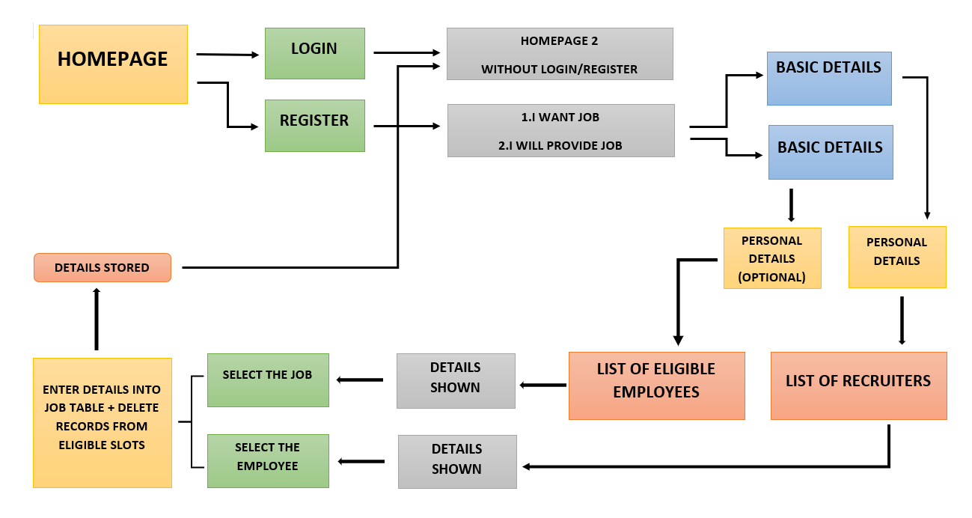

**3.2.1.3 Process Data**

|  |  |
| --- | --- |
| Display | User with defined roles can display the content of the database. Being more specific, employee can only view his/her personal information. Manager can see not only his/her personal information but also employees’ information who are working under his/her coverage. Admin and Employer can display their personal information and all employees’ information. |
| Edit | A user with employee role can edit his/her specific personal information. Manager can only edit his personal information that is under his/her coverage except user role type. Admin can edit all information related to all employees’ including their user role type. |
| Search | User with manager role type can search the content of database for the employees who are under his/her coverage. Admin roles can search all the employees’ information in the database. Search feature works on specific keywords showing employees’ characteristics, peculiarities, skills, features, and etc. For example, Employer wants to find employees who are well trained in “Java Programming Language”. He/she will write the specific keyword in the search bar and press the available search button. Afterwards, he/she will find a list of all the employees’ who know “Java Programming Language”. |
| Report | This feature is basically used to filter the contents of the search mechanism. For instance, as we mentioned in the above search feature. The HR wants to get a report of some specific employees who know “java programming Language”. The list of employees obtained from the result of search feature he/she can get the specific report by selecting the corresponding checkbox available for each employee. Or a manager role type can get a report of some or all employees’ who are working under his/her coverage by selecting the checkbox. Except employee role type, all other role types such as admin, HR, and manager can use this feature. |
| Update authentication | This feature can be used only by admin role type. Admin can update the role type of a specific user. For example, an employee got promotion and his role type will be changed from employee role to manager role.  Admin will be able to update this authentication mechanism. |

##### 3.3 Development Environment Requirments

* Visual Studio will be used for developing the HRMS web-based interface and its relation to person database module.
* **Visual Studio IDE**

The Visual Studio integrated development environment is a creative launching pad that you can use to edit, debug, and build code, and then publish an app. An integrated development environment (IDE) is a feature-rich program that can be used for many aspects of software development. Over and above the standard editor and debugger that most IDEs provide, Visual Studio includes compilers, code completion tools, graphical designers, and many more features to ease the software development process.

* **Microsoft SQL Server**

Microsoft SQL Server is a relational database server, developed by Microsoft; it is a software product whose primary function is to store and retrieve data as requested by other software applications, be it those on the same computer or those running on another computer across a network (including the Internet). There are at least a dozen different editions of Microsoft SQL Server aimed at different audiences and for different workloads (ranging from small applications that store and retrieve data on the same computer, to millions of users and computers that access huge amounts of data from the Internet at the same time).[9]

# 4. Data Model and Description

This section describes attributes of database objects and relationship between them with a data table dictionary and tables to overcome confusions. These data objects are made under the consideration of getting rid of unnecessary attributes and normalization factors. The HRMS application consists of two main database groups. First one is storing information for Personal Master Data module and the second one is for Authorization and Authentication Module.

## 4.1 Data Description of Personal Master Data Module

In this section we mainly describe each table of the Personal Master Data Module in details. We determine each table and its responsibility in the module. Each table keeps many fields related to the specific data object. Then in the following sections we will explain the relationships of each database module table with each other.

#### 4.1.1 Data objects

##### 4.1.1.1 TBL_REGISTER

|  |  |
| --- | --- |
| Name: | **TBL_REGISTER** |
| Description: | This table is created to store the details of the person who wants job or the person who wants to hire. After entering each and every detail on register page it will direct you to the login page and the details entered in the login page will be stored in the register table in the database.  After register there will be a login details also stored in this table. |

##### 4.1.1.2 TBL_EMPLOYEE

|  |  |
| --- | --- |
| g | **TBL_EMPLOYEE** |
| Description: | This table is used to save the details of those employees who wants job. We will store the details like the name, address, phone no, employee id, qualification, experience, salary expected, work location, current location, range(area), working hours etc.  When the user filled all these details then these details will be saved in the database as the employee details these will be used afterwards. |

##### 4.1.1.3 TBL_EMPLOYEE_Personal_Details

|  |  |
| --- | --- |
| Name: | **TBL_EMPLOYEE_Personal_Details** |
| Descriptioin: | This table is used to store each and every personal detail of the employee and will be saved in the database and will be shown to the employer who is providing job and in this table the details are all personal like residential address and some alternative phone no, age, gender and many like this only. |

##### 4.1.1.4 TBL_EMPLOYER

|  |  |
| --- | --- |
| Name: | **TBL_EMPLOYER** |
| Description: | This table stores the details about the employer who wants to hire an employee and for that the employer will some details to be fulfilled and these details are work experience needed, qualification wants, salary, location, phone no., name, employer id etc.  And these details will be stored in the database. |

##### 4.1.1.5 TBL_EMPLOYER_Personal_Details

|  |  |
| --- | --- |
| Name: | **TBL_EMPLOYER_Personal_Details** |
| Description: | This table keeps information about the employer personal details in which the employer has to enter all the personal details like address, gender, alternative mobile no and these details will be optional in case of employer. |

##### 4.1.1.6 TBL_JOB

|  |  |
| --- | --- |
| Name: | **TBL_JOB** |
| Description: | This table is used to save the job details of a person in this table the user will get to know that what are the job details he/she is having and in this table the details like empid, emprid, field on which the selection is done and job id will also be given and location stated by the employer and the salary is also specified according to the employer. |

#### 4.1.2 Relationships

Relationships between tables are made through a unique field which is employee id. Employee table creates the basic information table about an employee such as his/her id, name, surname, email, and etc. This provided employee id is a primary key for the employee table, but it will be a foreign key for all other tables using the specific employee id. All table mentioned above will manipulate employee personal data through that id. Therefore, employee id, the primary key, is like bridge between a unique employee and his/her relation to other data fields and tables.

## 4.2 Data Description of Authentication and Authorization Module

In this section all authentication and authorization module database tables will be described in details. We describe each table and its responsibility in the module. Each authentication and authorization database tables keep many fields related to the specific data object. Relationship between each table will be explained as well.

* TBL_Register/Login
* TBL_Employee
* TBL_Employee_Personal_Details
* TBL_Employer
* TBL_Employer_Personal_Details
* TBL_Job

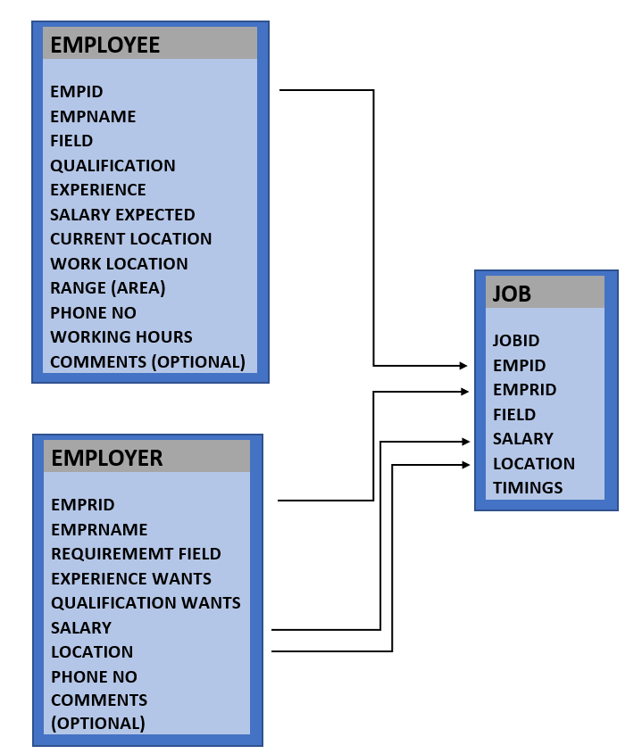

#### 4.2.2 Relationships

The relationship between these tables is designed in the way that if one table is saving some data then the other table is going to have that data otherwise there will be loss of data and cannot be stored. So, according to the structure the tables are designed in a connected form so that the data of both the tables can be accessed in the job table.

# 5 Behavioural Model and Description

## 5.1 Description for software behaviour

Each employee will be added to the system by entering the personal data of an employee by HR. At the creating state, HRMS will give an id to the newly added employee.

After being added by System, each employee has a right to be introduced to the system by admin. At this state, admin determines the role type of the user and this user is given a password automatically.

At the entering state of the system, each user sees the same interface which asks a username and a password.

After entering state, each user sees the same interface with different tabs related to their role type/s (manager, Employer, admin, employee). At this stage:

* Managers can

◦ Search employees under his responsibility or search all the users he/she desires, i.e a manager can search rows of the database.

◦ Get report of information related to the employees he/she desires to learn, i.e. a manager can search columns of the database.

* Employees can

◦ Edit their personal data

◦ see their data in editable form.

* Employer can

◦ Search employees who has the properties he/she desires.

◦ Get report about an employee, or employees.

Administrator can

|  |  |
| --- | --- |
| ◦ | Edit any user' s (manager, admin, Employer, employee) data |
| ◦ | Add user, in other words create a valid account to login. |
| ◦ | Edit role properties, for example there can be a need to change the attributes of each role type such that the type of tabs each user sees may change. For that kind of situation there may be need to change the properties of each role type. |
| ◦ | Add a new role type to the system. Since, our HRMS is going to be a generic program there can be an addition to the role types and our system will perfectly welcome that kind of need. |
| ◦ | Search the users who have the desired capabilities or properties specified. |

◦

## 5.2 State Transition Diagrams

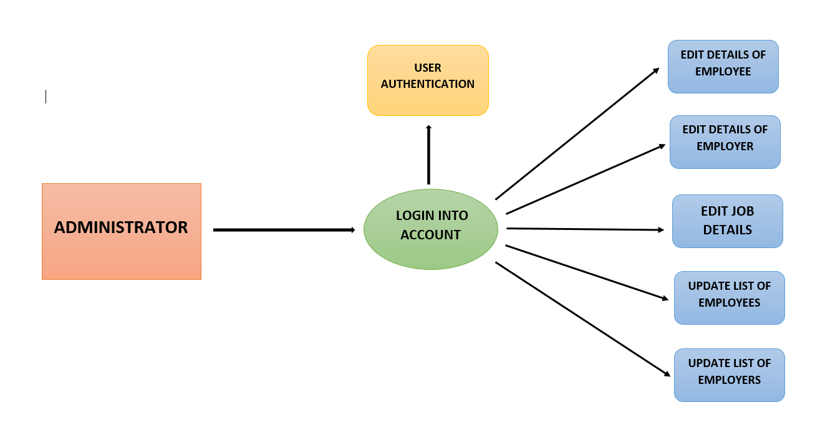

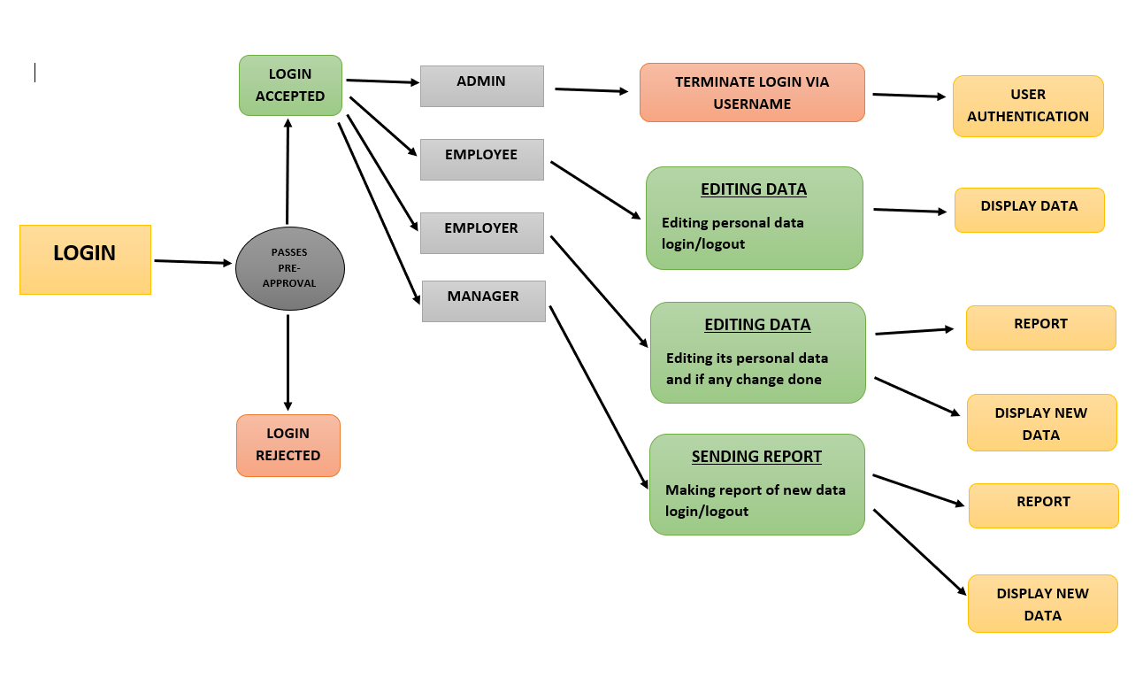

# 6 Planning

## 6.1Process Model

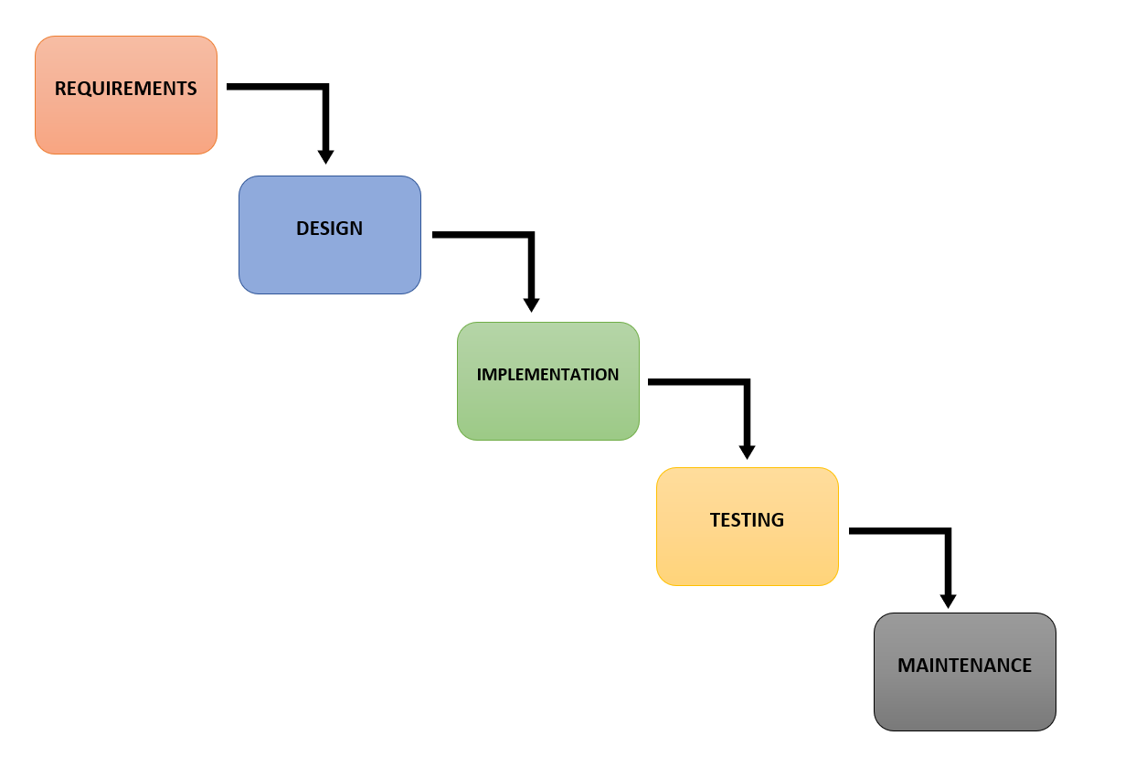

# 7 Conclusion

This document states the design level approach taken by the HCL Innovation Geeks Team for the project HRMS. After giving a basic information about what the HRMS is, the document briefly describes the problem and the solution we proposed to the problem with the figures to visualize better and steps taken to solve the problem. In other words this document introduces the technical details of the HRMS.

In the first part of the technical design, the major functions needed to develop an HRMS are introduced. Later on, these major functions and their sub-functions are visualized with the use case diagrams. In the second part, user interfaces are described in a detailed manner with figures. Lastly, data modules and their relationships are discussed.

To conclude, this document constitutes a base for the development of an HRMS.

**25 |** P a g e