### A CRM Application to Manage the Booking of Co-Living

Our co-living space project aims to create a vibrant and inclusive community where individuals can live, work, and connect with like-minded people. We believe that living together in a shared environment fosters collaboration, reduces isolation, and enhances the overall quality of life.  
  
The co-living space will feature a carefully designed layout that balances privacy and communal areas. Co-living Space is an application where customer Details is stored in order to choose the different AC rooms with Multiple Sharing. Special foods items will be selected by the user in Daily and make Payments in different modes. And Also give the feedback of the service like Room cleaning, internet connection and foods etc…

### Object

**What Is an Object?**   
Salesforce objects are database tables that permit you to store data that is specific to an organization. What are the types of Salesforce objects

Salesforce objects are of two types:

1. **Standard Objects**

2. **Custom Objects**

### **So, for our project Co-living Hostel, creating custom objects for Total Rooms,**

### **customer, room booking, payment , food selection and feedback.**

### 

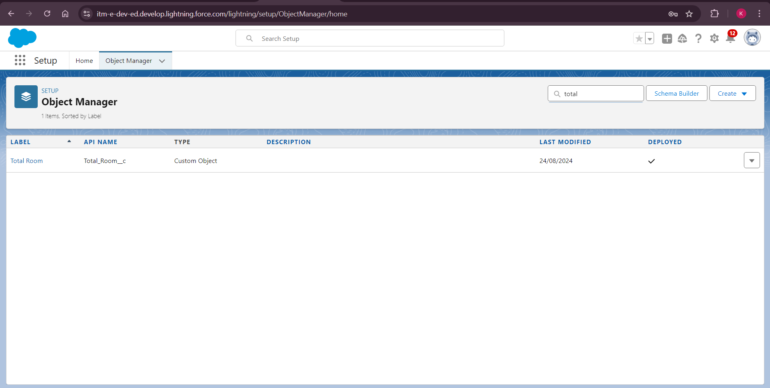

### Creating a Tab for Total Rooms

**To create a Tab:(Total Rooms)**   
1. Go to setup page > type Tabs in Quick Find bar > click on tabs > New (under custom object tab)

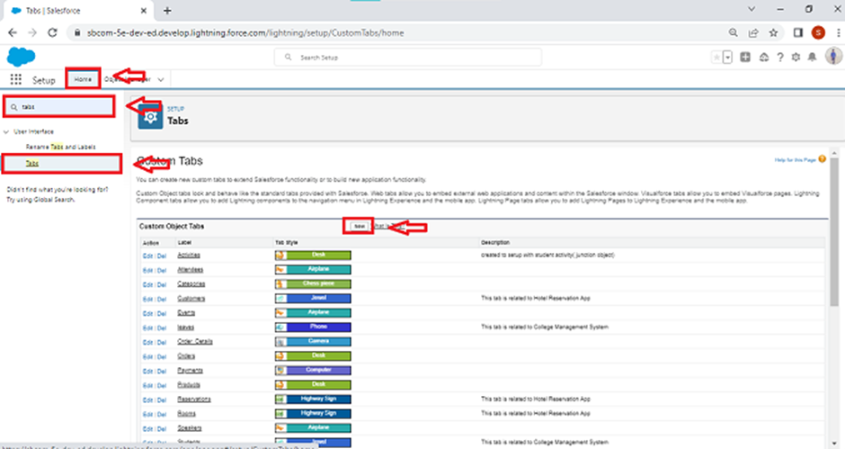

2. Select Object(Total Rooms) > Select the tab style.

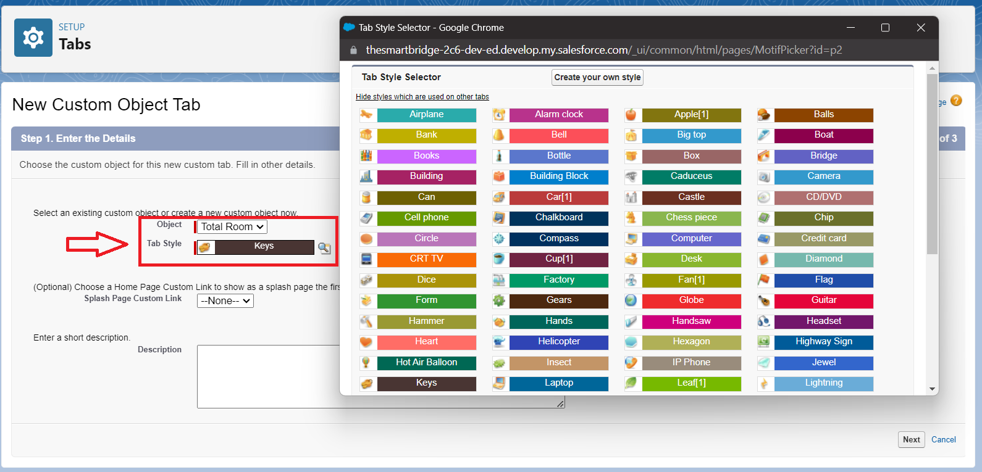

3. Next (Add to profiles page) keep it as default

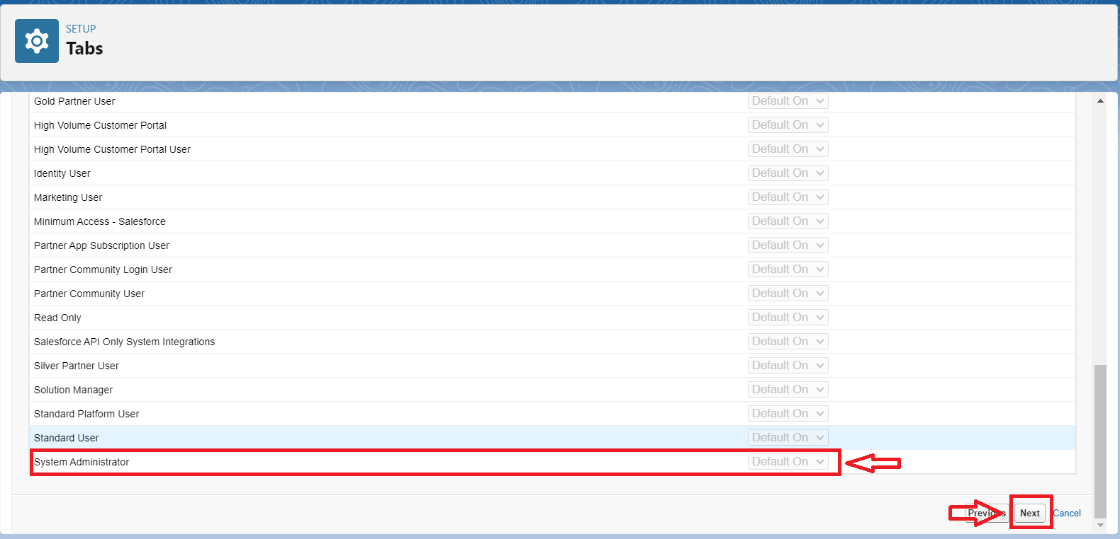

4. Next (Add to Custom App) keep it as default & Save.

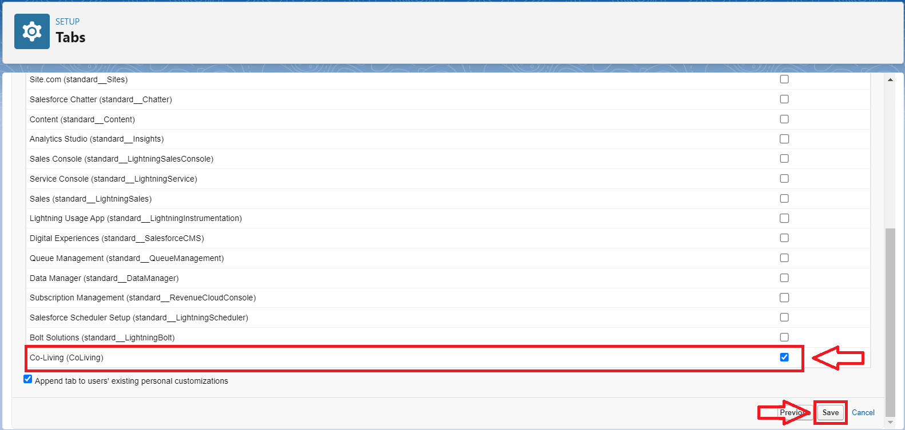

OUTPUT:

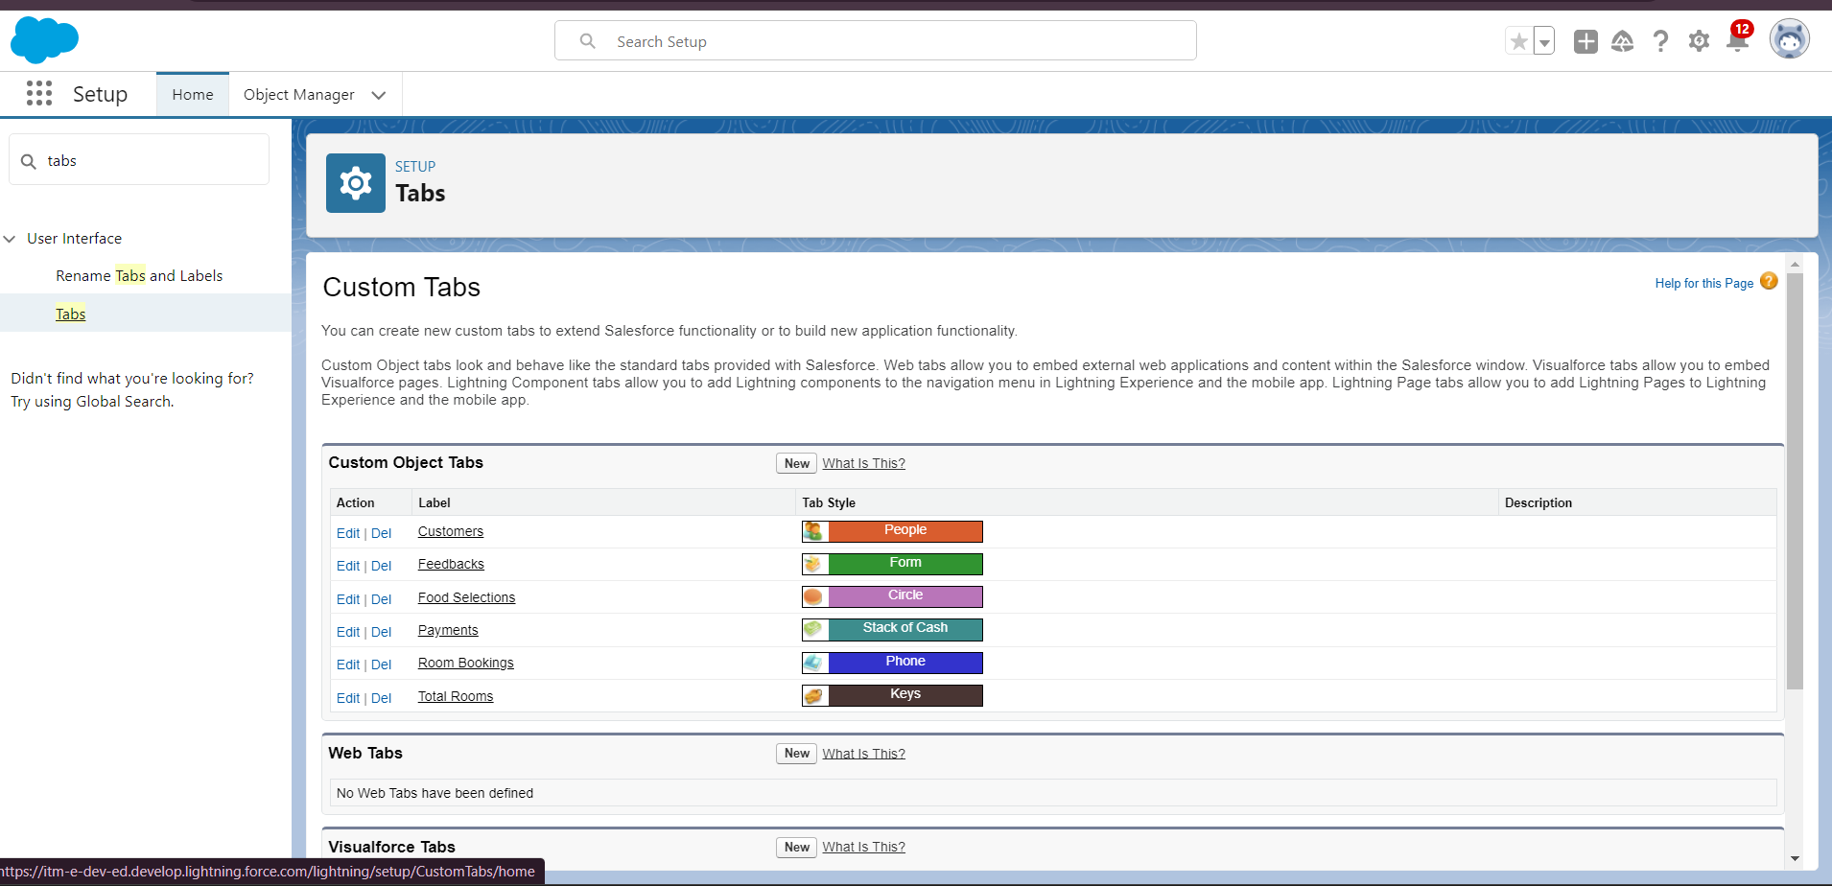

### Create a Lightning App

**To create a lightning app page:**  
1. Go to setup page > search “app manager” in quick find > select “app manager” > click on New lightning App.

2. Fill the app name in app details and branding > Next > (App option page) keep it as default > Next > (Utility Items) keep it as default > Next

3. To Add Navigation Items: Ctrl and Select the items (Total Rooms, Customers1, Room Booking, Payments1, Food selection, Feedbacks, Reports and Dashboards) from the search bar and move it using the arrow button > Next.

4. To Add User Profiles:

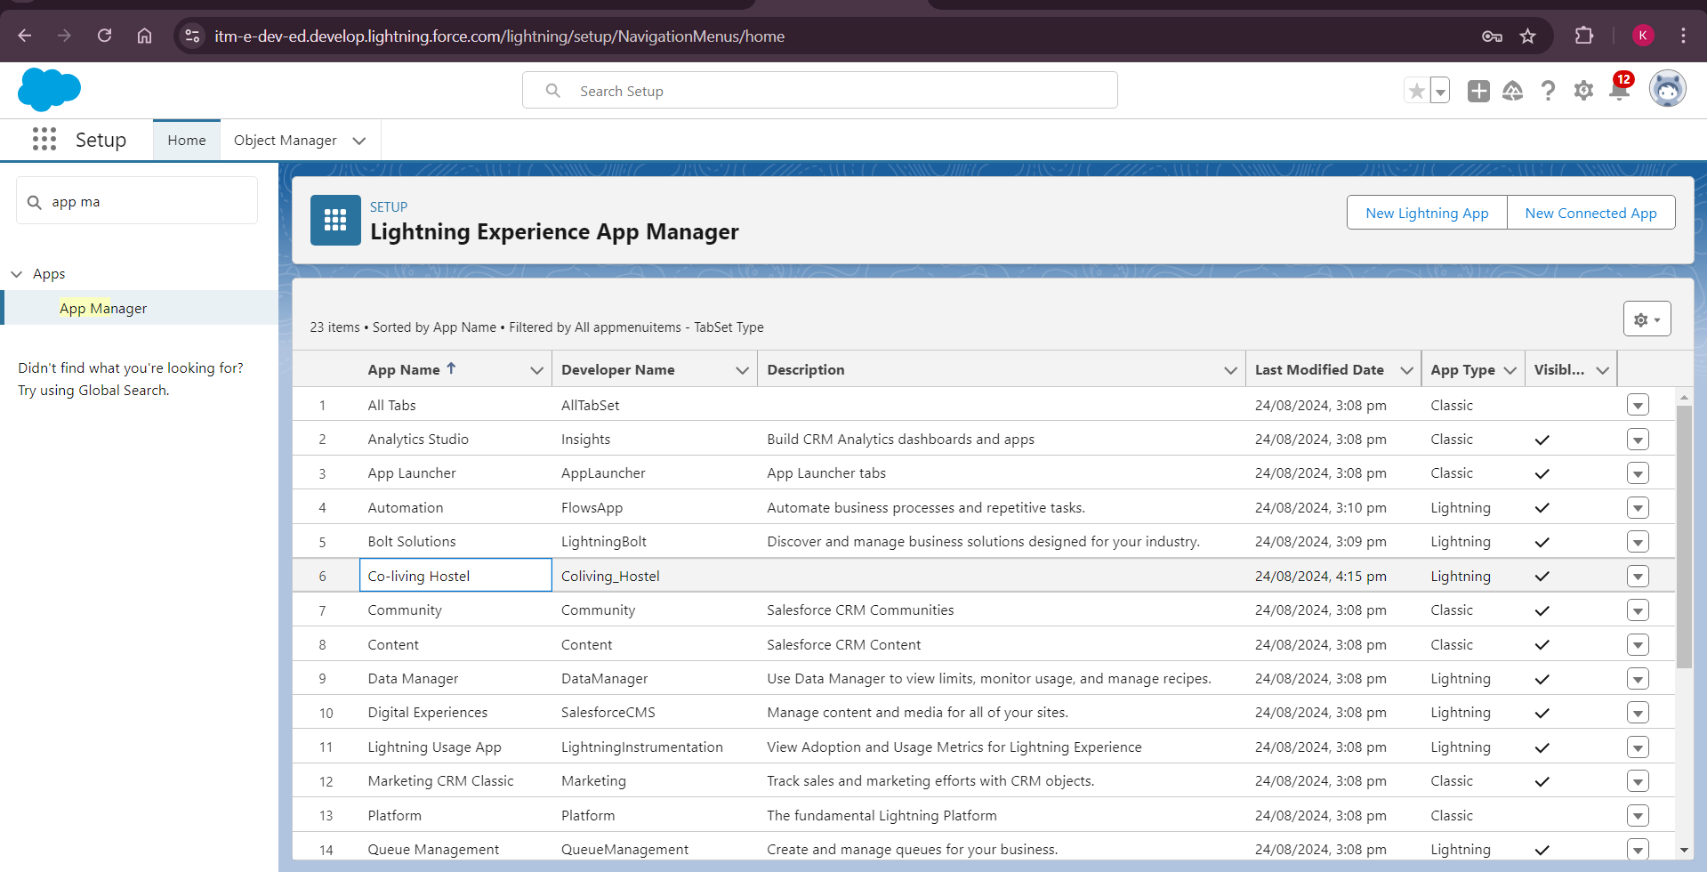

### Creation of fields for the customer1 object

**1. To create fields in an object:**  
1. Go to setup > click on Object Manager > type object name(Customer1) in search bar > click on the object.

2. Now click on “Fields & Relationships” > New

3. Select Data Type as a “Phone”

4. Click on next

5. Fill the Above as following:

1. Field Label: Phone no
2. Field Name : gets auto generated
3. Click on Next > Next > Save and new.

Repeated all above steps for Room booking object, payment, food selection, feedback and total rooms.

OUTPUT:

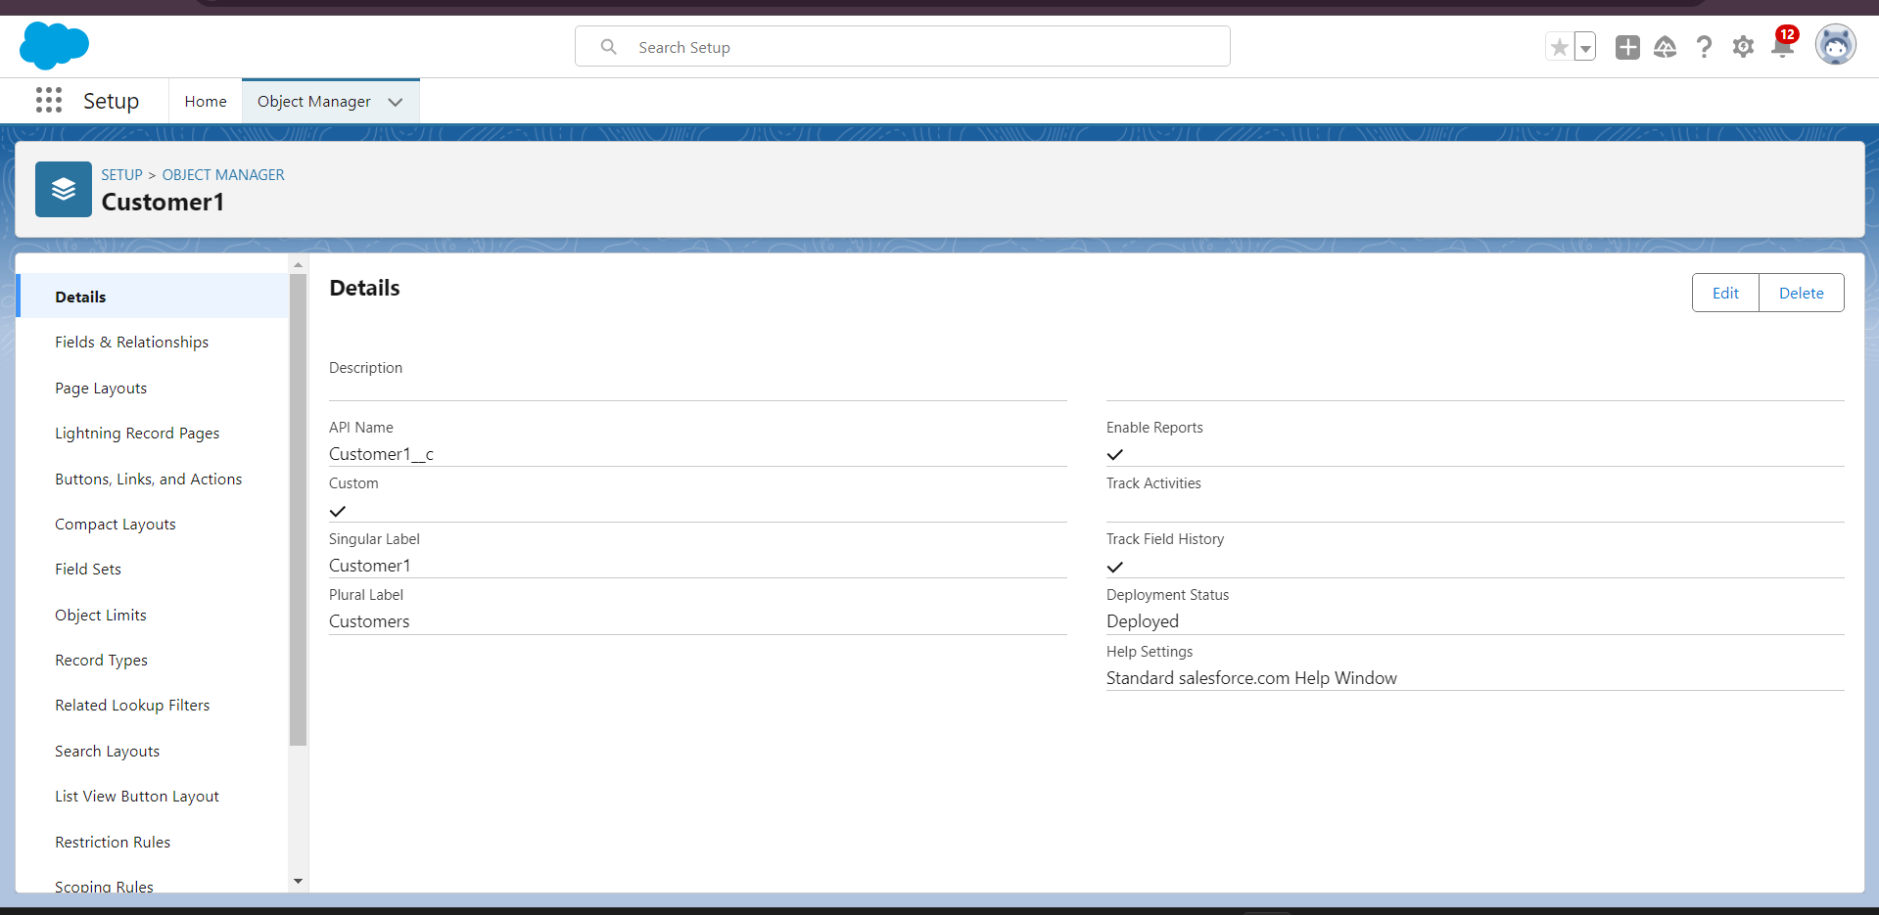

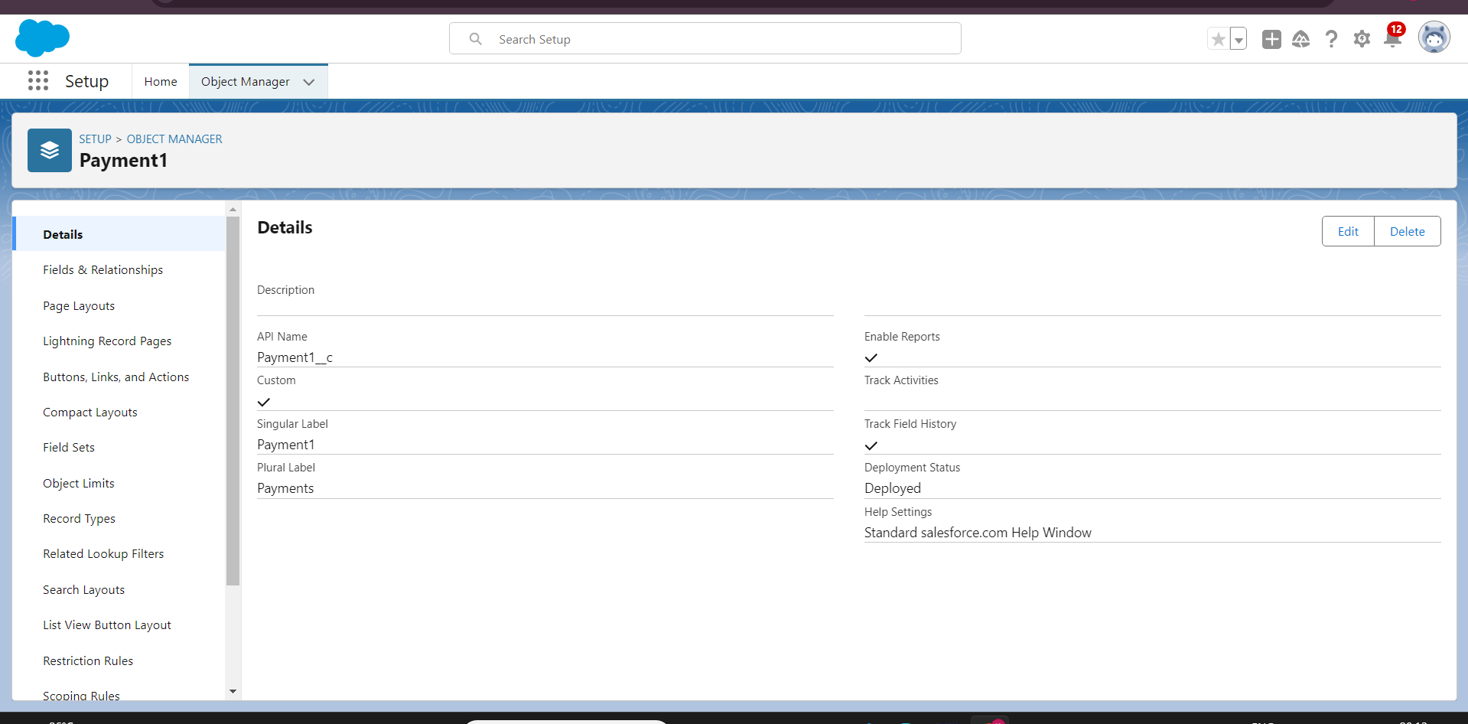

### create a validation rule to an Room Booking Object

1. Go to setup > click on Object Manager > type object name(Room Booking) in the search bar > click on the object.
2. Now click on “Validation rule” at top > New.
3. Enter Rule name “checkbox field” and make the validation should be Active.
4. Enter the formula in the formula Box “Advance_payment_for_1month__c = false” and check for syntax error.
5. Enter the error message “Checkbox should be checked”
6. Select error location as field(Advance payment for 1month)
7. Click on save.

OUTPUT:

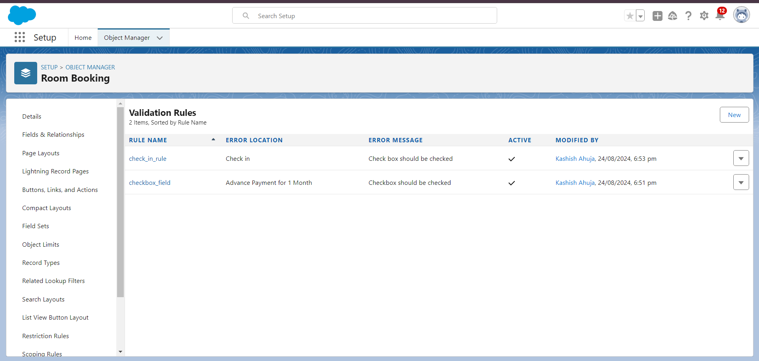

### Custom user Profile

**To create a new profile:**

1. Go to setup > type profiles in quick find box > click on profiles > clone the desired profile (Standard User)
2. Enter profile name (Custom User) > Save.
3. While still on the profile page, then click Edit.
4. Scroll down to Custom Object Permissions and Give All access permissions for Customers, Feedbacks, Food selections, Payments, Room Bookings and Total Rooms.
5. Scroll down and Click on Save.

OUTPUT:

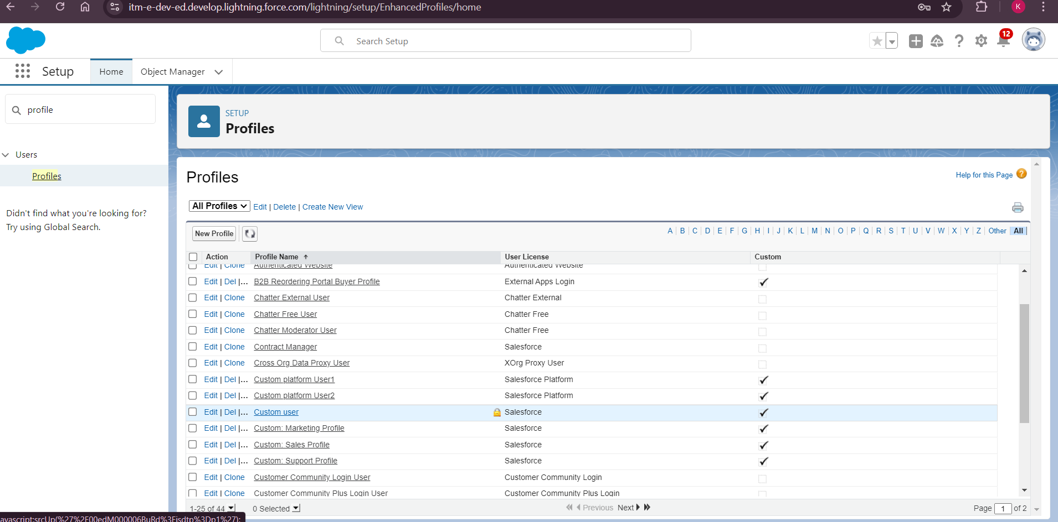

CREATING ROLES:

1. MARKETING ROLE

Go to quick find > Search for Roles > click on set up roles.

1. Click on Expand All and click on add role under CEO role.
2. Give Label as “Marketing” and Role name gets auto populated.
3. Then click on Save.

OUTPUT:

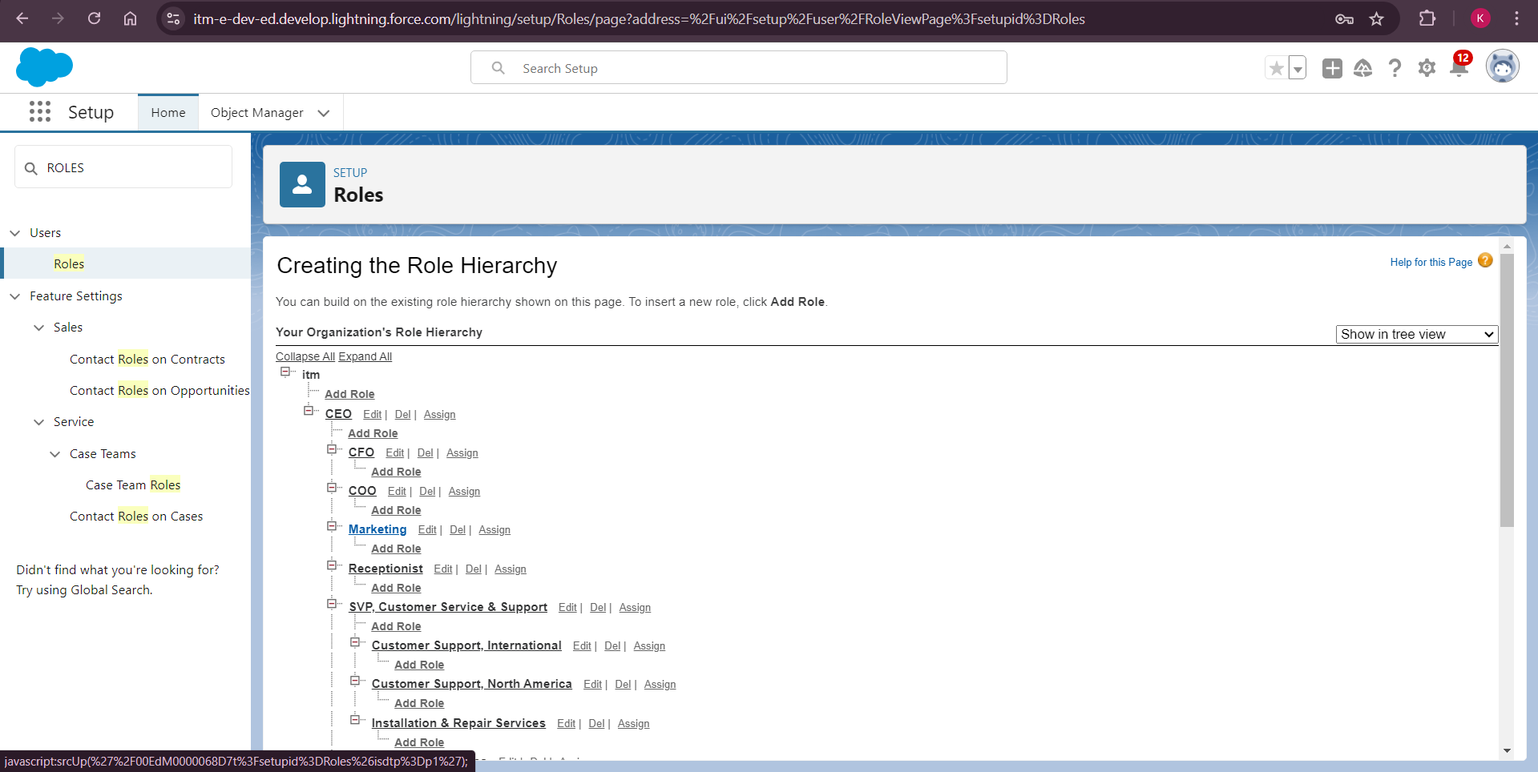

2. RECEPTIONIST ROLE

same as above process as in marketing role.

### Create User

1. Go to setup > type users in quick find box > select users > click New user.

1. Fill in the fields

* First Name : sandeep
* Last Name : gujja
* Alias : Give a Alias Name
* Email id : Give your Personal Email id
* Username : Username should be in this form: text@text.com
* Nick Name : Give a Nickname
* Role : CEO
* User licence : Salesforce
* Profiles : Custom user

3. Save.

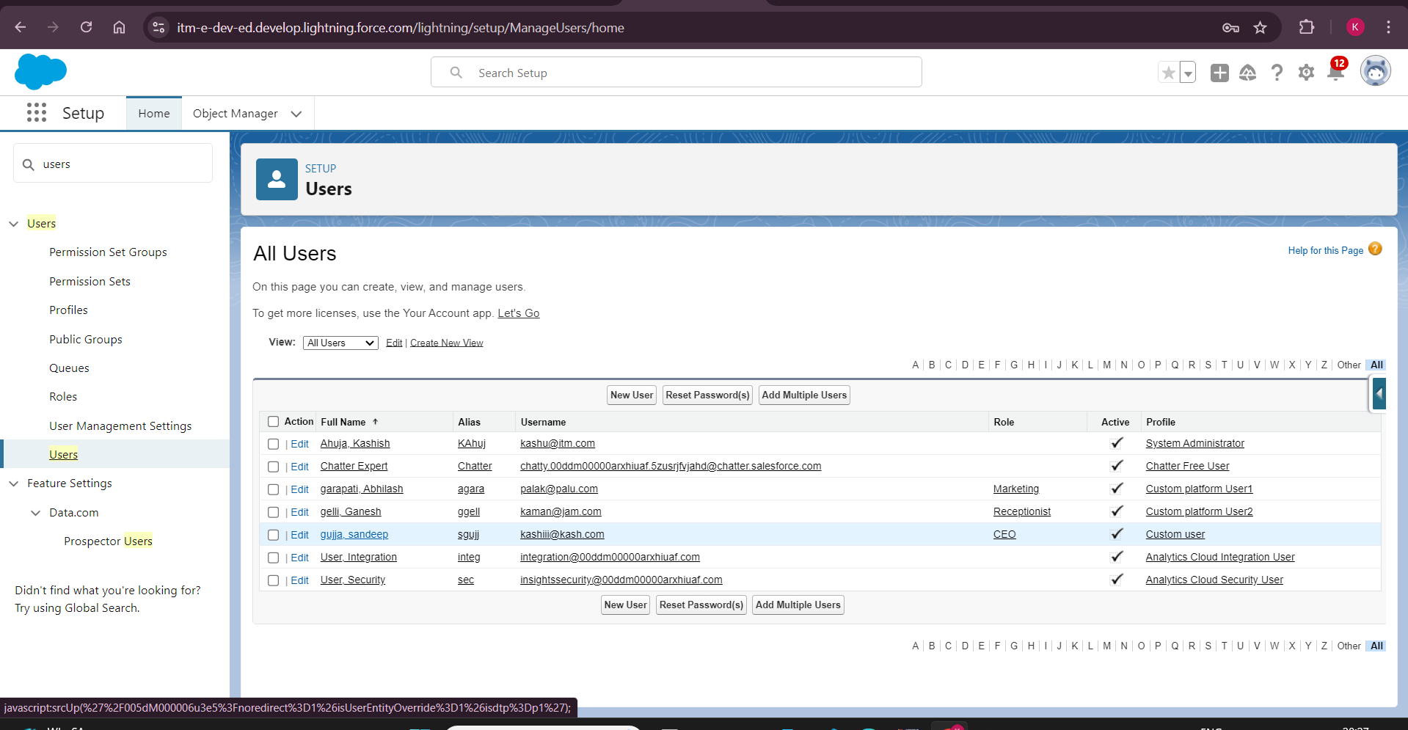

### Create a Record (Customers)

1. Click on App Launcher on the left side of the screen.
2. Search Co-living Hostel & click on it.
3. Click on the Customers Tab.
4. Click new and fill details & Save

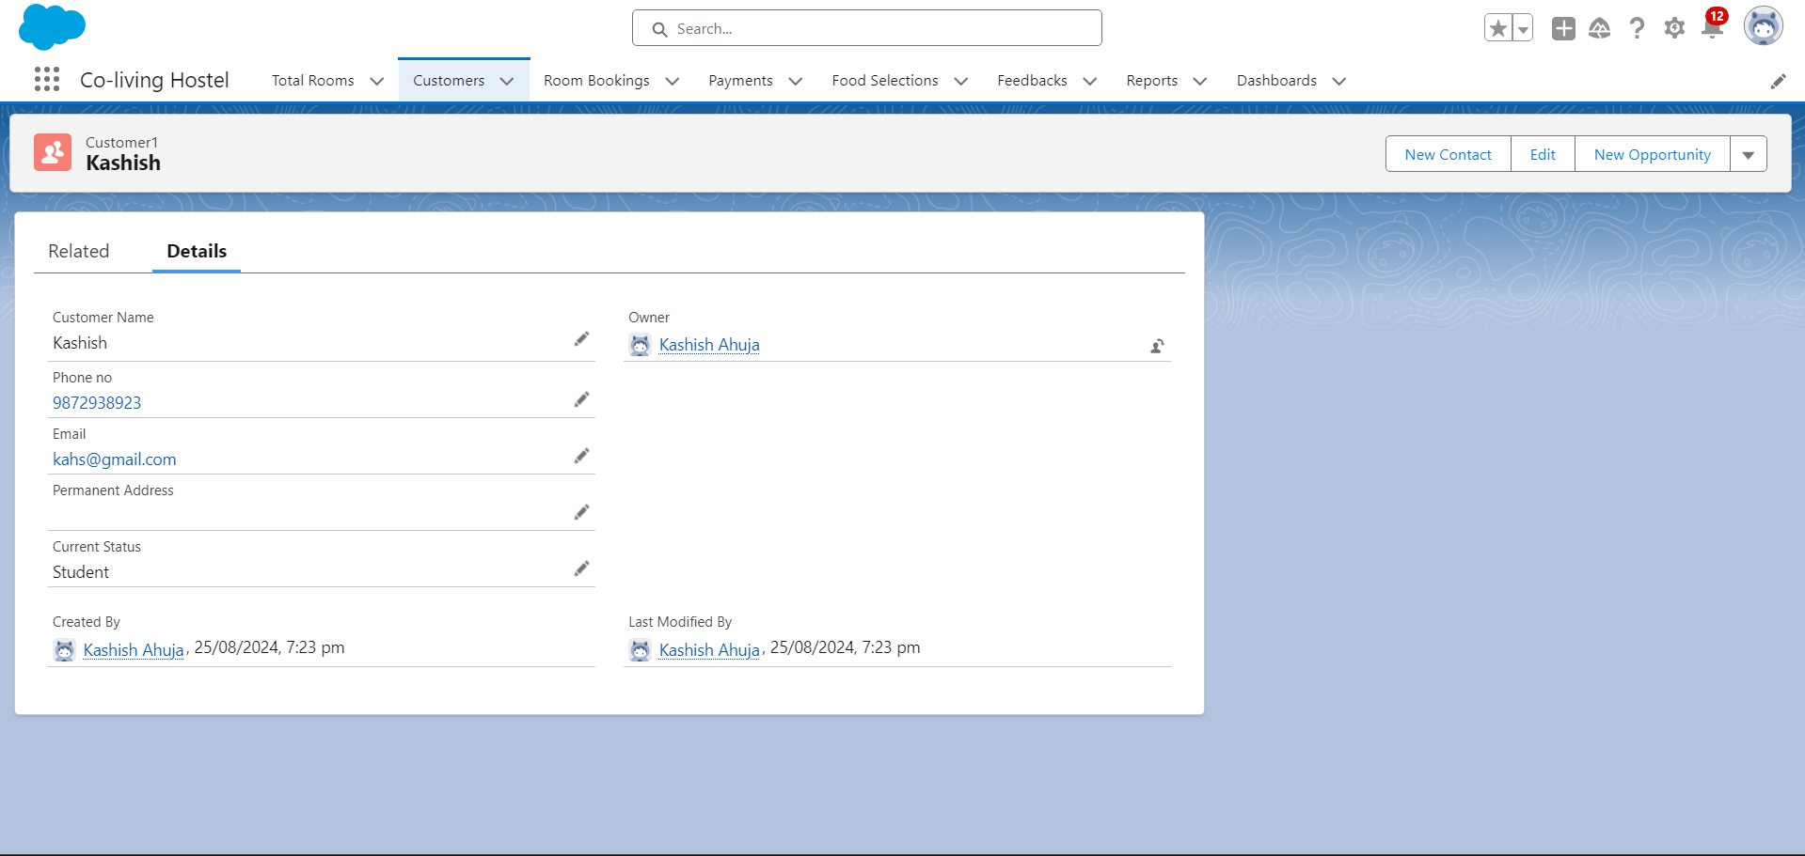

### 

### Create Report

1. Go to the app > click on the reports tab
2. Click New Report.
3. Select report type from category or from report type panel or from search panel “Customers with Room Bookings with Total Rooms ” > click on start report.
4. Customize your report
5. Add fields from left pane as shown below
6. Save or run it.

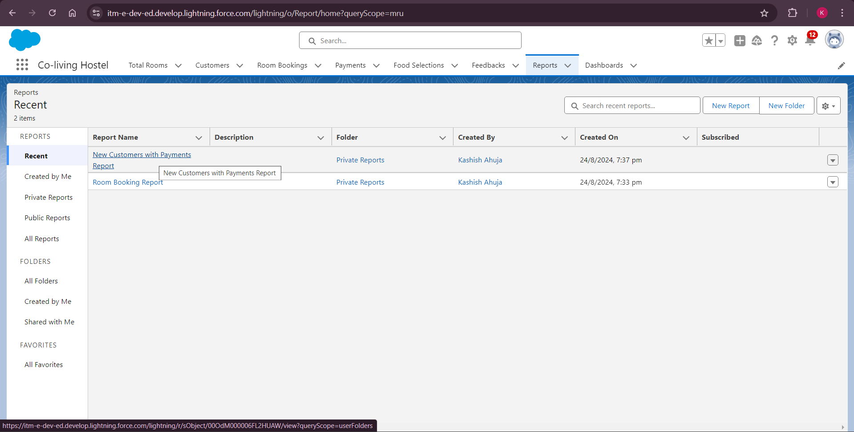

### Create Dashboard

1. Go to the app > click on the Dashboard tabs and click on new Dashboard
2. Give a Name and click on Create.
3. Select add component.
4. Select a Report Customer with Room Booking and click on select.
5. Click Add then click on Save and then click on Done.

OUTPUT:

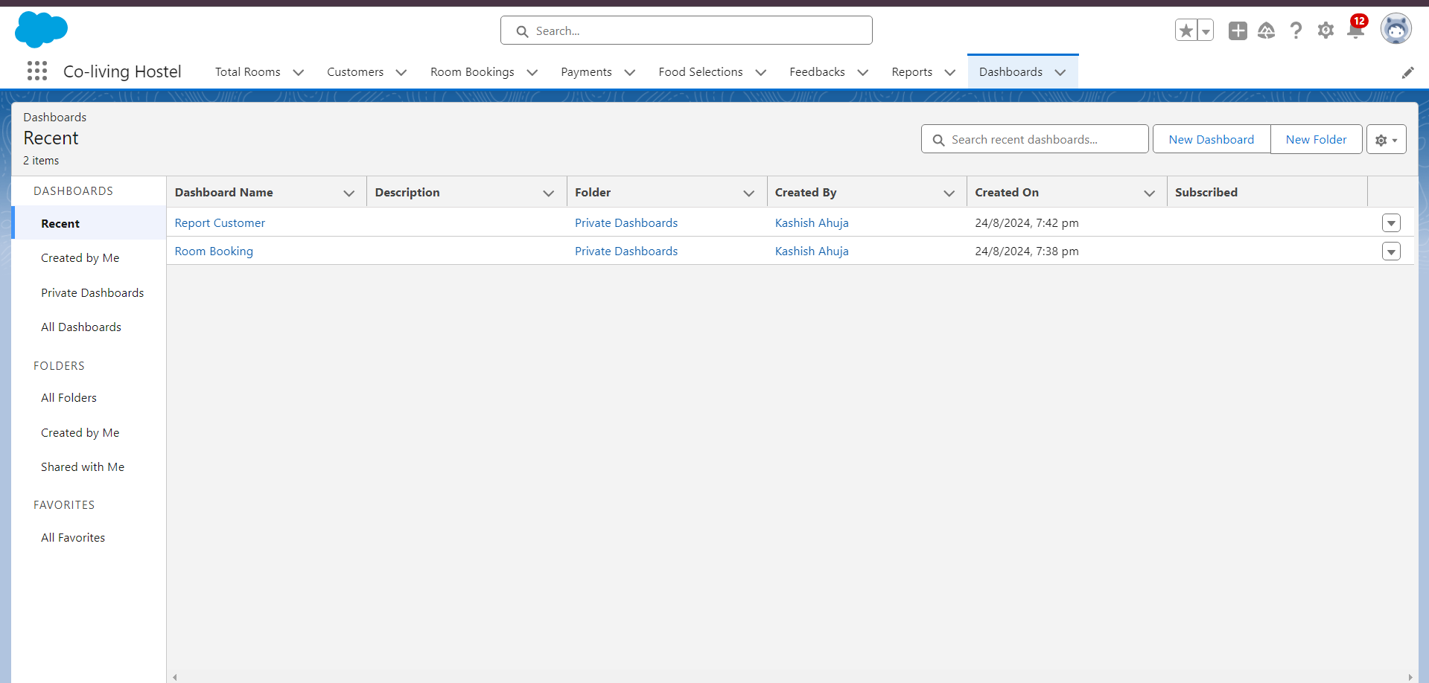

### Create a Flow

1. Go to setup > type Flow in quick find box > Click on the Flow and Select the New Flow.

1. Select the Record-triggered flow and Click on Create.

3. Select the Object as a Room Booking in the Drop down list.

4. Select the Trigger Flow when: “A record is Created or Updated”.

5. Select the Optimize the flow for: “Actions and Related Records” and Click on Done.

6. Under the Record-triggered Flow Click on “+” Symbol and In the Drop down List select the “Decision Element”.

1. Enter the Details Label: Field should be Update, API name: Gets Automatically Generated.
2. Enter the Outcome Details Label: Single sharing, Outcome API name: Gets Automatically Generated.

* Resource: Select Record.Room sharing.
* Operator: Select Equals.
* Value: Select Single sharing.
* Click on “Add Condition”
* Resource: Select Record.AC-3000.
* Operator: Select Equals.
* Value: Select False.
* Click on “+” Symbol In the Outcome Order.

and so on....

FINAL FLOW CREATED:

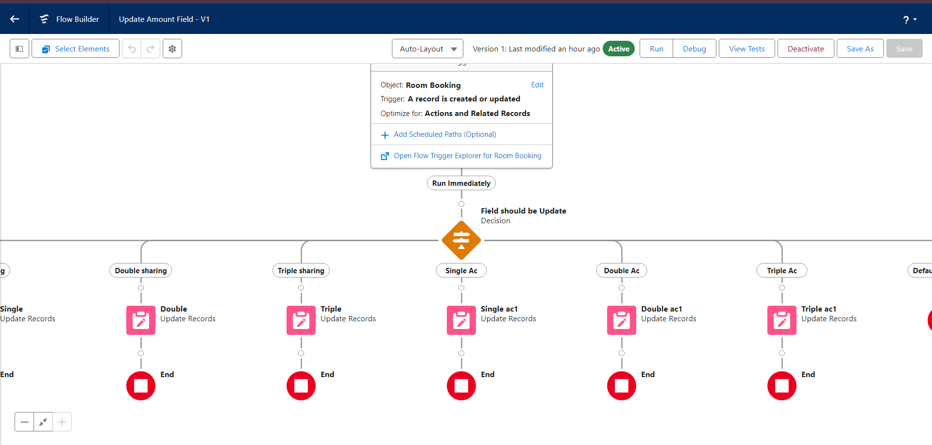

TESTED FLOW OUTPUT:

