CSS-

Inline CSS
Inline CSS involves directly embedding CSS styles within HTML elements using the style attribute. This method applies styles to individual elements, overriding external stylesheets.

Internal CSS
Internal CSS involves embedding CSS rules directly within an HTML document. This is achieved by using the <style> tag, typically placed inside the <head> section of the HTML file.

External CSS
External CSS involves writing CSS rules in a separate file (with a .css extension) and then linking that file to your HTML document. This approach promotes cleaner code, easier maintenance, and reusability of styles across multiple web pages.

Cascading Order in CSS (Simple Explanation)
Cascading Order means:
When multiple CSS rules apply to the same element, which one will win?
Browsers follow a priority system to decide this.

CSS Priority Rules (Highest → Lowest)

1. !important (Highest Priority)
- Overrides everything
p {
color: red !important;
}

2. Inline CSS
- Written directly inside HTML
<p style="color: blue;">Hello</p>

3. Specificity (Very Important)
More specific selector = higher priority

Example:
p { color: red; } /* low */
.class { color: blue; } /* higher */
#id { color: green; } /* highest */
Priority:
#id > .class > element

4. Source Order (Last Rule Wins)
If specificity is same → last written CSS applies
p { color: red; }
p { color: blue; } /* this will apply */

Final Priority Order (Shortcut Trick )
👉 "IISSS" Rule
- I → Important (!important)
- I → Inline CSS
- S → Specificity
- S → Source Order
Properties and Values in CSS-
What is property?
A property is what you want to change in an element.
Examples:
- color → text color
- font-size → text size
- background-color → background

What is a Value?
👉 A value is how you want it to look.
Examples:
color: red;
color: #00FF00;
color: rgb(0, 255, 0);
Here:
- color = property
- red / #00FF00 / rgb(...) = values

Property + Value = Declaration
👉 A declaration is a combination of property and value.
color: blue; ✔ This is one declaration

What is a Selector in CSS?
👉 A selector is used to target HTML elements so you can apply styles to them.
Simple selectors in CSS are the basic building blocks for targeting HTML elements you want to style. They directly select elements based on their name (like p for paragraphs), ID (using #), or class (using .). These selectors are straightforward and provide a fundamental way to apply styles to specific parts of your webpage

Types of Selectors (Most Important)

1. 🏷️ Element Selector
Targets HTML tags
p {
color: blue;
}
👉 All <p> tags will be blue

2. 🎯 Class Selector
Targets elements with a class
.box {
background-color: yellow;
}
<div class="box"></div>
👉 Uses . (dot)

3. 🆔 ID Selector
Targets a unique element
#header {
color: red;
}
<h1 id="header"></h1>
👉 Uses #
👉 Should be unique

4. 🌐 Universal Selector
Targets everything
* {
margin: 0;
}

5. 🧬 Group Selector
Apply same style to multiple elements
h1, p {
color: green;
}

6. 🔗 Descendant Selector
Targets elements inside another
div p {
color: blue;
}
👉 All <p> inside <div>

What is a Declaration in CSS?
👉 A declaration is a single line of CSS that defines:
- what to style (property)
- how to style it (value)

CSS Rules
CSS rules are the fundamental building blocks of CSS stylesheets. Each rule specifies how particular HTML elements should be styled. A rule consists of a selector, which identifies the element(s) to be styled, and a declaration block, which contains one or more property-value pairs that define the styles to be applied.

Comments-

/* This is a CSS comment */Simple Selectors
Attribute selectors-
Attribute selectors in CSS are used to select elements based on their attributes or attribute values for more precise styling.
Selector | Meaning
[attr] | Has attribute
[attr="value"] | Exact match
[attr^="val"] | Starts with
[attr$="val"] | Ends with
[attr*="val"] | Contains

Font families-
Font families in CSS specify a list of fonts that the browser uses to display text, choosing the first available one.

Example:
p {
font-family: Arial, Helvetica, sans-serif;
}

Font style-
Font style in CSS specifies whether text should be normal, italic, or oblique.

Font Size-
Font size controls how big or small the text appears on a webpage.
Font Weight-
Font weight refers to the thickness or boldness of characters .
Font shorthand-
Font shorthand is a CSS property used to set multiple font-related properties in a single declaration.
p {
font: italic bold 16px/1.5 Arial, sans-serif;
}
Google Fonts-
Google Fonts is a free library of fonts provided by Google Fonts.
<!DOCTYPE html>
<html>
<head>
<link href="https://fonts.googleapis.com/css2?family=Roboto&display=swap" rel="stylesheet">
<style>
body {
font-family: 'Roboto', sans-serif;
}
</style>
</head>
<body>
<h1>Hello World</h1>
</body>
</html>
Font variant-
Font variant in CSS is used to control different stylistic variations of text, such as small-caps.
p {
font-variant: small-caps;
}

Element Selectors-

Element selectors in CSS target HTML elements directly by their tag name. EXAMPLE-<p>, <h1>.
CLASS SELECTOR- (.)
ID SELECTOR-(#)
UNIVERSAL SELECTOR-(*)
GROUPING SELECTOR - Grouping selectors allow you to apply the same styles to multiple elements at once.
h1, p, div {
color: blue;
}
DIRECTION-
The direction property in CSS is used to control the text flow direction (LTR or RTL), though using the HTML dir attribute is recommended for better semantics.
Text alignment-
Text alignment in CSS is used to control the horizontal positioning of text within an element using values like left, right, center, and justify.
Text decoration-
Text decoration in CSS is used to style text with lines such as underline, overline, or line-through.
Text transform-
Text transform in CSS controls how text is capitalized (uppercase, lowercase, etc.), regardless of the original HTML text.

Important Background Properties
selector {
background-image: url("image.jpg");
}
- background-size → controls image size
background-size: cover; /* fills entire screen */
background-size: contain; /* fits image inside */
- background-repeat → controls repeating
background-repeat: no-repeat;
- background-position → sets position
background-position: center;
- background-attachment → scroll behavior
background-attachment: fixed

- background gradient-Colors flow in a straight line.
background: linear-gradient(to right, red, blue)
👉 Direction options:
to right
to left
to top
to bottom
👉 With angle:
background: linear-gradient(45deg, red, yellow);

Opacity in CSS
Opacity controls how transparent an element is.
- opacity: 1 → fully visible (default)
- opacity: 0 → completely invisible
- opacity: 0.5 → semi-transparent
These are three ways to define colors in CSS — RGB, HEX, and HSL

1. RGB (Red, Green, Blue)
👉 Defines color using intensity of Red, Green, Blue (0–255)
color: rgb(255, 0, 0); /* red */
color: rgb(0, 255, 0); /* green */
color: rgb(0, 0, 255); /* blue */
👉 With transparency:
color: rgba(255, 0, 0, 0.5); /* 50% transparent red */
✔ Easy to understand
✔ Good for dynamic values (JS)

🔹 2. HEX (Hexadecimal)
👉 Uses base-16 values (0–9, A–F)
color: #ff0000; /* red */
color: #00ff00; /* green */
color: #0000ff; /* blue */
👉 Short form:
color: #f00; /* same as #ff0000 */
✔ Most commonly used
✔ Compact format

🔹 3. HSL (Hue, Saturation, Lightness)
👉 More human-friendly way to adjust colors
color: hsl(0, 100%, 50%); /* red */
color: hsl(120, 100%, 50%); /* green */
color: hsl(240, 100%, 50%); /* blue */
- Hue (0–360) → color type
- Saturation (0–100%) → intensity
- Lightness (0–100%) → brightness
👉 With transparency:
color: hsla(0, 100%, 50%, 0.5);
✔ Best for designing & tweaking shades
✔ Easy to make lighter/darker colors

1. RGBA (Red, Green, Blue, Alpha)
👉 Based on RGB + transparency
color: rgba(255, 0, 0, 1); /* fully visible red */
color: rgba(255, 0, 0, 0.5); /* semi-transparent red */
color: rgba(255, 0, 0, 0); /* invisible */
✔ Values:
- Red, Green, Blue → 0–255
- Alpha → 0–1

🔹 Example
.box {
background-color: rgba(0, 0, 0, 0.5);
color: white;
}
👉 Creates a dark transparent background (very common in UI)

🔹 2. HSLA (Hue, Saturation, Lightness, Alpha)
👉 Based on HSL + transparency
color: hsla(0, 100%, 50%, 1); /* red */
color: hsla(0, 100%, 50%, 0.5); /* transparent red */
✔ Values:
- Hue → 0–360
- Saturation → %
- Lightness → %
- Alpha → 0–1

CSS Box Model
The CSS Box Model defines how every HTML element is structured as a rectangular box.
Each element consists of 4 parts:

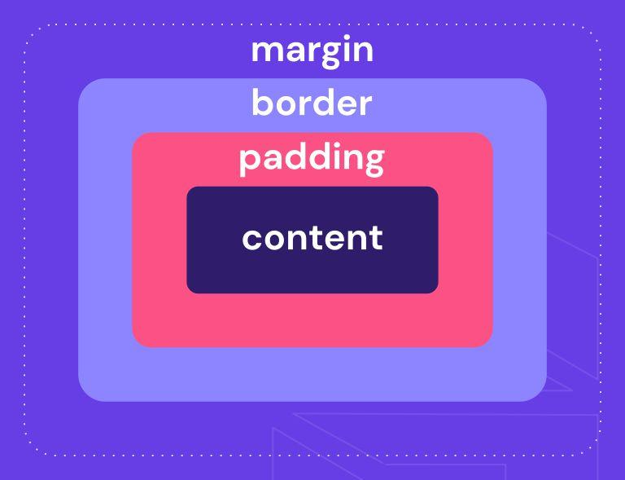

1. Content
- Actual data (text, image, etc.)
- Size controlled by:
width, height

2. Padding(top, right, bottom, left)
- Space inside the box, around content
padding: 10px;

3. Border
- Surrounds padding + content
border: 2px solid black;

4. Margin
- Space outside the box
margin: 20px;

Padding vs Margin:
Property | Meaning
Padding | Space inside (content → border)
Margin | Space outside (border → other elements)
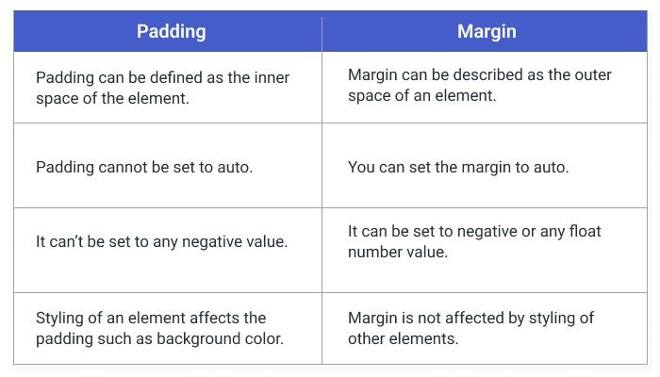

Border
Border = visible outline around an element
div {
border: 2px solid black;
}
👉 This means:
- 2px → thickness
- solid → style
- black → color

Outline in CSS
Outline is a line drawn outside the border of an element.

CSS UNITS-
Unit Type | Examples | Behavior
Absolute | px, cm, in | Fixed size
Relative | em, rem, % | Depends on parent
Viewport | vw, vh | Depends on screen

BLOCK VS INLINE VS INLINE-BLOCK
Property | Block | Inline | Inline-Block
New line | ✅ Yes | ❌ No | ❌ No
Width/Height | ✅ Yes | ❌ No | ✅ Yes
Space taken | Full width | Content only | Content + set size

Visibility in CSS
visibility controls whether an element is visible or hidden, without removing it from the layout.

Visibility vs Display
Property | visibility: hidden | display: none
Visible? | ❌ No | ❌ No
Space occupied? | ✅ Yes | ❌ No
Layout affected? | ❌ No | ✅ Yes

Display: none
display: none completely removes an element from the webpage.

Key Points:
- Element is not visible
- It takes no space
- It is removed from document flow
- Other elements shift and adjust automatically

- position: sticky;
- position: fixed;
- position: absolute;
- position: relative;
- position: static;
- */
- position:absolute;
- top: 50px;
- left: 50px;
- 👉 If question asks “which removes element from flow?”
Answer: absolute & fixed
- 👉 If asks “which keeps space?”
Answer: static, relative, sticky

Pseudo-Elements in CSS
Pseudo-elements let you style specific parts of an element or create content that doesn’t exist in HTML.
👉 They use double colon ::

1. ::before
Adds content before an element
p::before {
content: "👉 ";
color: red;
}

🔹 2. ::after
Adds content after an element
p::after {
content: " ✔";
color: green;
}

🔹 3. ::first-letter
Styles the first letter
p::first-letter {
font-size: 30px;
color: blue;
}

🔹 4. ::first-line
Styles the first line
p::first-line {
font-weight: bold;
}

🔹 5. ::selection
Styles selected text
::selection {
background: yellow;
color: black;
}
z-index controls which element appears on top when elements overlap.
.box1 {
position: relative;
z-index: 1;
}
.box2 {
position: relative;
z-index: 10;
}
👉 .box2 will be on top
Because 10 > 1

Stacking Context with Parent & Child (a.k.a. “stacking containers”)
When people say “stacking containers”, they usually mean parent and child stacking contexts—how layers are grouped and compared.

🔹 Core Idea
- A parent can create a stacking context (container)
- All its children are stacked inside it only
- A child’s z-index is limited to its parent’s context

CSS Specificity
CSS Specificity decides which CSS rule wins when multiple rules target the same element.
👉 It’s like a priority system (weight system)

📊 Specificity Order (Most Important 🔥)
Selector Type | Priority
!important | 🔥 Highest
Inline styles | 1000
ID (#id) | 100
Class (.class) | 10
Element (div) | 1

Pseudo-Elements in CSS (Detailed)

🔹 Definition
Pseudo-elements let you style specific parts of an element or insert content that doesn’t exist in HTML.
👉 Syntax:
selector::pseudo-element {
property: value;
}
<!DOCTYPE html>
<html>
<head>
<style>
p::before {
content: "👉 ";
color: red;
}

p::after {
content: " ✔";
color: green;
}
</style>
</head>

<body>

<p>Hello World</p>

</body>
</html>

Pseudo-Classes in CSS (Clear + Detailed)
Pseudo-classes are used to style elements based on their state, position, or condition—without changing HTML or using JavaScript.
👉 Syntax:
selector:pseudo-class {
property: value;
}
✔ Uses single colon :
<!DOCTYPE html>
<html>
<head>
<style>
button {
background: gray;
padding: 10px;
}
button:hover {
background: blue;
}
button:active {
background: red;
}
/* Input focus */
input:focus {
border: 2px solid green;
}
</style>
</head>
<body>
<button>Click Me</button>
<br><br>
<input type="text" placeholder="Click me">
</body>
</html>

What is Flexbox?
Flexbox (Flexible Box Layout) is a layout system used to align, arrange, and distribute space among elements inside a container.
👉 Works in one direction:
- Row (horizontal)
- Column (vertical

📌 Example (ROW)
.container {
display: flex;
flex-direction: row;
justify-content: center; /* horizontal */
align-items: center; /* vertical */
}

📌 Example (Column)
.container {
display: flex;
flex-direction: column;
justify-content: center; /* vertical */
align-items: center; /* horizontal */
}
Feature | Block | Inline | Inline-Block
New line | ✅ Yes | ❌ No | ❌ No
Width/Height | ✅ Yes | ❌ No | ✅ Yes
Space taken | Full width | Content only | Content + set size

li:nth-child(2n)
👉 Selects even elements (2,4,6...)
Flexbox axes:
• Main axis → horizontal (left ↔ right)
• Cross axis → vertical (top ↕ bottom)

