GROUP_5

AceIt

Group Members:

|  |  |
| --- | --- |
| Vishwa Joshi | AU2140112 |
| Kashish Jethmalani | AU2140029 |
| Shrey Bhadja | AU2140030 |
| Jeel Kadivar | AU2140181 |
| Milan Godhaviya | AU2140078 |

LINEAR ALGEBRA IN COLLABORATIVE FILTERING mvsmvslmlsmlRECOMMENDER SYSTEM.

**Abstract:**

One of the entertainment options are movies, but it might be difficult to select one among the millions of options available each year. However, under certain circumstances, recommendation systems are far more useful. The objective of this work is to enhance the performance and accuracy of a common filtering method. Although there are several ways to create a recommendation system, collaborative-based filtering is the most straightforward and preferable one.

**Problem statement-**

This project aims to tackle the topic of recommender systems utilizing applied linear algebra learnings. To generate fresh suggestions, the Collaborative filtering approach for recommender systems only relies on the historical interactions that have been recorded between users and products. The project's prediction would be made via Pearson Correlation and k Nearest Neighbors. Finally, predicting the ratings of the new item for the given user using programming language to automate the process will be accomplished utilizing the similarity of the k nearest neighbors.

**Link to the repo:**

[**https://github.com/kashishjethmalani/MAT248_Project**](https://github.com/kashishjethmalani/MAT248_Project)

# Introduction

In the vast field of mathematics known as linear algebra, vectors, matrices, linear combinations, and vector spaces are all studied. The topic of linear algebra has advanced, and it now finds use in many other contexts. In recommender systems, one may use linear models to forecast a product's rating based on the rating (or implicit feedback) matrix. In addition to this, one of the most often used similarity metrics for collaborative filtering recommender systems to determine how much two users are associated is the Pearson Correlation Coefficient (PCC).

1. BACKGROUND

Recommender systems have become an important research area, recommender systems directly help users to identify content, products, or services (such as books, digital products, movies, websites, etc.) with the aggregation and analysis of suggestions from other users, which also means the reviews from several authorities and users.

Recommender systems are first defined as ones in which "recommendations are offered by individuals as inputs, which are subsequently collected and directed to appropriate receivers by the system".

# MOTIVATION/ SCOPE

The motivation for collaborative filtering comes from the idea that people often get the best recommendations from someone with tastes similar to theirs.

The growth of the Internet has made it much more difficult to effectively extract useful information from all the available online information. Collaborative filtering is one of the techniques used for dealing with this problem.

The project aims to automate and simplify the process of giving better recommendations as more information about users is collectedthrough the learning of linear algebra. Online streaming platforms such as Netflix use advanced and hybrid forms of recommendation engines.

# LITERATURE SURVEY

The importance of Linear Algebra in this project is extremely crucial. In this scenario, Nearest Neighborhood, The standard method of Collaborative Filtering is known as the **Nearest Neighborhood**algorithm. There are user-based CF and item-based CF. (We will be extensively using **Pearson Correlation**)

1. APPROACH

We outlined some of the procedures that go into the movie recommending system from the publications we cited. We'll go through each one in turn:

1. Load the data

* Load the rating data
* Load the movies data

1. Cleaning both the data
2. Merging both the data
3. Creating a rating data frame with average ratings and the number of ratings
4. Making histograms
5. Sorting the data
6. Main functions (with the functions of graph too).
7. Cleaning the data again
8. Sorting the data frame again
9. Taking input followed by printing the results.

Sample output:

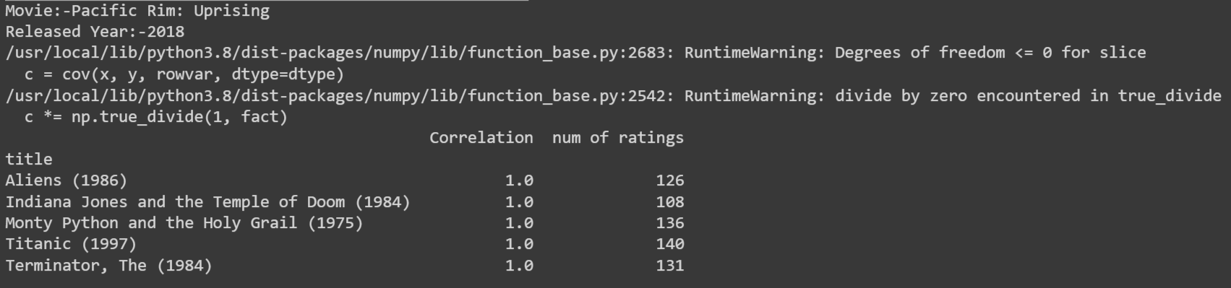

1. BRIEF EXPLANATION

Here, recommending movies using the item-based methodology is the goal. First, the dataset must be extracted in order to collect data about the target movie and user ratings. In order to avoid problems with handling large datasets, the collaborative filtering process secondly starts with preparing the rating dataset so that the KNN model may use it. The top k nearest neighbors are then obtained by calculating the cosine similarity between the target movies and other movies. The necessary suggested film list is then displayed, with the distance between each film listed in descending order. If K=1 in the KNN algorithm, Cases are categorized by the vast majority of their neighbors, with the case being assigned to the category that is most frequent among its nearest neighbors.

1. CONCLUSION

In this project, the CF filtering strategy is utilized for better outcomes in order to eliminate the utilization of content-based filtering. The proposed system is proven to be more accurate and reliable when compared to the current system. Additionally, accuracy and efficiency are observed to rise when the suggested methodology is applied to various larger datasets, demonstrating the correctness and efficiency of our system. It is more practical to use this CF filtering. The primary goal was to enhance the standard recommendation algorithm and deliver better outcomes. The project effort was successful since it accomplished what we set out to do. In the future, datasets can be enhanced with other features (year of release, actor, genre, casting information, etc.) to improve the accuracy and creativity of recommendations.

# References

[1] Analysis of Movie Recommender System using Collaborative Filtering. (2017, May 30). *International Journal of Recent Trends in Engineering and Research*, *3*(5), 338–346.

[2] Agrawal, S. K. (2021, July 13). *Recommendation System -Understanding The Basic Concepts*. Analytics Vidhya. Retrieved November 12, 2022, from

[3] Analysis of Movie Recommender System using Collaborative Filtering. (2017, May 30). *International Journal of Recent Trends in Engineering and Research*, *3*(5), 338–346.

## BIBLIOGRAPHY

[1]<https://www.analyticsvidhya.com/blog/2021/07/recommendation-system-understanding-the-basic-concepts/>

[2]<https://doi.org/10.23883/ijrter.2017.3232.zpbxj>

[3]<https://realpython.com/build-recommendation-engine-collaborative-filtering/>