**Lab#4 (Heroku) 10 points**

**Due Date: 7 July 2021**

We have learned about deploying ML model using Heroku. Heroku is a cloud Platform as a Service that helps developers quickly deploy, manage, and scale applications without infrastructure headaches. In this lab evaluation, you will have hands-on experience of deploying a ML model on Heroku.

Please take necessary screenshot of all the actions and its execution at each of the steps below.

**Instruction:**

1. Build a ML model for the Fish market dataset - A Database of common fish species for fish market model. You can download the dataset from the following link: <https://www.kaggle.com/aungpyaeap/fish-market>

**[Note: You can either decide to work this as a regression problem to determine the weight of the fish or as a classification problem to determine the fish species. The student has the freedom to choose what ML model they want to build for the specific Fish dataset**.]

1. Build a frontend webpage using html/css through which inputs can be provided and predictions can be obtained.
2. Host your above model in Heroku and provide the **instructor with the URL through which the model can be used to make new prediction**.

**Rubrics**

1. All the above-mentioned steps are completed and all necessary screenshots are provided.
2. All the files mentioned in the submissions are uploaded. Any missing file in submission or any file submission in a different format will automatically lead to a grade of zero.
3. Provide a well descriptive README file for your model in your GitHub. Students should follow the video posted in DC Connect-> Week 5 -> 5. README file to make a complete README file in GitHub. Provide the URL to the corresponding GitHub repo to the instructor.
4. Has the student provided the URL to access the model hosted in Heroku?
5. The URL provided makes the predictions without any error.

**Submission Format:**

1. A single word document including the screenshots mentioned in mandatory screenshot section. Please make sure to include all necessary screenshots to showcase the work completion. The word file should also contain the URL to access the model hosted in Heroku and also the URL to your GitHub repo where the code is uploaded. The word file should also contain information about your problem statement and if you have built a classification or a regression model.

1. A folder with the following code:
2. Jupyter notebook for model building
3. Saved model .pkl file.
4. Python code for Flask API
5. Dataset
6. Procfile
7. requirement.txt
8. html/css file

**Mandatory Screenshots to be included in the word document**

1. The Home page of Heroku that shows your name.

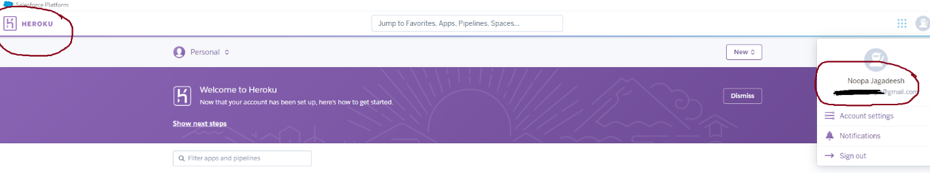

1. Your app names

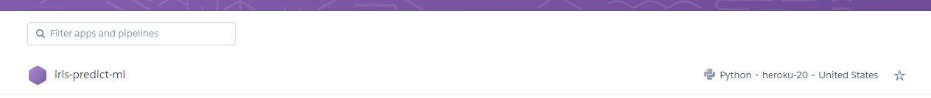

1. Screenshot showing you have established the connection between Heroku and your GitHub Repo.

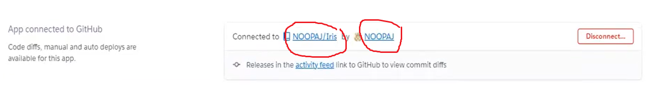

1. Screenshot of Build log

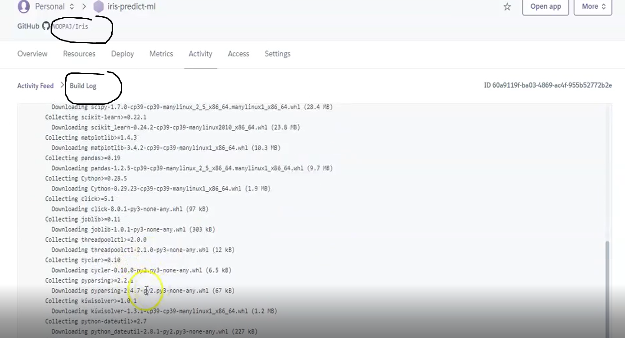

1. The Screenshot indicating your model was successfully launched.

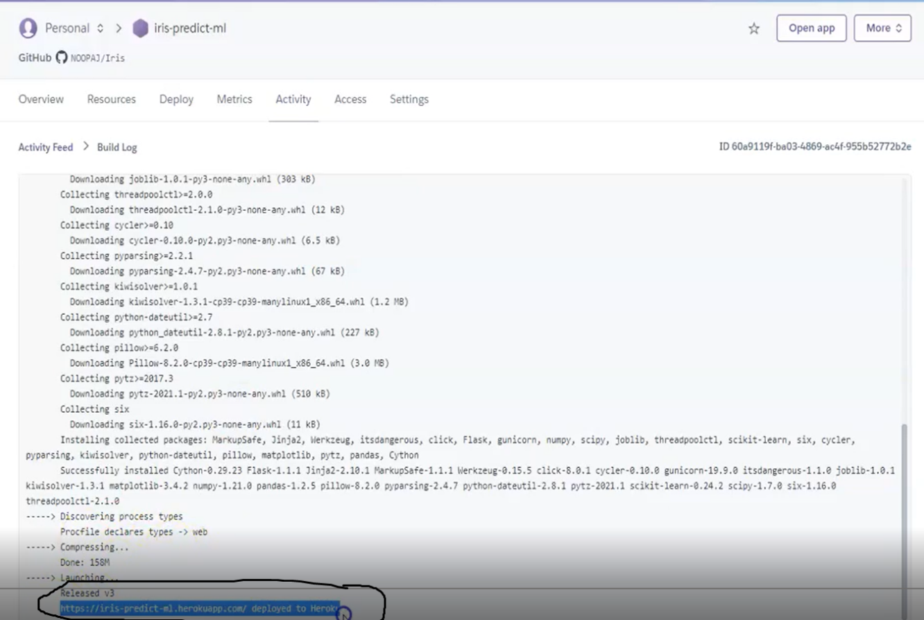

1. Your app making predictions.

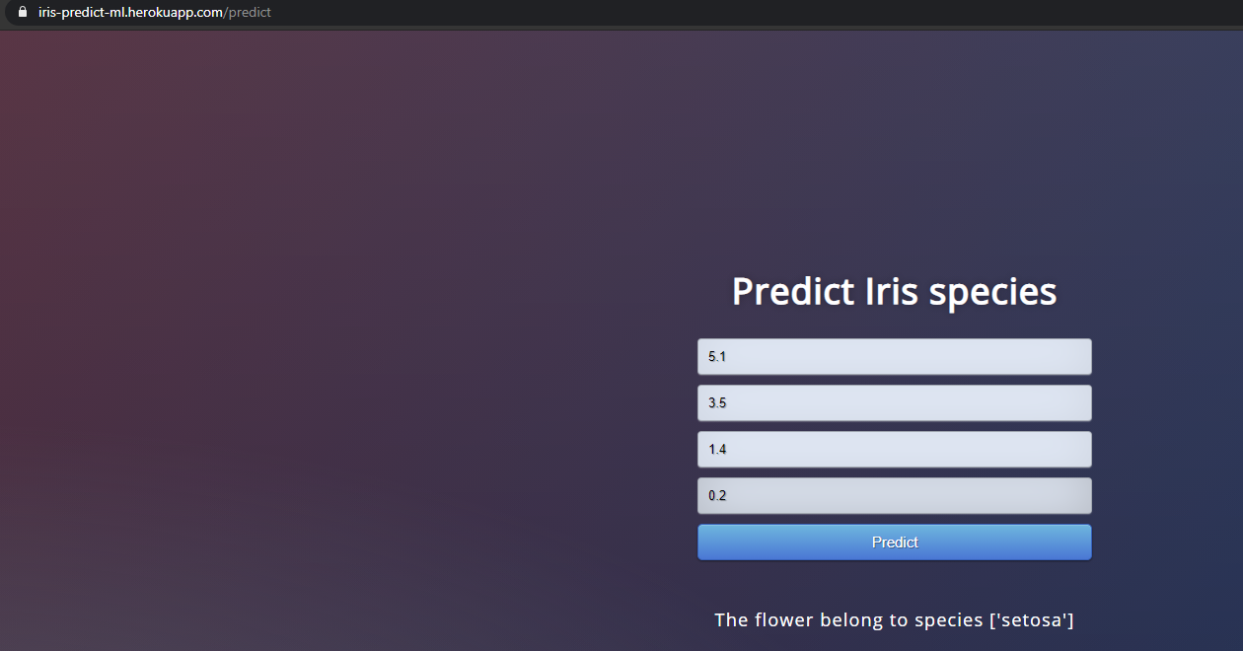

**Additional Help:**

I am providing few files that I used to prepare the video for deploying the **Iris classification model** on Heroku. The students can modify/tweak these files for use in this evaluation if needed.

**Note:**

Any kind of violation of academic integrity including copying other students work and copying answers directly from Internet will automatically lead to the assignment to be graded as zero.

Late assessments will be subject to a 20% per calendar day late penalty unless otherwise stated by the professor/instructor. Students should communicate to the professor/instructor in advance of the due date for any requests for a due date extension as a result of exceptional circumstances.