Lab 4

# Part 1:

1. Import csv file.

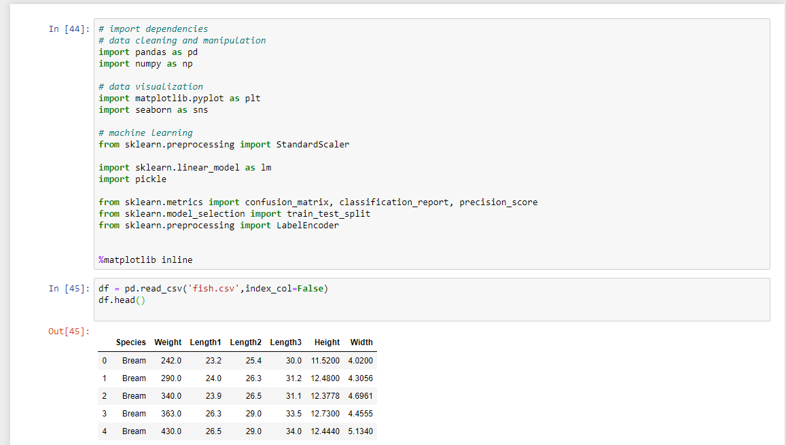

1. Verify correlation between columns, Split data into 70% train, 30% test. Separate “Species” column as that is our target variable and convert it to “categorical” type (like data encoding).

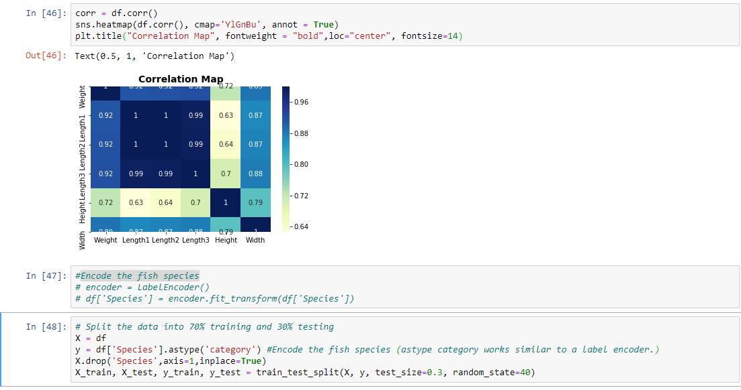

1. Create a Logistic regression model, train and export it to a pickle file.

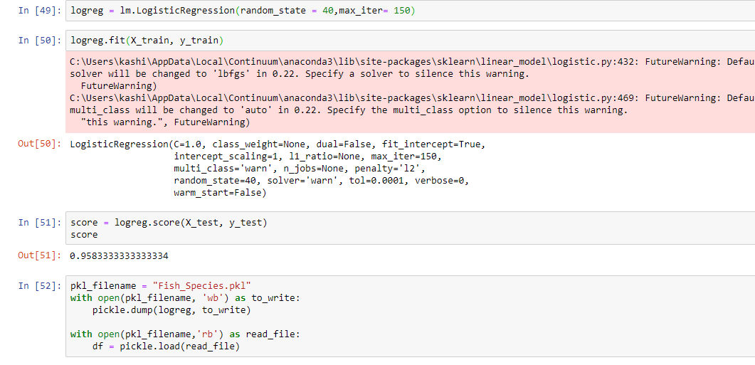

# Part 2:

1. Create flaskapp.py where we import the pickle file and code the backend for flask app.

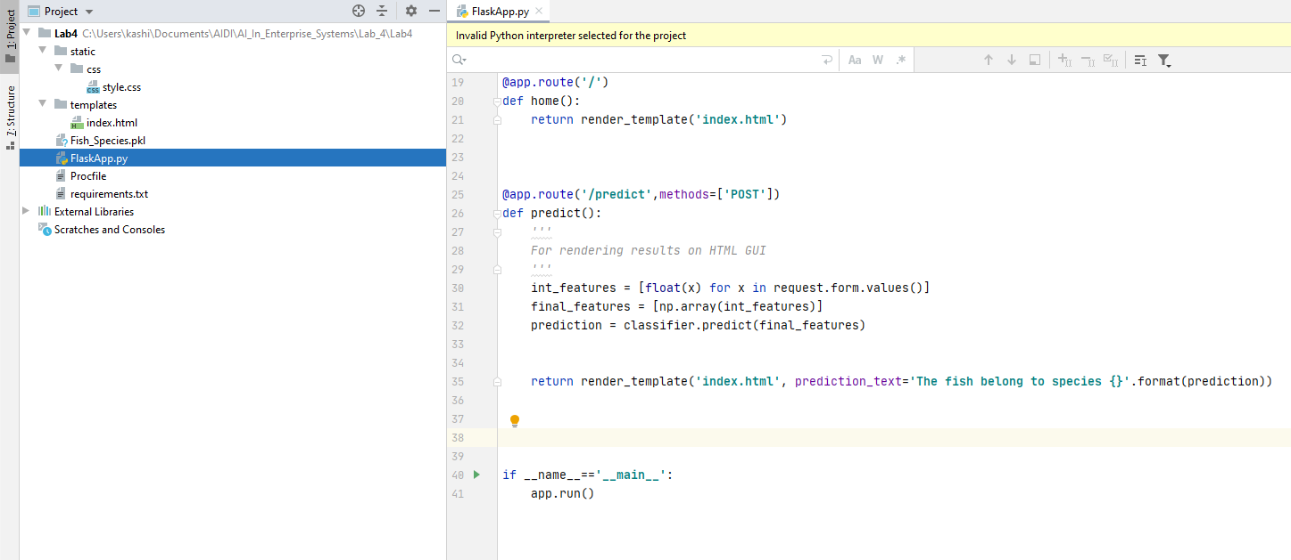

1. Create the html and css file and run the flask app.

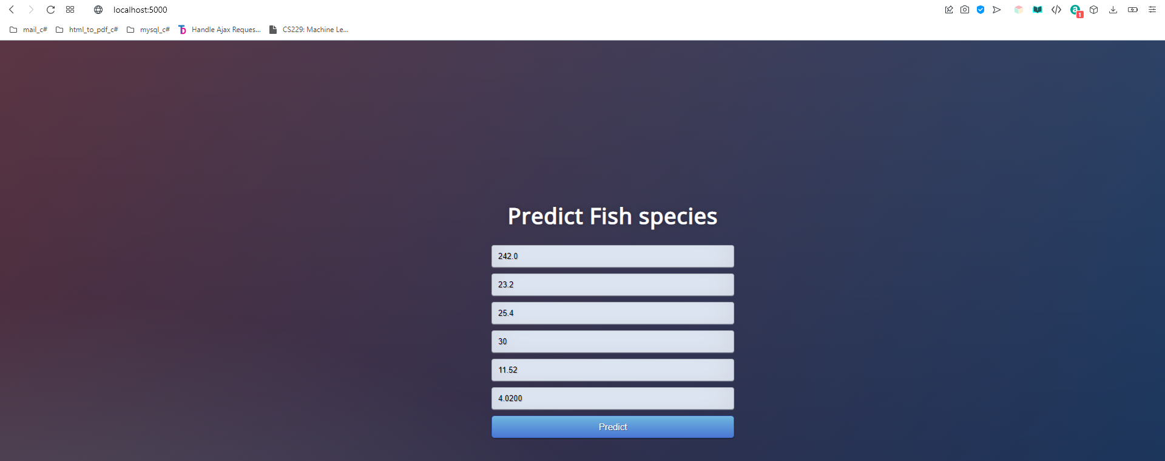

1. After providing values, and pressing predict button, you receive the prediction result.

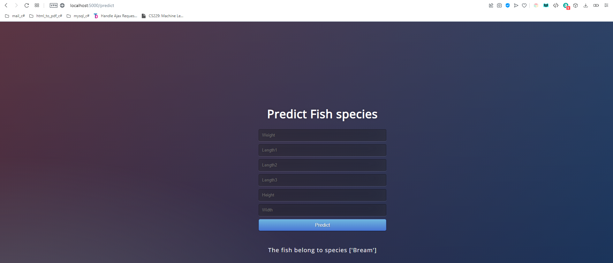

# Part 3:

1. Heroku Home Page

