GitHub : https://github.com/Ayushgautam2007/Hero-Vired-Assignment.git
Task1. System Monitoring Setup

- Install and configure htop to monitor CPU, memory, and processes

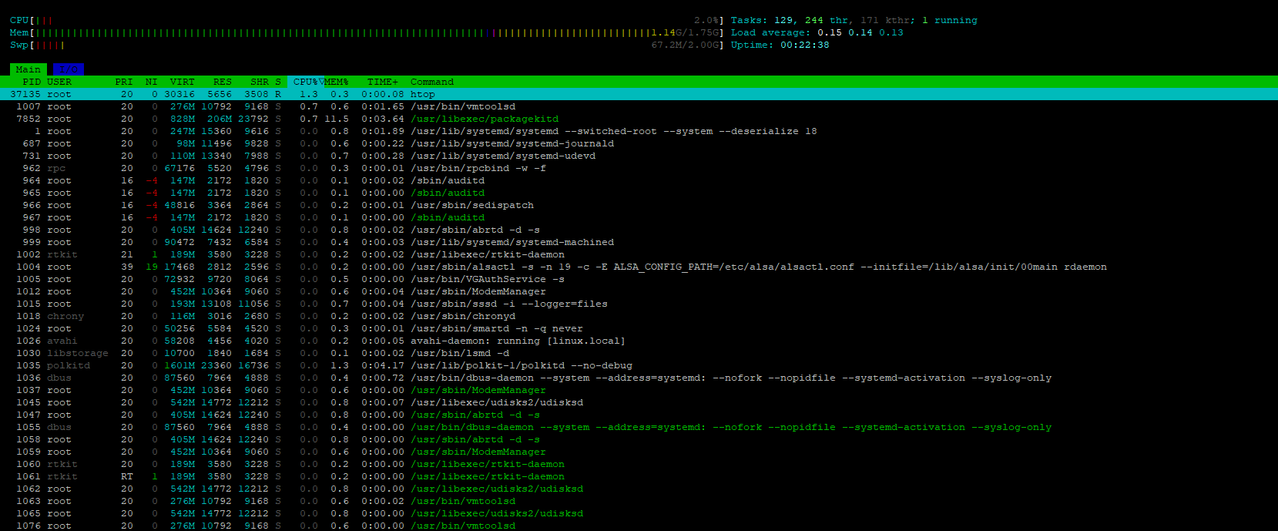

- df and du for-disk usage tracking:
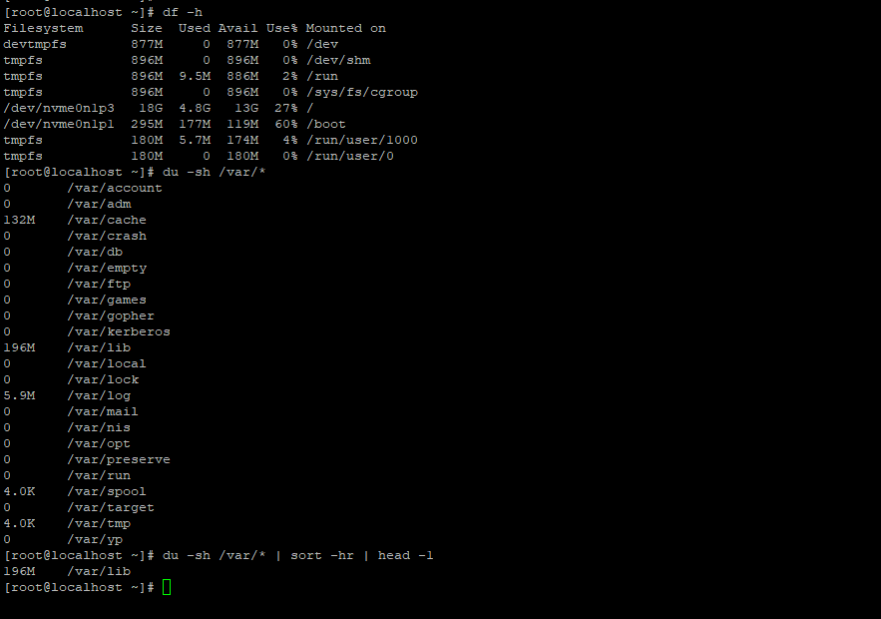

- process monitoring to identify resource-intensive applications.
- Process Monitoring

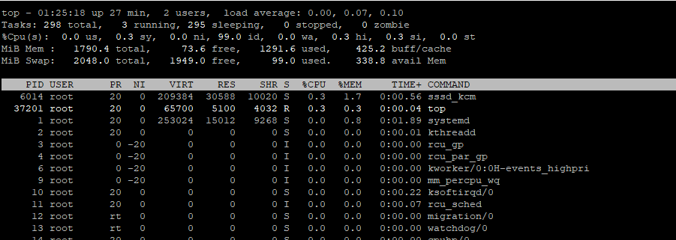
- Memory Monitoring
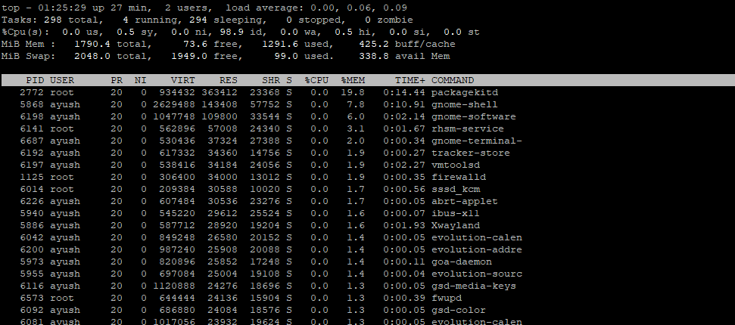

- System Monitoring Script:
- Script upload on GitHub and o/p is shared in this screenshot.
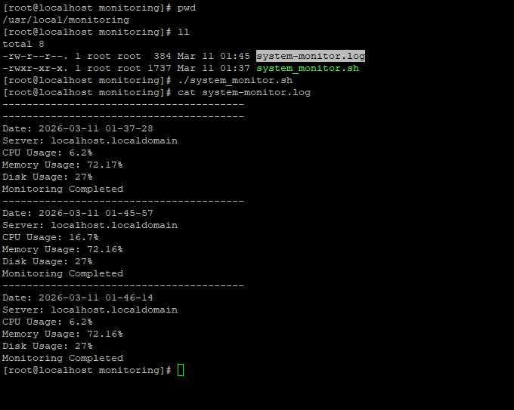

Task2: - User Management and Access Control

- Create user accounts with secure password:
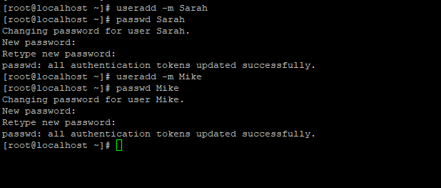

- Set up dedicated directories:


- Give the Appropriate Permissions:

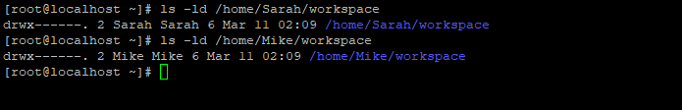
- Password policy to enforce expiration and complexity (e.g., passwords expire every 30 days).
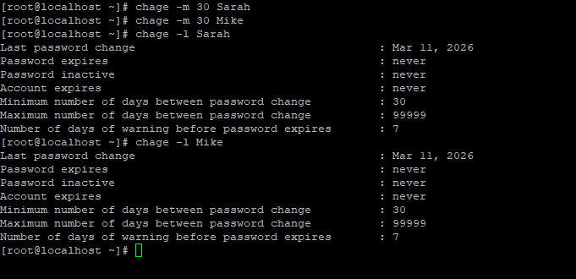

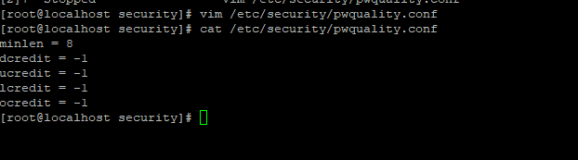

Task3: Backup Configuration for Web Servers:

- Sarah: Backup the Apache configuration (/etc/httpd/) and document root (/var/www/html/):-
- Configure Apache and their respective directories:
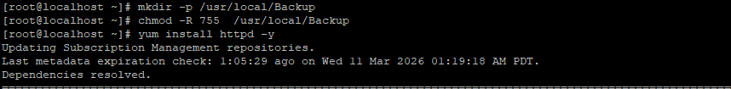
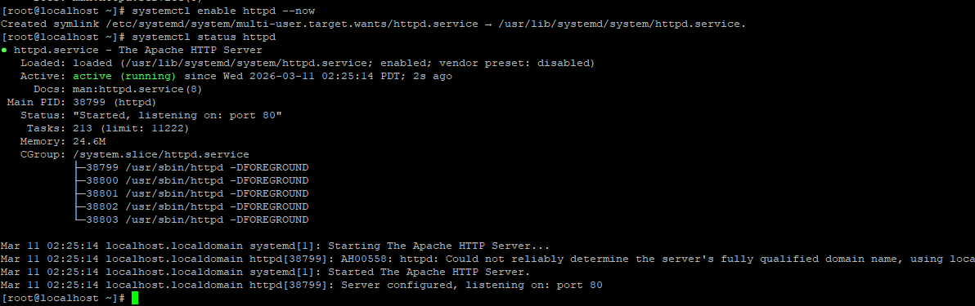

- Backup Script for Check service and take backup of conf. and code:
Script upload on GitHub and o/p is shared in this screenshot.

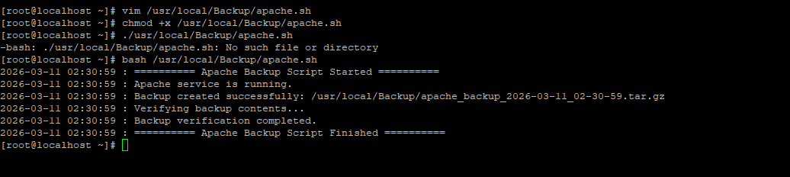

- Mike: Backup the Nginx configuration (/etc/nginx/) and document root (/usr/share/nginx/html/).
- Configure Nginx and their respective directories:
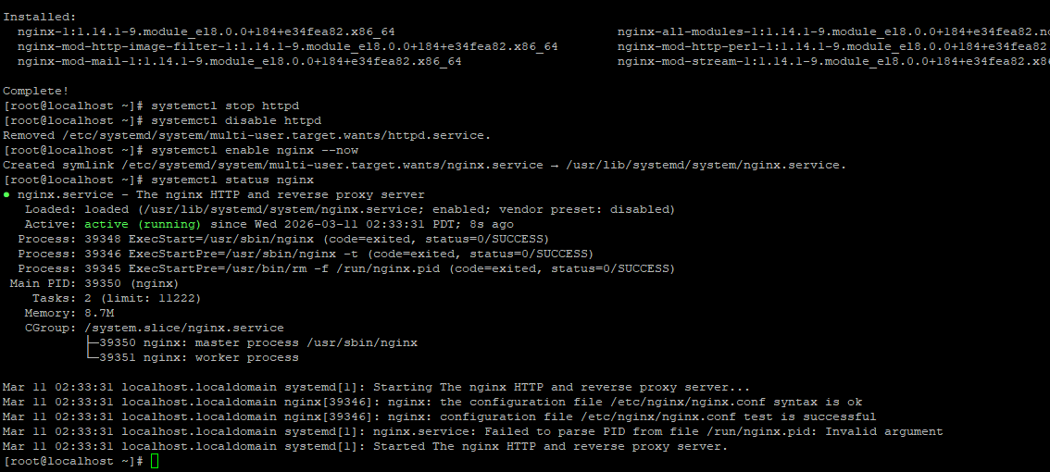

- Backup Script for Check service and take backup of conf. and code:
Script upload on GitHub and o/p is shared in this screenshot.
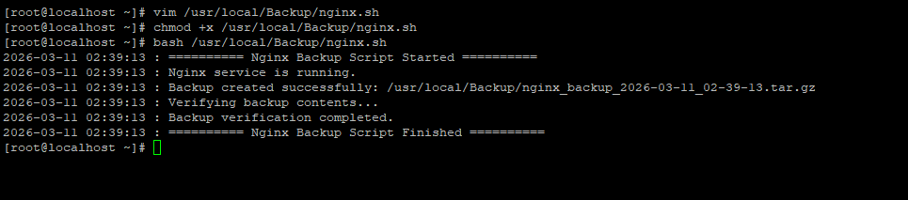

- Cron job configurations for Sarah and Mike:
