#include <stdio.h>

typedef struct

{

int start;

int end;

}

Perfect;

static int check_per(int num)

{

int sum = 0;

for (int i = 1; i <= num / 2; i++) {

if (num % i == 0) {

sum += i;

}

}

if (sum == num) {

return 1; // Number is perfect

} else {

return 0; // Number is not perfect

}

}

int main()

{

Perfect p;

printf("Enter the starting number: ");

scanf("%d", &p.start);

printf("Enter the ending number: ");

scanf("%d", &p.end);

printf("Perfect numbers between %d and %d:\n", p.start, p.end);

int count = 0;

for (int i = p.start; i <= p.end; i++) {

if (check_per(i)) {

printf("%d\n", i);

count++;

}

}

printf("Total perfect numbers found: %d\n", count);

return 0;

}

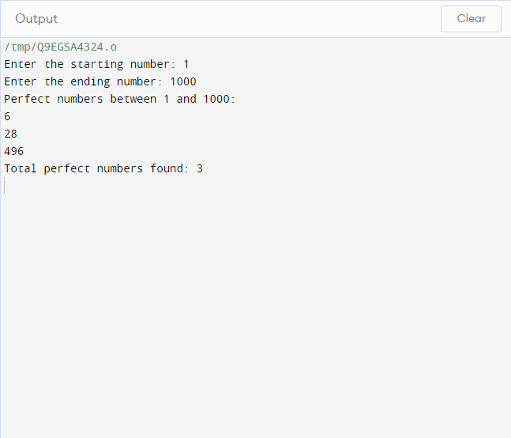

class Perfect:

def __init__(self, start, end):

self.start = start

self.end = end

@staticmethod

def check_per(num):

divisors = []

for i in range(1, num // 2 + 1):

if num % i == 0:

divisors.append(i)

if sum(divisors) == num:

return True

else:

return False

if __name__ == '__main__':

start = int(input("Enter the starting number: "))

end = int(input("Enter the ending number: "))

p = Perfect(start, end)

print(f"Perfect numbers between {p.start} and {p.end}:")

count = 0

for num in range(p.start, p.end + 1):

if p.check_per(num):

print(num)

count += 1

print(f"Total perfect numbers found: {count}")

