1)

#include <stdio.h>

int main() {

printf("Numbers between 2000 and 3200 (inclusive) that are divisible by 7 but not a multiple of 5:\n");

for (int num = 2000; num <= 3200; num++)

{

if (num % 7 == 0 && num % 5 != 0)

{

printf("%d ", num);

}

}

return 0;

}

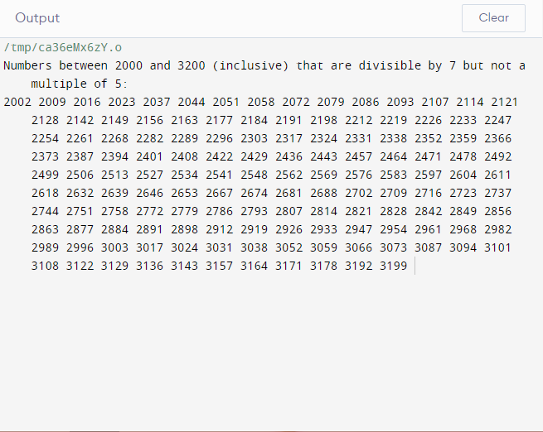

def find_numbers():

print("Numbers between 2000 and 3200 (inclusive) that are divisible by 7 but not a multiple of 5:")

numbers = []

for num in range(2000, 3201):

if num % 7 == 0 and num % 5 != 0:

numbers.append(num)

print(numbers)

if __name__ == "__main__":

find_numbers()

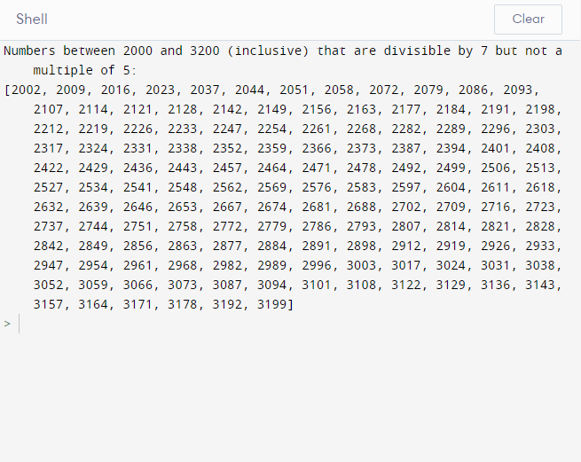

2)

#include <stdio.h>

#include <ctype.h>

int main()

{

char sentence[100];

printf("Enter a sentence: ");

fgets(sentence, sizeof(sentence), stdin);

int letters = 0, digits = 0;

for (int i = 0; sentence[i] != '\0'; i++)

{

if (isalpha(sentence[i]))

letters++;

else if (isdigit(sentence[i]))

digits++;

}

printf("LETTERS %d\n", letters);

printf("DIGITS %d\n", digits);

return 0;

}

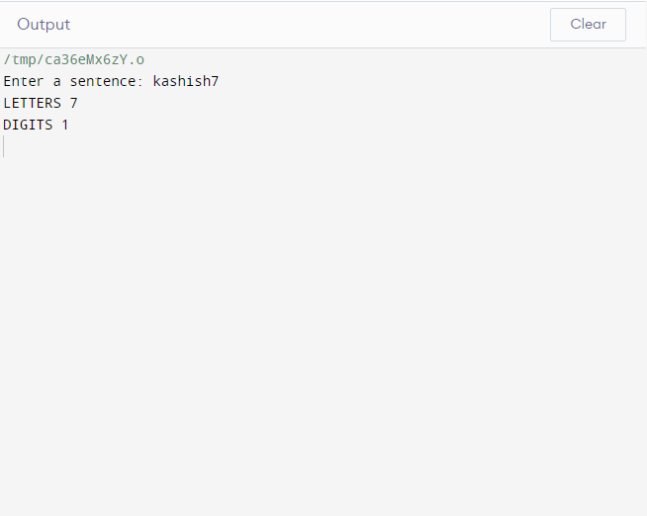

def count_letters_and_digits(sentence):

letters = sum(1 for char in sentence if char.isalpha())

digits = sum(1 for char in sentence if char.isdigit())

return letters, digits

if __name__ == "__main__":

sentence = input("Enter a sentence: ")

letters, digits = count_letters_and_digits(sentence)

print(f"LETTERS {letters}")

print(f"DIGITS {digits}")

