**Batch: B-1 Roll No.: 16010122104**

**Experiment / assignment / tutorial No. 03**

**Grade: AA / AB / BB / BC / CC / CD /DD**

**Signature of the Staff In-charge with date**

|  |
| --- |
| **TITLE :Multi-dimensional Arrays (Jagged Array)** |

**AIM:** Write a program which stores information about n players in a two dimensional array. The array should contain the number of rows equal to the number of players. Each row will have a number of columns equal to the number of matches played by that player which may vary from player to player. The program should display player number (index +1), runs scored in all matches and its batting average as output. (It is expected to assign columns to each row dynamically after getting value from the user.

**_____________________________________________________________________**

**Expected OUTCOME of Experiment:**

**CO2:** Explore arrays, vectors, classes and objects in C++ and Java.

**______________________________________________________________________**

**Books/ Journals/ Websites referred:**

1. E. Balagurusamy , “Programming with Java” McGraw-Hill.
2. Sachin Malhotra, Saurabh Choudhary, “Programming in Java”, Oxford Publications.

**_____________________________________________________________________**

**Pre Lab/ Prior Concepts:**

Arrays

**Multi-Dimensional Array**:

10 12 43 11 22

20 45 56 1 33

30 67 32 14 44

40 12 87 14 55

50 86 66 13 66

60 53 44 12 11

A multi-dimensional array is one that can hold all the values above. You set them up like this:

**int[ ][ ] numbers = new int[**6**][**5**];**

The first set of square brackets is for the rows and the second set of square brackets is for the columns. In the above line of code, we're telling Java to set up an array with 6 rows and 5 columns.

aryNumbers[0][0] = 10;  
aryNumbers[0][1] = 12;  
aryNumbers[0][2] = 43;  
aryNumbers[0][3] = 11;  
aryNumbers[0][4] = 22;

So the first row is row 0. The columns then go from 0 to 4, which is 5 items.

**Class Diagram:**

**Algorithm:**

1. Start

2. Create a Scanner object named scanner to read input

3. Print "Enter the number of players: "

4. Read n from the user using scanner

5. Create a two-dimensional array named playerData of size n

6. Create a one-dimensional array named battingAverage of size n

7. For i from 0 to n-1, do steps 8 to 14

   a. Print "Enter the number of matches played by player i+1: "

   b. Read matchesPlayed from the user using scanner

   c. Allocate memory for playerData[i] with matchesPlayed number of elements

   d. Print "Enter runs scored in each match for player i+1: "

   e. Set totalRuns to 0

   f. For j from 0 to matchesPlayed-1, do steps g and h

      g. Read runs scored in each match from the user and store it in playerData[i][j]

      h. Add playerData[i][j] to totalRuns

      i. End loop

   j. Calculate battingAverage[i] as totalRuns divided by matchesPlayed

8. End of loop

9. Print "\nPlayer Information:"

10. For i from 0 to n-1, do steps 11 and 12

    a. Print "Player i+1: Runs scored: "

    b. For j from 0 to length of playerData[i] - 1, do step c

       c. Print playerData[i][j] and a space

    d. Print "Batting Average: " followed by battingAverage[i]

    e. End loop

11. End of loop

12. End

**Implementation details:**

import java.util.Scanner;

public class PlayerInformation

 {

    public static void main(String[] args)

    {

        Scanner scanner = new Scanner(System.in);

        System.out.print("Enter the number of players: ");

        int n = scanner.nextInt();

        int[][] playerData = new int[n][];

        double[] battingAverage = new double[n];

        for (int i = 0; i < n; i++)

        {

            System.out.print("Enter the number of matches played by player " + (i + 1) + ": ");

            int matchesPlayed = scanner.nextInt();

            playerData[i] = new int[matchesPlayed];

            System.out.println("Enter runs scored in each match for player " + (i + 1) + ": ");

            int totalRuns = 0;

            for (int j = 0; j < matchesPlayed; j++)

            {

                playerData[i][j] = scanner.nextInt();

                totalRuns += playerData[i][j];

            }

            battingAverage[i] = (double) totalRuns / matchesPlayed;

        }

        System.out.println("\nPlayer Information:");

        for (int i = 0; i < n; i++)

        {

            System.out.print("Player " + (i + 1) + ": Runs scored: ");

            for (int j = 0; j < playerData[i].length; j++)

            {

                System.out.print(playerData[i][j] + " ");

            }

            System.out.println("Batting Average: " + battingAverage[i]);

        }

    }

}

**Output:**

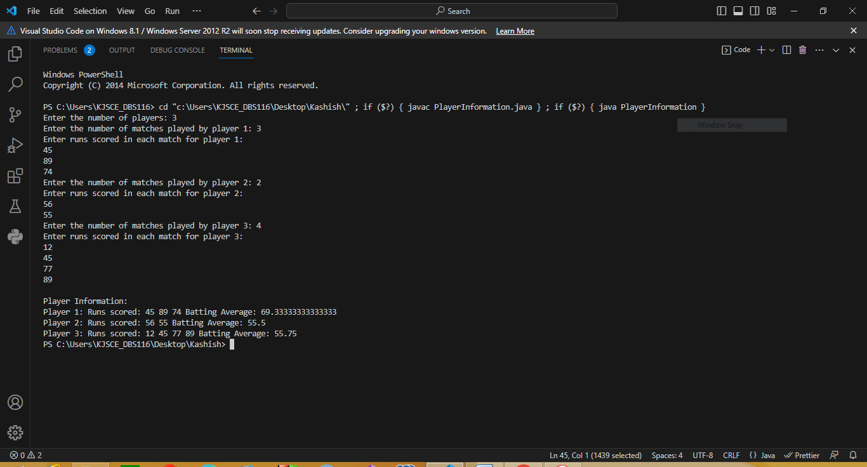

**Conclusion:**

Hence, we learned the various implementations of multi-dimensional arrays.

**Date: 07/08/2023 Signature of faculty in-charge**

**Post Lab Descriptive Questions**

**Q.1 Create a jagged array of integers. This array should consist of two 2-D arrays. First 2-D array should contain 3 rows having length of 4,3,and 2 respectively. Second 2-D array should contain 2 rows with length 3 and 4 respectively.**

**Ans:**

public class JaggedArrayExample

{

    public static void main(String[] args)

    {

        int[][] firstArray =

        {

            {1, 2, 3, 4},

            {5, 6, 7},

            {8, 9}

        };

        int[][] secondArray =

        {

            {10, 11, 12},

            {13, 14, 15, 16}

        };

        int[][][] jaggedArray = {firstArray, secondArray};

        for (int i = 0; i < jaggedArray.length; i++)

        {

            System.out.println("Array " + (i + 1) + ":");

            for (int j = 0; j < jaggedArray[i].length; j++)

            {

                for (int k = 0; k < jaggedArray[i][j].length; k++)

                {

                    System.out.print(jaggedArray[i][j][k] + " ");

                }

                System.out.println();

            }

            System.out.println();

        }

    }

}

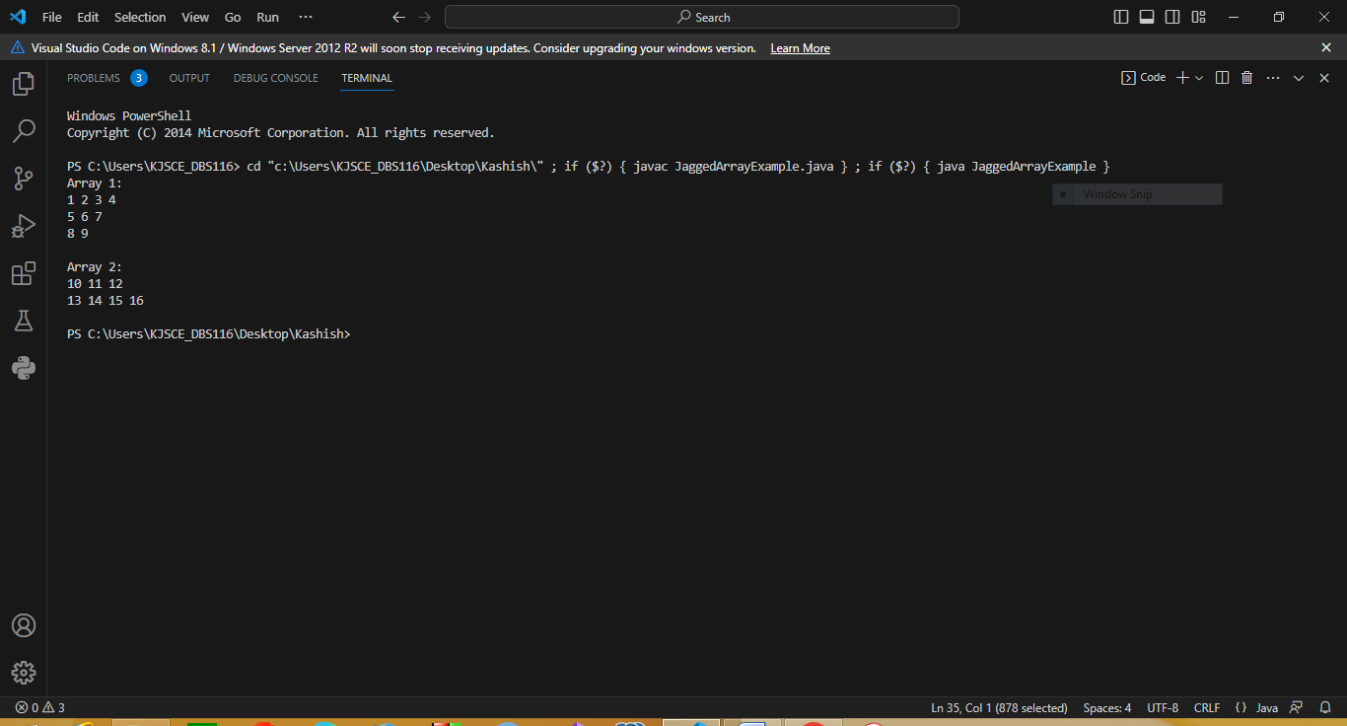

**Q.2 Consider the following code**

int number[] = new int[5];

After execution of this statement, which of the following are true?

(A) number[0] is undefined

(B) number[5] is undefined

(C) number[4] is null

(D) number[2] is 0

(E) number.length() is 5

(i) (C) & (E)

(ii) (A) & (E)

(iii) (E)

(iv) (B), (D) & (E)

**Ans:**

**(i) (C) & (E)**

**Q.3 Write a program to create an array where ith row has i columns.**

**Ans:**

import java.util.Scanner;

public class JaggedArrayExample

{

    public static void main(String[] args)

    {

        Scanner scanner = new Scanner(System.in);

        System.out.print("Enter the number of rows: ");

        int numRows = scanner.nextInt();

        int[][] jaggedArray = new int[numRows][];

        for (int i = 0; i < numRows; i++)

        {

            jaggedArray[i] = new int[i + 1];

        }

        for (int i = 0; i < numRows; i++)

        {

            for (int j = 0; j <= i; j++)

            {

                jaggedArray[i][j] = i + j;

            }

        }

        for (int i = 0; i < numRows; i++)

        {

            for (int j = 0; j <= i; j++) {

                System.out.print(jaggedArray[i][j] + " ");

            }

            System.out.println();

        }

    }

}

