

| **TITLE :** An Array of Objects |
| --- |

**AIM:** Write a program which accepts information about n no of customers from user

.Create an array of objects to store account_id ,name,balance.

Your program should provide following functionalities

1. To add account

2. To delete any account detail

3. To display account details.

_____________________________________________________________________

**Expected OUTCOME of Experiment:**

**CO1:** Understand the features of object oriented programming compared with

procedural approach with C++ and Java

**CO2:** Explore arrays, vectors, classes and objects in C++ and Java.

______________________________________________________________________

**Books/ Journals/ Websites referred:**

1. Ralph Bravaco , Shai Simoson , “Java Programing From the Group Up” Tata

McGraw-Hill.

2. Grady Booch, Object Oriented Analysis and Design .

_____________________________________________________________________

**Pre Lab/ Prior Concepts:**

Arrays of Objects:

Unlike traditional array which store values like string, integer, boolean, etc. array of

objects stores objects. The array elements store the location of reference variables of

the object.

For example:

class Student {

   int rno;

String name;

float avg;

}

Student(int r, String name, float average)

{

rno=r;

this.name=name;

avg=average;

}

Student studentArray[] = new Student[n];

● The above statement creates the array which can hold references to n number of

Student objects. It doesn&#39;t create the Student objects themselves. They have to be

created separately using the constructor of the Student class. The studentArray contains

n number of memory spaces in which the address of n Student objects may be stored.

for ( int i=0; i&lt;studentArray.length; i++) {

studentArray[i]=new Student(r,name,average);

}

● The above for loop creates n Student objects and assigns their reference to the

array elements. Now, a statement like the following would be valid.

studentArray[i].r=1001;

.

**Class Diagram:**

**Algorithm:**

Start

Declare class Accounts with instance variables account_id, name, and balance

Declare static variables acc[] (array of Accounts objects), count, and n

Define main method

    Initialize Scanner object sc

    Print "Enter the number of Accounts: "

    Read n from user

    Initialize acc[] with size n

    Loop from i = 0 to n-1

        Initialize acc[i] as a new Accounts object

    End loop

    Initialize flag as true

    While flag is true

        Print menu options

        Read choice from user

        Switch case choice

            Case 1:

                If count is equal to n

                    Print "Limit reached. Can't add more records."

                Else

                    Call add() method

                End if

                Break

            Case 2:

                If count is less than or equal to 0

                    Print "Account records are empty. No data present to be deleted."

                Else

                    Call delete() method

                End if

                Break

            Case 3:

                If count is less than or equal to 0

                    Print "Empty record database. Nothing to display."

                Else

                    Call display() method

                End if

                Break

            Case 4:

                Set flag as false

                Exit

            Default:

                Print "Invalid option entered."

        End switch

    End while

End main

Define static method add()

    Initialize Scanner object sc1

    Initialize add_acc as a new Accounts object

    Print "Enter the account id: "

    Read add_acc.account_id from user

    Loop from i = 0 to count-1

        While add_acc.account_id is equal to acc[i].account_id

            Print "Enter the account id: "

            Read add_acc.account_id from user

        End while

    End loop

    Print "Enter name of account holder: "

    Read [add_acc.name](http://add_acc.name/) from user

    Print "Enter balance of account: "

    Read add_acc.balance from user

    Set acc[count] as add_acc

    Increment count by 1

    Print "Account Record added successfully."

End add()

Define static method delete()

    Initialize Scanner object sc2

    Print "Enter the account ID: "

    Read account_id from user

    Initialize delete_index as -1

    Loop from i = 0 to length of acc array

        If acc[i].account_id is equal to account_id

            Set delete_index as i

            Break

        End if

    End loop

    If delete_index is equal to -1

        Print "Account record not present in database"

    Else

        Print "Account record successfully deleted"

        Loop from i = delete_index + 1 to length of acc array

            Set acc[i-1] as acc[i]

        End loop

        Decrement count by 1

    End if

End delete()

Define static method display()

    Print "Account ID\tAcc. Holder Name\tBalance"

    Sort acc array based on balance in ascending order

    Loop from i = 0 to count-1

        If acc[i].account_id is not equal to 0

            Print acc[i].account_id, acc[i].name, and acc[i].balance

        End if

    End loop

End display()

End

**Implementation details:**

import java.util.*;

public class Accounts {

    int account_id;

    String name;

    float balance;

    static Accounts acc[];

    static int count = 0;

    static int n;

    public static void main(String args[]) {

        Scanner sc = new Scanner(System.in);

        System.out.println("Enter the number of Accounts: ");

        n = sc.nextInt();

        acc = new Accounts[n];

        for(int i = 0; i< acc.length;i++) {

            acc[i] = new Accounts();

        }

        boolean flag = true;

        while(flag) {

            System.out.println();

            System.out.println("Choose the functionality you want to perform:");

            System.out.println("1. Add account details\n2. Delete account details\n3. Display account details\n4. Exit");

            int choice = sc.nextInt();

            switch(choice) {

                case 1:

                    if (count == n) {

                        System.out.println("Limit reached. Can't add more records.");

                    }

                    else {

                        add();

                    }

                    break;

                case 2:

                    if (count <= 0) {

                        System.out.println("Account records are empty. No data present, to be deleted");

                    }

                    else {

                        delete();

                    }

                    break;

                case 3:

                    if (count <= 0) {

                        System.out.println("Empty record database. Nothing to display.");

                    }

                    else{

                        display();

                    }

                    break;

                case 4:

                    flag = false;

                    System.exit(0);

                    break;

                default:

                    System.out.println("Invalid option entered.");

            }

        }

    }

    public static void add() {

        Scanner sc1 = new Scanner(System.in);

        Accounts add_acc = new Accounts();

        System.out.println("Enter the account id: ");

        add_acc.account_id = sc1.nextInt();

        for (int i = 0; i < count; i++) {

            while(add_acc.account_id == acc[i].account_id) {

                System.out.println("Enter the account id: ");

                add_acc.account_id = sc1.nextInt();

            }

        }

        System.out.println("Enter name of account holder: ");

        add_acc.name = sc1.next();

        System.out.println("Enter balance of account: ");

        add_acc.balance = sc1.nextFloat();

        acc[count++] = add_acc;

        System.out.println("Account Record added successfully.");

    }

    public static void delete() {

        Scanner sc2 = new Scanner(System.in);

        System.out.println("Enter the account ID: ");

        int account_id = sc2.nextInt();

        int delete_index = -1;

        for (int i = 0; i < acc.length; i++) {

            if (acc[i].account_id == account_id) {

                delete_index = i;

                break;

            }

        }

        if (delete_index == -1) {

            System.out.println("Account record not present in database");

        }

        else {

            System.out.println("Account record successfully deleted");

            for (int i = delete_index + 1; i < acc.length; i++){

                acc[i - 1] = acc[i];

        }

        count --;

        }

    }

    public static void display() {

        System.out.println("Account ID\tAcc. Holder Name\tBalance");

        int n=acc.length;

        for(int i=0;i<n-1;i++)

        {

            for(int j=0;j<n-i-1;j++)

            {

                if(acc[i].balance<acc[j].balance)

                {

                    float temp = acc[j].balance;

                    acc[j].balance = acc[j+1].balance;

                    acc[j+1].balance = temp;

                }

            }

        }

        for (int i = 0; i < count; i++) {

            if (acc[i].account_id != 0) {

                System.out.println(acc[i].account_id + "\t\t" + acc[i].name + "\t\t\t" + acc[i].balance);

            }

        }

    }

}

**Output:**

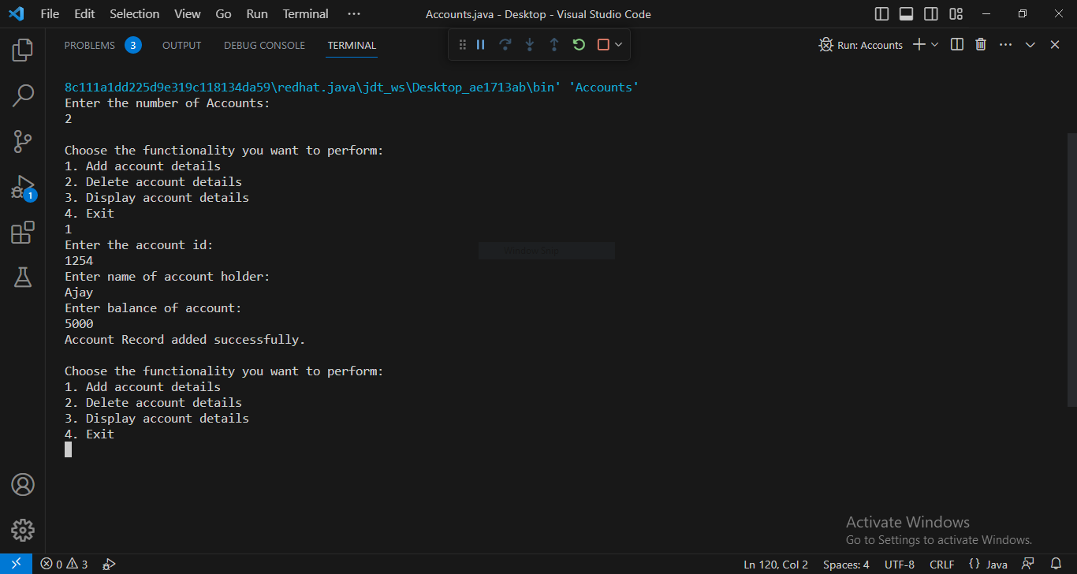

**Conclusion:**

We learned the implementation of arrays as objects.

**Date: 22/08/2023 Signature of faculty in-charge**

**Post Lab Descriptive Questions**

Q.1  If an array of objects is of size 10 and a data value have to be retrieved from 5 th

object then ________________ syntax should be used.

a)Array_Name[4].data_variable_name;

b)Data_Type Array_Name[4].data_variable_name;

c)Array_Name[4].data_variable_name.value;

d) Array_Name[4].data_variable_name(value);

**Ans:  (a) Array_Name[4]. data_variable_name;**

 Q.2)The Object array is created in _____________________

a)Heap memory

b) Stack memory

c) HDD

d) ROM

**Ans: a)Heap memory**