Batch: A-3 Roll No.: 16010122104

Experiment No. 05

Grade: AA / AB / BB / BC / CC / CD /DD

Signature of the Staff In-charge with date

Title: Implementation of OR function with bipolar inputs and targets using Adaline network. Assume the required parameters for training of the network.
___________________________________________________________________________________
Objective: To learn Adaline network.
___________________________________________________________________________________
Expected Outcome of Experiment:

CO2: To understand the features of neural networks and different learning methods.
____________________________________________________________________________________
Books/ Journals/ Websites referred:

____________________________________________________________________________________
Pre Lab/ Prior Concepts:

Adaptive Linear Neuron (Adaline):
Adaline which stands for Adaptive Linear Neuron, is a network having a single linear unit.
It was developed by Widrow and Hoff in 1960.
Some important points about Adaline are as follows −
- It uses bipolar activation function.
- It tries to minimize the Mean-Squared Error (MSE) between the actual output and the desired/target output.
The weights and the bias are adjustable

Architecture:

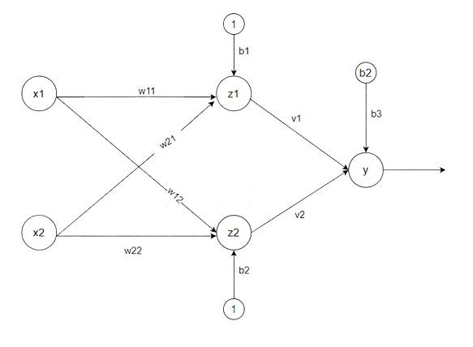

Algorithm:
Step 1: Initialize the following to start the training −Weights, Bias, Learning rate α
Step 2: While the stopping condition is False do steps 3 to 7.
Step 3: for each training set perform steps 4 to 6.
Step 4: Set activation of input unit xi = si for (i=1 to n).
Step 5: compute net input to output unit
Here, b is the bias and n is the total number of neurons.
Step 6: Update the weights and bias for i=1 to n
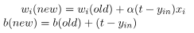

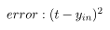
and calculate
Step 7: Test the stopping condition. The stopping condition may be when the weight changes at a low rate or no change.

____________________________________________________________________________________
Implementation Details:

Implementation of OR function with bipolar inputs and targets using Adaline network.

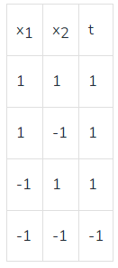
import numpy as np

# OR function with bipolar inputs and outputs
inputs = np.array([[-1, -1], [-1, 1], [1, -1], [1, 1]]) # Bipolar inputs
targets = np.array([-1, 1, 1, 1]) # OR function outputs in bipolar form

# Initialize weights as equal and same, bias as 1, and learning rate
initial_weight_value = 0.5 # Initial weight value (equal and same for both weights)
weights = np.array([initial_weight_value, initial_weight_value]) # Equal weights
bias = 1.0 # Bias initialized to 1
learning_rate = 0.1 # Learning rate
max_epochs = 1000 # Maximum number of epochs to allow for convergence check
convergence_threshold = 1e-5 # Threshold for convergence (error tolerance)

# Adaline training
print(f"Initial weights: {weights}, Bias: {bias}\n")

epoch = 0
previous_total_error = float('inf') # Set initial total error to infinity

while epoch < max_epochs:
print(f"Epoch {epoch + 1}")
total_error = 0 # Reset total error for the current epoch

for i in range(len(inputs)):
# Step 4: Set activation of input unit xi = si
x = inputs[i]
target = targets[i]

# Step 5: Compute net input to output unit
net_input = np.dot(weights, x) + bias

# Step 6: Calculate squared error
error = (target - net_input) # Error term
squared_error = error ** 2 # Squared error

# Update weights and bias
weights += learning_rate * error * x
bias += learning_rate * error

# Accumulate total error
total_error += squared_error

# Display the updated weights and bias
print(f"Training set {i + 1}: Input: {x}, Target: {target}")
print(f"Net Input: {net_input:.4f}, Error: {error:.4f}, Squared Error: {squared_error:.4f}")
print(f"Updated weights: {weights}, Updated Bias: {bias:.4f}\n")

# Check for convergence
if abs(previous_total_error - total_error) < convergence_threshold:
print("Convergence reached!")
break

# Update for the next epoch
previous_total_error = total_error
epoch += 1
print(f"Total Error after Epoch {epoch}: {total_error:.6f}")
print("-" * 50)

# Print final results
print(f"Final weights: {weights}, Final Bias: {bias}")
print(f"Training completed in {epoch + 1} epochs.")

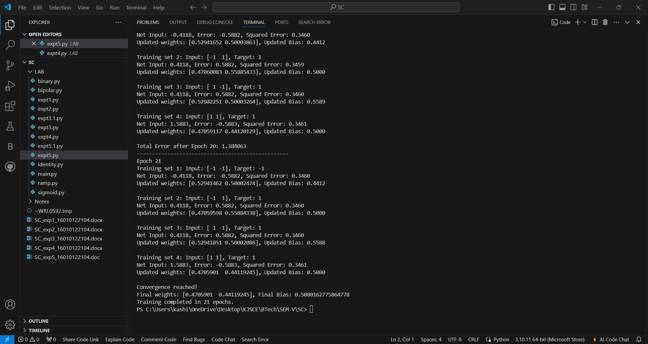

Conclusion: We learnt how to implement Adaline network for OR and AND NOT function.

Post Lab Descriptive Questions:
Use Adaline network to train AND NOT function with bipolar inputs and targets. Perform 1 epoch of training

import numpy as np

# Define bipolar inputs for AND NOT function
inputs = np.array([[-1, -1], [-1, 1], [1, -1], [1, 1]]) # Bipolar inputs
targets = np.array([-1, -1, 1, -1]) # Bipolar outputs for AND NOT

# Initialize weights, bias, and learning rate
weights = np.random.uniform(-1, 1, size=2) # Random weights between -1 and 1
bias = np.random.uniform(-1, 1) # Random bias between -1 and 1
learning_rate = 0.1 # Learning rate
epochs = 1 # Number of epochs, only 1 for this example

# Adaline training for 1 epoch
print(f"Initial weights: {weights}, Bias: {bias}\n")

for epoch in range(epochs):
print(f"Epoch {epoch + 1}")

for i in range(len(inputs)):
# Set activation of input unit xi = si
x = inputs[i]
target = targets[i]

# Compute net input to output unit
net_input = np.dot(weights, x) + bias

# Compute error
error = target - net_input

# Update weights and bias
weights += learning_rate * error * x
bias += learning_rate * error

# Display the updated weights and bias
print(f"Training set {i + 1}: Input: {x}, Target: {target}")
print(f"Net Input: {net_input:.4f}, Error: {error:.4f}")
print(f"Updated weights: {weights}, Updated Bias: {bias:.4f}\n")

print("-" * 50)

print(f"Final weights after 1 epoch: {weights}, Final Bias: {bias}")

Output:
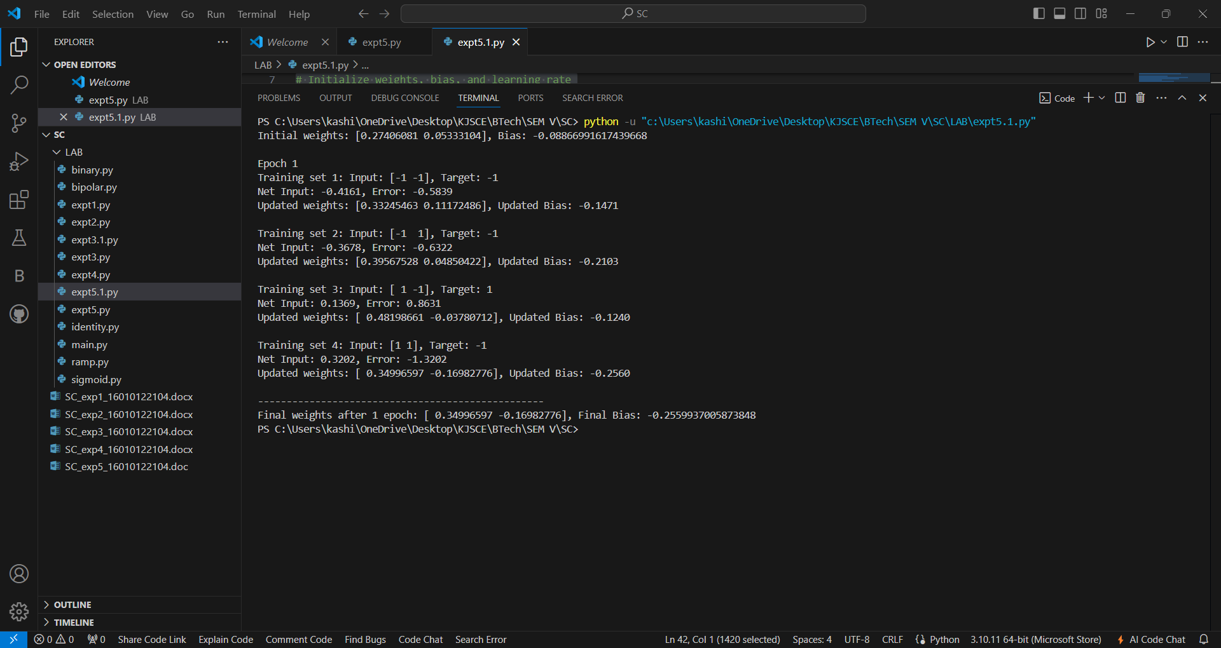

Date: 03/09/2024 Signature of faculty in-charge

