Batch: A-3 Roll No.: 16010122104

Experiment No. 06

Grade: AA / AB / BB / BC / CC / CD /DD

Signature of the Staff In-charge with date

Title: To implement XOR LOGIC using perceptron network.
___________________________________________________________________________________
Objective: Implement multilayer perceptron for XOR function with binary inputs and target.
___________________________________________________________________________________
Expected Outcome of Experiment:

CO2 : Analyze various neural network architectures ____________________________________________________________________________________
Books/ Journals/ Websites referred:

____________________________________________________________________________________
Pre Lab/ Prior Concepts:

Perceptron Model

Linear separability

Design of Classifier using Multi-layer Perceptron model for XOR logic of 2 inputs

Truth table for XOR logic

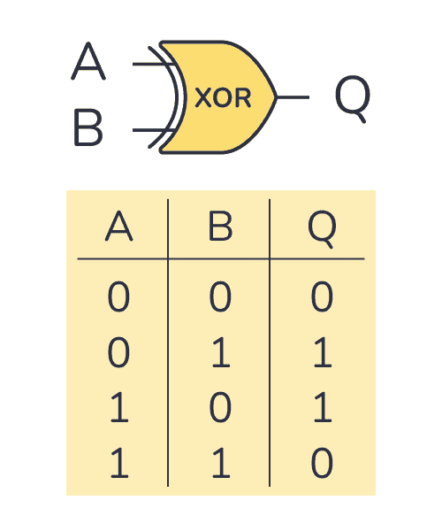

Classifier using Multi-layer Perception Network for implementing XOR logic for 2 inputs.

Code:

import numpy as np

# Activation function and its derivative
def sigmoid(x):
return 1 / (1 + np.exp(-x))

def sigmoid_derivative(x):
return x * (1 - x)

# XOR Input and Target Output
inputs = np.array([[0, 0], [0, 1], [1, 0], [1, 1]])
targets = np.array([[0], [1], [1], [0]])

# Initialize parameters
input_layer_neurons = 2 # Number of features in input
hidden_layer_neurons = 2 # Number of hidden neurons
output_neurons = 1 # Output neurons (since XOR has 1 output)

# Randomly initialize weights and biases
np.random.seed(1)
weights_input_hidden = np.random.uniform(size=(input_layer_neurons, hidden_layer_neurons))
weights_hidden_output = np.random.uniform(size=(hidden_layer_neurons, output_neurons))
bias_hidden = np.random.uniform(size=(1, hidden_layer_neurons))
bias_output = np.random.uniform(size=(1, output_neurons))

# Set learning parameters
learning_rate = 0.5
epochs = 10000 # Number of iterations

# Training the MLP
for epoch in range(epochs):
# Forward Propagation
hidden_layer_input = np.dot(inputs, weights_input_hidden) + bias_hidden
hidden_layer_activation = sigmoid(hidden_layer_input)

output_layer_input = np.dot(hidden_layer_activation, weights_hidden_output) + bias_output
predicted_output = sigmoid(output_layer_input)

# Compute the error (difference between predicted and actual output)
error = targets - predicted_output

# Backpropagation
d_predicted_output = error * sigmoid_derivative(predicted_output)

error_hidden_layer = d_predicted_output.dot(weights_hidden_output.T)
d_hidden_layer = error_hidden_layer * sigmoid_derivative(hidden_layer_activation)

# Update weights and biases
weights_hidden_output += hidden_layer_activation.T.dot(d_predicted_output) * learning_rate
bias_output += np.sum(d_predicted_output, axis=0, keepdims=True) * learning_rate

weights_input_hidden += inputs.T.dot(d_hidden_layer) * learning_rate
bias_hidden += np.sum(d_hidden_layer, axis=0, keepdims=True) * learning_rate

# Optional: Print error during training
if (epoch + 1) % 1000 == 0:
print(f'Epoch {epoch + 1}, Error: {np.mean(np.abs(error))}')

# Output after training
print("\nTraining complete. Final outputs after 10000 epochs:")
print(predicted_output)

# Testing the network with binary inputs
for i in range(len(inputs)):
print(f"Input: {inputs[i]} -> Predicted Output: {predicted_output[i]} (Target: {targets[i]})")

Output:

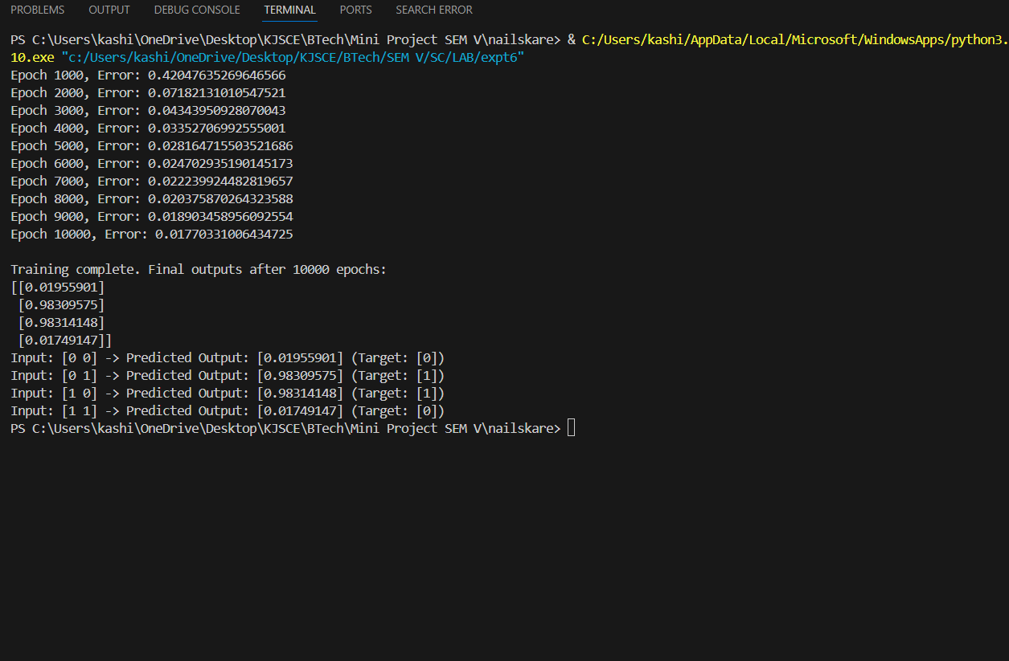

Conclusion: Thus, we have successfully implemented classifier using MLP for linearly non-separable XOR functions of 2 inputs

Post Lab Descriptive Questions :

- Why is XOR-logic function being Linearly notseparable?
Ans:
The XOR (Exclusive OR) logic function is considered linearly non-separable because there is no way to separate its outputs using a straight line in a two-dimensional space.
In more detail:
- In the XOR problem, the inputs are two binary values, and the output is also binary.
- For XOR:
  - (0, 0) → 0
  - (0, 1) → 1
  - (1, 0) → 1
  - (1, 1) → 0
If we plot these points on a 2D Cartesian plane, the points representing (0, 0) and (1, 1) (both with output 0) lie in different regions compared to (0, 1) and (1, 0) (both with output 1). No straight line can separate the points into two distinct regions, one for output 0 and one for output 1.
This is why XOR is not linearly separable—there is no linear decision boundary (a straight line) that can classify the outputs correctly. A single-layer perceptron can only solve linearly separable problems, but the XOR logic function requires a multi-layer perceptron (MLP) with at least one hidden layer and non-linear activation functions to solve the problem.

- Design a classifier using MLP perceptron model for implementing NOT XOR logic
Ans:
The NOT XOR (XNOR) function is the inverse of the XOR function. The XNOR logic outputs 1 when both inputs are the same and 0 when the inputs are different. The XNOR truth table is as follows:
Input 1 | Input 2 | XNOR Output
0 | 0 | 1
0 | 1 | 0
1 | 0 | 0
1 | 1 | 1
MLP Design for XNOR Logic:
To implement XNOR using a Multi-Layer Perceptron (MLP), we will follow a similar approach as for XOR, but we will change the target outputs to represent XNOR logic. The network architecture remains the same: 2 input neurons, 2 hidden layer neurons, and 1 output neuron.

Date: 22/10/2024 Signature of faculty in-charge

