Batch: A-3 Roll No.: 16010122104
Experiment No. : 07
Grade: AA / AB / BB / BC / CC / CD /DD

Signature of the Staff In-charge with date

Title: Error Back propagation algorithm
____________________________________________________________________________________
Objective: To Write a program to implement error back propagation algorithm in MLP.
____________________________________________________________________________________
Expected Outcome of Experiment:

CO2 : Analyze various neural network architectures
____________________________________________________________________________________
Books/ Journals/ Websites referred:

____________________________________________________________________________________
Pre Lab/ Prior Concepts:
____________________________________________________________________________________

Back-propagation training algorithm :
- Initialize Weights and Biases:
  - Start with small random values for the weights and biases in the network.
- Feed Forward:
  - Pass the input data through the network layer by layer.
  - Each neuron processes the data using its weights, applies an activation function, and passes the result to the next layer until the output layer produces the final output.
- Calculate the Error:
  - Compare the network’s output to the target (actual) value using a loss function (e.g., difference between output and target).
- Backpropagate the Error:
  - Starting from the output layer, compute how much each weight contributed to the error.
  - Move backward through the network, calculating the gradients (the direction and size of change needed) for each weight.
- Update Weights:
  - Adjust the weights based on the error and gradients to make the network perform better.
  - The weights are updated in small steps controlled by a learning rate.
- Repeat:
  - Perform steps 2 to 5 multiple times (epochs) until the error becomes very small, meaning the network has learned.

Implementation Details :

To implement EBPT algorithm to find the new weights for the network given for given input output pair for certain no. of epochs.
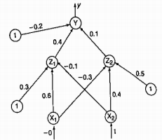

It is presented with the input pattern [0, 1] and the target output is 1.
Use a learning rare a = 0.25 and binary sigmoidal activation function.

Program:
import math

# Initial weights
W11, W21, W12, W22, W31, W32 = 0.2, 0.3, 0.4, 0.5, 0.6, 0.7

# Learning rate
alpha = 0.25

# Input and target output
X1, X2 = 0, 1
target = 1

# Number of epochs
epochs = 1000

# Training loop
for epoch in range(epochs):
# Forward propagation
Z1 = X1 * W11 + X2 * W21
Z2 = X1 * W12 + X2 * W22
O1 = 1 / (1 + math.exp(-Z1))
O2 = 1 / (1 + math.exp(-Z2))
Y = O1 * W31 + O2 * W32
Y_hat = 1 / (1 + math.exp(-Y))

# Error calculation
delta = (Y_hat - target) * Y_hat * (1 - Y_hat)

# Backward propagation and weight update
delta1 = delta * W31 * O1 * (1 - O1)
delta2 = delta * W32 * O2 * (1 - O2)
W11 -= alpha * delta1 * X1
W21 -= alpha * delta1 * X2
W12 -= alpha * delta2 * X1
W22 -= alpha * delta2 * X2
W31 -= alpha * delta * O1
W32 -= alpha * delta * O2

# Print final weights
print("Final weights:")
print("W11:", W11)
print("W21:", W21)
print("W12:", W12)
print("W22:", W22)
print("W31:", W31)
print("W32:", W32)

output:
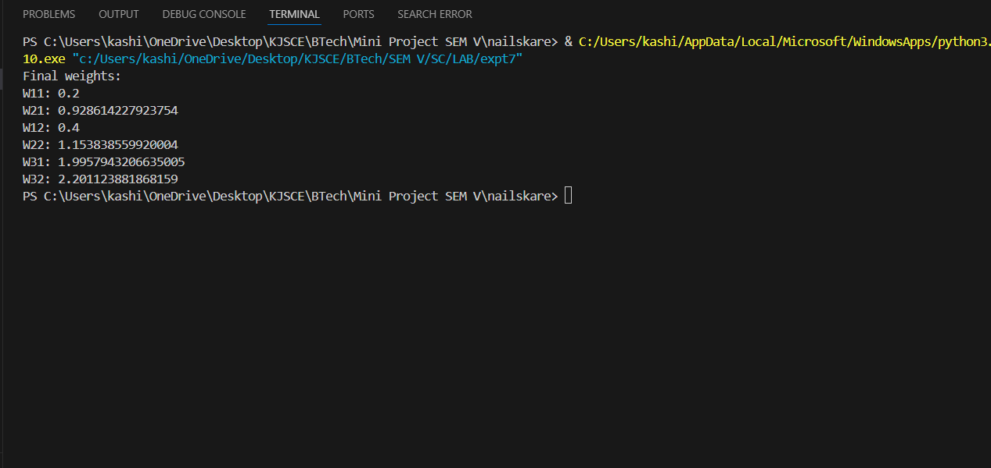

Conclusion:.

Post Lab Descriptive Questions :

- What is meant by local and global minima?
Ans:
- Global Minima: In the context of neural networks and optimization, a global minimum refers to the lowest possible point in the entire error/loss surface. This is the point where the model's error or loss is minimized across all possible configurations of the weights and biases. If the training algorithm reaches the global minimum, the network has found the best possible solution to the problem based on the given data.
- Local Minima: A local minimum is a point where the error is lower than in the surrounding points, but not necessarily the lowest possible error across the entire surface. The optimization algorithm may get "stuck" in this point because any small movement from the current position will increase the error, even though a better, lower point (global minimum) might exist elsewhere.
In backpropagation and gradient descent, the objective is to minimize the error by adjusting the weights. However, the error surface is often complex and filled with multiple local minima, making it challenging to find the global minimum.

- What are factors that can improve the convergence of learning in Back propagation learning algorithm
Ans:
Learning Rate:
- The learning rate (η\etaη) determines the size of the weight updates during training. A small learning rate may lead to slower convergence, while a large learning rate may cause the algorithm to overshoot the minima and become unstable.
- Adaptive learning rates (like using learning rate schedules) or dynamic optimizers (like Adam or RMSProp) can help improve convergence.
Momentum:
- Momentum helps prevent the optimization process from getting stuck in local minima by adding a fraction of the previous update to the current one. This smoothens the updates and speeds up convergence.

Date: 22/10/2024 Signature of faculty in-charge

