Batch: A-3 Roll No.: 16010122104
Experiment No. : 09
Grade: AA / AB / BB / BC / CC / CD /DD

Signature of the Staff In-charge with date

Title: Implementation of de-fuzzification methods (Center of Sum, Centre of
Gravity, Mean of Maximum).
____________________________________________________________________________________
Objective: To understand de-fuzzification methods
____________________________________________________________________________________
Expected Outcome of Experiment:

CO4 : Apply basics of Fuzzy logic and neural networks ____________________________________________________________________________________
Books/ Journals/ Websites referred:

____________________________________________________________________________________
Pre Lab/ Prior Concepts:
____________________________________________________________________________________

Defuzzification :
Defuzzification is the process of producing a quantifiable result in Crisp logic, given fuzzy sets and corresponding membership degrees. It is the process that maps a fuzzy set to a crisp set. It is typically needed in fuzzy control systems. These will have a number of rules that transform a number of variables into a fuzzy result, that is, the result is described in terms of membership in fuzzy sets. Defuzzification is the conversion of a fuzzy quantity to a precise quantity, just as fuzzification is the conversion of a precise quantity to a fuzzy quantity. µ
For example, Fig (a) shows the first part of the Fuzzy output and Fig (b) shows the second part of the Fuzzy output.
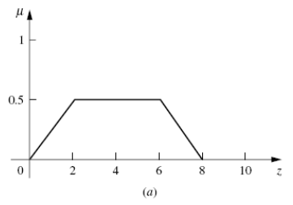
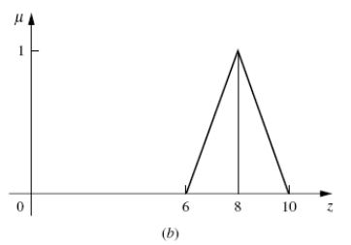
Then Fig (c) shows the union of the two parts (a) and (b).
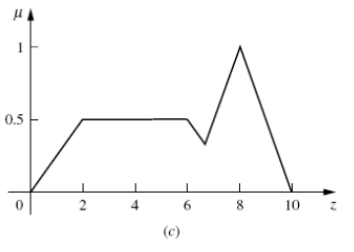

Different Defuzzification methods
- Max membership method

This method is also known as height method and is limited to peak output functions. This method is given by the algebraic expression:
µ(z*) >= µ(z) for all z ∊ Z.

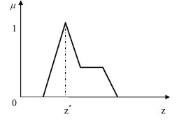
- Center of gravity or centroid
This method is also known as the centre of mass, centre of area or centre of gravity. It is the most commonly used defuzzification method. The defuzzified output z* is given by:
z* = ∫µ(z).zdz / ∫µ(z)dz

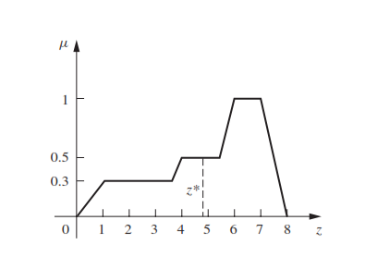

- Centre of sums

This method employs the algebraic sum of the individual fuzzy subsets instead of their union. The calculations here are very fast, but the main drawback is that the intersecting areas are added twice. The defuzzified value z* is given by
z* = ∫ z*∑µ(z).zdz / ∫ ∑µ(z)dz
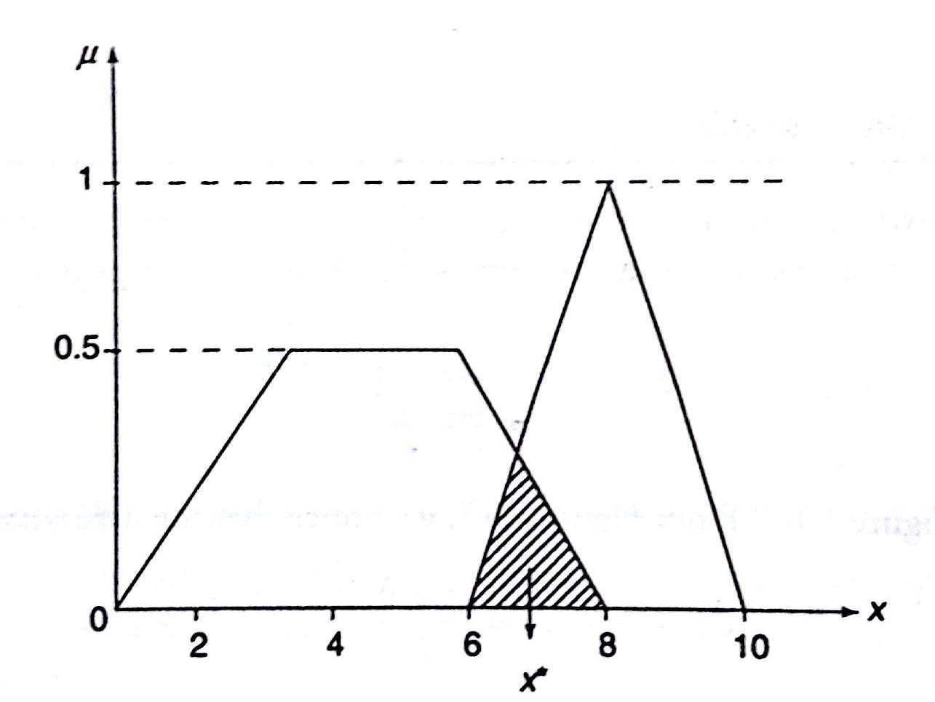

- Mean of maximum method
This method is also known as the middle of the maxima. This is closely related to the max-membership method, except that the locations of the maximum membership can be nonunique. The output here is given by:
z* = ∑z' / n ; where z' is the maximum value of the membership function.
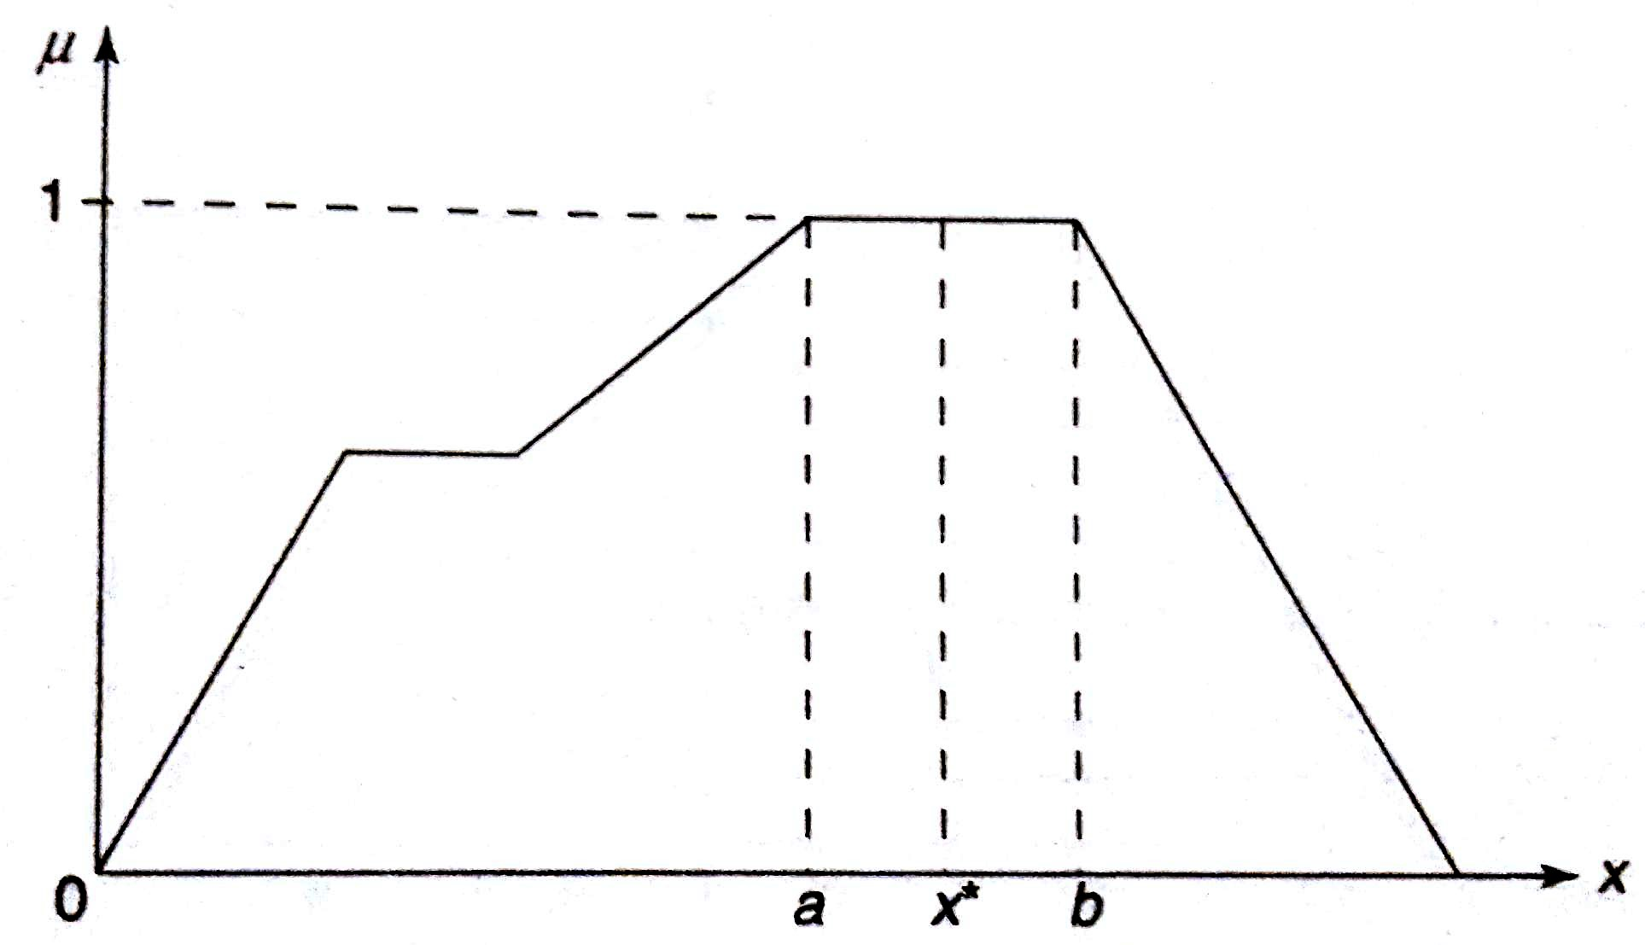

____________________________________________________________________________________
- Weighted average method
This method is valid for symmetrical output membership functions only. Each membership function is weighted by its maximum membership value. The output in the case is given by
z* = ∑µ(z').z' / ∑µ(z') ; where z' is the maximum value of the membership function.

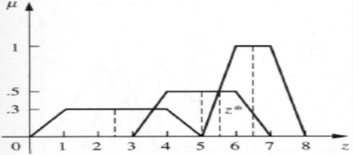

- Centre of Largest Area
This method can be adopted when the output of at least two convex fuzzy subsets which are not overlapping. The output, in this case, is biased towards a side of one membership function. When output fuzzy st has at least two convex regions, then the centre of gravity of the convex fuzzy subregion having the largest are is used to obtain the defuzzified value z*. The value is given by

z* = ∫ µc(z).zdz / ∫ ∑µc(z)dz

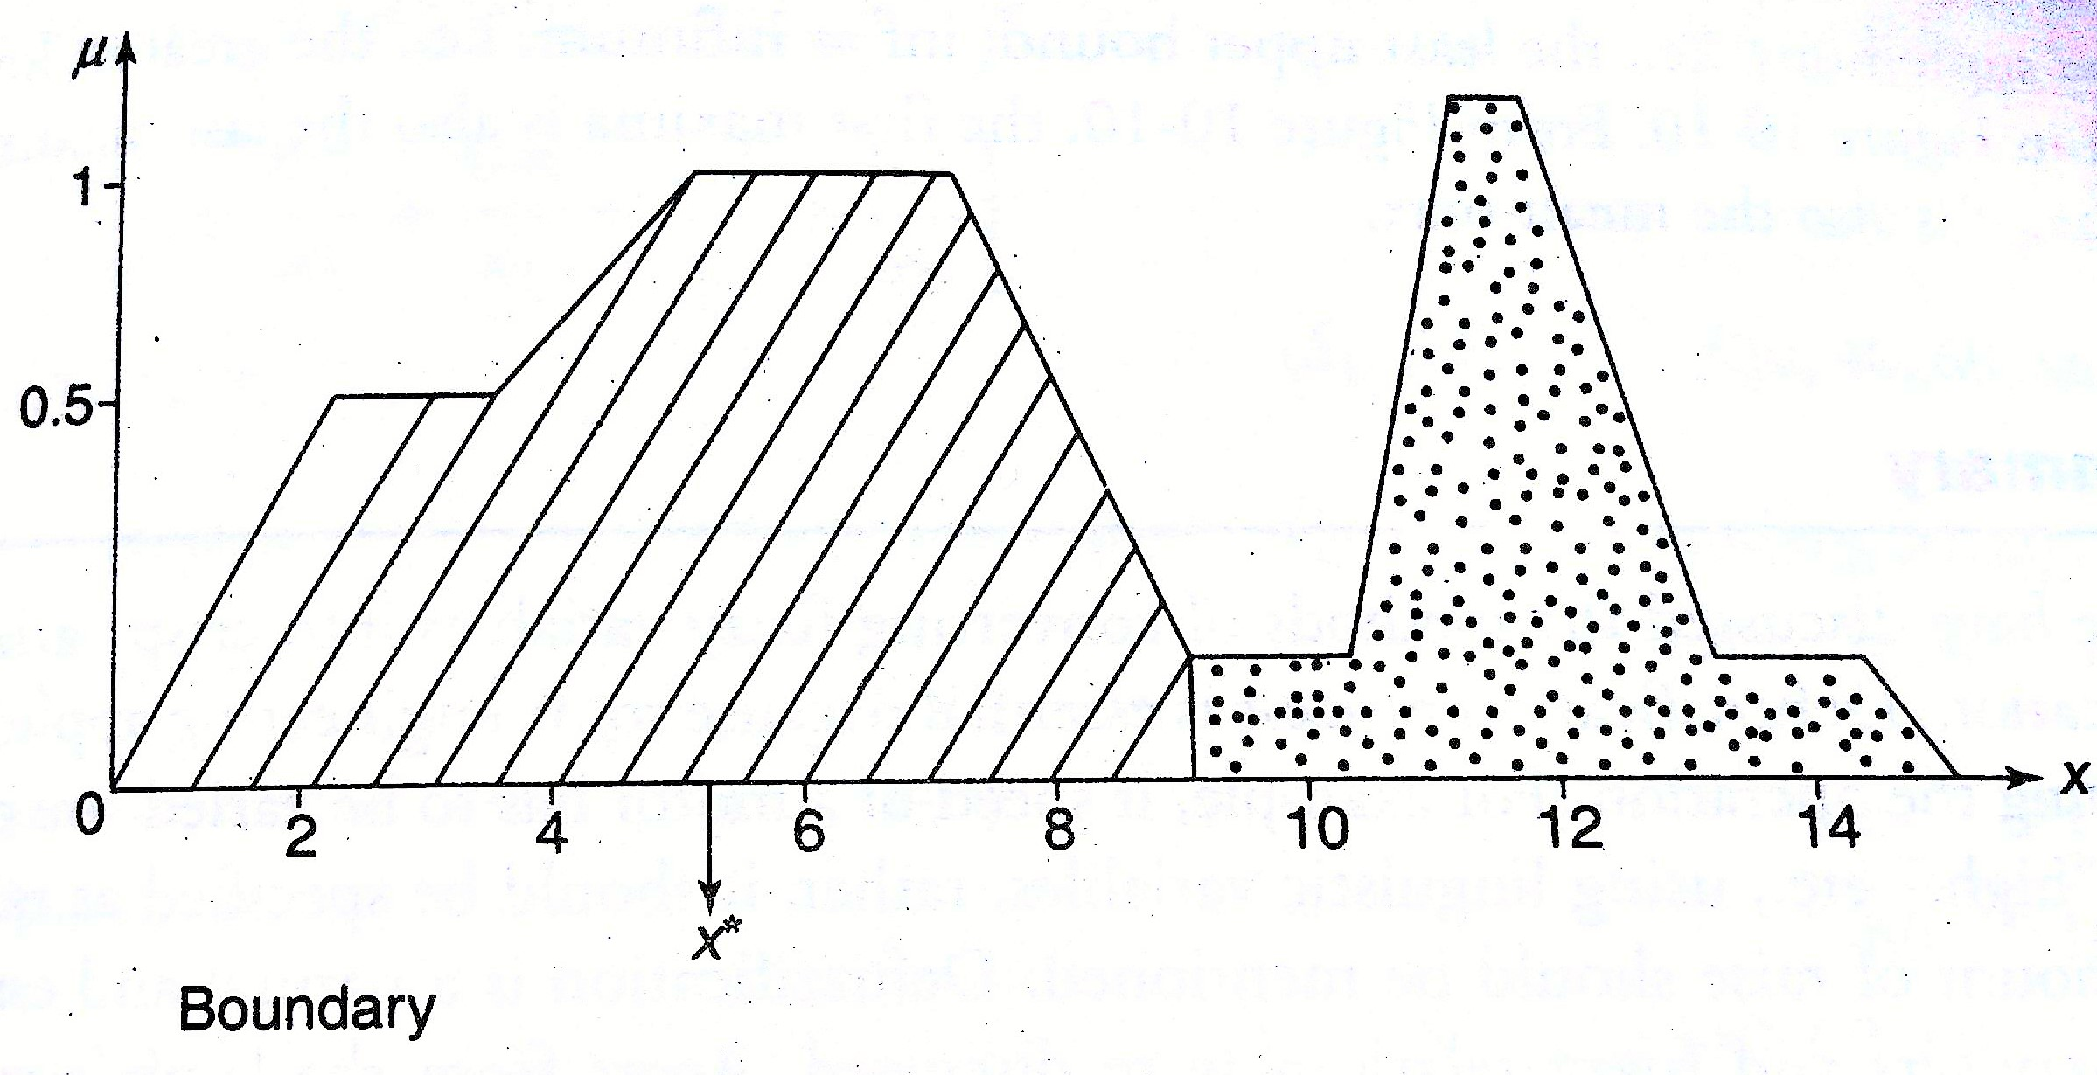

Implementation Details:

import numpy as np
import matplotlib.pyplot as plt
x = np.linspace(0, 10, 100)

mu_A = np.maximum(0, np.minimum((x-2)/2, 1, (6-x)/2))
mu_B = np.maximum(0, np.minimum((x-5)/2, 1, (9-x)/2))

# 1. Max Membership Method (Height Method)
def max_membership_method(mu):
return x[np.argmax(mu)]

# 2. Center of Gravity (Centroid Method)
def center_of_gravity(mu):
return np.sum(mu * x) / np.sum(mu)

# 3. Center of Sums (For simplicity, we'll take the sum of two sets)
def center_of_sums(mu_A, mu_B):
combined_mu = mu_A + mu_B
return np.sum(combined_mu * x) / np.sum(combined_mu)

# 4. Mean of Maximum Method
def mean_of_maximum(mu):
max_val = np.max(mu)
max_positions = x[mu == max_val]
return np.mean(max_positions)

# 5. Weighted Average Method
def weighted_average_method(mu):
max_val = np.max(mu)
return np.sum(max_val * x) / np.sum(max_val)

# 6. Center of Largest Area (Assuming non-overlapping sets for simplicity)
def center_of_largest_area(mu_A, mu_B):
area_A = np.sum(mu_A)
area_B = np.sum(mu_B)
if area_A > area_B:
return np.sum(mu_A * x) / np.sum(mu_A)
else:
return np.sum(mu_B * x) / np.sum(mu_B)

# Calculate defuzzified values
z_max_membership = max_membership_method(mu_A)
z_center_gravity = center_of_gravity(mu_A)
z_center_sums = center_of_sums(mu_A, mu_B)
z_mean_max = mean_of_maximum(mu_A)
z_weighted_avg = weighted_average_method(mu_A)
z_largest_area = center_of_largest_area(mu_A, mu_B)

# Plotting
plt.figure(figsize=(10, 8))

# Plot fuzzy set A
plt.subplot(2, 2, 1)
plt.plot(x, mu_A, label="Set A", color="blue")
plt.axvline(z_max_membership, color="red", linestyle="--", label="Max Membership")
plt.axvline(z_center_gravity, color="green", linestyle="--", label="Centroid")
plt.axvline(z_mean_max, color="purple", linestyle="--", label="Mean of Max")
plt.title("Fuzzy Set A with Defuzzified Values")
plt.legend()

# Plot fuzzy set B
plt.subplot(2, 2, 2)
plt.plot(x, mu_B, label="Set B", color="orange")
plt.axvline(z_center_sums, color="red", linestyle="--", label="Center of Sums")
plt.axvline(z_largest_area, color="green", linestyle="--", label="Center of Largest Area")
plt.title("Fuzzy Set B with Defuzzified Values")
plt.legend()

# Union of A and B
plt.subplot(2, 2, 3)
combined_mu = mu_A + mu_B
plt.plot(x, combined_mu, label="Union of A and B", color="purple")
plt.title("Union of Fuzzy Sets A and B")
plt.legend()

# Weighted Average
plt.subplot(2, 2, 4)
plt.plot(x, mu_A, label="Set A", color="blue")
plt.axvline(z_weighted_avg, color="orange", linestyle="--", label="Weighted Average")
plt.title("Weighted Average Method")
plt.legend()

plt.tight_layout()
plt.show()

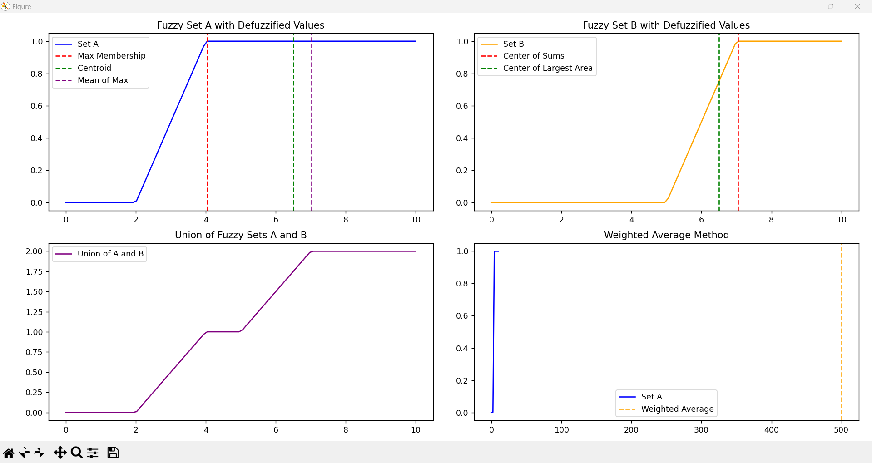

Conclusion: Implementation of defuzzification methods was done successfully.

Post Lab Descriptive Questions :
Find crisp value corresponding to the following fuzzy output sets using various de-fuzzification methods.
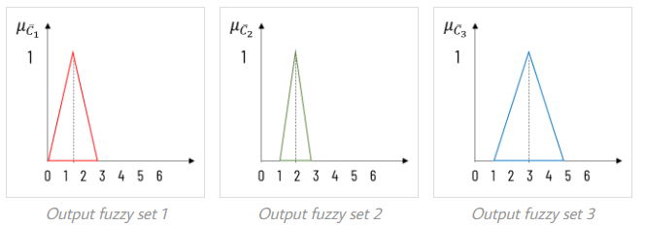

Ans:
- Max Membership Method (Height Method):
  - For each fuzzy set, the crisp value corresponds to the point where the membership function reaches its maximum.
  - In this image, each fuzzy set has a maximum membership of 1 at different locations:
    - For Set 1, the peak is at x=1.5x = 1.5x=1.5.
    - For Set 2, the peak is at x=3x = 3x=3.
    - For Set 3, the peak is at x=4.5x = 4.5x=4.5.
  - Therefore, the crisp values would be:
    - Set 1: 1.5
    - Set 2: 3
    - Set 3: 4.5
- Center of Gravity (Centroid Method):
  - This method finds the center of the area under each membership function curve. We would calculate the weighted average for each set based on the area and its location.
  - Without exact data points, we approximate the centroid for each triangular fuzzy set as the center of the base:
    - Set 1: x≈1.5x \approx 1.5x≈1.5
    - Set 2: x≈3x \approx 3x≈3
    - Set 3: x≈4.5x \approx 4.5x≈4.5
- Mean of Maximum (Middle of Maxima):
  - For cases where the maximum membership occurs over a range of values, this method takes the midpoint of the maximum range.
  - Since each set has a single peak:
    - Set 1: 1.5
    - Set 2: 3
    - Set 3: 4.5
- Weighted Average Method:
  - This method assumes symmetrical membership functions. It calculates the average by weighting each peak value by its membership degree.
  - For symmetric triangular sets with maximum membership at a single peak:
    - Set 1: 1.5
    - Set 2: 3
    - Set 3: 4.5
- Center of Largest Area (CLA):
  - If we had multiple convex regions in a fuzzy set, we would take the center of the largest region. However, each fuzzy set in the image has one main peak, so we use the peak location:
    - Set 1: 1.5
    - Set 2: 3
    - Set 3: 4.5
Thus, for all methods, assuming symmetric triangles and single peaks, the crisp values for Sets 1, 2, and 3 would approximately be 1.5, 3, and 4.5, respectively.

