Adaptive Staircase Procedure
PSY 310: Lab in Psychology
Lab Report
Date: 13th September 2026
Name: Kashish Somani
Enrollment: AU2420074

GitHub Link: ______________________________

Introduction
Estimate of sensory or perceptual threshold: Adaptive Staircase Method. In an adaptive staircase, the intensity of the stimulus will be varied on-line based on participant's performance. This allows for focussing trials around the stimulus level the participant can discriminate, instead of giving all stimulus intensities equally.
The method is particularly useful when the stimulus is difficult to perceive or discriminate because the procedure can move towards the participant's threshold while the experiment is taking place. The task used in the present experiment was an orientation discrimination task using the adaptive staircase procedure. The participant was shown a Gabor patch that was tilted to the left or right, relative to vertical, and was asked to report the direction of the tilt.
This was done to find the smallest angle between orientations that was reliably discriminated. The staircase 1-up 3-down method was used to design the experiment. This rule is that the stimulus level varies with the participant's responses so that the staircase can get closer to the level of performance that corresponds to the participant's discrimination threshold.
Adaptive staircase procedures can be helpful because they allow an estimate of a threshold with an efficiency that does not require the presentation of all possible intensities of the stimulus. The purpose of the present experiment was to try to obtain an orientation discrimination threshold by this method and to simultaneously record the responses and reaction times of the person.
The experiment was designed using psychophysical staircase method mentioned in the submitted draft and references from Hairston and Maldjian (2009), Zhang et al. (2019) and Cherry (2019).

Method

Participant
The participant was a 20-year-old female undergraduate student studying in her third year of college at Ahmedabad University. The participant was briefed about the task and had given her consent to participate, before beginning the experiment.

Materials

PsychoPy was used to create and run the experiment. The exported data contain the version of PsychoPy used (2026.2.3) and an adaptive staircase task. The target stimulus was a Gabor patch in the experiment. The spatial frequency of the Gabor patch was 8; it was presented after a fixation display. This task was presented with a left/right response format. The participant's task was to decide whether the Gabor patch was tilted to the left or the right. The direction of tilt was varied by the program. The experimental task was thus an orientation discrimination task with the change of orientation being the manipulated stimulus attribute.

Procedure

All trials started with a fixation display for 500ms. This was followed by presentation of the Gabor patch. The participant then used the left or right key to answer depending on the orientation shift that they perceived.The staircase to be planned was carried out in accordance with a 1 up 3 down procedure. The range of stimuli was from a maximum of 20° to a minimum of 1°. The planned step sizes were 2, 1, 1 and 0.5. The experiment was to be conducted 100 times and the response, stimulus, intensity, tilt, accuracy of response and reaction time were recorded.

However, the exported file has 436 columns representing completed trial rows, instead of just 100 trials as described in the procedure submitted. The exported dataset is used for the results section of this report as this is the data actually collected for analysis.

Design
A within-subjects design was employed in the experiment. The independent variable was the shift of the orientation of the Gabor patch from the vertical axis, set to be adapted by the staircase. Discrimination accuracy was the dependent variable. Reaction time was also measured for each trial.

Results
The exported dataset had 437 rows. Out of these 436 rows had completed trial numbers and one row at the end was not complete. The completed trials were therefore used to look at the recorded staircase behavior’s recorded intensity started at 10 degrees. Went up during the first trials. The first six recorded intensities were 10 degrees, 12 degrees, 14 degrees, 16 degrees, 18 degrees and 20 degrees. After getting to 20 degrees the recorded intensity stayed at 20 degrees, for the rest of the completed trials.
Trial | Intensity (°) | Recorded pattern
1 | 10 | Initial intensity
2 | 12 | Increased
3 | 14 | Increased
4 | 16 | Increased
5 | 18 | Increased
6 | 20 | Reached maximum
7–436 | 20 | Remained at maximum
This pattern is different from the expected staircase pattern where stimulus intensity rises and falls around the threshold. In the export there are no identifiable decreases after the intensity reaches 20°. Therefore, the data do not contain a sequence of reversal points from which a final threshold can be calculated.
Another problem appears in the response variables. The variable labelled stair. Response is recorded as 0.0 for all 436 completed trials. Similarly, the key.resp.corr column contains the text key_resp.corr of trial-by-trial correctness values. Because the actual correctness information required by the staircase is not available in these columns it is not possible to reconstruct the intended 1-up 3-down staircase, from this export.
Recorded Staircase
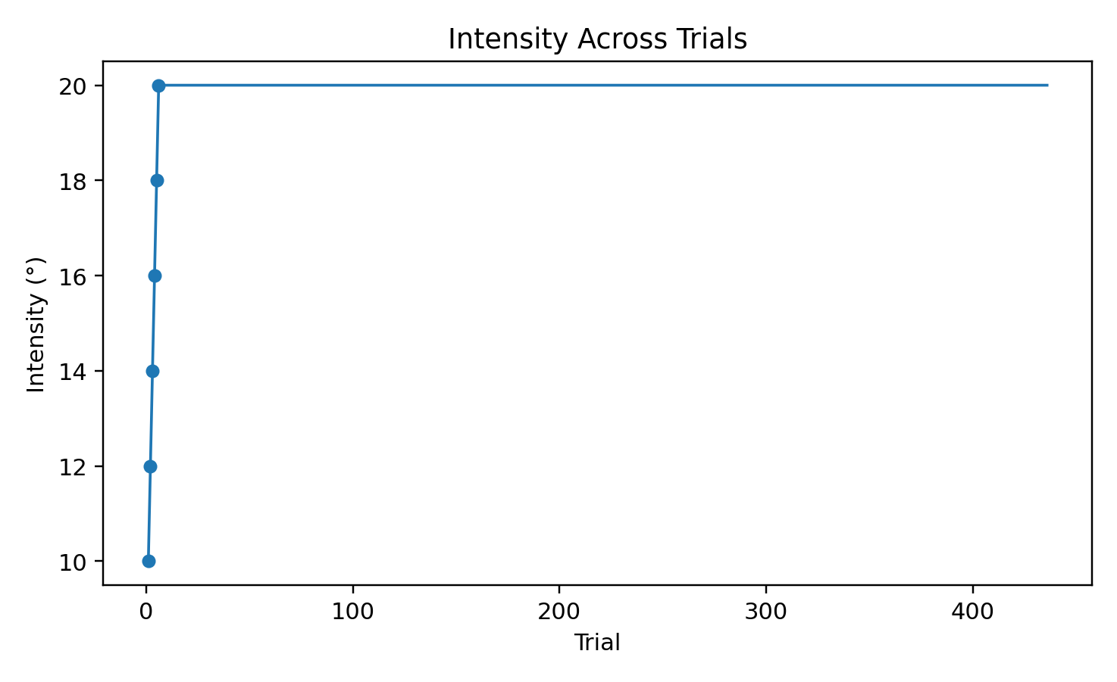
Figure 1. Recorded stimulus intensity across the completed trials. The intensity reaches 20° during the first six trials and remains at 20° thereafter.Results: Threshold and Reversals
In an adaptive staircase experiment, reversal points are important because they indicate changes in the direction of the staircase. For the present procedure, the final reversal intensities would normally be identified and averaged to obtain the estimated discrimination threshold.
However, no valid reversal sequence can be identified in the exported data. The intensity only increases during the first six recorded trials and then remains at the maximum value of 20°. Since the response variable needed to determine whether the staircase should become easier or harder is not correctly recorded, there is no defensible set of final reversal intensities.
Reversal | Trial | Intensity
Not identifiable | — | —
Not identifiable | — | —
Not identifiable | — | —
Not identifiable | — | —
Not identifiable | — | —
Table 2. Reversal points could not be calculated from the exported response data. No numerical value has been entered because doing so would require information that is not present in the dataset.

Interpretation of the Recorded Data

The actual data indicate that stimulus intensity was high and reached peak values early in the experiment. This means that exported stairs were not adapted around a threshold. Thus, it is impossible to conclude what the value 20° is the participant's JND. Twenty degrees is the highest stimulus recorded, not the threshold stimulus.

The purpose of the experiment was to determine the smallest angle which could be reliably discriminated. A threshold estimate would involve having to correctly pass the correct and incorrect responses to the staircase routine, in addition to changes in stimulus intensity and identifiable reversals. The present export does not show the following requirements:

Data Recording Issue

The exported file indicates that the staircase response and correct variables were not scored in the proper manner for threshold calculation. This is relevant since the staircase rule is based on the participant's actual performance. The staircase cannot generate the desired number of reversals if the same response value is given or recorded on all trials.

Discussion
The Adaptive Staircase Method was designed to obtain an efficient estimate of the orientation discrimination threshold by fine-tuning the stimulus based on the participant's performance. In the present experiment a 1-up, 3-down staircase and a Gabor patch orientation discrimination task were employed. It was designed to make fewer trials at intensities which were obviously too difficult or too easy, and to focus measurements near the discrimination threshold.
The real data exported, however, do not have the staircase like behavior. The intensity was raised from 10° to 20° in the first six trials recorded and stayed at 20° for the remaining 13 trials that were completed. In addition, the exported staircase response variable is always 0.0 in the data set and the correctness column does not have any actual correctness values. These responses affect the reversal points and therefore the participant's JND cannot be determined from this set of responses.
This experiment should thus not be reported as a number threshold. This especially is not to be interpreted as the participant's JND, this is the highest intensity they have measured at 20°.
The current dataset is therefore not limited in its use of the psychophysical method, but rather by its available response recording. The participant's actual left/right response and the correctness on the individual trials would have to be written correctly into PsychoPy, and sent to the staircase routine for the intended analysis. The staircase could vary in intensity according to the 1-up, 3-down rule, show reversals, and have the final intensities of reversals averaged in response-to-response information.
Overall, the documents available for export provide a description of the stimulus presentation and of the intensity sequence but are not adequate for a proper estimation of perceptual threshold. The graph and tables therefore show the observed behavior and not the unsupported JND value.

References:
Hairston, W. D., & Maldjian, J. A. (2009). An adaptive staircase procedure for the E-Prime programming environment. Computer Methods and Programs in Biomedicine, 93(1), 104–108. https://doi.org/10.1016/j.cmpb.2008.08.003

