KAAS UMBRELLA

A report submitted in partial fulfillment of the Academic requirements for the award of the degree of Bachelor of Technology

Submitted by

# KASHISH SINGHAL (21H51A1247)

**A. SANDHYA GAYATRI (21H51A1245)**

**E. ANIRUDH (21H51A1208)**

# V.ADITYA (21H51A1219)

UNDER THE COURSE

# SOCIAL INNOVATION IN PRACTICE



**CENTRE FOR ENGINEERING EDUCATION RESEARCH CMR COLLEGE OF ENGINEERING & TECHNOLOGY**

# (Autonomous)

(NAAC Accredited with ‘A+’ Grade & NBA Accredited) (Approved by AICTE, Permanently Affiliated to JNTU Hyderabad)

KANDLAKOYA, MEDCHAL ROAD HYDERABAD-501401

**2022-2023**



# CENTRE FOR ENGINEERING EDUCATION RESEARCH

**CMR COLLEGE OF ENGINEERING & TECHNOLOGY (AUTONOMOUS)**

(NAAC Accredited with ‘A+’ Grade & NBA Accredited) (Approved by AICTE, Permanently Affiliated to JNTU Hyderabad) KANDLAKOYA, MEDCHAL ROAD, HYDERABAD-501401



CERTIFICATE

This is to certify that the report entitled “KAAS UMBRELLA” is bonafide work done by KASHISHSINGHAL(21H51A1247),A.SANDHYAGAYATRI(21H51A1245),E.ANIRUDH (21H51A1208),V.ADITYA(21H51A1219) of II B.TECH I Semester in partial fulfillment of the requirements for the award of the degree of Bachelor of Technology, submitted to Center for Engineering Education Research, CMR College of Engineering & Technology , Hyderabad during the Academic Year of 2022-23.

**(**Names of the Project Coordinators)

1. Ms. ARCHANA BATHULA Asst.professor, CSE, (B.SURESH RAM)
2. Mr. K. RAJU Asst. professor, ECE  **HOD CEER**



# DECLARATION

We, the students of II B. Tech I Semester of **Centre for Engineering Education Research** , **CMR COLLEGE OF ENGINEERING & TECHNOLOGY**, Kandlakoya, Hyderabad, hereby declare, that under the supervision of our course coordinators, we have independently carried out the project titled “**KAAS UMBRELLA**” and submitted the report in partial fulfillment of the requirement for the award of Bachelor of Technology in by the **Jawaharlal Nehru Technological University, Hyderabad (JNTUH)** during the academic year 2022-2023.

NAME ROLL NO SIGNATURE

|  |  |  |
| --- | --- | --- |
| KASHISH SINGHAL | 21H151A1247 |  |
| A. SANDHYA GAYATRI | 21H51A1245 |  |
| E. ANIRUDH | 21H51A1208 |  |
| V.ADITYA | 21H151A1219 |  |



# ACKNOWLEDGEMENT

We are obliged and grateful to thank **B. Suresh Ram, Head (CEER), CMRCET**, for his cooperation in all respects during the course.

We would like to thank the Principal of **CMRCET, Dr.V.A. Narayana**, for his support in the course of this project work.

Finally, we thank all our faculty members and Lab Assistants for their valid support.

We own all our success to our beloved parents, whose vision, love and inspiration has made us reach out for these glories.



# TABLE OF CONTENTS

|  |  |  |  |
| --- | --- | --- | --- |
| **CHAPTERS** | | **DESCRIPTION** | **PAGE No** |
|  |  | Abstract |  |
| 1 |  | Introduction | 1 |
| 2 |  | Literature Review | 2 |
| 3 |  | Problem Definition |  |
|  | 3.1 | Problem Statement | 5 |
|  | 3.2 | Objective | 6 |
|  | 3.3 | Requirement Analysis | 6 |
|  | 3.4 | Methodology | 10 |
| 4 | 4.1 | Circuit Diagram | 11 |
|  | 4.2 | Conceptual Design | 12 |
|  | 4.3 | Block Diagram | 13 |
| 5 | 5.1 | Implementation | 14 |
|  | 5.2 | Conclusion | 14 |
| 6 |  | Future scope | 15 |
| 7 |  | Source Code | 16 |
| 8 |  | Appendix |  |
|  | 8.1 | Reference | 18 |
| 9 |  | Student Details | 19 |
|  |  | Poster | 20 |
|  |  | Team Photo | 21 |



**ABSTRACT**

Nowadays technology is everywhere. Technology like smartphones have become a part of our life. We cannot live without them, even for a second. Many importance transactions, everything is in our smartphones these days, which create a continuous urge of checking on those devices. But not everything goes as we wanted. Nowadays due to changing climatic conditions it's hard to predict the weather conditions. Given such unpredictable weather it’s hard to take precautions every day. We have to carry an umbrella always irrespective of the weather. Carrying it in hand every time is also a problem. This problem is for students and working people, who constantly need to engage themselves with mobile devices. So, there is a need of an automatic umbrella which doesn’t required to be held in hands. So that anyone who wants to works or use their mobile device even in rain, it shouldn’t be a problem.

The objective of our project is to help all the students, working people by making an handsfree umbrella with which they don’t have to worry about the weather and can effortlessly use their mobile devices even while walking in rain. Our project can turn your ordinary bag into a hybrid bag by having an umbrella attached to it. So, when ever rain starts just with push of a button the umbrella, which initially rests on the bag, opens up and protects us from the rain and also leaving our hands to do any work. Since ages we have been using the traditional umbrella which needs to be held in hand, which only protects the one under it and fails to protect his/her accessories from rain, and also restricts our hand to doing only one job i.e., holding the umbrella. But these problems won’t be anymore because with our project i.e., KAAS UMBRELLA, there is no need of catching it without hand which makes our hand restriction free, and also protects the person under it along with the accessories. These all can be done with an ease of just clicking a button. Moreover, we can also use this even if it’s not raining, to protect ourselves from the sun. this project comes in handy for all the seasons. In winter – to protect ourselves from snow, in summer – to protect ourselves from sun, in rain – to protect ourselves from rain.



# CHAPTER 1

**INTRODUCTION**

In the rainy season, an umbrella is a must-have item. The issue with umbrellas is that they must be carried separately from your other belongings and need the use of one hand at all times. Also, umbrellas need to be kept separately in buckets, which leads to individuals forgetting about them and losing them in many situations. So, with a meet to its objectives, we develop a smart solution to all umbrella-related concerns. Our suggested product is a backpack with an integrated umbrella. The umbrella does not need to be held separately, and the user has full use of both hands even when the umbrella is open. Even opening the umbrella is an effortless process that requires only a single click.



# CHAPTER 2

**LITERATURE REVIEW:**

## Traditional Umbrella:

* The widely used solution by most of the population in the world is “AN UMBRELLA”. It has been around since ancient times.

***Advantages:***

* It is affordable by most of the different economical classes.
* It is useful for both Summer and Rainy seasons.

***Disadvantages:***

* We have to carry it everywhere irrespective of the weather.
* An Umbrella can only help one person from soaking wet.
* It is an additional gear.
* Often people forget it.

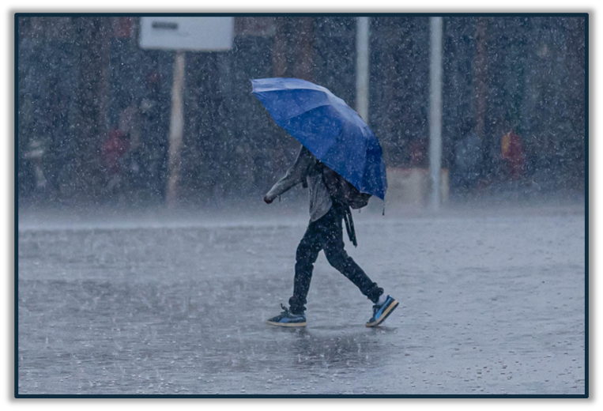



# Raincoat:

* This is a wearing gear for the people to not soak wet in rain.

***Advantages:***

* Helps the person cover his entire body in order to protect him from rain.
* Easy to carry everywhere.

***Disadvantages:***

* Covers entire body of a person but not his accessories.
* Takes time to wear.
* Useless once torn.

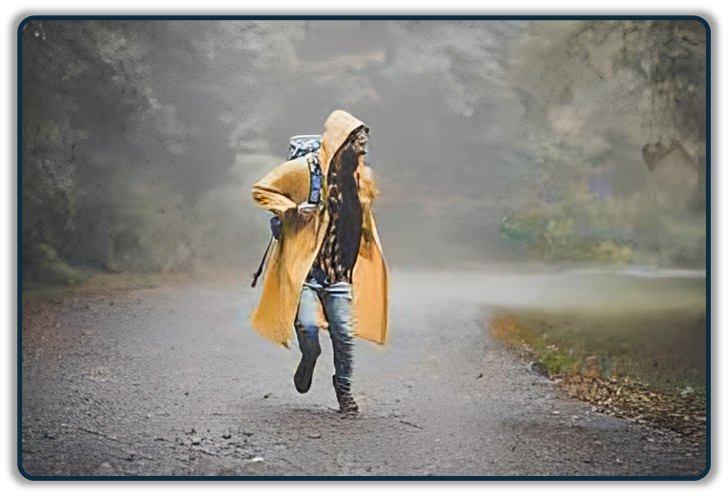



## *Hats/Caps:*

* This is a head gear helpful for preventing your head getting wet due to rain.

***Advantages:***

* It helps in preventing with rain obstructing our view
* Easy to carry and trendy.

***Disadvantages:***

* Only protects the head from soaking wet not the entire body.
* Wearing a head cap for an extended period of time can damage your hair and trap its natural oils, making them dry.

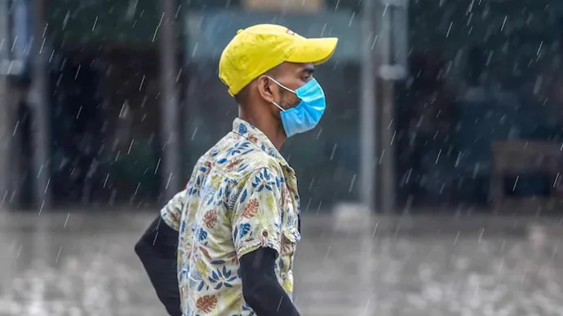



**CHAPTER 3**

**PROBLEM DEFINITION**

# PROBLEM STATEMENT:

Nowadays due to changing climatic conditions it's hard to predict the weather conditions. Given such unpredictable weather it’s hard to take precautions every day. We have to carry an umbrella always irrespective of the weather. Carrying it in hand every time is also a problem. This problem is for students and working people. So, there is a need of an automatic umbrella which doesn’t required to be held in hands.

Our team has decided to work on this project to help students, working people by making an handsfree umbrella with which they don’t have to worry about the weather and can effortlessly use their mobile devices even while walking in rain

* + - Handsfree umbrella
    - Bag attached umbrella no need to carry separately
    - No risk of forgetting or loosing umbrella
    - Automatic opening closing on button press
    - Protects from rain as well as sunlight as needed



# 3.2 OBJECTIVE:

Our main objective of creating the device is to help the students and working people who use their smartphones a lot for their respective works. Our project helps the users to protect themselves from rain, snow, and sun. Ultimately, our goal is to give the user the ability to use their hands even while in rain or snow and to make it as effortless as possible.

# REQUIREMENT ANALYSIS:

* + - ARDUINO UNO
    - BATTERY
    - SERVO MOTORS
    - JUMPER WIRE
    - PUSH BUTTON
    - G.I. WIRES
    - WOODEN SUPPORT
    - UMBRELLA CLOTH



## SOFTWARE DESCRIPTION

1. Arduino tool (IDE) version 1.8.15

## Power Supply:

In the circuit, Arduino board, LCD module and LEDs need a 5V regulated DC for their operation. To achieve this, a battery is used. A battery is connected to the Arduino via jumper wires.

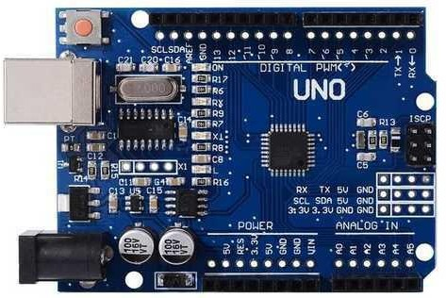

## FIG NO.6-Arduino Uno Board



**Servo Motors:**

A **servo motor** is a type of motor that can rotate with great precision. Normally this type of motor consists of a control circuit that provides feedback on the current position of the motor shaft, this feedback allows the servo motors to rotate with great precision. If we want to rotate an object at some specific angles or distance, then we use a servo motor. It is just made up of a simple motor which runs through a **servo mechanism.**

All servo motors work directly with +5V supply rails but we have to be careful on the amount of current the motor would consume or else the servo motors may fail due to excessive current passage.

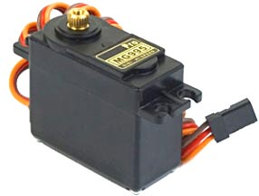

## FIG NO-8: MG995 Servo Motor



**Push Button:**

A push button switch is a mechanical device used to control an electrical circuit in which the operator manually presses a button to actuate an internal switching mechanism. They come in a variety of shapes, sizes, and configurations, depending on the design requirements.

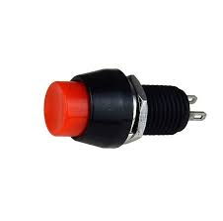

Push Button



* 1. **METHODLOGY:**

An umbrella is much needed product in rainy season. The problems associated with umbrellas is that it needs to be carried separately along with your other stuff and it occupies one hand all the time. Also, umbrellas are to be kept separately in buckets which leads to people forgetting about umbrella in many cases and losing them.

Well, we are here to design a smart solution to all umbrella related problems with a customized solution. Our proposed device is a bag pack that has an integrated umbrella with auto rain sensing. The umbrella does not need to be carried separately and both hands of the user are free even when the umbrella is open. Even opening the umbrella is an automatic operation with no manual efforts needed.

As the rain starts with just a single click of push button, the umbrella that is attached to the bag opens.

The modern umbrella consists of Servo motorized system with transparent plastic cover with push button and Arduino controller integrated in a bag pack. The push-button umbrella system is a unique modern-day gadget that changes the way umbrella is used.

The push-button is used to protect us from rain fall. If there is rainfall, then push the button which then sends trigger to the Arduino controller. The Arduino now operates the motors to open the small umbrella shed to protect user from rain.



# CHAPTER 4

* 1. **CIRCUIT DIAGRAM:**

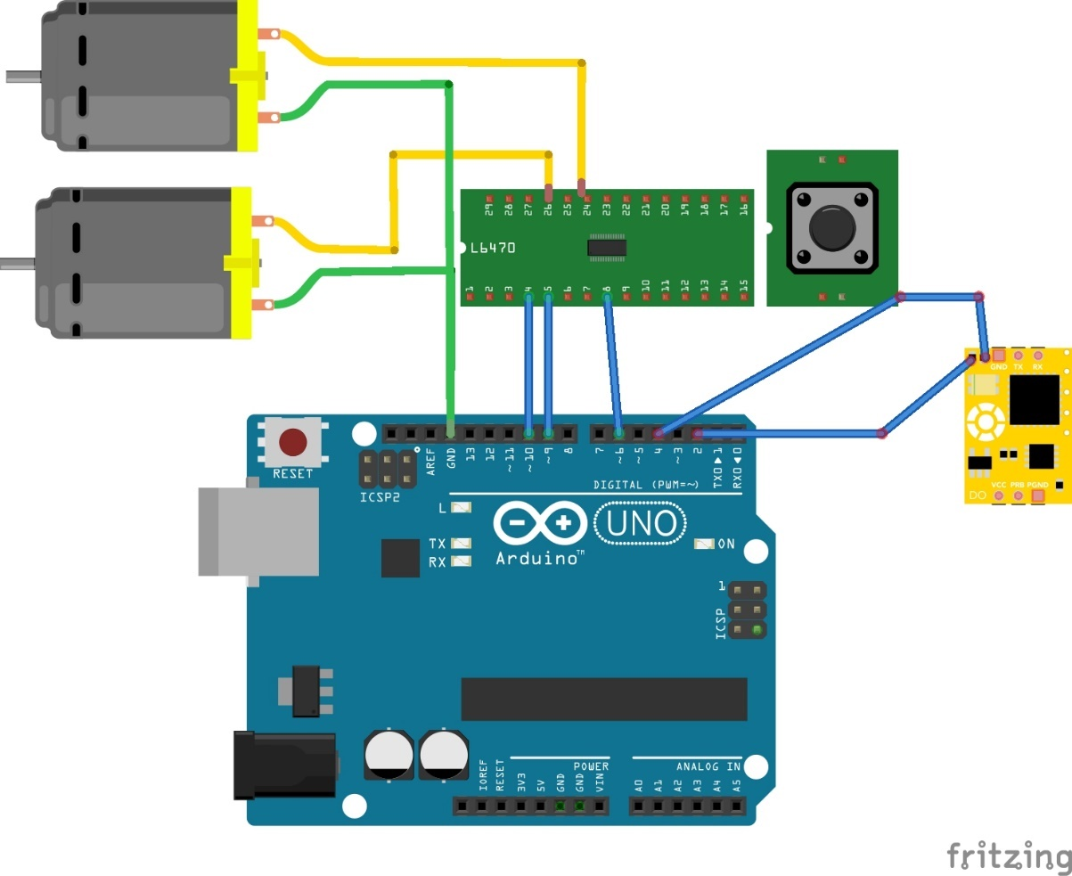



* 1. **CONCEPTUAL DESIGN:**



If opened

If closed



Push Button is pressed

Servo motor rotates forwards

If the person is bit away

from the door.

Servo motor rotates backwards

Umbrella opens

Umbrella closes



* 1. **BLOCK DIAGRAM:**

**BASIC BLOCK DIAGRAM OF KAAS UMBRELLA**



# CHAPTER 5

* 1. **IMPLEMENTATION:**

Working of this “KAAS UMBRELLA” is very easy. Whenever rain falls or snow falls, the push button is pressed by the user and then the umbrella opens with a second and protect the user also giving him the freedom of using his hands however he wants to because there is no need of holding this “KAAS UMBRELLA”.

* 1. **CONCLUSION:**

In the rainy season, an umbrella is a must-have item. The issue with umbrellas is that they must be carried separately from your other belongings and need the use of one hand at all times. Also, umbrellas need to be kept separately in buckets, which leads to individuals forgetting about them and losing them in many situations. So, with a meet to its objectives, we develop a smart solution to all umbrella-related concerns. Our suggested product is a backpack with an integrated umbrella. The umbrella does not need to be held separately, and the user has full use of both hands even when the umbrella is open. Even opening the umbrella is an effortless process that requires only a single click. Hence, we introduce “KAAS UMBRELLA”.



# CHAPTER 6

**FUTURE SCOPE**

This project has a lot of potential in the coming future. As it reduces the effort of a regular person using a regular umbrella. With just one click the umbrella opens and protects the person from rain, snow and sun. Nowadays due to changing climatic conditions it's hard to predict the weather conditions. Given such unpredictable weather it’s hard to take precautions every day. We have to carry an umbrella always irrespective of the weather. Carrying it in hand every time is also a problem. This problem is for students and working people. So, there is a need of an umbrella which doesn’t required to be held in hands. In the rainy season, an umbrella is a must-have item. The issue with umbrellas is that they must be carried separately from your other belongings and need the use of one hand at all times. Also, umbrellas need to be kept separately in buckets, which leads to individuals forgetting about them and losing them in many situations. So, our model meets all the above stated problems thus, making it the best solution for the above problems and also making it the best alternative for the regular old-fashioned umbrella. Our model also helps students and working professionals to use their hands during rain and snow because it’s handsfree. So, a lot of students and working professionals who need a bag will definitely buy our kaas umbrella. In the coming future all the bags and umbrellas will be replaced by KASS UMBRELLAs.



# CHAPTER 7

**SOURCE CODE**

Servo myservo; // create servo object to control a servo

// twelve servo objects can be created on most boards

void setup () {

myservo. attach (3); // attaches the servo on GIO2 to the servo object

myservo. write (110);

pinMode (7, INPUT_PULLUP);

}

void loop () {

int s = digitalRead (7);

if (s == LOW)

{

delay (100);

while (1)

{

myservo. write (60); // tell servo to go to position in variable 'pos'

delay (2000); // waits 15ms for the servo to reach the position

int s = digitalRead (7);

if (s == Lode)

{

myservo. write (110); // tell servo to go to position in variable 'pos'

delay (2000); // waits 15ms for the servo to reach the position

break;

}

}

}

// else

// {

// myservo. write (110); // tell servo to go to position in variable 'pos'

// delay (2000); // waits 15ms for the servo to reach the position

// }

}



# CHAPTER 8

**REFERENCES**

* [**https://www.quickcompany.in/patents/rain-sensing-umbrella-rain-sensing-hands-free-auto-open-closed-umbrella-bag#documents**](https://www.quickcompany.in/patents/rain-sensing-umbrella-rain-sensing-hands-free-auto-open-closed-umbrella-bag%23documents)
* **https://risingsealevel.wordpress.com/the-other-one/**
* **https://youtu.be/cLdQXfJ2XeA**



# CHAPTER 9

**STUDENT DETAILS:**

## TEAM 07

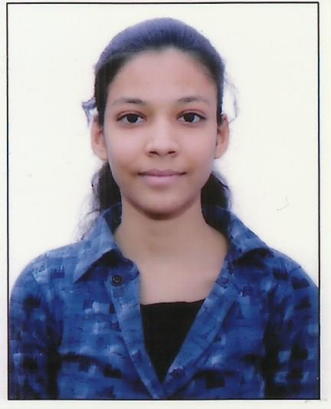

**NAME: KASHISH SINGHAL**

**ROLL NO: 21H51A1247**

**BRANCH: IT**

**CMRCET**

**NAME: A.SANDHYA GAYATRI**

**ROLL NO: 21H51A1245**

**BRANCH: IT**

**CMRCET**

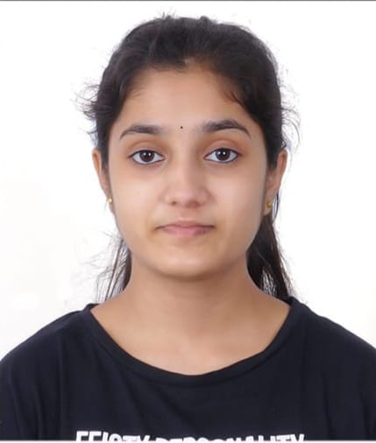

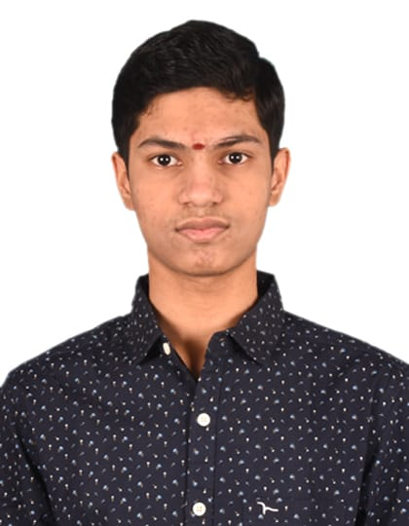

**NAME: E.ANIRUDH**

**ROLL NO: 21H51A1208**

**BRANCH: IT**

**CMRCET**

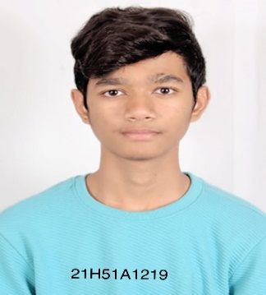

**NAME: V.ADITYA**

**ROLL NO: 21H51A1219**

**BRANCH: IT**

**CMRCET**

**POSTER**



**TEAM PHOTO**

