NMAM INSTITUTE OF TECHNOLOGY, NITTE
Department of Information Science and Engineering

OPERATING SYSTEMS
PROGRAMMING ASSIGNMENT REPORT
AI-Assisted Synchronization Algorithms with Program-Generated HTML Simulation
Readers-Writers Problem and Dining Philosophers Problem

SUBMITTED BY

Name | Kashish T Karkera
Registration / USN | NNM24IS102
Course | Operating Systems
GitHub Repository | https://github.com/kashishtkarkera/OS_TASK2

SUBMITTED TO
Dr Jason Elroy Martis Associate Professor
Dept Information Science and Engineering, Nitte

The only way a multi-threaded program is correct is if the result does not depend on which thread the scheduler runs first. This is no longer automatic if two threads touch the same data: their steps can interleave in ways the programmer never intended, and the output may change from run to run. Thus, operating systems provide synchronization mechanisms that constrain the conditions under which a thread may enter a shared access region and when it must wait.
This assignment studies two classical coordination problems, and provides two solutions for each. The Readers-Writers problem is about how many readers can share a resource while one writer needs it exclusively. The Dining Philosophers problem here with exactly four philosophers and four forks asks how competing threads can each acquire two shared resources without blocking each other indefinitely. For each problem, two solutions are given, one using semaphores and the other a monitor. This gives us four different programs, all in Python.
The aims of the work are:
- To have mutual exclusion wherever accesses conflict, so that the shared data is never corrupted
- to make sure that no group of threads can end up waiting on each other indefinitely (deadlock)
- to check whether any thread can be repeatedly passed over (starvation) under each policy
- to record the real sequence of state changes during execution and convert it into an HTML simulation.

In this program the shared resource is an integer called shared_data, which starts at 0. Readers read it and writers increase it by 1. There are 3 readers and 2 writers. Each thread runs its cycle 3 times. The number of readers the number of writers and the total number of rounds are all defined as variables. Between steps each thread waits for a time that is up to 0.6 seconds. This means that the threads overlap in ways each time the program runs. Two semaphores are. Both start with a value of 1. The first semaphore is called reader_mutex. It protects the counter called active_readers, which shows how many readers are reading at the same time. The second semaphore is called shared_resource. It protects the shared_data.

A reader follows these steps. It logs that it is thinking, then waits for a bit. After that it logs that it is waiting. Then it locks the reader_mutex. Increases the active_readers by 1. If the active_readers count is now 1 this is the reader to enter so it takes the shared_resource and stops any waiting writers. After that it unlocks the reader_mutex reads the value and logs that it is reading. After the pause it logs "done". To leave it locks the reader_mutex again. Decreases the active_readers. If the count goes to 0 this was the reader so it gives up the shared_resource and allows a waiting writer to enter.

A reader that comes in while others are reading sees that the active_readers count is already higher than 0 and does not touch the shared_resource. This is how multiple readers can read at the time.

A writer is simpler. It logs "waiting" takes the shared_resource adds 1 to the shared_data, logs "writing" with the value, waits, logs "done" and then releases the shared_resource. The writer holds the semaphore the time, including during the wait. During that time no reader and no other writer can get in.
The reader_mutex is needed because the active_readers is also shared. If two readers changed it at the time an update could be lost and the shared_resource might be released too early or not at all.
This solution gives priority to readers. If new readers keep arriving before the current ones finish the active_readers never drops to 0 the shared_resource is never. A waiting writer has to keep waiting. That is called starvation of the writers. In this program the readers only do 3 rounds each so the writers do get their turn eventually but, with readers or more rounds the delay could be much longer. There is no deadlock because no thread holds one semaphore while waiting for another that another thread needs. The only nesting that exists is that the first reader takes the shared_resource while holding the reader_mutex. A writer holding the shared_resource never asks for the reader_mutex so no cycle can form.

The program solves the problem as the semaphore version. It uses the shared integer named shared_data three readers, two writers and three rounds for each. The difference is that all synchronization lives inside one class called ReadWriteMonitor. Because Python does not have a built‑in monitor, ReadWriteMonitor uses a lock and condition variables from the threading module.

ReadWriteMonitor has one lock named `self.lock` and two condition variables created on that lock: `reader_condition` and `writer_condition`. ReadWriteMonitor stores three pieces of state. First `active_readers` tells how many readers are reading now. Second `is_writing` tells whether a writer is writing now. Third `waiting_writers` tells how many writers are waiting. Threads do not touch these variables directly. Threads only call four methods: `start_read` `end_read` `start_write` and `end_write`.

How each method works:

- `start_read`: first the reader takes the lock and waits on `reader_condition` while a writer is writing or any writer is waiting. When the condition becomes `start_read` increases `active_readers` by one and then proceeds to read.

- `end_read`: the reader decreases `active_readers`. If end_read finds that `active_readers` is now zero it calls `writer_condition.notify()`. Wakes a waiting writer.

- `start_write`: the writer increases `waiting_writers` so that everyone sees that a writer is waiting. Then the writer waits on `writer_condition` while a writer is writing or any readers are active. After the wait ends, `start_write` decreases `waiting_writers`. Sets `is_writing` to True.

- `end_write`: the writer sets `is_writing` to False. If `end_write` sees another writer waiting it wakes one writer with `notify()`. If no writers are waiting, `end_write` wakes all waiting readers by calling `reader_condition.notify_all()`.

Every wait is, inside a while loop, not an if. A thread that wakes up checks the condition again because the state may have changed while it was sleeping. When a thread waits the lock is released

There are 4 philosophers (NUM_PHILOSOPHERS) and 4 forks, and each philosopher eats 3 times (EATING_ROUNDS). Philosopher i needs two forks. The left one is fork i, and the right one is fork (i + 1) % 4. So every fork is shared by two neighbours, and two neighbours can never eat at the same time. The forks are the shared resources. The critical section is the eating step, where a philosopher holds both forks.
Each fork has its own semaphore, and all of them start at 1. They are in the list forks. The list fork_owner records who holds each fork, and the value -1 means the fork is free. There is also a third kind of semaphore called room. It starts at NUM_PHILOSOPHERS - 1, which is 3, and it allows only three philosophers at a time to try to pick up forks.
What a philosopher does in each round
- Logs “thinking” and pauses for a random time.
- Logs “hungry” and acquires room. If three philosophers are already inside, it waits here.
- Logs “acquiring”, then acquires its left fork, sets fork_owner[left] to its number, and logs that it has the left fork.
- Acquires its right fork and sets fork_owner[right]. Then it logs “eating” and pauses while it eats.
- Logs “releasing”, sets both entries of fork_owner back to -1, and releases the two fork semaphores.
- Releases room, and the next round begins.

This program has 4 philosophers (NUM), and each one eats 3 times (ROUNDS). Philosopher i uses fork i and fork (i + 1) % 4. The monitor is the class TableMonitor. It has one lock, self.lock, and a list self.conditions with one condition variable for each philosopher. All four conditions are built on that same lock. It also has a list self.state that holds the state of every philosopher (thinking, hungry or eating). The lists fork_owner and self.state are only changed inside the monitor, while the lock is held.
The idea is that a philosopher may start eating only if neither of its two neighbours is eating. Because each fork is shared by exactly two neighbours, “no neighbour is eating” means the same as “both of my forks are free”. So the monitor checks the neighbours’ states and does not look at the forks themselves.
How pick_up(i) works
- The philosopher takes the lock sets its state to "hungry" and logs it.
- It works out its two neighbours: left = (i + NUM - 1) % NUM and right = (i + 1) % NUM.
- It waits on its own condition, self.conditions[i], as long as the left or the right neighbour is in the “eating” state.
- When that condition is false it logs "acquiring". Sets fork_owner[i] and fork_owner[(i + 1) % NUM] to its number. So both forks are taken together in one step
- It sets its state to “eating” and logs “eating”. Then pick_up returns, the lock is released, and the philosopher eats during pause().
How put_down(i) works
The philosopher takes the lock again and logs “releasing”. It sets both of its forks back to -1 and sets its state to “thinking”. Then it calls notify() on the conditions of its left and right neighbours, because they are the only ones who might have been waiting for these forks. A woken neighbour checks the while condition again, since the state could have changed in the meantime, and goes back to waiting if a neighbour is eating.

All four programs work the same way, so I’ll describe the process once and say where they differ. A run goes through five stages: start the program, let the threads synchronize, record every state change, write the HTML file, and open it in a browser. What I explain in this section is the recording of the state changes and the writing of the file.

1. The recording part
Each program consists of three variables at the very beginning which are used for logging purposes. events is an empty list which contains the information about actions. log_lock is a lock which guards that list. start_time is a variable which is set once during the startup of the program. All times are counted relative to it.
Every time a thread changes its status, the log(who, state, note) function is called. At first, log_lock is acquired by the function. In the dictionary, there is stored the time in seconds passed since start_time (with 3 decimal places precision), who is either the name or ID of the thread, the state, a comment and shared data. Without log_lock, it is possible that two threads would simultaneously add to the list and corrupt one item.
 | Readers-Writers | Dining Philosophers
Who | “Reader 1”, “Writer 2”, ... | the philosopher number, 0 to 3
Shared data in each event | value | forks

The threads also call pause() between their steps, which sleeps for a random time between 0.1 seconds and MAX_DELAY (0.6 seconds). Without it the threads would finish almost at once and you would hardly see them overlap. The pauses do not replace the synchronization. They only make the overlapping visible, while the semaphores and the monitor still decide who may enter.

2. Generating the HTML file
The web page is stored in the program as one long text string, HTML_TEMPLATE. It holds the layout, the styling and the JavaScript that plays the events back. At one place in the JavaScript it contains the placeholder __EVENTS__.
The main function main() creates the threads, starts them, and then waits for all of them with join(). Only after every thread has finished does it call make_html(filename). That function turns the list into JSON text with json.dumps(events), replaces __EVENTS__ in the template with this text, and writes the finished page to a file. In this way the list of events becomes the JavaScript variable events inside the page.

Readers-Writers Using Semaphore
The illustration depicts readers going into the reading portion while the writers gain exclusive access to the common resource.
Example sequence:
0.002s Reader 1 → thinking value=0
0.002s Reader 2 → thinking value=0
0.003s Reader 3 → thinking value=0
0.003s Writer 1 → thinking value=0
0.004s Writer 2 → thinking value=0
0.163s Reader 2 → waiting (wants to read) value=0
0.163s Reader 2 → reading (read value 0) value=0
0.257s Writer 2 → waiting (wants to write) value=0
The exact order varies between executions because the programs use concurrent threads and random delays.

Readers-Writers Using Monitor
The execution shows readers and writers entering the monitor and waiting when the required condition is not satisfied.
Example sequence:

0.001s Reader 1 → thinking value=0

0.002s Reader 2 → thinking value=0

0.002s Reader 3 → thinking value=0

0.002s Writer 1 → thinking value=0

0.003s Writer 2 → thinking value=0

0.167s Reader 1 → waiting (wants to read) value=0

0.167s Reader 1 → reading (read value 0) value=0

0.245s Reader 3 → waiting (wants to read) value=0

Dining Philosophers Using Semaphore
The execution shows philosophers moving through different states and acquiring/releasing forks.
Example sequence:
0.002s P0 → thinking
0.002s P1 → thinking
0.003s P2 → thinking
0.003s P3 → thinking
0.136s P0 → hungry (wants to eat)
0.136s P0 → acquiring (picking up forks)
0.136s P0 → acquiring (has left fork 0)
0.136s P0 → eating (has forks 0 and 1)

Dining Philosophers Using Monitor
The execution shows philosophers waiting until both required forks are available. Example sequence:
0.002s P0 → thinking
0.002s P1 → thinking
0.003s P2 → thinking
0.003s P3 → thinking
0.112s P3 → hungry (wants to eat)
0.112s P3 → acquiring (picking up forks 3 and 0)
0.112s P3 → eating (has both forks)
0.2s P2 → hungry (wants to eat)

Race conditions
A race condition occurs when two threads access the same data simultaneously, and the outcome is determined by which of the threads accesses it first. The programs safeguard the following from such a scenario:
• shared_data, safeguarded by shared_resource in the semaphore version and by the monitor in the monitor version.
• active_readers counter, safeguarded by reader_mutex. Otherwise, two simultaneous arrivals of readers can raise the counter from 0 to 1, and the counter will be undercounted, allowing for the release of shared_resource while a reader is inside.
• fork_owner in the Dining Philosophers programs, safeguarded by the fork semaphores or by the monitor lock.

Mutual exclusion
Mutual exclusion is a rule that allows one thread to be inside the critical section at a time when their accesses might conflict. In the Readers‑Writers problem the writer must work alone while readers can work at the time with each other. In the Dining Philosophers scenario each fork belongs to one philosopher. Two neighboring philosophers can never eat at the same time.
This is shown on the simulation pages. On the Readers‑Writers pages a CONFLICT will appear if the writer works at the time, as any other thread and on the Dining Philosophers pages two neighbors will never eat at the same time.

Deadlock
Deadlock means that a group of threads wait for each other forever. Deadlock needs four conditions at the time: mutual exclusion, hold and wait, no preemption and circular wait.
Deadlock can be avoided by removing one of those conditions.
Here is how deadlock could happen if there is no room.Every philosopher picks up the fork first. If all four do it at the time P0 holds fork 0 and waits for fork 1. P1 holds fork 1 and waits for fork 2. P2 holds fork 2. Waits, for fork 3.. Finally P3 holds fork 3 and waits for fork 0 creating a full circle of deadlock.

Starvation
Starvation is different from deadlock. The system keeps working, but one thread is passed over again and again.
- In the semaphore Readers-Writers, readers have priority. If new readers keep arriving before the old ones leave, shared_resource is never released and a waiting writer can be delayed for a very long time .
- In the monitor Readers-Writers, writers have priority, because a new reader must wait when waiting_writers is above 0. This protects the writers, but readers can now be delayed.

Aspect | Semaphore | Monitor
Structure | Uses synchronization primitives such as semaphores | Combines shared data, a lock, and condition variables
Waiting | Threads block using acquire() | Threads wait using condition variables
Resource control | Programmer explicitly performs acquire() and release() operations | Resource access is controlled inside monitor methods
Error risk | Incorrect acquire()/release() ordering can cause synchronization problems | Encapsulation makes synchronization easier to organize
Level of abstraction | Lower-level synchronization mechanism | Higher-level synchronization abstraction
Conditions | Conditions are usually managed explicitly by the programmer | Conditions are represented using condition variables

The following images shows outputs pf HTML stimulation:

10.1 Readers-Writers Using Semaphore
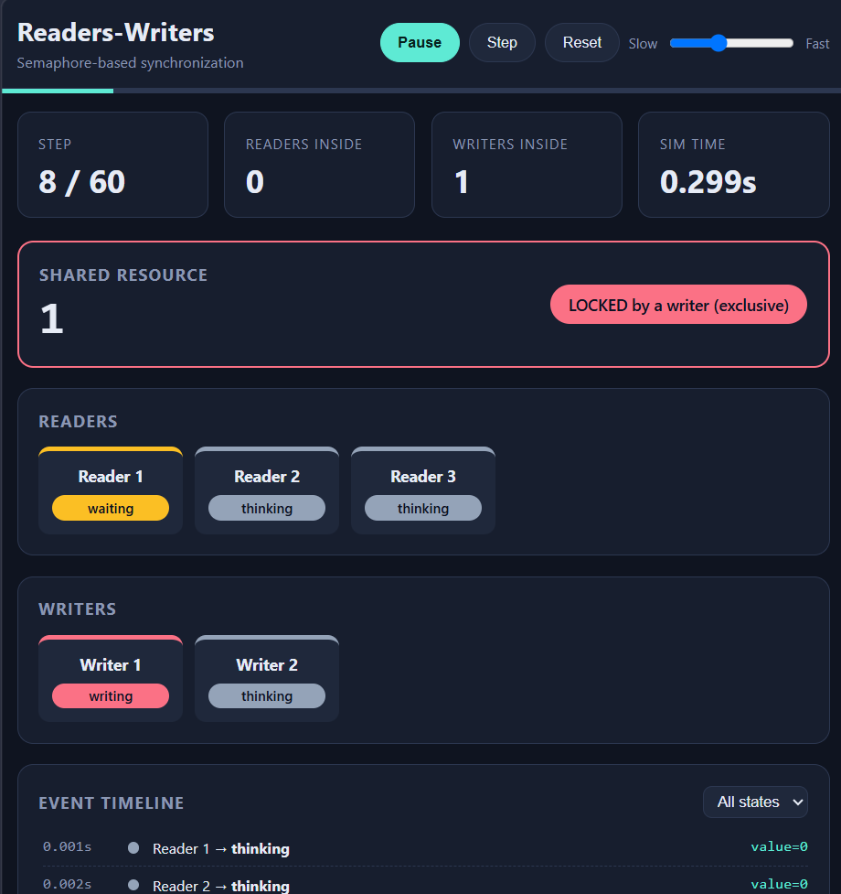

10.1 Readers-Writers Using Monitors
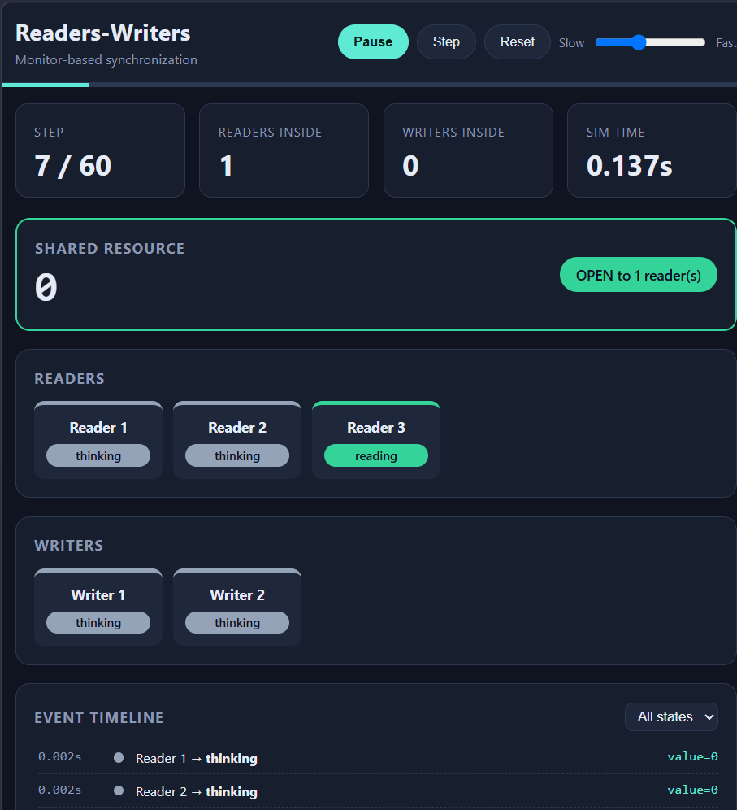

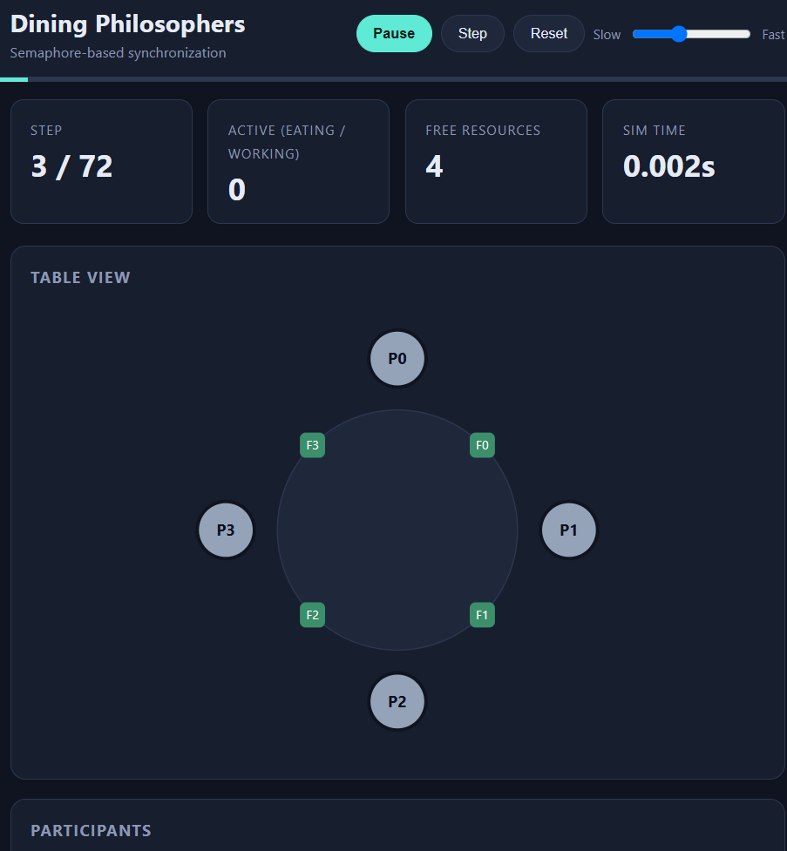

10.4 Dining Philosophers Using Monitor

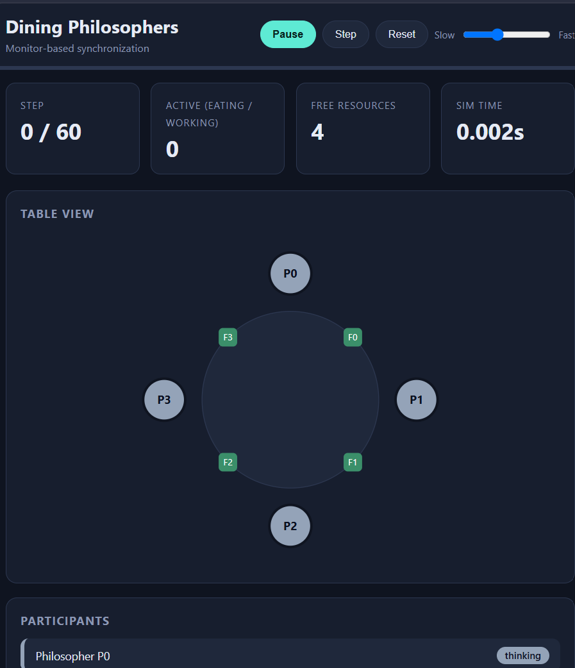

I used Claude from Anthropic in its chat application with the model name shown in your chat to create the HTML simulation page to fix it and to help write the explanations in this report.
The first request for the simulation was to redesign the Dining Philosophers monitor template with a design but keep the same logic and to make it reusable for the other three programs.
After that I sent each of my four programs. Asked for the report sections based on my own code.
The first draft of the explanations used names that are not in my code such as mutex and rw_lock and described the Dining Philosophers monitor as checking a fork-owner array while my program actually checks the neighbours’ states.
I noticed this by comparing the text with my code. The sections were rewritten from the real files.In the version of the Dining Philosophers page the forks were also drawn between the wrong philosophers, which was corrected after checking it against the code.

[1] Bernstein, Philip A., and Nathan Goodman. "Concurrency control in distributed database systems." ACM Computing Surveys (CSUR) 13.2 (1981): 185-221.
[2] Smith, Reid. "Communication and control in problem solver." IEEE Transactions on computers 29.12 (1980): 1104-1113.
[3] Keedy, James Leslie, John Rosenberg, and Kotagiri Ramamohanarao. "On Synchronizing Readers and Writers with Semaphores." The Computer Journal 25.1 (1982): 121-125.
[4] Kawash, Jalal. "Process synchronization with readers and writers revisited." Journal of computing and information technology 13.1 (2005): 43-51.
[5] Lehmann, Daniel, and Michael O. Rabin. "On the advantages of free choice: A symmetric and fully distributed solution to the dining philosophers problem." Proceedings of the 8th ACM SIGPLAN-SIGACT symposium on Principles of programming languages. 1981.
[6] Bhargava, Deepshikha, and Sonali Vyas. "Agent based solution for dining philosophers problem." 2017 International Conference on Infocom Technologies and Unmanned Systems (Trends and Future Directions)(ICTUS). IEEE, 2017.
[7] Holt, Richard C. "Some deadlock properties of computer systems." ACM Computing Surveys (CSUR) 4.3 (1972): 179-196.
[8] Singhal, Mukesh. "Deadlock detection in distributed systems." Computer 22.11 (1989): 37-48.
[9] Zhou, MengChu, and Maria Pia Fanti, eds. Deadlock resolution in computer-integrated systems. CRC Press, 2004.
[10] Shakor, Mohammed Y. "Scheduling and synchronization algorithms in operating system: a survey." Journal of Studies in Science and Engineering 1.2 (2021): 1-16.

I declare that I have personally tested and understood the submitted programs. I have disclosed the AI tools and external resources used in developing this assignment. I can explain the synchronization logic, generated HTML simulation, and modifications made to the code. I have not knowingly submitted another student's work or unacknowledged third-party material as my own.

Name: Kashish T Karkera
USN: NNM24IS102

Signature:
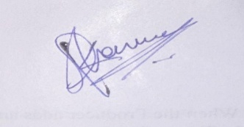

Date: 26/10/2026

