LeetCode Assignment
Question Name: Calculate delayed arrival time
LeetCode question number: 2651
Platform: LeetCode
Problem link: https://leetcode.com/problems/calculate-delayed-arrival-time/submissions/2192465493/
C source code
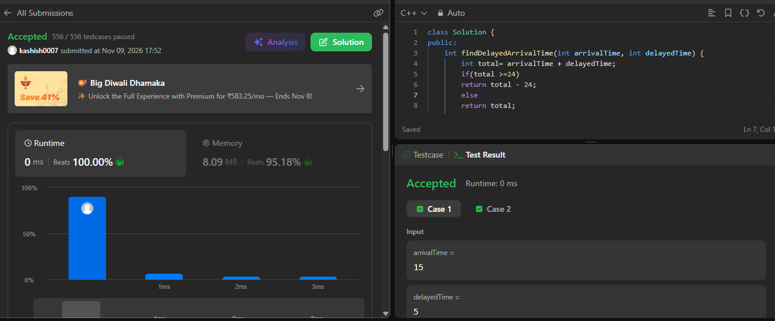

Name – Kashish Upadhyay
Roll no- 26csu254

