LeetCode Assignment
Question Name:
LeetCode question number: 2652
Platform: LeetCode
Problem link: https: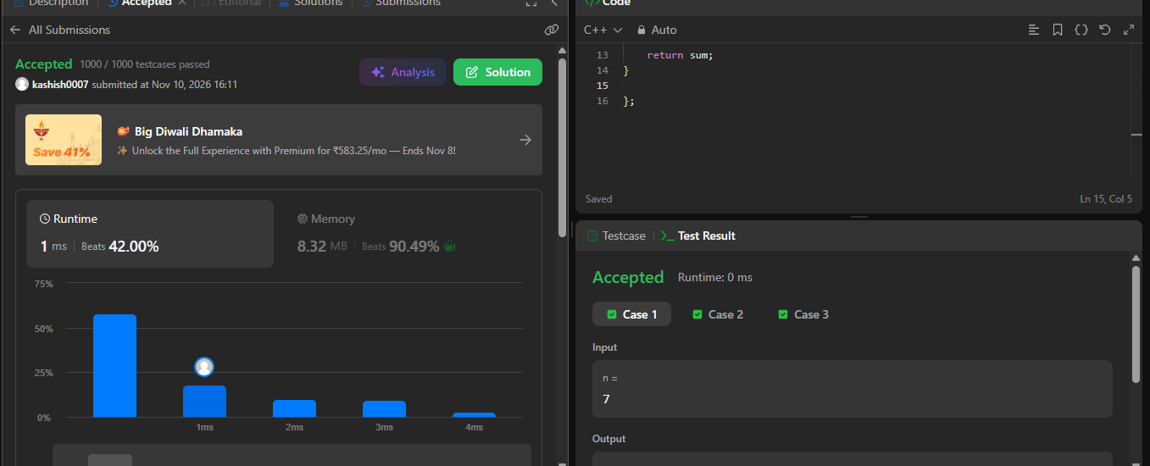

Name – Kashish Upadhyay
Roll no- 26csu254

