LeetCode Assignment
Question Name: total distance traveled
LeetCode question number: 2739
Platform: LeetCode
Problem link: https://leetcode.com/problems/smallest-even-multiple/submissions/2192477629/
C source code: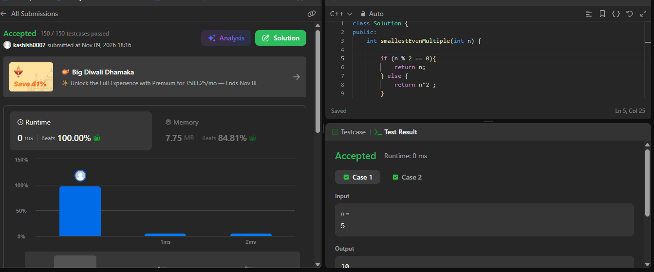

Name – Kashish Upadhyay
Roll no- 26csu254

