LeetCode Assignment
Question Name: count odd numbers in an interval range
LeetCode question number: 1523
Platform: LeetCode
Problem link: https://leetcode.com/problems/count-odd-numbers-in-an-interval-range/submissions/2193095718/
C code
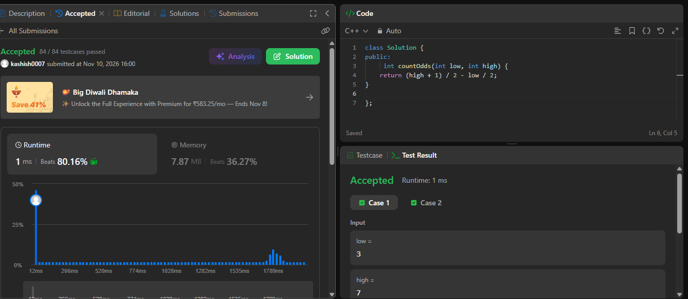

Name – Kashish Upadhyay
Roll no- 26csu254

