LeetCode Assignment
Question Name: count operations to obtain zero
LeetCode question number: 2169
Platform: LeetCode
Problem link: https://leetcode.com/problems/count-operations-to-obtain-zero/submissions/2193090801/

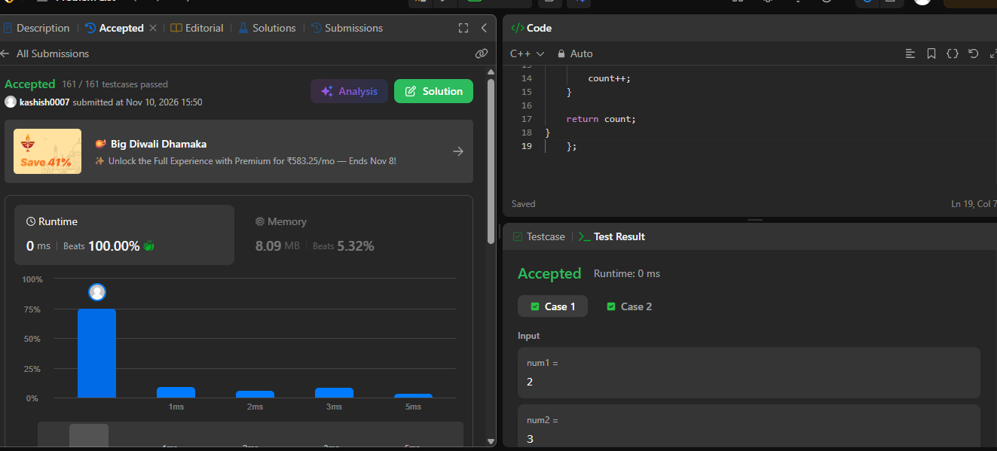

Name – Kashish Upadhyay
Roll no- 26csu254

