LeetCode Assignment
Question Name: add two integers
LeetCode question number: 2235
Platform: LeetCode
Problem link: https://leetcode.com/problems/add-two-integers/submissions/2192457501/
C source code
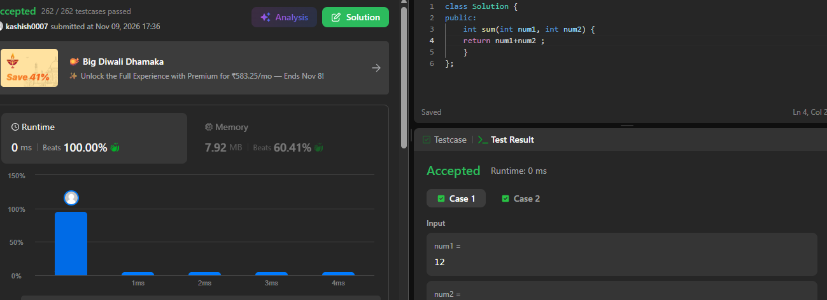

Name – Kashish Upadhyay
Roll no- 26csu254

