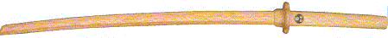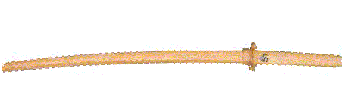
Kasumi Shinto Ryu Kenjutsu
The founder of Kasumi Shinto Ryu Kenjutsu is now known to be the famous Tsukahara Bokuden according to new research also known as a famous warrior by the name of Doumou “Hisamoto” (1522 - 1589 ).
The link between the previously known only as Shinto Ryu was due to Muso Gonnosuke in obtaining his teaching license from the original ryu. Gonnosuke, later became the founder of Jo-Jutsu or nowadays known also as Jo-Do .
I will leave to you to research more into the history of the ryu, and Koryu.com web site has at present recent aquired information regarding the ryu history.
There are basic twelve Kata associated with Kasumi Shinto Ryu, 8 tachi (long sword) and 4 kodachi ( short sword), the movements are large and circular, and in some cases resemble techniques used in Shindo Muso Ryu Jodo.
Many of the pure fighting skills like Kenjutsu have developed into an art that, if studied deeply, has much more to offer in the spiritual development than simply looking at as a way of attack or defense.
The techniques are mainly practiced with wooden swords and are thought in this order.

1 - AI SURI (MIGI) 9 - INCHU

2 – AI SURI (HIDARI) 10 – UKE KAESHI

3 – JU 11 – MIUKI DOME

4 – CHI BARAI 12 – TSUKI DASHI
(Alternative) TSUKI DASHI
5 – SARIN

6 – UKE-NAGASHI

7 – NITO AI

8 – SURI KOMI
on

Saturday
the 9th of July 2005
start at 11.00am to 17.00pm
at YAWARA MARTIAL ARTS CENTRE
203 MERTON ROAD
SOUTHFIELDS
LONDON SW18 5EE

