Species richness patterns of cavity-nesting birds in India

Kavish Shah

***Introduction***

‘Primary Cavity Nesters (PCNs)’ or ‘excavators’ are vertebrates that can excavate cavities in trees for nesting or roosting. These cavities may then be used by a broad range of other vertebrate and insect species for nesting, roosting, food storage and cover. The distribution and availability of suitable tree cavities may thus influence the distribution and abundance of cavity adopters (Newton, 1994). These passerines, ducks, birds of prey, and small mammals that require but cannot excavate tree holes are termed as secondary cavity nesters (SCNs). These act as consumers of excavated or natural cavities and populate the third or second tier in nest webs respectively. A third guild, ‘Weak cavity excavators (WCEs)’ or ‘Facultative excavators’ may excavate their own cavity, rely on cavities produced by excavators or use natural cavities. For the purpose of this study, WCEs have been clubbed with SCNs due to their weak excavation capabilities and limited ability to supply nesting cavities to SCNs (Martin & Eadie, 1999).

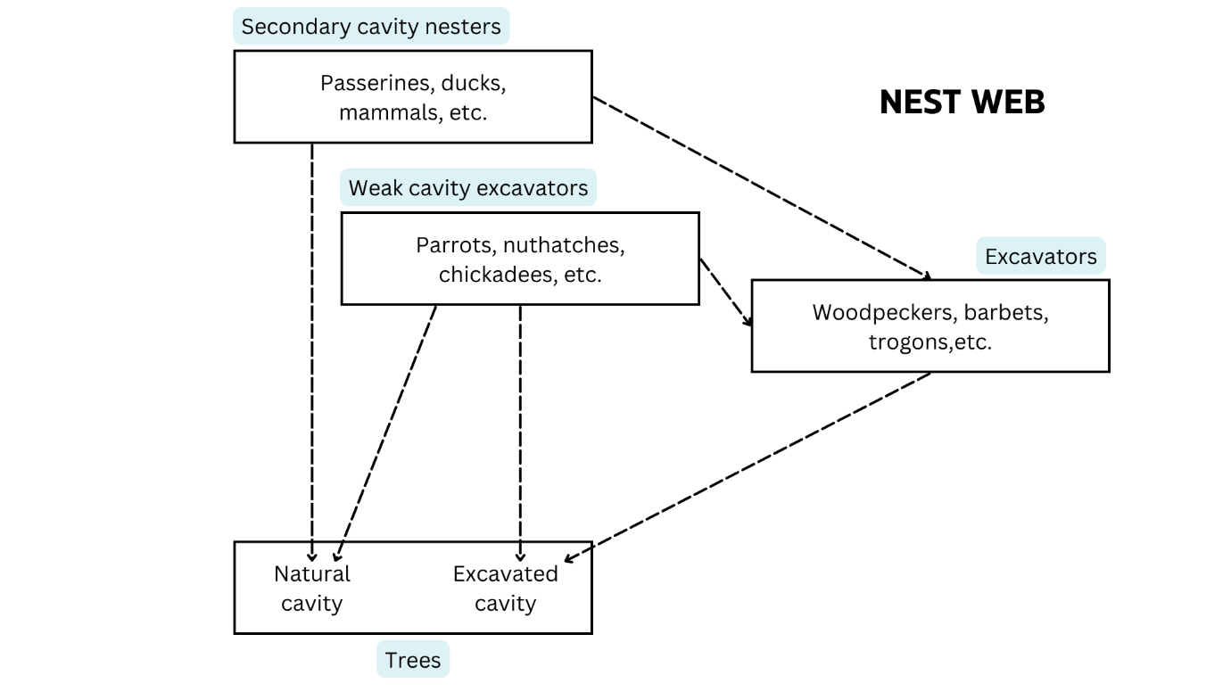

Figure . Illustration of a cavity nest web adopted from Martin & Eadie (1999).

A global review by Van Der Hoek et al. (2020) suggests that SCN richness shows a stronger positive relationship with excavator richness in predominantly tropical areas. However, no such information is available for the Indian subcontinent. I focused on avian cavity nesters in India and tried to map their richness across the country.

***Methodology***

List of cavity-nesting vertebrates found in India was obtained from (Patel et al., 2021). Distribution ranges of birds were obtained from BirdLife International and Handbook of the Birds of the World (2024). This data included distribution ranges of all 11,000+ birds found across the globe and consisted of 17,000+ polygons bundled in a *.gpkg* file. This .gpkg file had to be converted into an ESRI Shapefile in order to perform further analysis. However, simply opening the file in QGIS and trying to export it as a shapefile gave an error due to the large size. This was solved by opening the attribute table and selecting the first 6000 features using ‘Select features using an expression’ option. I input the operation ‘OBJECTID < 6001’ and clicked on select features. In this manner, the GeoPKG was broken down and exported as 3 ESRI shapefiles each containing ~6000 features.

Further analyses were done in R (version 4.3.3) using packages "tidyverse", "sf", "raster", "rgdal", and "letsR". Workflow for the R script has been drawn in *Figure 2*. The R script has been uploaded on GitHub at <https://github.com/kashkounts/CavityNesters_India> for reference.

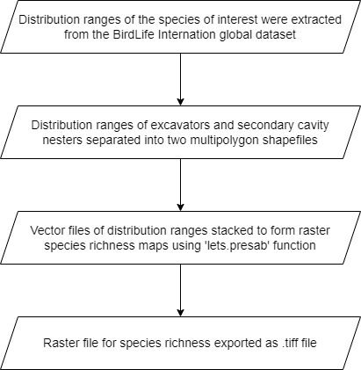

Figure . Workflow for R script

The raster files were then opened in QGIS (3.34.11-Prizren). Raster calculation was used to calculate relative excavator richness in each grid cell.

Finally, symbology was adjusted to improve map readability and maps were printed using the print layout option.

***Results***

The Himalayas and the Western Ghats seem to be hotspots for cavity-nesting birds in India. The richness patterns of excavators (Figure 3) and SCNs (Figure 4) show considerable overlap which might be indicative of a positive relationship between these two guilds. The western Himalayas have a high relative richness of excavators (Figure 5). Relative richness is measured as number of excavators per secondary nesting species. It indicates areas where excavators are proportionally highly speciose and thus might play a keystone role in structuring the cavity-nesting community.

Degree of reliance of an SCN on tree cavities for nesting depends on whether that species is obligate or facultative cavity nester. However, this life history data is missing for many species in the Indian subcontinent. Data shows that species found in the north-east region of India are especially data deficient (Figure 6). Obligate cavity nesters may be especially vulnerable to habitat modifications such as deforestation and selective logging due to their dependency on tree cavities for nesting. Therefore, I recommend future studies to focus on collecting data regarding nesting habits of birds in these data poor regions. This data may be of paramount importance for deciding conservation priorities for these forest specialist species.

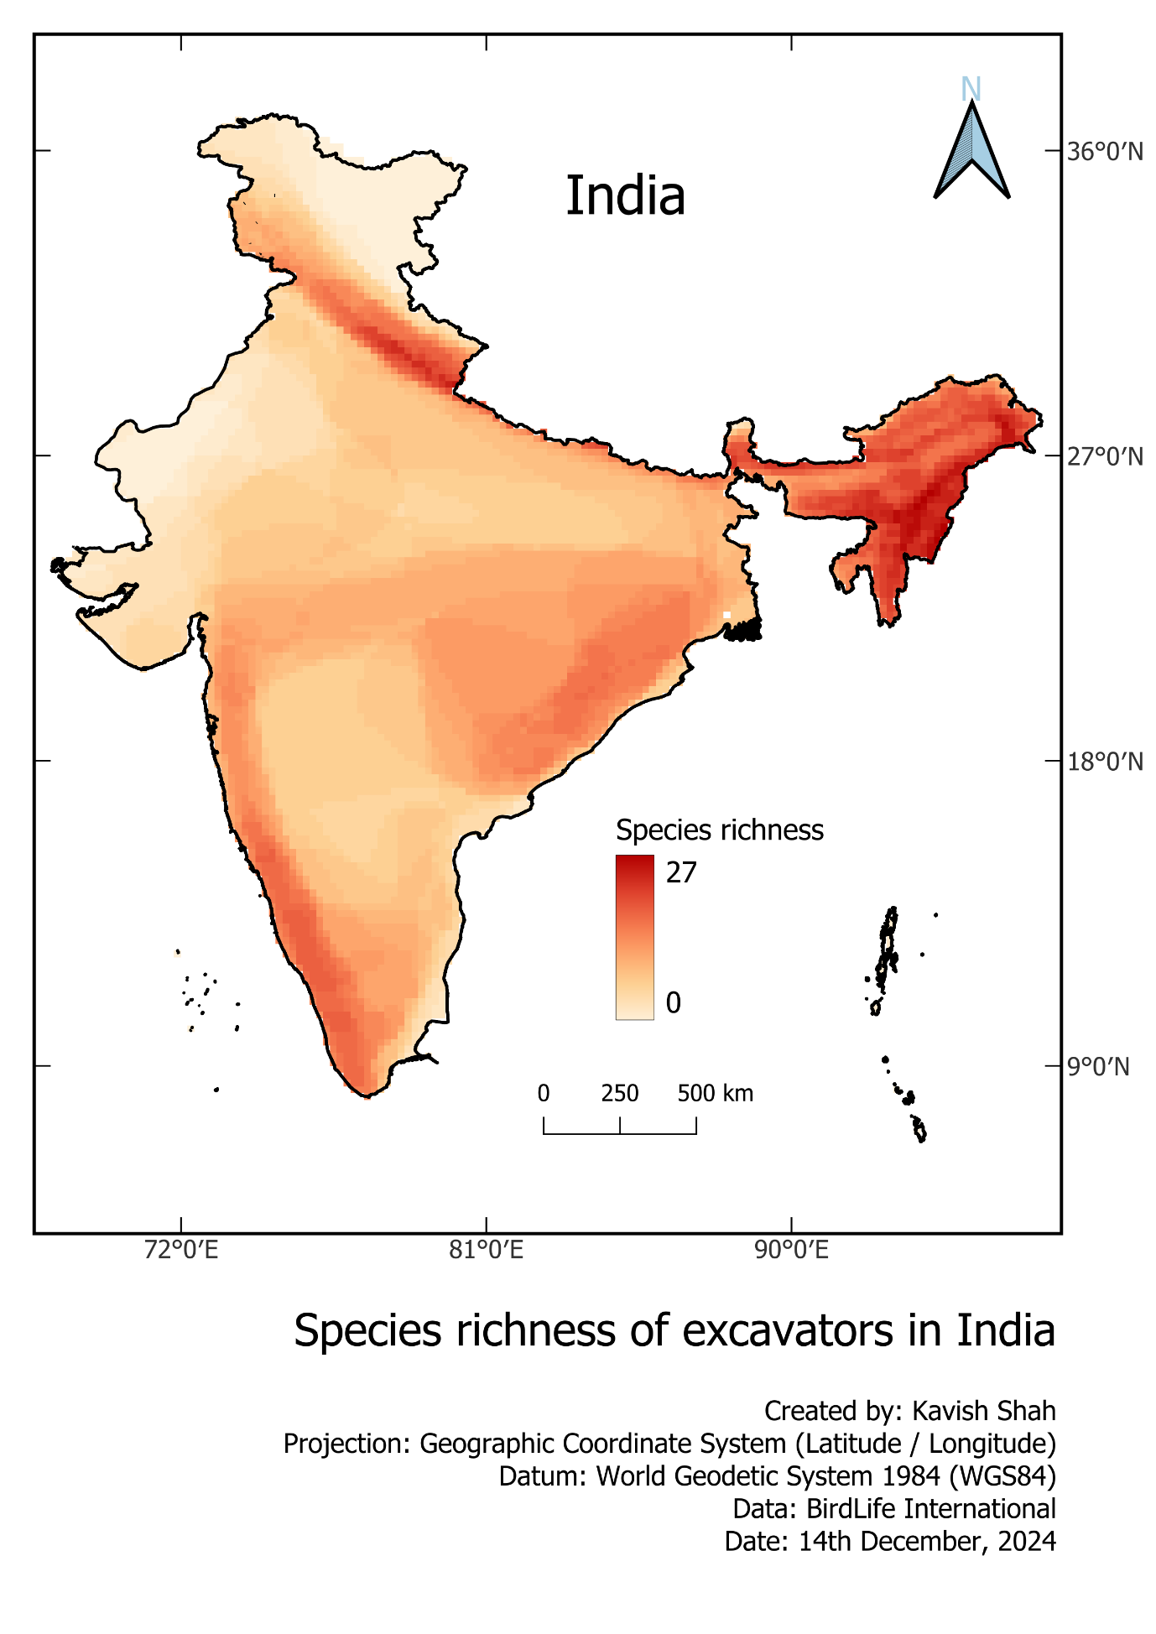

Figure . Heat map showing species richness of excavating birds across India.

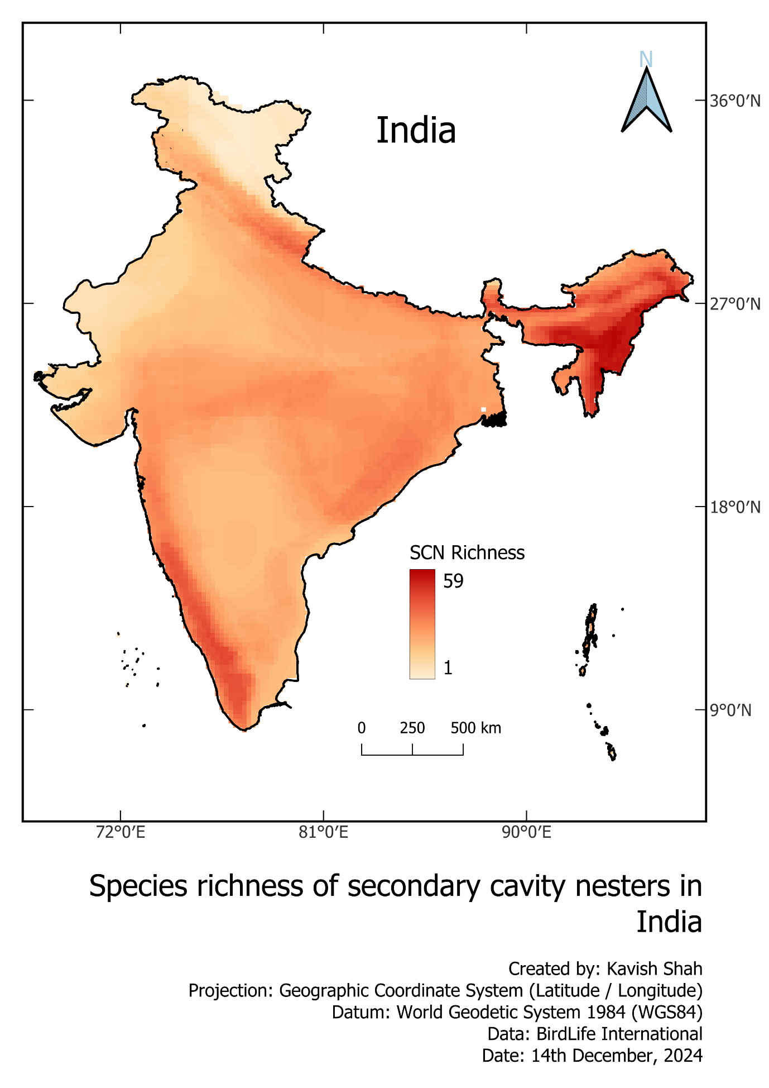

Figure . Heat map showing species richness of secondary cavity-nesting birds in India.

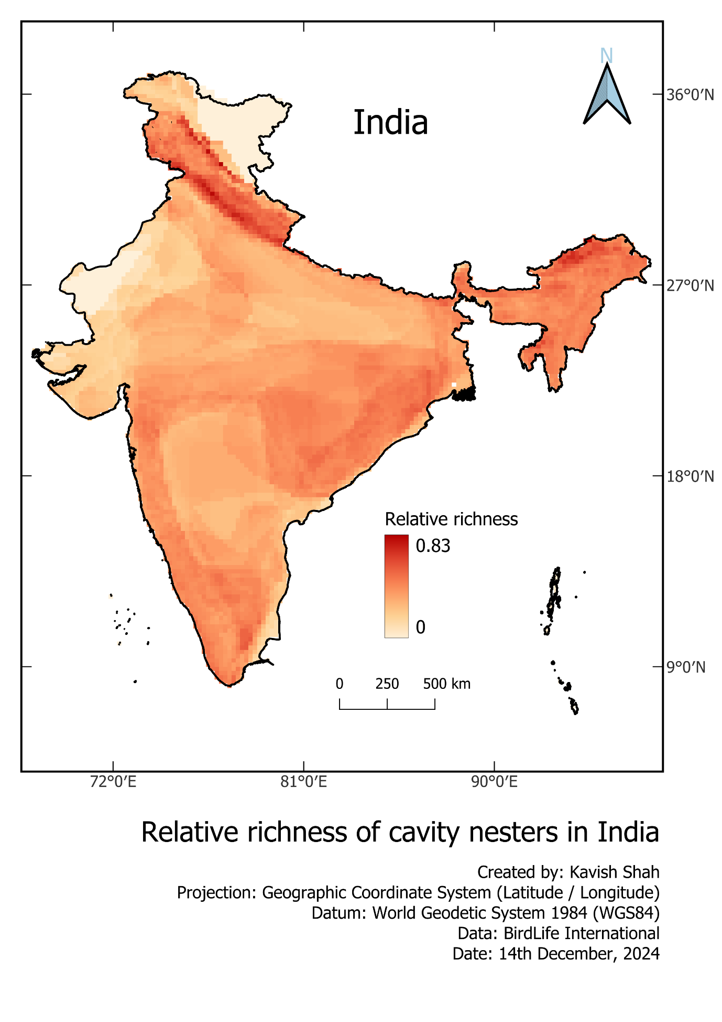

Figure . Heat map showing relative richness across India. Relative richness is calculated as the number of excavator species per secondary cavity nesting species in each grid cell.

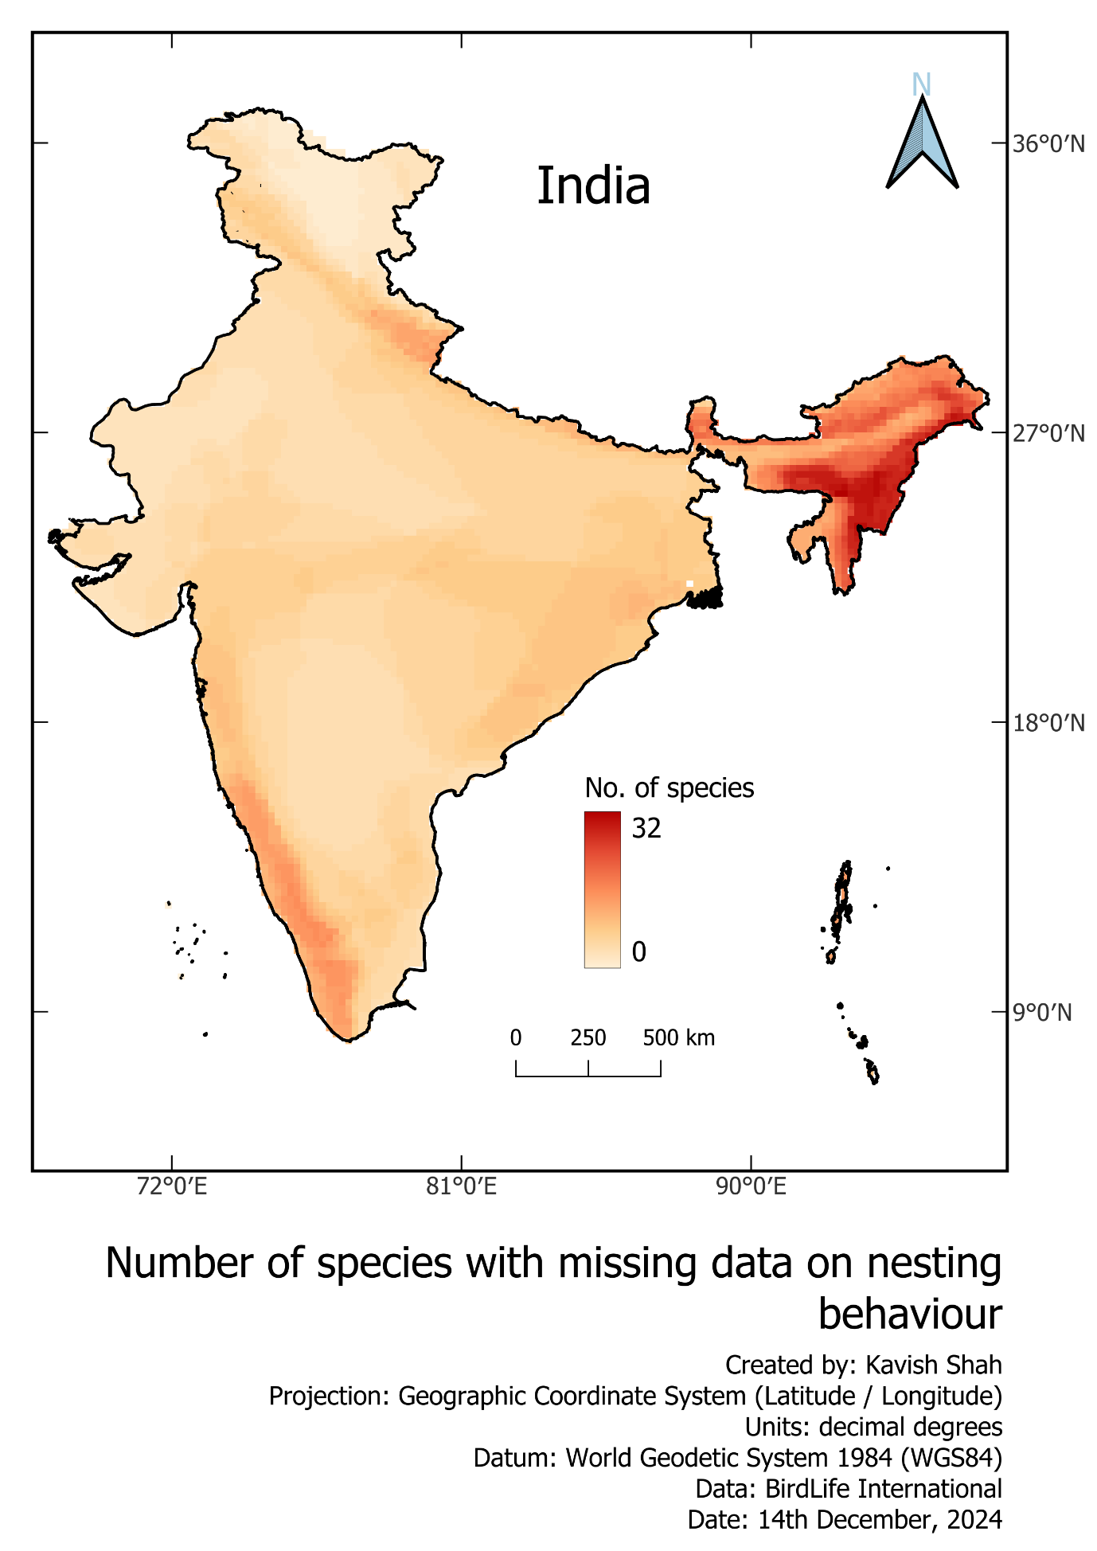

Figure . Heat map showing number of species that lack data on nesting behaviour (Obligate versus facultative cavity nester).

***References:***

BirdLife International and Handbook of the Birds of the World (2024) Bird species distribution maps of the world. Version 2024.2. Available at <http://datazone.birdlife.org/species/requestdis>.

Martin, K., & Eadie, J. M. (1999). Nest webs: A community-wide approach to the management and conservation of cavity-nesting forest birds. *Forest Ecology and Management*, *115*(2–3), 243–257. https://doi.org/10.1016/S0378-1127(98)00403-4

Newton, I. (1994). The role of nest sites in limiting the numbers of hole-nesting birds: A review. *Biological Conservation*, *70*(3), 265–276. https://doi.org/10.1016/0006-3207(94)90172-4

Patel, B., Sivaraman, S., & Balakrishanan, P. (2021). Use of tree cavities by Indian vertebrates: Status of research, knowledge gaps and future conservation perspectives. *Current Science*, *121*(4), 490. https://doi.org/10.18520/cs/v121/i4/490-501