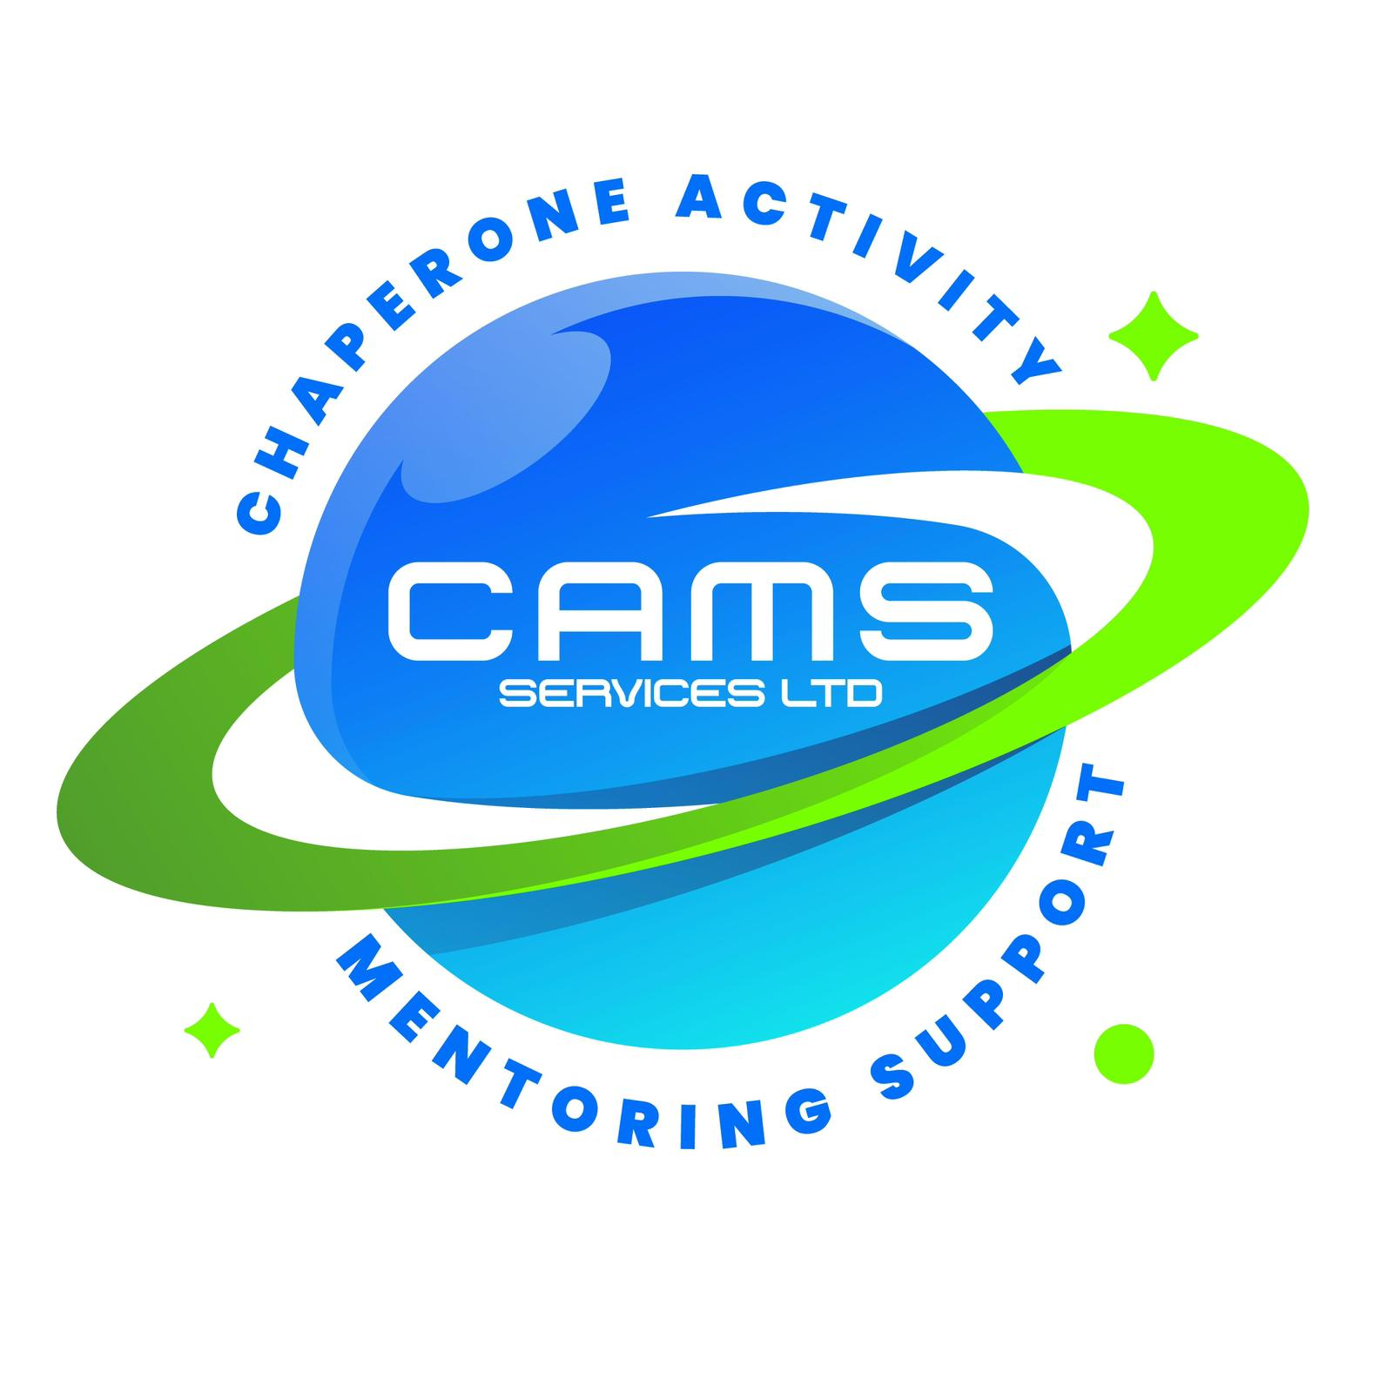
CAMS SERVICES LTD
admin@camsservices.co.uk
+44 7939 990587
www.camsservices.co.uk

INCIDENT REPORTING PROCEDURE
(Draft – Subject to HR/Legal Review)
Confidential – Internal Use Only

PURPOSE
CAMS Services is committed to maintaining a safe environment for children, young people, staff, mentors, contractors, volunteers, and visitors.
This procedure outlines the process for reporting, recording, reviewing, and responding to incidents, accidents, safeguarding concerns, near misses, and other events that may affect the safety, wellbeing, or operation of CAMS Services.

SCOPE
This procedure applies to:
- Mentors.
- Employees.
- Contractors.
- Volunteers.
- Any individual representing or working on behalf of CAMS Services.

INCIDENTS REQUIRING REPORTING
The following incidents should be reported as soon as possible:
- Safeguarding concerns.
- Accidents or injuries.
- Health and safety incidents.
- Near misses.
- Missing child or young person incidents.
- Aggressive, threatening, or abusive behaviour.
- Property damage.
- Transport-related incidents.
- Data breaches or confidentiality concerns.
- Any incident that may affect the welfare, safety, or wellbeing of a child, young person, or vulnerable individual.

IMMEDIATE ACTION
Where an incident occurs, the individual involved must:
- Prioritise the safety and welfare of all individuals involved.
- Seek medical assistance where required.
- Contact emergency services where necessary.
- Follow safeguarding procedures where applicable.
- Inform management as soon as reasonably practicable.

REPORTING PROCESS

Step 1 – Notify Management
The incident must be reported to management immediately or as soon as possible following the incident.

Step 2 – Complete Documentation
The appropriate documentation should be completed, including:
- Incident Report Form.
- Safeguarding Report Form (where applicable).
- Risk Assessment Review (where required).
Reports should be completed as soon as possible following the incident while details remain accurate.

Step 3 – Management Review
Management will:
- Review the incident.
- Assess any safeguarding implications.
- Determine whether further action is required.
- Implement appropriate support measures where necessary.

Step 4 – Follow-Up
Where appropriate, CAMS Services may:
- Conduct a safeguarding review.
- Update risk assessments.
- Arrange supervision or support meetings.
- Contact parents, carers, schools, local authorities, or other agencies.
- Implement corrective actions to reduce future risks.

RECORD KEEPING
Incident records will be:
- Maintained securely.
- Treated as confidential.
- Accessible only to authorised individuals.
- Retained in accordance with legal, safeguarding, and organisational requirements.

CONFIDENTIALITY
Information relating to incidents will be:
- Handled sensitively and professionally.
- Shared only on a need-to-know basis.
- Processed in accordance with UK GDPR and the Data Protection Act 2018.
Confidentiality may be overridden where safeguarding concerns require information sharing to protect a child, young person, or vulnerable individual.

RESPONSIBILITIES
All mentors, staff, and representatives are responsible for:
- Reporting incidents promptly.
- Providing accurate and factual information.
- Cooperating with investigations and reviews.
- Following safeguarding, health and safety, and organisational procedures.
Management is responsible for:
- Reviewing incidents.
- Ensuring appropriate action is taken.
- Maintaining records.
- Monitoring trends and recurring concerns.

REVIEW
This procedure will be reviewed periodically and updated where necessary to:
- Maintain safeguarding compliance.
- Support health and safety requirements.
- Promote best practice.
- Reflect operational and legislative changes.

APPROVAL
Approved By: ______________________________
Position: _________________________________
Signature: ________________________________
Date: ____________________________________

