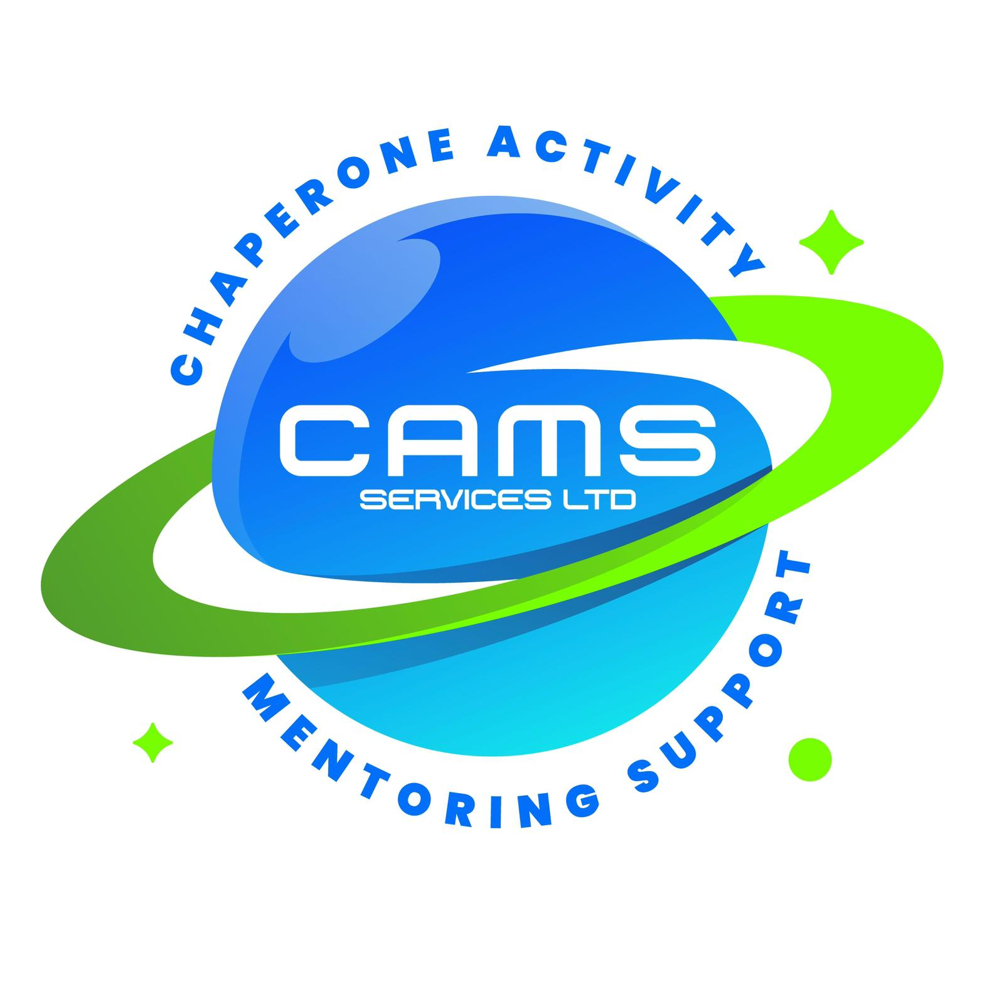
CAMS SERVICES LTD
admin@camsservices.co.uk
+44 7939 990587
www.camsservices.co.uk

Local Authority Data Sharing Agreement

PARTIES
This Agreement is made between:
CAMS Services
("The Provider")
and
Local Authority Name: __________________________
("The Authority")
Effective Date: __________________________

PURPOSE
The purpose of this Agreement is to establish the lawful sharing of information between CAMS Services and the Local Authority to support the delivery of mentoring and intervention services for children and young people.
Both parties agree to share information only where it is necessary, proportionate, lawful, and relevant to the provision of services and safeguarding responsibilities.

INFORMATION TO BE SHARED
Information shared under this Agreement may include:
- Personal details.
- Contact information.
- Educational information.
- Attendance records.
- Behavioural information.
- Special Educational Needs (SEN) and Education, Health and Care Plan (EHCP) information.
- Safeguarding information.
- Social care information.
- Progress reports.
- Outcome reports.
Only information that is necessary for service delivery, safeguarding, and statutory responsibilities will be shared.

LEGAL BASIS
Information sharing will be conducted in accordance with:
- UK General Data Protection Regulation (UK GDPR).
- Data Protection Act 2018.
- Children Act 1989.
- Children Act 2004.
- Working Together to Safeguard Children (current version).
- Relevant safeguarding legislation and statutory guidance.

RESPONSIBILITIES OF CAMS SERVICES
CAMS Services agrees to:
- Store information securely.
- Restrict access to authorised personnel only.
- Use information solely for agreed and lawful purposes.
- Report actual or suspected data breaches promptly.
- Maintain confidentiality and data security.
- Comply with all applicable data protection legislation.

RESPONSIBILITIES OF THE LOCAL AUTHORITY
The Authority agrees to:
- Share accurate, relevant, and up-to-date information.
- Ensure information sharing is lawful and proportionate.
- Notify CAMS Services of significant updates that may affect service delivery or safeguarding.
- Report actual or suspected data breaches promptly.
- Comply with applicable data protection legislation.

CONFIDENTIALITY
All information shared under this Agreement shall be treated as confidential unless disclosure is:
- Required by law.
- Necessary for safeguarding purposes.
- Required by a court order.
- Permitted under relevant legislation or statutory guidance.
Both parties agree to maintain appropriate confidentiality procedures at all times.

INFORMATION SECURITY
Both parties agree to:
- Use secure methods of communication and data transmission.
- Protect information from unauthorised access, disclosure, loss, or misuse.
- Maintain appropriate technical and organisational security measures.
- Comply with their respective internal data protection and information security policies.

RETENTION AND DISPOSAL
Records will be retained only for as long as necessary to meet:
- Legal requirements.
- Contractual obligations.
- Safeguarding responsibilities.
- Operational and regulatory requirements.
When records are no longer required, they will be securely destroyed or disposed of in accordance with organisational retention policies and data protection legislation.

REVIEW
This Agreement will be reviewed periodically and updated as required to reflect changes in:
- Legislation.
- Safeguarding guidance.
- Operational requirements.
- Best practice.

SIGNATURES

For CAMS Services
Name: ______________________________
Position: ___________________________
Signature: __________________________
Date: _______________________________

For the Local Authority
Authority Name: ______________________________
Name: ______________________________________
Position: ___________________________________
Signature: __________________________________
Date: ______________________________________

