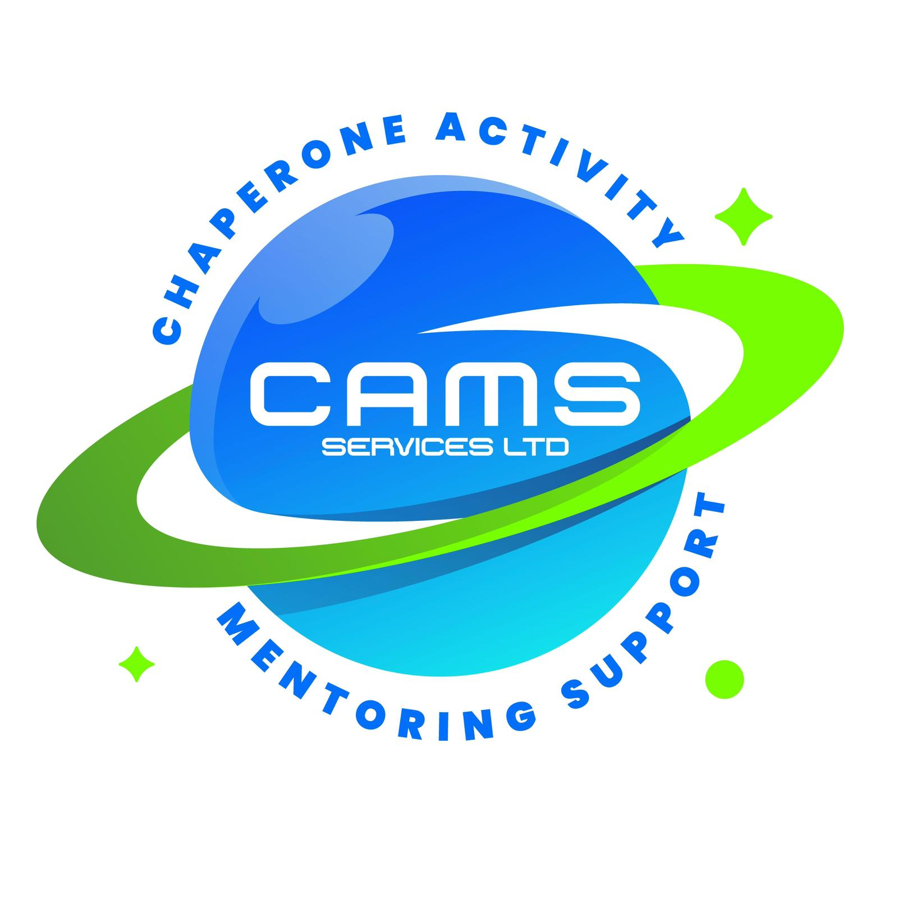
CAMS SERVICES LTD
admin@camsservices.co.uk
+44 7939 990587
www.camsservices.co.uk

MENTOR SUPERVISION RECORD
Confidential – Internal Use Only

SUPERVISION DETAILS
Mentor Name: _______________________________________
Supervisor Name: ____________________________________
Position: ___________________________________________
Date of Supervision: ________________________________
Location / Method
☐ Face-to-Face
☐ Telephone
☐ Video Call
☐ Other: ___________________________
Type of Supervision
☐ Scheduled Supervision
☐ Follow-Up Supervision
☐ Safeguarding Review
☐ Performance Support
☐ Probation Review (where applicable)
☐ Other: ___________________________
CASELOAD AND WORK UPDATE
Please provide a summary of the mentor's current caseload, recent activities, achievements, workload, and any significant developments since the previous supervision session.
SAFEGUARDING DISCUSSION
Were any safeguarding concerns discussed?
☐ No Concerns Raised
☐ Concern Raised
If yes, please provide details:

Important: Any safeguarding concerns identified during supervision must be managed in accordance with the CAMS Services Safeguarding Policy and Child Protection Policy. An Incident / Safeguarding Report Form should be completed where required.
PERFORMANCE AND PROFESSIONAL PRACTICE
Please discuss the following areas where applicable:
☐ Communication
☐ Professional Conduct
☐ Reliability and Attendance
☐ Record Keeping
☐ Safeguarding Compliance
☐ Session Delivery
☐ Professional Boundaries
☐ Time Management
☐ Quality of Reports
☐ Relationship Building
☐ Other: ___________________________
Comments
WELLBEING AND SUPPORT
Has the mentor discussed any wellbeing concerns or support needs?
☐ No
☐ Yes
If yes, please provide details:
TRAINING AND PROFESSIONAL DEVELOPMENT
Training completed since the previous supervision:

Additional training or development required:
ACTIONS AGREED
Please record any agreed actions, responsibilities, and target completion dates.
Action | Responsible Person | Target Date
REVIEW DATE
Next Supervision Date: ______________________________

MENTOR COMMENTS
Please record any additional comments, feedback, or matters the mentor wishes to raise.
SUPERVISION OUTCOME
☐ Satisfactory
☐ Development Required
☐ Additional Support Required
☐ Follow-Up Supervision Required
☐ Performance Review Required
☐ Safeguarding Follow-Up Required

DECLARATION
We confirm that this supervision meeting has taken place and that the information recorded is an accurate reflection of the discussion.

Mentor
Name: ___________________________________________
Signature: _______________________________________
Date: ____________________________________________

Supervisor
Name: ___________________________________________
Position: ________________________________________
Signature: _______________________________________
Date: ____________________________________________

