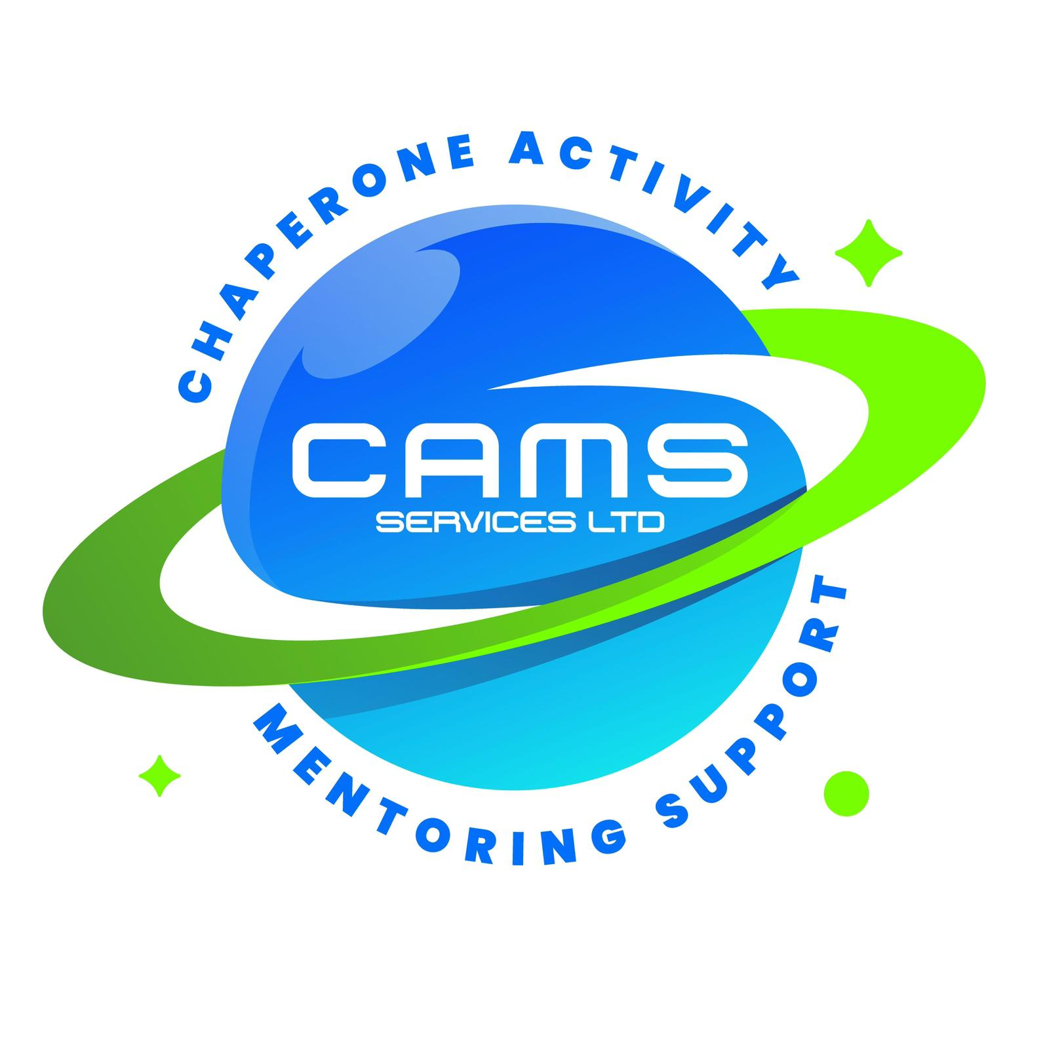
CAMS SERVICES LTD
admin@camsservices.co.uk
+44 7939 990587
www.camsservices.co.uk

PERFORMANCE REVIEW TEMPLATE
(Draft – Subject to HR/Legal Review)
Confidential – Internal Use Only

REVIEW DETAILS
Staff / Mentor Name: _______________________________________
Role: _________________________________________________
Reviewer: ______________________________________________
Review Date: ___________________________________________
Review Period: _________________________________________
Type of Review
☐ Probation Review (where applicable)
☐ Annual Review
☐ Mid-Year Review
☐ Follow-Up Review
☐ Performance Improvement Review
☐ Other: ___________________________
ROLE SUMMARY
Please summarise the individual's key responsibilities during the review period.

PERFORMANCE SUMMARY
Please provide an overall summary of performance, including achievements, contributions, strengths, and any notable developments during the review period.

PERFORMANCE ASSESSMENT
Please assess performance in the following areas.
Performance Area | Excellent | Good | Satisfactory | Improvement Required
Attendance and Reliability | ☐ | ☐ | ☐ | ☐
Professional Conduct | ☐ | ☐ | ☐ | ☐
Communication Skills | ☐ | ☐ | ☐ | ☐
Safeguarding Compliance | ☐ | ☐ | ☐ | ☐
Record Keeping and Administration | ☐ | ☐ | ☐ | ☐
Session Delivery and Engagement | ☐ | ☐ | ☐ | ☐
Professional Boundaries | ☐ | ☐ | ☐ | ☐
Teamwork and Collaboration | ☐ | ☐ | ☐ | ☐
Quality of Work | ☐ | ☐ | ☐ | ☐
Time Management | ☐ | ☐ | ☐ | ☐
ACHIEVEMENTS
Please record any significant achievements, positive outcomes, contributions, or examples of good practice demonstrated during the review period.

DEVELOPMENT AREAS
Please identify any areas requiring additional support, coaching, development, or improvement.

TRAINING AND PROFESSIONAL DEVELOPMENT

Training completed during this review period

Recommended training or development

OBJECTIVES AND ACTION PLAN
Please record the objectives agreed for the next review period.
Objective | Action Required | Target Date
OVERALL REVIEW OUTCOME
☐ Exceeds Expectations
☐ Meets Expectations
☐ Satisfactory
☐ Improvement Required
☐ Performance Improvement Plan Required

STAFF / MENTOR COMMENTS

REVIEWER COMMENTS
NEXT REVIEW DATE
Date: ____________________________________________

DECLARATION
We confirm that this performance review has been discussed and accurately reflects the review meeting.

Staff / Mentor
Name: ___________________________________________
Signature: _______________________________________
Date: ____________________________________________

Reviewer
Name: ___________________________________________
Position: ________________________________________
Signature: _______________________________________
Date: ____________________________________________

