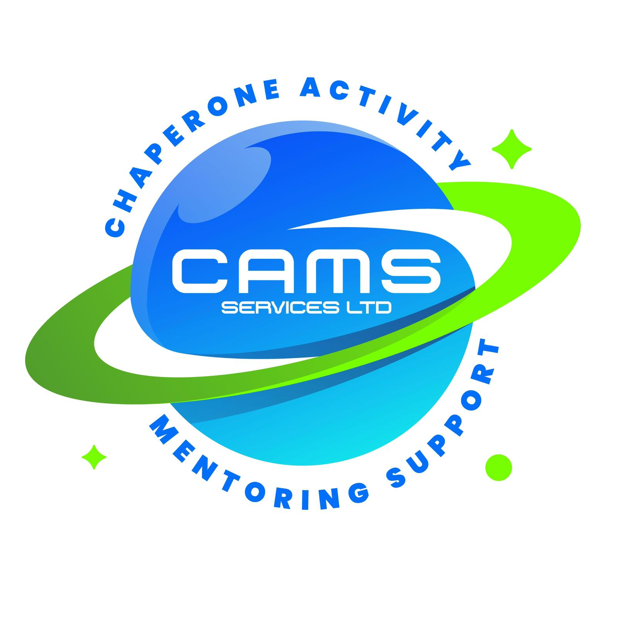
CAMS SERVICES LTD
admin@camsservices.co.uk
+44 7939 990587
www.camsservices.co.uk

Policy Version: 2.0
Review Date: Annually
Approved By: Director

QUALITY ASSURANCE & CONTINUOUS IMPROVEMENT

PROCEDURE
Confidential – Internal Use Only

Purpose
CAMS Services Ltd is committed to delivering safe, effective, person-centred, and high-quality services.
This procedure outlines how the organisation monitors, reviews, and improves service quality, safeguarding practice, operational effectiveness, and service user outcomes.
Quality assurance helps ensure that services remain safe, responsive, compliant, and focused on achieving positive outcomes for children, young people, adults, families, schools, and partner organisations.
Scope
This procedure applies to:
- Directors and Management
- Designated Safeguarding Lead (DSL)
- Employees
- Mentors
- Support Workers
- Contractors
- Volunteers
- Chaperones
- Partner Organisations where applicable
- All CAMS Services activities and services
Objectives
The objectives of this procedure are to:
- Maintain high standards of service delivery.
- Monitor safeguarding effectiveness.
- Evaluate service outcomes.
- Promote continuous improvement.
- Identify strengths and areas for development.
- Support compliance with legislation and organisational policies.
- Improve service user experiences.
- Support workforce development.
Quality Assurance Principles
CAMS Services Ltd will:
- Place service users at the centre of service delivery.
- Promote a culture of learning and improvement.
- Monitor services regularly.
- Seek feedback from stakeholders.
- Learn from incidents, complaints, and safeguarding concerns.
- Use evidence to inform decision-making.
- Implement improvements where required.
- Monitor the effectiveness of changes made.
Quality Assurance Activities
Quality assurance activities may include:

Service User Feedback
- Children and young people
- Adults receiving support
- Parents and carers
- Schools and professionals

Operational Monitoring
- Attendance monitoring
- Session delivery reviews
- Record keeping audits
- Compliance checks
- Referral management

Safeguarding Monitoring
- Safeguarding concerns
- Safeguarding referrals
- DSL oversight
- Safeguarding audits
- Safeguarding training compliance

Workforce Monitoring
- Supervision records
- Training compliance
- DBS compliance
- Professional development
- Staff wellbeing

Service Review Activities
- Incident reviews
- Complaints analysis
- Compliments and positive feedback
- Risk assessment reviews
- Policy and procedure reviews
Feedback and Consultation
CAMS Services Ltd will seek feedback from:
- Children and young people
- Adults receiving support
- Parents and carers
- Schools
- Local Authorities
- Commissioners
- Partner organisations
- Staff and contractors
Feedback may be collected through:
- Surveys
- Feedback forms
- Review meetings
- Complaints and compliments
- Quality assurance reviews
Feedback findings will contribute to service improvement planning.

Learning from Incidents and Concerns
Quality assurance activities will consider:
- Safeguarding concerns
- Incident reports
- Complaints
- Near misses
- Professional conduct concerns
- Service delivery issues
Learning identified through reviews will be used to improve practice, policies, procedures, and staff development.
Continuous Improvement Planning
Where improvements are identified, CAMS Services Ltd may:
- Develop action plans
- Review policies and procedures
- Provide additional training
- Implement service improvements
- Improve communication systems
- Strengthen safeguarding arrangements
- Introduce new quality measures
Improvement actions should include:
- Clear objectives
- Named responsibilities
- Timescales
- Progress monitoring
Governance and Oversight
The Director is responsible for overseeing quality assurance arrangements and ensuring that improvement actions are implemented where required.
Quality assurance information may be reviewed through:
- Management meetings
- Service reviews
- Safeguarding reviews
- Audit findings
- Feedback reports
- Improvement action plans

Responsibilities

Director / Management
Responsible for:
- Leading quality assurance activities.
- Monitoring service performance.
- Reviewing safeguarding effectiveness.
- Approving improvement actions.
- Monitoring implementation of improvements.

Staff and Representatives
Responsible for:
- Participating in quality assurance activities.
- Maintaining accurate records.
- Providing feedback.
- Supporting service improvements.
- Reporting concerns appropriately.
Record Keeping
Quality assurance records may include:
- Audit reports
- Feedback reports
- Improvement plans
- Training records
- Supervision records
- Incident reports
- Complaints records
- Safeguarding reviews
Records will be stored securely and maintained in accordance with organisational procedures and data protection requirements.
Monitoring and Review
The Director will periodically review:
- Service quality
- Safeguarding performance
- Feedback trends
- Workforce development
- Improvement actions
- Service outcomes
This procedure will be reviewed annually or sooner where:
- Legislation changes
- Safeguarding reviews identify learning
- Organisational changes occur
- Significant incidents occur
- Service reviews identify improvements

Procedure Commitment
CAMS Services Ltd is committed to maintaining a culture of accountability, learning, safeguarding, and continuous improvement to ensure safe, effective, and high-quality services for all service users.

Approval
Approved By: ______________________________
Position: _________________________________
Signature: ________________________________
Date: ____________________________________

