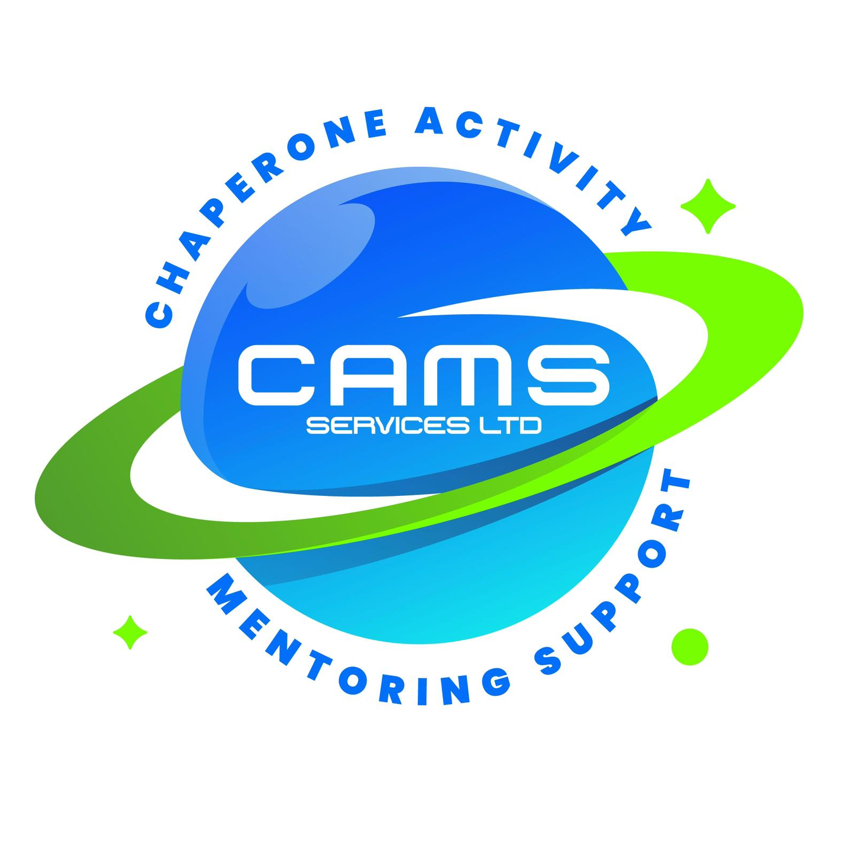
CAMS SERVICES LTD
admin@camsservices.co.uk
+44 7939 990587
www.camsservices.co.uk

Policy Version: 1.0
Review Date: Annually
Approved By: Director

SAFEGUARDING LEAD ROLE DESCRIPTION
(Draft – Subject to HR/Legal Review)
Confidential – Internal Use Only

ROLE TITLE
Designated Safeguarding Lead (DSL)

REPORTS TO
Director, CAMS Services Ltd

PURPOSE OF THE ROLE
The Designated Safeguarding Lead (DSL) is responsible for leading safeguarding arrangements across CAMS Services Ltd and ensuring that children, young people, vulnerable adults, staff, contractors, and volunteers are protected from harm.
The DSL acts as the organisation's lead safeguarding professional and provides advice, guidance, oversight, and support regarding safeguarding concerns, child protection matters, information sharing, and safer working practices.
The welfare of children and young people remains the primary consideration at all times.

KEY RESPONSIBILITIES
The Designated Safeguarding Lead will:
• Lead safeguarding and child protection arrangements across CAMS Services Ltd.
• Promote a safeguarding culture throughout the organisation.
• Ensure safeguarding concerns are managed appropriately.
• Receive, review, and respond to safeguarding reports.
• Maintain oversight of safeguarding records.
• Provide safeguarding advice to staff and representatives.
• Support safer recruitment arrangements.
• Monitor safeguarding compliance.
• Support quality assurance activities relating to safeguarding.
• Liaise with external safeguarding agencies where required.
• Ensure safeguarding procedures remain effective and up to date.
SAFEGUARDING CASE MANAGEMENT
The DSL is responsible for:
• Receiving safeguarding concerns.
• Reviewing safeguarding reports.
• Assessing levels of risk.
• Determining appropriate safeguarding actions.
• Making referrals where required.
• Maintaining safeguarding records.
• Monitoring safeguarding outcomes.
• Ensuring concerns are escalated appropriately.
• Supporting staff involved in safeguarding matters.

EXTERNAL AGENCY LIAISON
The DSL may liaise with:
• Children's Social Care.
• Local Authority Safeguarding Teams.
• Police.
• Local Authority Designated Officer (LADO).
• Schools and Educational Settings.
• Health Professionals.
• Early Help Services.
• Other Relevant Agencies.
The DSL will ensure that information sharing is lawful, proportionate, and in accordance with safeguarding procedures.
POLICY AND PROCEDURE OVERSIGHT
The DSL may support the review and development of:
• Safeguarding and Child Protection Policy.
• Low-Level Concerns Procedure.
• Allegations Against Staff Procedure.
• Information Sharing Policy.
• Safer Recruitment Policy.
• DBS Checking and Management Procedure.
• Online Safety Procedures.
• Risk Assessment Procedures.
• Staff Code of Conduct.
• Other safeguarding-related documents.

TRAINING AND WORKFORCE DEVELOPMENT
The DSL will:
• Maintain appropriate safeguarding training.
• Undertake DSL-level safeguarding training.
• Participate in safeguarding updates and refresher training.
• Support safeguarding induction arrangements.
• Contribute to workforce safeguarding awareness.
• Promote safeguarding learning and best practice.
• Maintain records of safeguarding training where required.
QUALITY ASSURANCE RESPONSIBILITIES
The DSL may contribute to:
• Safeguarding Audits.
• Case File Reviews.
• Compliance Monitoring.
• Incident Reviews.
• Learning Reviews.
• Service Evaluations.
• Self-Assessment Reports (SAR).
• Quality Improvement Plans (QIP).
• Safeguarding Improvement Actions.
The DSL may identify strengths, risks, trends, and areas requiring development.
RECORD KEEPING
The DSL will support:
• Accurate safeguarding records.
• Secure storage of safeguarding information.
• GDPR-compliant information handling.
• Appropriate information sharing.
• Retention and disposal arrangements.
• Safeguarding reporting systems.
All safeguarding information must be handled confidentially and securely.
SAFER RECRUITMENT AND DBS OVERSIGHT
The DSL may support:
• DBS compliance monitoring.
• Risk assessments relating to disclosures.
• Safeguarding suitability reviews.
• Safer recruitment processes.
• Workforce safeguarding compliance.
PROFESSIONAL STANDARDS
The DSL is expected to:
• Act professionally and ethically.
• Maintain confidentiality.
• Demonstrate sound judgement.
• Promote safeguarding best practice.
• Maintain professional boundaries.
• Challenge unsafe practices where necessary.
• Act in the best interests of children and young people.
PERSON SPECIFICATION
The Designated Safeguarding Lead should demonstrate:

Essential
• Experience working with children, young people, or vulnerable adults.
• Strong safeguarding knowledge.
• Understanding of child protection processes.
• Excellent communication skills.
• Ability to manage confidential information.
• Ability to assess risk and make informed decisions.
• Commitment to safeguarding and welfare.

Desirable
• DSL Training.
• Safeguarding Leadership Experience.
• Multi-Agency Working Experience.
• Knowledge of SEND, SEMH, or Alternative Provision Settings.
• Quality Assurance or Compliance Experience.
TRAINING REQUIREMENTS
The DSL should complete and maintain:
• DSL Safeguarding Training.
• Child Protection Training.
• Prevent Awareness Training.
• Safer Recruitment Training (where applicable).
• GDPR and Information Sharing Training.
• Mental Health Awareness Training.
• Relevant Refresher Training.

ROLE COMMITMENT
CAMS Services Ltd is committed to ensuring that the Designated Safeguarding Lead is appropriately trained, supported, and empowered to fulfil safeguarding responsibilities and promote the safety, welfare, and wellbeing of children and young people.

