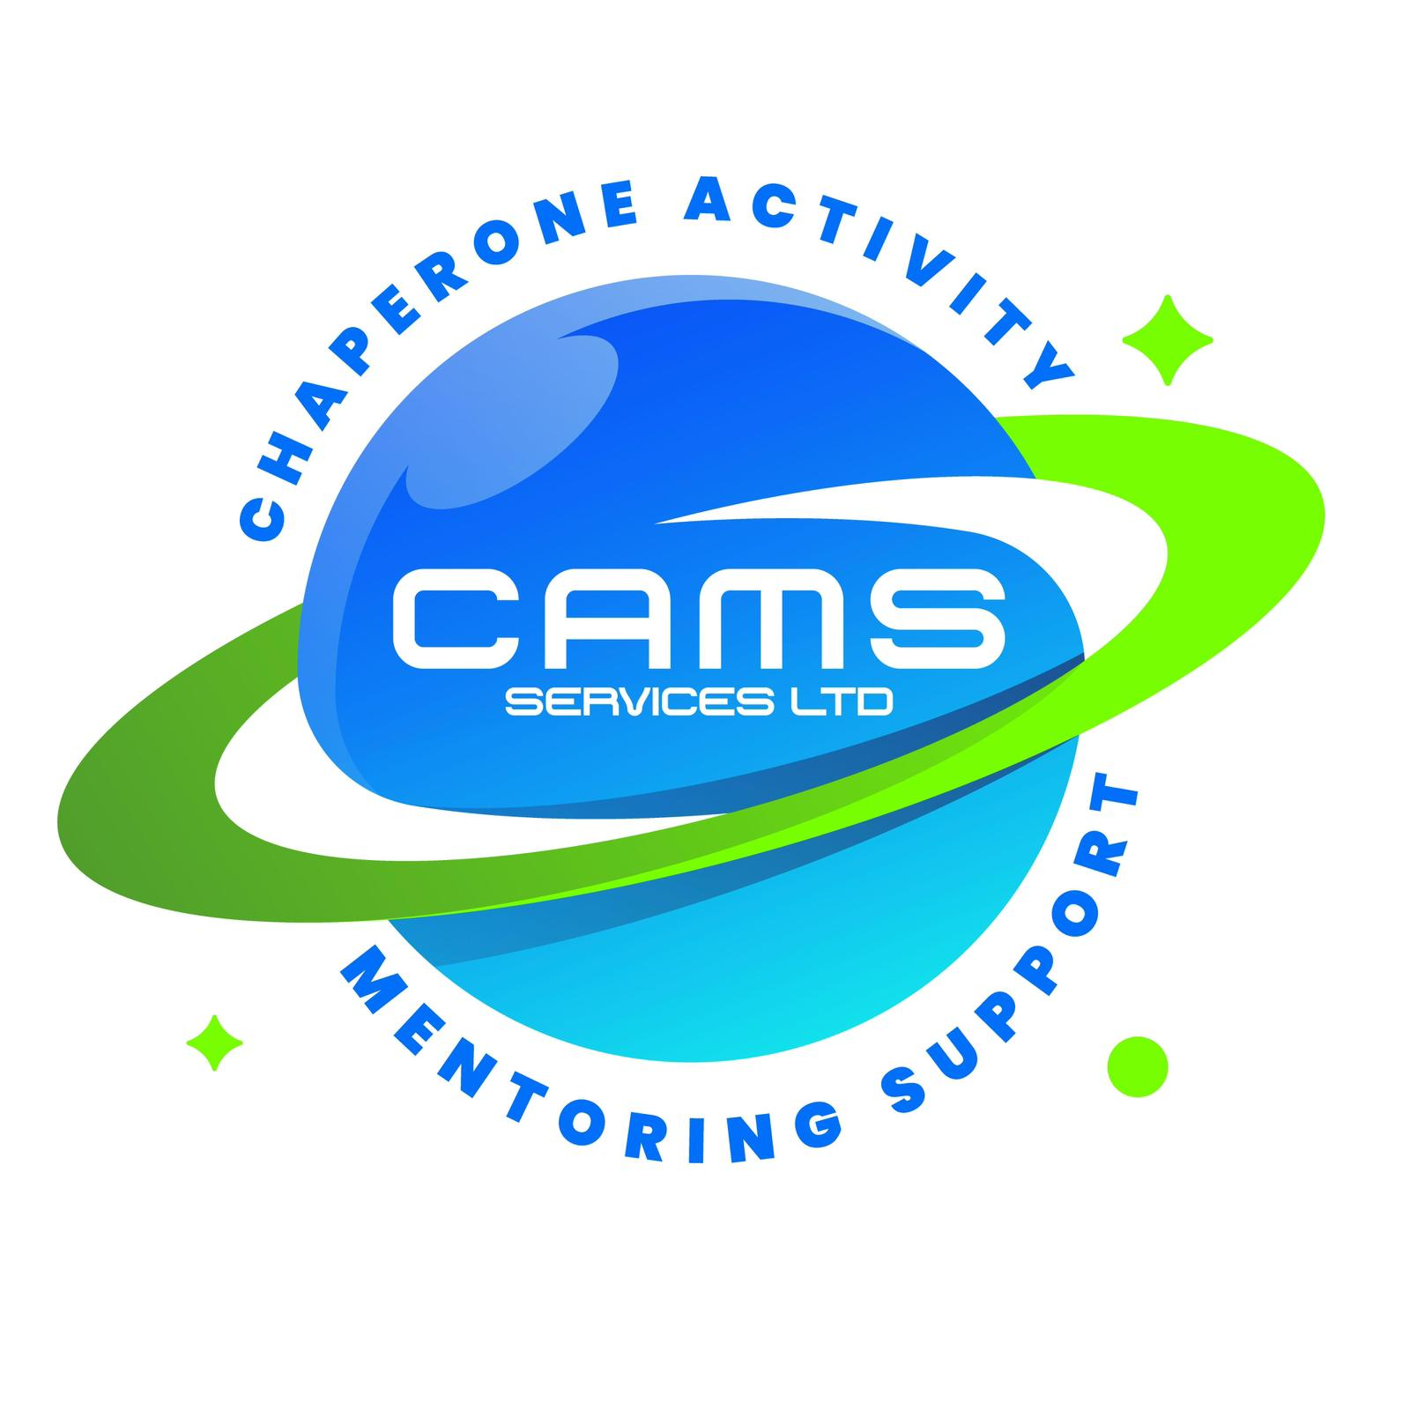
CAMS SERVICES LTD
admin@camsservices.co.uk
+44 7939 990587
www.camsservices.co.uk

School Partnership Agreement
Confidential – Internal Use Only

PARTIES
This Partnership Agreement is made between:
CAMS Services Ltd
("the Provider")
and
School Name: ______________________________
("the School")
Effective Date: ______________________________
PURPOSE
The purpose of this Partnership Agreement is to establish a collaborative working relationship between CAMS Services Ltd and the School to support children and young people through mentoring, intervention, wellbeing, and support services.
This Agreement provides a framework for partnership working and does not replace any contractual, commissioning, funding, or service-level agreement that may exist between the parties.
SHARED COMMITMENT
Both parties agree to:
- Promote the welfare, safety, and wellbeing of children and young people.
- Work collaboratively to achieve positive outcomes.
- Maintain open, honest, and professional communication.
- Share relevant information lawfully, proportionately, and appropriately.
- Respect confidentiality and data protection requirements.
- Promote inclusive, child-centred, and safeguarding-led practice.
- Support continuous improvement through effective partnership working.
CAMS SERVICES LTD COMMITMENTS
CAMS Services Ltd will:
- Deliver mentoring, intervention, and support services professionally, safely, and effectively.
- Maintain robust safeguarding, child protection, and quality assurance procedures.
- Ensure mentors and representatives are appropriately recruited, trained, supervised, and DBS checked where required.
- Provide agreed attendance records, progress reports, and outcome information.
- Participate in review meetings and multi-agency discussions where appropriate.
- Notify the School promptly of safeguarding concerns, incidents, or significant issues affecting service delivery.
- Work collaboratively with school staff to support positive outcomes for pupils.
SCHOOL COMMITMENTS
The School will:
- Provide accurate referral information and relevant supporting documentation.
- Share safeguarding, welfare, behavioural, medical, and risk information where appropriate.
- Identify a designated contact for communication and coordination.
- Inform CAMS Services Ltd of significant changes affecting referred pupils.
- Support agreed interventions and individual support plans.
- Participate in review meetings where appropriate.
- Promote effective communication between relevant school staff and CAMS Services Ltd.
COMMUNICATION
Both parties agree to maintain effective communication regarding:
- Referrals
- Attendance and engagement
- Progress updates
- Review meetings
- Outcome monitoring
- Safeguarding concerns
- Service development opportunities
- Operational matters affecting service delivery
Communication may take place through:
- Email
- Telephone
- Face-to-face meetings
- Virtual meetings
- Secure information-sharing systems
Both parties will endeavour to respond to communications within reasonable timescales.
SAFEGUARDING
Both parties acknowledge their shared responsibility to safeguard and promote the welfare of children and young people.
Safeguarding concerns identified by either party will be reported promptly through agreed safeguarding procedures and statutory reporting processes where required.
The welfare of the child or young person shall remain the primary consideration in all partnership activities.
CONFIDENTIALITY AND DATA PROTECTION
Both parties agree to:
- Handle personal information lawfully, fairly, and securely.
- Share information only where necessary, proportionate, and lawful.
- Comply with the UK General Data Protection Regulation (UK GDPR) and the Data Protection Act 2018.
- Restrict access to confidential information to authorised personnel only.
- Maintain appropriate technical and organisational security measures.
Where appropriate, information sharing will be supported by a separate Data Sharing Agreement or Information Sharing Agreement.
REVIEW OF THE PARTNERSHIP
This Partnership Agreement will be reviewed periodically, or sooner where necessary, to reflect:
- Changes in legislation
- Safeguarding guidance
- Operational requirements
- Service developments
- Best practice
Areas considered during review may include:
- Partnership effectiveness
- Communication arrangements
- Referral processes
- Safeguarding practice
- Outcomes achieved
- Opportunities for continuous improvement
AGREEMENT

For CAMS Services Ltd
Name: ______________________________
Position: ___________________________
Signature: __________________________
Date: ______________________________

For the School
School Name: _______________________
Name: ______________________________
Position: ___________________________
Signature: __________________________
Date: ______________________________

