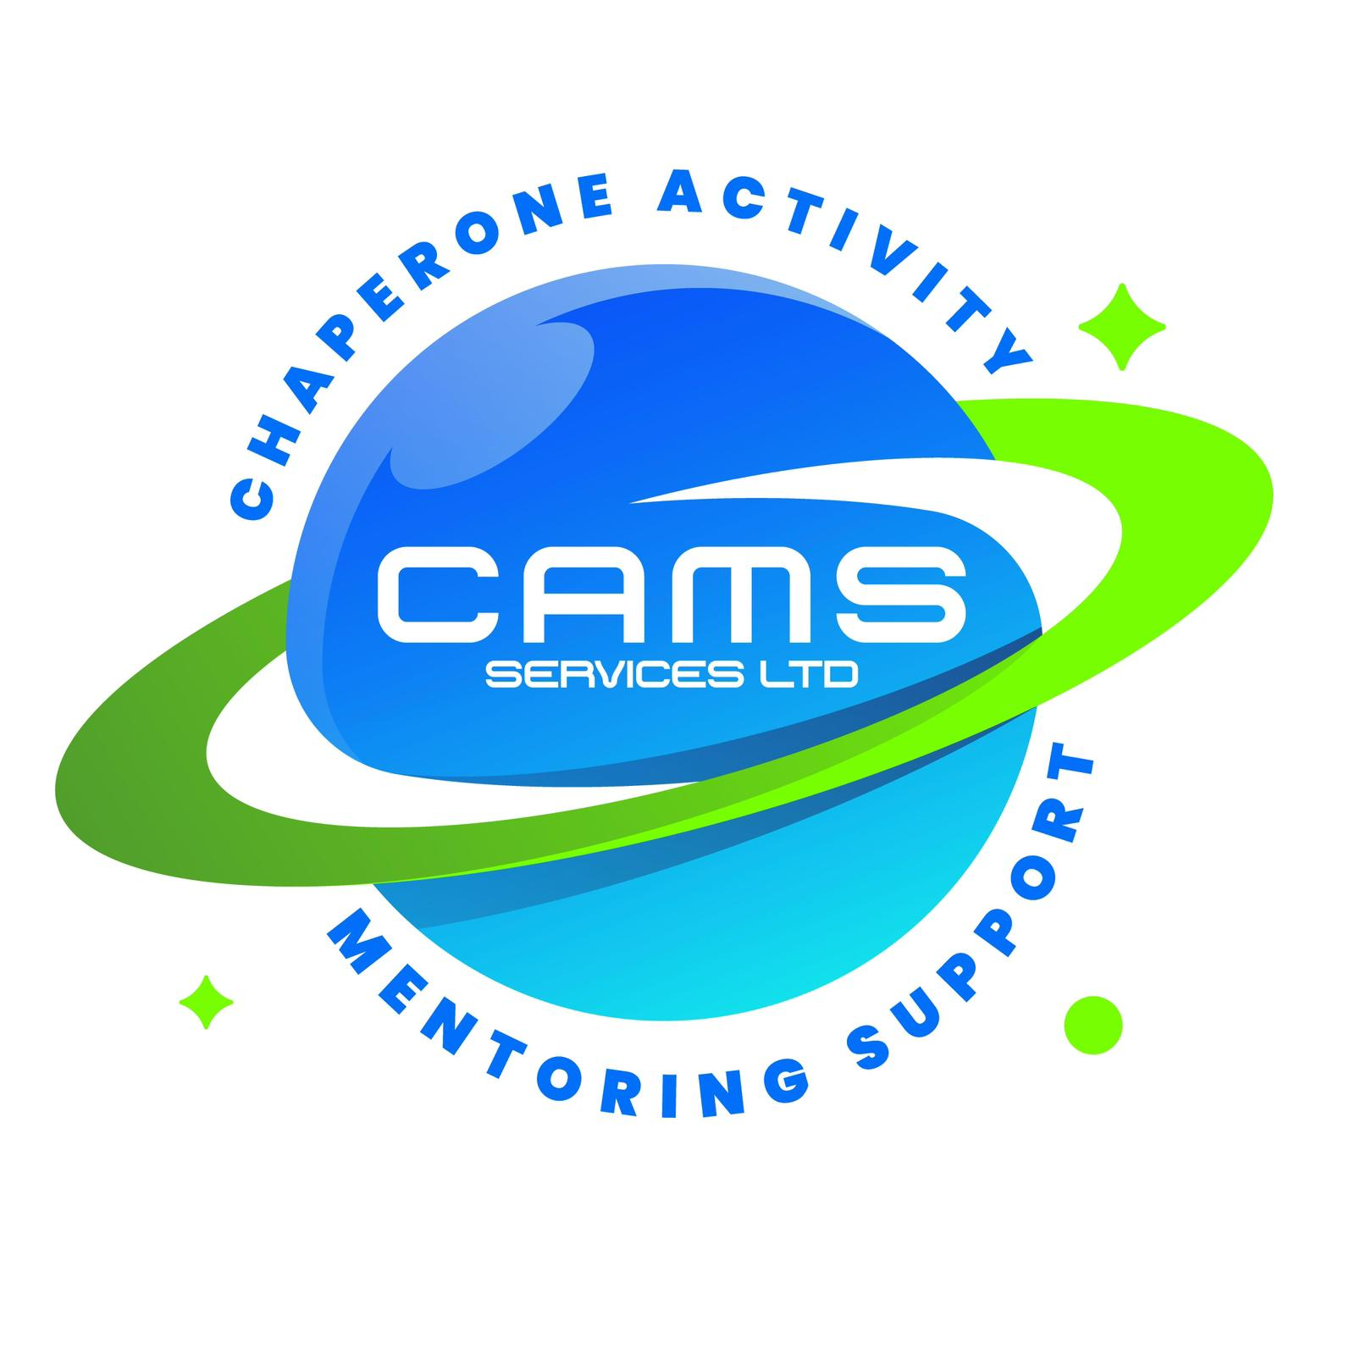
CAMS SERVICES LTD
admin@camsservices.co.uk
+44 7939 990587
www.camsservices.co.uk

School Service Agreement

Confidential – Internal Use Only

PARTIES
This Agreement is made between:
CAMS Services Ltd
("the Provider")
and
School Name: ______________________________
("the School")
Effective Date: ______________________________
PURPOSE
The purpose of this Agreement is to establish the arrangements under which CAMS Services Ltd will provide mentoring, intervention, wellbeing, and support services to pupils referred by the School.
This Agreement sets out the responsibilities of both parties and supports the delivery of safe, effective, child-centred, and safeguarding-led services.
SERVICES
Subject to individual referrals and agreed service arrangements, CAMS Services Ltd may provide:
- One-to-one mentoring
- Behaviour and emotional wellbeing support
- Special Educational Needs and Disabilities (SEND) support
- Attendance and engagement support
- Community-based interventions
- Transition support
- Family engagement
- Alternative education support
- Personal development and life skills
- Other agreed intervention or support services
Services will be tailored to the individual needs of each pupil and delivered in accordance with agreed support plans, safeguarding requirements, and applicable legislation.
RESPONSIBILITIES OF CAMS SERVICES LTD
CAMS Services Ltd agrees to:
- Deliver services professionally, safely, and in accordance with agreed standards.
- Maintain appropriate safeguarding and child protection procedures.
- Ensure personnel are suitably recruited, trained, supervised, and DBS checked where required.
- Maintain appropriate public liability and professional insurance.
- Keep accurate records relating to service delivery.
- Provide agreed attendance records, progress reports, and outcome summaries.
- Report safeguarding concerns, incidents, or significant issues without unnecessary delay.
- Comply with the UK General Data Protection Regulation (UK GDPR), the Data Protection Act 2018, and other applicable legislation.
RESPONSIBILITIES OF THE SCHOOL
The School agrees to:
- Provide accurate referral information and supporting documentation.
- Share relevant safeguarding, welfare, behavioural, medical, and risk information.
- Identify a named contact responsible for communication with CAMS Services Ltd.
- Inform CAMS Services Ltd of any significant changes affecting referred pupils.
- Support communication with parents, carers, and other professionals where appropriate.
- Participate in review meetings where required.
- Notify CAMS Services Ltd of any concerns that may affect safe service delivery.
SAFEGUARDING
Both parties agree to work collaboratively to safeguard and promote the welfare of children and young people.
Any safeguarding concern identified during service delivery will be managed in accordance with statutory guidance and each organisation's safeguarding procedures.
School Designated Safeguarding Lead (DSL)
Name: ______________________________
Position: ___________________________
Contact Details: _____________________
The welfare of the child or young person shall remain the primary consideration at all times.
CONFIDENTIALITY AND DATA PROTECTION
Both parties agree to:
- Handle personal information lawfully, fairly, and securely.
- Share information only where necessary, proportionate, and lawful.
- Comply with the UK GDPR and the Data Protection Act 2018.
- Protect confidential information from unauthorised access or disclosure.
- Ensure information is only accessed by authorised personnel.
Where appropriate, information sharing will be supported by a separate Data Sharing Agreement or Information Sharing Agreement.
REPORTING
Where agreed, CAMS Services Ltd may provide:
- Attendance records
- Session reports
- Progress updates
- Review meeting summaries
- Outcome reports
- Incident reports
- Safeguarding notifications where required
Reporting arrangements and timescales will be agreed between both parties.
FEES AND PAYMENT
Fees and payment arrangements will be agreed separately and may be documented through:
- Purchase Orders
- Service Schedules
- Commissioning Agreements
- Funding Agreements
- Written Quotations
- Other agreed contractual arrangements
Invoices will be submitted and paid in accordance with the agreed payment terms.

TERM AND TERMINATION
Either party may terminate this Agreement by providing written notice in accordance with any agreed contractual arrangements.
Immediate termination may occur where:
- Safeguarding concerns make continuation inappropriate.
- Serious legal or regulatory issues arise.
- There is a material breach of this Agreement.
- Safe delivery of services can no longer be maintained.
Termination will not affect any safeguarding responsibilities or outstanding legal obligations.
REVIEW
This Agreement will be reviewed periodically and updated where necessary to reflect:
- Changes in legislation
- Safeguarding guidance
- Operational requirements
- Service developments
- Best practice
AGREEMENT
For CAMS Services Ltd
Name: ______________________________
Position: ___________________________
Signature: __________________________
Date: ______________________________
For the School
School Name: _______________________
Name: ______________________________
Position: ___________________________
Signature: __________________________
Date: ______________________________

