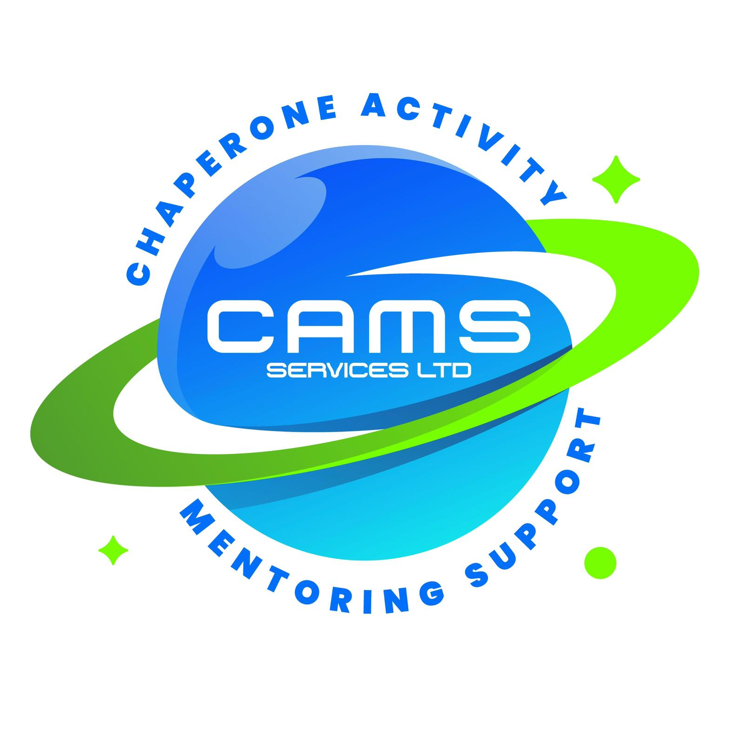
CAMS SERVICES LTD

admin@camsservices.co.uk

+44 7939 990587

www.camsservices.co.uk

SELF-EMPLOYED MENTOR AGREEMENT

Confidential – Internal Use Only

MENTOR INFORMATION
Name: ___________________________________
Address: _________________________________
Telephone: _______________________________
Email: ___________________________________
Start Date: ______________________________
Role: Self-Employed Mentor
DBS Certificate Number: ___________________
DBS Expiry Date (if applicable): ___________
PURPOSE
This Agreement sets out the terms and conditions under which the Mentor will provide mentoring and support services on behalf of CAMS Services Ltd.
The Agreement establishes expectations relating to safeguarding, professional conduct, confidentiality, service delivery, compliance, and quality assurance.

SELF-EMPLOYED STATUS
The Mentor acknowledges and agrees that they are engaged by CAMS Services Ltd as a self-employed contractor and not as an employee, worker, or agent.
The Mentor is responsible for:
• Their own Income Tax and National Insurance contributions.
• Compliance with HMRC requirements.
• Maintaining appropriate business records.
• Submitting invoices and supporting documentation.
• Managing their own pension arrangements.
Nothing in this Agreement shall create an employment relationship.
The Mentor is not entitled to:
• Holiday Pay.
• Sick Pay.
• Pension Contributions.
• Redundancy Pay.
• Maternity or Paternity Pay.
• Any other employment-related benefits.
NO GUARANTEE OF WORK
The Mentor acknowledges that:
• CAMS Services Ltd does not guarantee referrals.
• CAMS Services Ltd does not guarantee assignments.
• CAMS Services Ltd does not guarantee minimum hours.
• CAMS Services Ltd does not guarantee minimum earnings.
Assignments will be allocated according to:
• Service Demand.
• Referral Volumes.
• Availability.
• Safeguarding Considerations.
• Operational Requirements.
The Mentor is under no obligation to accept assignments offered.
PAYMENT
Hourly Rate: £15.00 per hour
Payment Schedule:
Monthly following receipt of:
• Approved Invoice.
• Completed Session Reports.
• Attendance Records where required.
The Mentor is responsible for submitting:
• Hours Worked.
• Session Reports.
• Invoices.
• Expense Claims.
• Supporting Documentation.
Approved expenses may be reimbursed where:
• Prior approval has been obtained.
• Appropriate receipts are provided.
All payments are subject to verification and approval procedures.
DUTIES AND RESPONSIBILITIES
The Mentor agrees to:
• Provide mentoring services professionally.
• Promote positive outcomes for children and young people.
• Follow support plans and agreed interventions.
• Maintain professional standards.
• Complete required reports and documentation.
• Communicate effectively with management.
• Support safeguarding-led practice.
• Follow organisational procedures.
• Comply with GDPR and confidentiality requirements.
PROFESSIONAL BOUNDARIES
The Mentor agrees to maintain professional boundaries at all times whilst delivering services on behalf of CAMS Services Ltd.
The Mentor must:
• Act as a positive role model.
• Maintain professional relationships with children, young people, families, schools, local authorities, and partner organisations.
• Use appropriate language, behaviour, and communication at all times.
• Avoid favouritism or inappropriate personal relationships.
• Avoid excessive personal disclosure.
• Maintain appropriate physical and emotional boundaries.
• Follow safeguarding policies and procedures.
• Use approved communication methods only.
• Protect confidential information at all times.
Mobile phones must only be used for purposes directly related to the support session, including communication with CAMS Services Ltd, safeguarding concerns, emergencies, accessing session resources, navigation where required, or completing required records and documentation.
Personal phone calls, text messages, social media use, video viewing, gaming, or any other personal activity during session hours are not permitted.
Mentors must not engage in personal conversations or activities that distract from the support being provided to the child, young person, family, or service user.
The Mentor must not:
• Develop inappropriate relationships with service users.
• Share personal information unnecessarily.
• Communicate through unauthorised social media platforms.
• Accept inappropriate gifts or incentives.
• Engage in conduct that may place service users or themselves at risk.
• Make or receive personal phone calls during sessions unless there is an emergency.
• Send or respond to personal text messages during contact hours.
• Access personal social media platforms whilst supporting service users.
• Watch videos, stream content, or engage in personal online activity unrelated to the session.
• Play games or engage in activities that distract from service delivery.
• Use personal devices in a manner that compromises safeguarding, confidentiality, or professionalism.
• Take photographs, videos, or audio recordings of children and young people without prior authorisation and appropriate consent.
The Mentor must ensure that children and young people receive their full attention throughout the session and act in a manner that promotes safety, engagement, safeguarding, and positive outcomes.
The use of personal mobile phones for non-work-related purposes during contact hours is considered unprofessional conduct and may result in:
• Additional supervision or monitoring.
• Removal from specific assignments.
• Suspension of future work allocations.
• Immediate termination of assignments or contractual arrangements with CAMS Services Ltd where concerns are serious or repeated.
All interactions must remain professional and safeguarding-led.

AVAILABILITY AND SESSION EXPECTATIONS
The Mentor is expected to:
• Attend agreed sessions punctually.
• Arrive prepared.
• Deliver support safely and professionally.
• Communicate changes promptly.
• Report concerns immediately.
• Complete records following each session.
Availability may vary according to referral demand and operational requirements.
SAFEGUARDING
The Mentor agrees to:
• Comply with all safeguarding procedures.
• Report safeguarding concerns immediately.
• Complete safeguarding documentation where required.
• Follow safeguarding reporting procedures.
• Maintain professional boundaries.
• Act in the best interests of children and young people.
The welfare of children and young people remains the primary consideration at all times.
DBS REQUIREMENTS
The Mentor must:
• Maintain satisfactory Enhanced DBS clearance.
• Notify CAMS Services Ltd immediately of any changes affecting suitability.
• Disclose arrests, cautions, convictions, investigations, or safeguarding concerns.
• Cooperate with DBS compliance monitoring procedures.
Failure to maintain satisfactory DBS status may result in suspension or termination of assignments.
RIGHT TO WORK
The Mentor confirms that they have the legal right to work within the United Kingdom and agrees to provide evidence where requested.
HEALTH AND SAFETY
The Mentor agrees to:
• Follow Health and Safety procedures.
• Complete risk assessments where required.
• Report accidents, incidents, hazards, and near misses.
• Follow Lone Working procedures.
• Promote safe working practices.
• Take reasonable care of themselves and others.
INSURANCE
The Mentor is responsible for maintaining:
• Public Liability Insurance.
• Professional Indemnity Insurance (where applicable).
• Appropriate Vehicle Insurance where transport duties are undertaken.
Evidence of insurance may be requested at any time.
INFORMATION SHARING
The Mentor agrees to comply with:
• Information Sharing Policy.
• GDPR and Data Protection Policy.
• Safeguarding Procedures.
Information may only be shared:
• For safeguarding purposes.
• For service delivery purposes.
• Where legally required.
• Through approved communication channels.
CONFIDENTIALITY
The Mentor agrees that all client, safeguarding, operational, and company information shall remain confidential during and after engagement with CAMS Services Ltd.
Information must not be disclosed to unauthorised individuals except where safeguarding or legal obligations require disclosure.
Confidentiality obligations continue following termination of this Agreement.
TRAINING AND CPD
The Mentor may be required to complete:
• Safeguarding Training.
• Health and Safety Training.
• GDPR Training.
• Professional Boundaries Training.
• Risk Assessment Training.
• Mental Health Awareness Training.
• Other mandatory training identified by CAMS Services Ltd.
The Mentor agrees to participate in Continuing Professional Development (CPD) activities where required.
SUPERVISION AND SUPPORT
The Mentor may be required to participate in:
• Supervision Meetings.
• Case Discussions.
• Safeguarding Reviews.
• Quality Assurance Reviews.
• Professional Development Meetings.
Supervision may be used to support safeguarding, wellbeing, professional development, and service quality.
RECORD KEEPING
The Mentor agrees to maintain accurate and up-to-date:
• Session Reports.
• Attendance Records.
• Progress Updates.
• Incident Reports.
• Safeguarding Records.
• Invoices.
• Expense Claims.
Records must be submitted within agreed timescales and stored securely.
QUALITY ASSURANCE
The Mentor agrees to participate in:
• File Audits.
• Compliance Monitoring.
• Session Report Reviews.
• Safeguarding Audits.
• Feedback Activities.
• Service Reviews.
Information gathered may contribute to:
• Self Assessment Reports (SAR).
• Quality Improvement Plans (QIP).
• Service Improvement Activities.
COMPLAINTS, CONDUCT AND MALPRACTICE
The Mentor agrees to cooperate with:
• Complaints Investigations.
• Safeguarding Investigations.
• Professional Conduct Reviews.
• Quality Assurance Reviews.
• Malpractice Investigations.
CAMS Services Ltd reserves the right to suspend assignments pending investigation where appropriate.
TERMINATION
Either party may terminate this Agreement by providing:
30 Days Written Notice
CAMS Services Ltd reserves the right to terminate immediately where there are concerns relating to:
• Safeguarding.
• Gross Misconduct.
• Breach of Confidentiality.
• Loss of DBS Clearance.
• Failure to Comply with Policies.
• Unprofessional Conduct.
• Reputational Risk.
Upon termination, the Mentor must:
• Return company property.
• Submit outstanding documentation.
• Return or securely delete confidential information.
• Maintain confidentiality obligations.

DECLARATION
I confirm that:
• I have read and understood this Agreement.
• I understand my safeguarding responsibilities.
• I understand my confidentiality obligations.
• I agree to comply with CAMS Services Ltd policies and procedures.
• I understand my responsibilities as a self-employed contractor.
• I agree to maintain professional standards while representing CAMS Services Ltd.
SIGNATURES

For CAMS Services Ltd
Name: ___________________________________
Position: Director
Signature: ________________________________
Date: ____________________________________

Mentor
Name: ___________________________________
Signature: ________________________________
Date: ____________________________________

