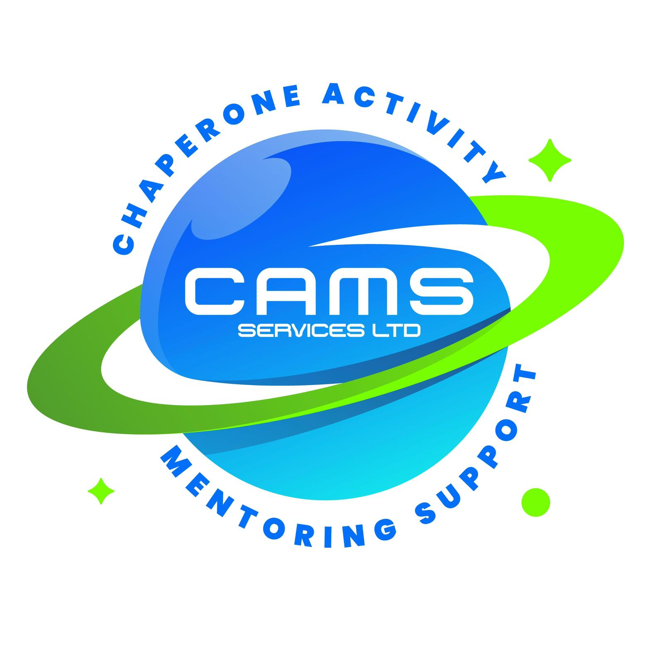
CAMS SERVICES LTD
admin@camsservices.co.uk
+44 7939 990587
www.camsservices.co.uk

STAFF HANDBOOK
(Draft – Subject to HR/Legal Review)
Confidential – Internal Use Only

WELCOME
Welcome to CAMS Services Ltd.
This Staff Handbook provides guidance regarding professional standards, safeguarding expectations, operational procedures, compliance requirements, and organisational values.
All employees, mentors, contractors, volunteers, and representatives are expected to read, understand, and comply with the policies and procedures outlined within this handbook.
This handbook should be read alongside all CAMS Services policies, procedures, agreements, and role-specific documentation.
ABOUT CAMS SERVICES
CAMS Services Ltd provides safeguarding-led mentoring, intervention, education support, wellbeing services, and community-based support for children and young people.
Our aim is to deliver safe, professional, child-centred services that improve engagement, wellbeing, confidence, resilience, independence, and positive life outcomes.
OUR MISSION
To provide safe, high-quality, safeguarding-led support that empowers children and young people to reach their potential and achieve positive outcomes.
OUR VALUES
CAMS Services Ltd is committed to:
• Safeguarding Children and Young People
• Professionalism and Integrity
• Respect and Inclusion
• Accountability and Responsibility
• Equality and Fairness
• Partnership Working
• Continuous Improvement
• Positive Outcomes
ORGANISATIONAL STRUCTURE
The organisation operates under the leadership of the Director and may include:
• Designated Safeguarding Lead (DSL)
• Quality Assurance and Compliance Functions
• Administration and Business Support Functions
• Employees
• Self-Employed Mentors
• Contractors
• Volunteers
Organisational arrangements may change as the business develops.
PROFESSIONAL CONDUCT
All individuals representing CAMS Services Ltd are expected to:
• Behave professionally.
• Treat others with dignity and respect.
• Maintain professional boundaries.
• Promote positive outcomes.
• Follow organisational procedures.
• Protect the reputation of CAMS Services Ltd.
Discrimination, bullying, harassment, victimisation, abuse, or inappropriate conduct will not be tolerated.
PROFESSIONAL BOUNDARIES
Staff and mentors must:
• Maintain appropriate relationships with service users.
• Avoid dual relationships.
• Avoid sharing personal information unnecessarily.
• Use approved communication methods.
• Follow safeguarding procedures.
Professional boundaries must be maintained at all times.
MOBILE PHONE USE
Mobile phones must only be used for legitimate work-related purposes during sessions.
Personal calls, social media use, gaming, video streaming, or other personal activities must not interfere with service delivery.
Repeated misuse may result in disciplinary action or termination of engagement.
SAFEGUARDING
Safeguarding is everyone's responsibility.
Individuals must:
• Prioritise the welfare of children and young people.
• Report safeguarding concerns immediately.
• Follow safeguarding procedures.
• Participate in safeguarding training.
• Maintain professional boundaries.
Further information can be found within the Safeguarding and Child Protection Policy.
DBS AND SAFER RECRUITMENT
Where required, individuals must:
• Hold satisfactory DBS clearance.
• Cooperate with recruitment checks.
• Maintain compliance requirements.
• Report any circumstances affecting suitability.
Failure to comply may affect engagement or employment.
HEALTH AND SAFETY
Individuals are responsible for:
• Taking reasonable care of themselves and others.
• Following risk assessments.
• Reporting hazards, accidents, incidents, and near misses.
• Supporting safe working practices.
• Following health and safety procedures.

LONE WORKING
Where individuals work alone:
• Lone Working procedures must be followed.
• Communication arrangements must be maintained.
• Risk assessments must be followed.
• Concerns must be reported immediately.
No individual is expected to place themselves at risk.
ONLINE SAFETY AND SOCIAL MEDIA
Individuals must:
• Follow the Online Safety Policy.
• Protect confidential information.
• Maintain professional boundaries online.
• Avoid inappropriate communication with service users.
• Use social media responsibly.
Personal social media accounts must not be used to communicate with current service users.
CONFIDENTIALITY AND DATA PROTECTION
Individuals must:
• Protect confidential information.
• Follow GDPR requirements.
• Store information securely.
• Report data breaches immediately.
Confidentiality obligations continue after engagement ends.
ATTENDANCE AND TIMEKEEPING
Individuals are expected to:
• Attend work and appointments punctually.
• Notify management of absence promptly.
• Provide appropriate notice where sessions cannot be attended.
• Maintain accurate records of attendance where required.
TRAINING AND PROFESSIONAL DEVELOPMENT
Individuals may be required to complete:
• Safeguarding Training.
• Health and Safety Training.
• GDPR Training.
• Online Safety Training.
• Professional Boundaries Training.
• Role-Specific Training.
Training compliance may be monitored through supervision and audits.
SESSION REPORTING AND RECORD KEEPING
Accurate records may include:
• Session Reports.
• Attendance Records.
• Progress Reports.
• Incident Reports.
• Safeguarding Records.
• Training Records.
Records must be factual, accurate, and completed promptly.
TRANSPORTING CHILDREN AND YOUNG PEOPLE
Where transport is provided:
• Appropriate consent must be obtained.
• Vehicle insurance requirements must be met.
• Risk assessments must be followed.
• Safeguarding procedures must be maintained.
DRESS CODE AND PRESENTATION
Individuals should:
• Dress appropriately for their role.
• Present themselves professionally.
• Ensure clothing is suitable for activities being undertaken.
• Promote a positive image of CAMS Services Ltd.
DRUGS, ALCOHOL AND SUBSTANCE MISUSE
Individuals must not:
• Attend work under the influence of drugs or alcohol.
• Consume alcohol or illegal substances whilst undertaking duties.
Any concerns should be reported immediately.
EQUALITY, DIVERSITY AND INCLUSION
CAMS Services Ltd is committed to:
• Equality of opportunity.
• Inclusion.
• Respect for diversity.
• Fair treatment for all.
Discrimination will not be tolerated.
WHISTLEBLOWING
Individuals are encouraged to raise concerns relating to:
• Safeguarding.
• Malpractice.
• Misconduct.
• Health and Safety.
• Unethical behaviour.
Concerns will be taken seriously and managed appropriately.
QUALITY ASSURANCE
The organisation may undertake:
• File Audits.
• Compliance Reviews.
• Safeguarding Audits.
• Training Monitoring.
• Service Reviews.
• Feedback Activities.
Information may contribute to Self Assessment Reports (SAR) and Quality Improvement Plans (QIP).
STAFF WELLBEING
CAMS Services Ltd recognises the importance of wellbeing and encourages individuals to seek support where required.
Support may be available through supervision, management guidance, training, and professional development opportunities.
COMPLAINTS AND CONCERNS
Complaints, concerns, incidents, or safeguarding matters should be reported promptly through appropriate channels.
Further information can be found within the Complaints Procedure.

POLICY COMPLIANCE
All individuals must comply with:
• Organisational Policies.
• Safeguarding Procedures.
• Health and Safety Requirements.
• Professional Conduct Expectations.
• Data Protection Requirements.
Failure to comply may result in disciplinary action, suspension, termination of engagement, or referral to relevant authorities.
ACKNOWLEDGEMENT
I confirm that I have received, read, understood, and agree to comply with the CAMS Services Ltd Staff Handbook.
Name: ______________________________
Role: _______________________________
Signature: __________________________
Date: ______________________________

