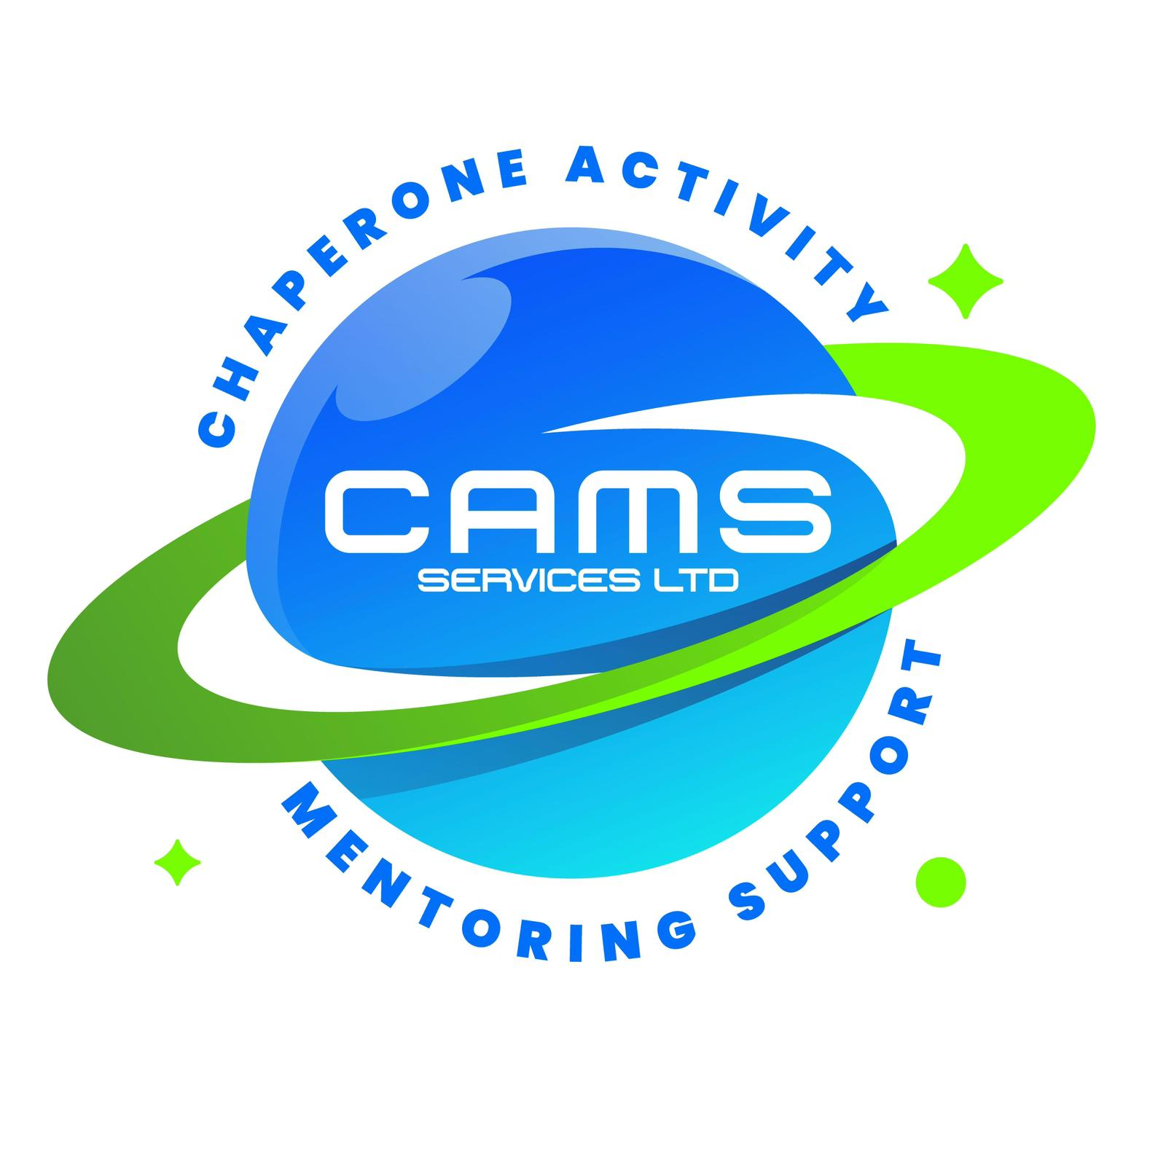
CAMS SERVICES LTD
admin@camsservices.co.uk
+44 7939 990587
www.camsservices.co.uk

STAFF TRAINING AND CONTINUING
PROFESSIONAL DEVELOPMENT (CPD) FRAMEWORK
Confidential – Internal Use Only

PURPOSE
CAMS Services Ltd is committed to ensuring that all employees, mentors, volunteers, contractors, and representatives possess the knowledge, skills, and competencies required to deliver safe, effective, and high-quality services.
This framework outlines the organisation's approach to induction, mandatory training, continuing professional development (CPD), and workforce development to support safeguarding, legal compliance, and continuous service improvement.
SCOPE
This framework applies to:
- Directors
- Designated Safeguarding Lead (DSL)
- Employees
- Self-Employed Mentors
- Support Workers
- Chaperones
- Volunteers
- Contractors
- Agency Workers (where applicable)
- Anyone delivering services on behalf of CAMS Services Ltd
TRAINING PRINCIPLES
CAMS Services Ltd is committed to:
- Providing a structured induction programme.
- Identifying mandatory training requirements.
- Promoting continuing professional development.
- Maintaining accurate training records.
- Monitoring training compliance.
- Supporting reflective practice.
- Encouraging lifelong learning and continuous improvement.
INDUCTION TRAINING
Before undertaking unsupervised duties, individuals should complete an induction programme appropriate to their role.
The induction programme may include:
- Safeguarding and Child Protection
- Professional Boundaries
- Code of Conduct
- Health and Safety
- Lone Working
- Equality, Diversity and Inclusion
- GDPR and Confidentiality
- Information Sharing
- Incident Reporting
- Risk Assessment
- Online Safety
- Behaviour Management
- Positive Handling Awareness
- Organisational Policies and Procedures
Completion of induction training should be recorded within the organisation's Training Compliance Matrix.
MANDATORY TRAINING
Mandatory training requirements will vary according to role and responsibilities.
Typical mandatory training includes:
Training Area | Recommended Frequency
Safeguarding Children | Annually
Child Protection | Annually
Health & Safety | Every 2 Years
GDPR & Data Protection | Annually
Information Sharing | Annually
Professional Boundaries | Annually
Equality, Diversity & Inclusion | Every 2 Years
Online Safety | Annually
Risk Assessment | Every 2 Years
Incident Reporting | Annually
Behaviour Management | Annually
Additional training may be required where responsibilities or legislation require.
CONTINUING PROFESSIONAL DEVELOPMENT (CPD)
CAMS Services Ltd encourages all personnel to participate in ongoing learning and professional development.
CPD activities may include:
- Online learning
- Workshops
- Webinars
- Conferences
- Professional reading
- Reflective practice
- Peer learning
- SEND training
- Mental Health Awareness
- Trauma-Informed Practice
- Other role-specific learning opportunities
Participation in CPD should be recorded using the organisation's CPD Record where appropriate.
TRAINING RECORDS
CAMS Services Ltd will maintain appropriate records relating to staff training and professional development.
These may include:
- Training Compliance Matrix
- Training Completion Records
- Continuing Professional Development (CPD) Records
Training records will be stored securely and managed in accordance with the Data Protection Act 2018 and UK GDPR.

SUPERVISION AND PROFESSIONAL DEVELOPMENT
Training and development needs may be identified through:
- Supervision meetings
- Performance reviews
- Safeguarding reviews
- Quality assurance activities
- Changes in legislation or guidance
- Service development priorities
Where appropriate, individual development plans may be agreed to support professional growth.
RESPONSIBILITIES

Director
The Director is responsible for:
- Approving training requirements.
- Monitoring organisational compliance.
- Supporting workforce development.
- Reviewing training arrangements.
- Ensuring adequate resources are available.

Managers and Supervisors
Managers and Supervisors are responsible for:
- Identifying training needs.
- Supporting staff development.
- Monitoring training compliance.
- Encouraging continuing professional development.

Employees, Mentors and Representatives
Individuals are responsible for:
- Completing mandatory training.
- Participating in refresher training where required.
- Maintaining professional competence.
- Recording relevant CPD activities.
- Informing management of additional training needs.
MONITORING AND REVIEW
CAMS Services Ltd will monitor:
- Mandatory training compliance.
- CPD participation.
- Induction completion.
- Refresher training requirements.
- Workforce development needs.
This framework will be reviewed annually, or sooner where legislation, guidance, or organisational requirements change.

FRAMEWORK COMMITMENT
CAMS Services Ltd is committed to maintaining a competent, confident, and professional workforce through effective training, safeguarding awareness, and continuous professional development, ensuring the highest standards of service delivery for children, young people, and families.

