

CS112 | Object-Oriented Programming
Project Report
Crime Case Tracking &
Investigation Report System
A Console-Based C++ Application Demonstrating
Hybrid Inheritance, Encapsulation, Polymorphism, and Layered Architecture
Submitted By | Alishba Razzaq — 2510301  Kashmala Rizwan — 2510279
Course | CS112 — Object-Oriented Programming
Program | BSSE-II | 2nd Semester | Spring 2026
Institution | Air University, Multan Campus
Language | C++ | Console Application

1. Introduction

1.1 Background and Motivation
This project is a simple C++ console application for managing crime cases, suspects, investigators, and reports. It demonstrates basic OOP concepts.
1.2 Project Objectives
- Simulate a realistic law enforcement data management system in a C++ console environment.
- Demonstrate all major OOP concepts: encapsulation, inheritance,polymorphism, and virtual destructors.
- Three-tier layered architecture (Data Layer, Logic Layer, Presentation Layer) to separate concerns cleanly.
- Implement a Prediction Engine that analyses existing case data and flags patterns.
- Manage dynamic memory safely using pointers, vectors, and virtual destructors.

1.3 Scope
The system is a runtime console application. All data lives in memory during execution. The architecture is intentionally designed to be extensible: additional case types, search features, or file persistence can be added with minimal changes to existing classes.
2. System Overview

2.1 What the System Does
The system runs as a menu-driven console application. When launched, it presents the user with a numbered menu offering nine operations grouped into three categories: Records, View, and Analysis.
Option | Feature | Description
1 | Register New Crime Case | Stores case ID, crime type, date, and location
2 | Add Suspect Profile | Records suspect details linked to a case
3 | Add Investigator | Stores officer badge, rank, department, and experience
4 | Generate Investigation Report | Combines case, scene, evidence, suspect, and investigator into one report
5 | View All Cases | Displays a formatted table of all registered cases
6 | View All Suspects | Lists all suspects with risk level and arrest status
7 | View All Investigators | Lists all investigators with rank and department
8 | View All Reports | Prints full details of every generated report
9 | Run Prediction Analysis | Finds similar past cases based on crime type, location, and suspect risk level
0 | Exit | Cleans up all dynamic memory and exits gracefully

2.2 Technology and Tools
- Language: C++17
- Compiler: G++ (tested with MinGW on Windows / GCC on Linux)
- Libraries used: <iostream>, <string>, <vector>, <algorithm>, <iomanip>
- Architecture: Three separate header files plus one main.cpp entry point
- Memory model: Dynamic allocation via new / delete with virtual destructors
3. System Architecture

3.1 Three-Tier Layered Design
The project uses three layers: Data Layer, Logic Layer, and Presentation Layer for better organisation.
Layer | File | Responsibility
Tier 1 — Data Layer | DataLayer.h | Defines PersonBase and CrimeBase: the two root classes. Contains private attributes, getters, setters, virtual destructors, and virtual display() methods.
Tier 2 — Logic Layer | LogicLayer.h | Extends Tier 1 with derived classes (SuspectProfile, InvestigatorProfile, CrimeScene, EvidenceRecord, CaseInvestigationReport) and the PredictionEngine. All business logic lives here.
Tier 3 — Presentation Layer | PresentationLayer.h | All console I/O functions: menus, input helpers, view functions, report generator UI, and prediction display. No data or logic — pure interaction.
Entry Point | main.cpp | Declares storage vectors, runs the do-while menu loop, routes to Presentation Layer functions, and cleans up memory on exit.

3.2 Include Chain
The header files form a strict one-directional include chain with no circular dependencies:

main.cpp
└─> PresentationLayer.h
└─> LogicLayer.h
└─> DataLayer.h

Each layer only knows about the layer below it, which is a clean dependency design that could support future refactoring into separate compilation units.
4. Class Design and OOP Concepts

4.1 Class Hierarchy Overview
The project contains 8 classes total: 2 base classes in the Data Layer (Tier 1), 4 derived classes in the Logic Layer (Tier 2), 1 top-level report class (Tier 3), and 1 utility class (PredictionEngine). The hierarchy is summarised in the table below.
Tier | Class | Inherits From | Role
T1 | PersonBase | — | Root class for all people (suspects, investigators)
T1 | CrimeBase | — | Root class for all crime data
T2 | SuspectProfile | PersonBase | Adds suspect-specific: code, criminal record, arrest status, risk level
T2 | InvestigatorProfile | PersonBase | Adds officer-specific: badge, rank, department, experience
T2 | CrimeScene | virtual CrimeBase | Adds scene data: condition, witnesses, forensics, secured status
T2 | EvidenceRecord | virtual CrimeBase | Adds evidence data: evidence ID, type, collector, lab result
T3 | CaseInvestigationReport | CrimeScene + EvidenceRecord | Final report combining all case data; links suspect and investigator via composition
— | PredictionEngine | — | Static utility class: finds similar cases using a scoring algorithm

4.2 Data Layer — Tier 1

4.2.1 PersonBase
PersonBase stores common information and provides getters, setters, and display functions.

4.2.2 CrimeBase
CrimeBase mirrors PersonBase in structure but holds crime-related data: caseID, crimeType, crimeDate, and crimeLocation. It has the same destructor and display() pattern. It is inherited virtually by CrimeScene and EvidenceRecord, which is the key design decision that resolves the diamond problem.

4.3 Logic Layer — Tier 2

4.3.1 SuspectProfile
Extends PersonBase using standard single inheritance. Adds four private attributes: suspectCode, criminalRecord, arrestStatus (Arrested / At Large), and riskLevel (High / Medium / Low). The display() method is overridden to call PersonBase::display() first, then append the suspect-specific fields. This is a clean example of method overriding and base-class method reuse.

4.3.2 InvestigatorProfile
Also extends PersonBase. Adds badgeNumber, rank, department, and yearsExperience (stored as int). Same display() override pattern as SuspectProfile.

4.3.3 CrimeScene (Virtual Inheritance)
Extends CrimeBase using the virtual keyword:
class CrimeScene : virtual public CrimeBase { ... };

The virtual keyword means that when CaseInvestigationReport inherits from both CrimeScene and EvidenceRecord, the CrimeBase subobject is shared — not duplicated. Without this, CaseInvestigationReport would contain two copies of CrimeBase, creating ambiguous member access: the diamond problem.
CrimeScene adds: sceneCondition, witnessCount (int), forensicFindings, and sceneSecured (bool).

4.3.4 EvidenceRecord (Virtual Inheritance)
Also extends CrimeBase virtually:
class EvidenceRecord : virtual public CrimeBase { ... };

Adds: evidenceID, evidenceType, collectedBy, and labResult.

4.3.5 CaseInvestigationReport (Multiple Inheritance — Tier 3)
This is the most complex class in the project. It uses multiple inheritance:
class CaseInvestigationReport : public CrimeScene, public EvidenceRecord { ... };

Because both CrimeScene and EvidenceRecord virtually inherit CrimeBase, there is only one CrimeBase subobject inside CaseInvestigationReport. The MRO (most-derived class) is responsible for initialising the virtual base, which is why the constructor explicitly calls CrimeBase() first:
CaseInvestigationReport(...) : CrimeBase(...), CrimeScene(...), EvidenceRecord(...), ...

The class also uses composition: it holds two pointers — SuspectProfile* suspect and InvestigatorProfile* investigator — that are linked via linkSuspect() and linkInvestigator() methods. These pointers are not owned by the report (they are not deleted in its destructor), which is correct since suspects and investigators have independent lifetime management in main.cpp.
Own attributes: reportID, verdict, caseStatus (Open / Under Review / Closed), approvedBy.

4.4 PredictionEngine
PredictionEngine checks case details and finds similar previous cases using a simple score.
Match Criterion | Points Awarded | Matching Logic
Crime type | +3 points | Case-insensitive partial string match via find()
Location | +2 points | Case-insensitive partial string match
Suspect risk level | +1 point | Only checked if the report has a linked suspect
Any report scoring 2 or more points is considered a similar case. Results are sorted in descending score order. The engine also generates a natural-language message based on the result count: a warning if 3 or more similar cases are found, a mild alert for 2, and a neutral message for 1 or none.
5. OOP Concepts Applied

5.1 Encapsulation
Every attribute in every class is private or protected. There are no public data members anywhere in the codebase. All access goes through explicitly defined public getters and setters. This ensures that the internal representation of a class can change without breaking the code that uses it. For example, if caseID were later changed from a string to an integer, only DataLayer.h would need updating — all calling code that uses getCaseID() would continue to compile unchanged.

5.2 Inheritance
Three types of inheritance are present:
- Single inheritance: SuspectProfile and InvestigatorProfile both extend PersonBase independently. This is the most straightforward form — each derived class adds its own fields and overrides display().
- Virtual inheritance: CrimeScene and EvidenceRecord both extend CrimeBase using the virtual keyword. This is the prerequisite for the diamond problem solution.
- Multiple inheritance: CaseInvestigationReport inherits from both CrimeScene and EvidenceRecord simultaneously. The virtual base ensures only one copy of CrimeBase exists in the final object.

5.3 Polymorphism
The display() method is declared virtual in PersonBase and CrimeBase, and overridden in every derived class. This means that when display() is called on a base-class pointer pointing to a derived object, the correct derived version runs — this is runtime polymorphism (dynamic dispatch). In viewAllReports(), the system calls r->display() on CaseInvestigationReport* pointers; the override chain correctly prints scene, evidence, suspect, and investigator details in sequence.

5.4 Dynamic Memory and Virtual Destructors
All major objects — suspects, investigators, and reports — are allocated with new and stored in vectors of pointers. The virtual destructors in PersonBase and CrimeBase ensure that when delete is called on a base-class pointer, the destructor chain unwinds correctly through all derived classes, preventing memory leaks. In main.cpp, all three vectors are cleaned up before the program exits:
for (auto r : reports) delete r;
for (auto s : suspects) delete s;
for (auto i : investigators) delete i;

5.5 Method Overriding and Base-Class Calls
Derived display() methods explicitly call their parent's display() before printing their own fields. For example, SuspectProfile::display() calls PersonBase::display() first, then appends suspect-specific output. This avoids code duplication and ensures that inherited fields are always printed regardless of which level of the hierarchy is being displayed.
6. Functional Requirements

6.1 Core Features
# | Feature | Detail
FR1 | Register Crime Case | User provides case ID, crime type, date (DD-MM-YYYY format), and location. Stored as CaseEntry struct in a vector.
FR2 | Add Suspect Profile | Full person details plus suspect code, criminal record, arrest status (menu-driven), and risk level (High/Medium/Low). Stored as SuspectProfile* in a vector.
FR3 | Add Investigator | Full person details plus badge number, rank, department, and years of experience. Stored as InvestigatorProfile* in a vector.
FR4 | Generate Report | User selects a registered case, enters scene and evidence details, creates a CaseInvestigationReport, optionally links a suspect and investigator.
FR5 | View All Cases | Tabular display of all registered cases with aligned columns using setw.
FR6 | View All Suspects | Tabular display showing name, code, arrest status, and risk level.
FR7 | View All Investigators | Tabular display showing name, badge, rank, and department.
FR8 | View All Reports | Full display() call on each CaseInvestigationReport, printing complete nested data.
FR9 | Prediction Analysis | Takes crime type, location, and risk level as input; queries all reports through PredictionEngine; displays scores, reasons, and a summary message.

7. Non-Functional Requirements
Property | Implementation
Memory Safety | Virtual destructors in PersonBase and CrimeBase guarantee the full destructor chain runs on delete through base pointers. main.cpp performs explicit cleanup before exit.
Encapsulation | Zero public data members across all classes. Every attribute is private or protected and accessed only through getters and setters.
No Diamond Ambiguity | CrimeScene and EvidenceRecord both use virtual inheritance from CrimeBase, ensuring CaseInvestigationReport holds exactly one CrimeBase subobject with no ambiguous member access.
Readability | Each class has a single clearly defined responsibility. Header guards (#ifndef / #define / #endif) prevent multiple inclusion.
Performance | All operations run in-memory on vectors. No disk I/O. Lookup and display are O(n) over small datasets typical of a demonstration system.
Maintainability | The three-tier architecture means the UI (PresentationLayer) can be replaced without touching DataLayer or LogicLayer. New class types can be added at any tier independently.
Portability | Standard C++17 with no platform-specific APIs. Compiles on Windows (MinGW), Linux (GCC), and macOS (Clang) without modification.
8. UML Class Diagram
The diagram below shows the full class hierarchy. Solid inheritance arrows represent regular public inheritance. Dashed inheritance arrows represent virtual inheritance. The purple multiple-inheritance arrows show that CaseInvestigationReport inherits from both CrimeScene and EvidenceRecord, forming the diamond pattern that is resolved by virtual CrimeBase.

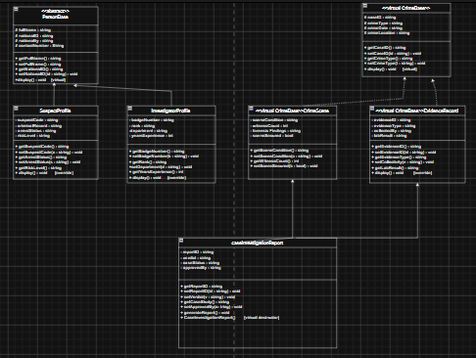

9. Code Walkthrough

9.1 DataLayer.h — Base Classes
PersonBase defines the private attributes and provides a virtual display() with virtual ~PersonBase(). This ensures that any class inheriting from PersonBase — directly or indirectly — can be safely deleted through a PersonBase pointer. The same pattern is repeated in CrimeBase.
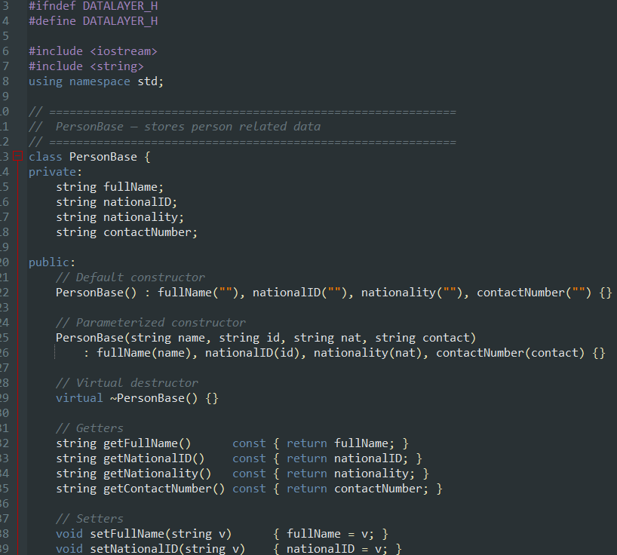
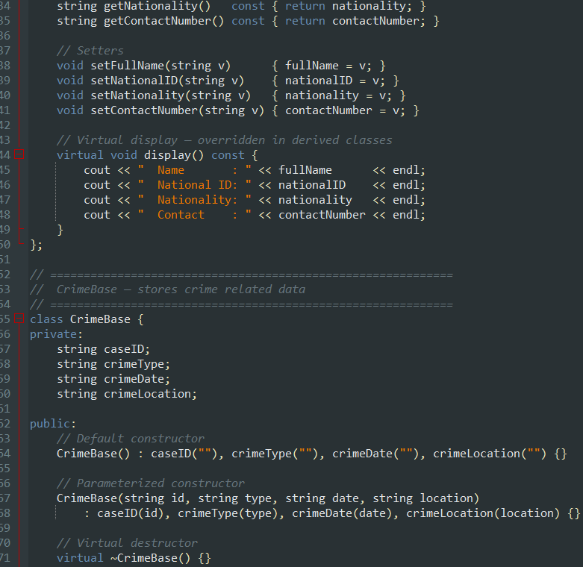
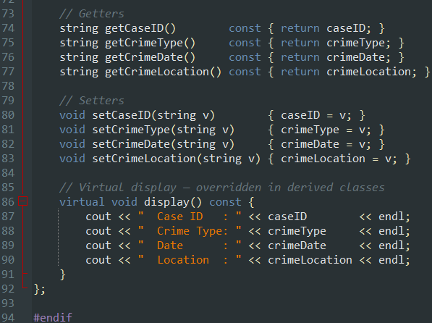

9.2 LogicLayer.h — Derived Classes and Prediction
SuspectProfile and InvestigatorProfile demonstrate simple single-level inheritance. Their constructors call the PersonBase constructor through the initialiser list. Their display() overrides first call PersonBase::display(), then add their own output — a clean chain of responsibility.
CrimeScene and EvidenceRecord use virtual public CrimeBase to set up the diamond-safe hierarchy. Their constructors pass the CrimeBase arguments up through the initialiser list.
CaseInvestigationReport calls all three constructors in its initialiser list: CrimeBase first (as required by the C++ standard for virtual bases), then CrimeScene and EvidenceRecord. Its display() method prints the report header, then delegates to CrimeScene::display() and EvidenceRecord::display(), and finally prints linked suspect and investigator data via their own display() methods.
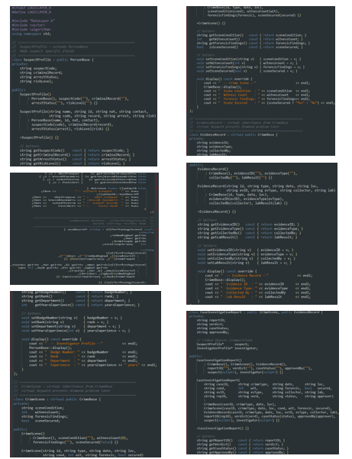
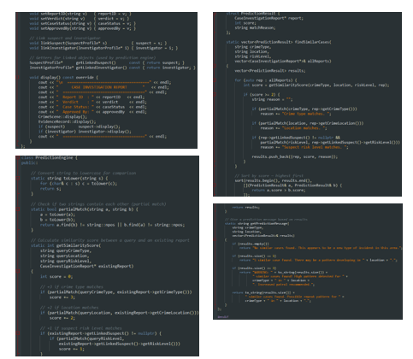

9.3 PresentationLayer.h — User Interface
The Presentation Layer contains only free functions — no classes. Input helpers (getStr, getInt) centralise all cin operations. printTitle() and printLine() maintain consistent console formatting. Each menu option maps to a dedicated function that collects input, creates objects, and calls Logic Layer methods. No business logic appears in this layer.
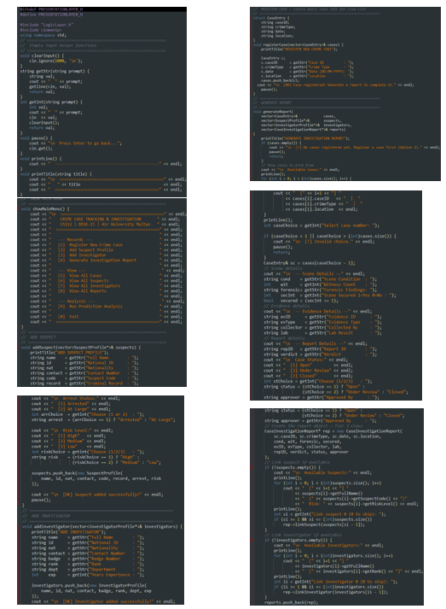
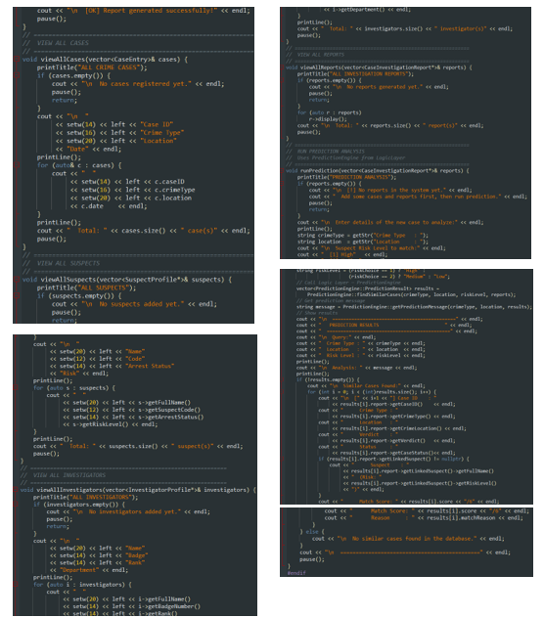

9.4 main.cpp — Entry Point
main() declares four vectors of pointers and runs a do-while loop that calls showMainMenu() and routes via a switch statement. On exit (choice == 0), it iterates all three pointer vectors and deletes each object, relying on virtual destructors for correct cleanup. The design means main.cpp has no knowledge of class internals — it only calls Presentation Layer functions.

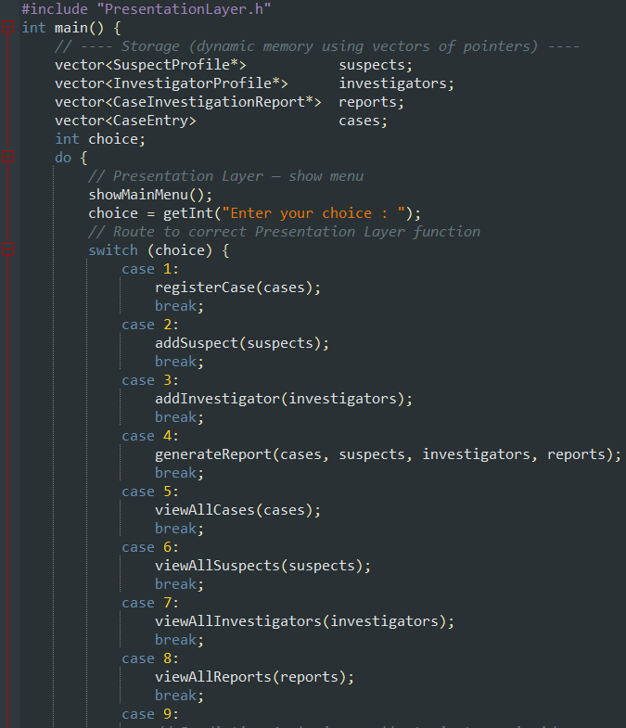
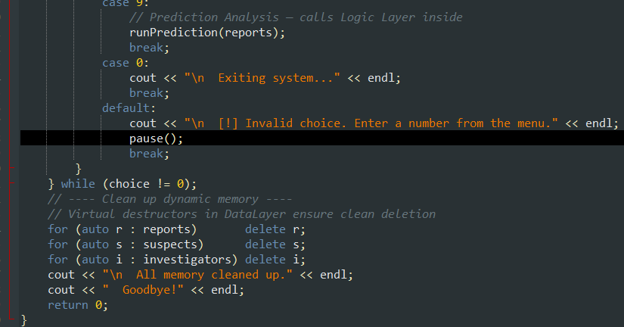

10. Prediction Engine

10.1 Algorithm Design
The PredictionEngine is a logic-layer feature that goes beyond basic CRUD. It allows a user to describe a new case and find similar past cases in the database. This simulates a basic investigative pattern-matching tool, which is a real capability used in crime analysis software.

10.2 Scoring Function
The getSimilarityScore() static method takes a crime type, location, and risk level as query parameters along with a pointer to an existing report. It uses case-insensitive partial string matching (partialMatch via std::string::find) to check each field, awarding 3 + 2 + 1 points respectively. The use of partial matching means a query of "Theft" will match a report labelled "Vehicle Theft".

10.3 Output
findSimilarCases() returns a vector of PredictionResult structs, each holding the matched report pointer, its score, and a human-readable matchReason string. The results are sorted by score (descending) using std::sort with a lambda comparator. getPredictionMessage() generates a context-aware message string based on result count, with a high-alert warning when 3 or more matches are found.
11. Test Scenarios

11.1 Sample Test Flow
The following sequence verifies all 9 menu options in one test run:

Step | Action | Input | Expected Output
1 | Register Case | Case ID: C001, Type: Robbery, Date: 01-01-2026, Location: Lahore | [OK] Case registered
2 | Add Suspect | Name: Ali Raza, Code: S001, Risk: High, Arrest: Arrested | [OK] Suspect added
3 | Add Investigator | Name: Sara Ahmed, Badge: B001, Rank: Inspector, Dept: CID, Exp: 5 | [OK] Investigator added
4 | Generate Report | Select case C001, add scene/evidence, link suspect S001 and investigator B001 | [OK] Report generated
5 | View Cases | — | Table showing C001, Robbery, Lahore, 01-01-2026
6 | View Suspects | — | Table showing Ali Raza, S001, Arrested, High
7 | View Investigators | — | Table showing Sara Ahmed, B001, Inspector, CID
8 | View Reports | — | Full case report display for C001
9 | Run Prediction | Type: Robbery, Location: Lahore, Risk: High | Match found for C001 with score 5/6

11.2 Edge Cases Handled
- Generating a report when no cases are registered: shows a warning message and returns without crashing.
- Running prediction with no reports: shows an informational message and returns.
- Skipping suspect or investigator link during report generation: pointers remain nullptr; display() checks for null before printing.
- Entering 0 when prompted to link a suspect or investigator: correctly skips without error.
- All dynamic memory is freed even if the user exits immediately without creating any objects.

12. Conclusion

12.1 Summary
This project successfully demonstrates the major OOP concepts using a crime management system.

12.2 What We Learned
- Virtual inheritance is not just a theoretical concept — it is necessary whenever a class inherits from two classes that share a common base. Without it, CaseInvestigationReport would contain duplicate CrimeBase subobjects and the code would not compile.
- The layered architecture (Data / Logic / Presentation) is a pattern found in production software, not just academic projects. Separating concerns makes each file shorter, easier to test, and easier to change independently.
- Virtual destructors matter. Storing derived objects as base-class pointers and deleting them through those pointers is standard C++ practice — but only safe when the base declares a virtual destructor.
- Polymorphism through display() overriding made the reporting feature trivially simple: viewAllReports() calls one method on each pointer and the full hierarchy handles the rest automatically.
- The PredictionEngine demonstrates that business logic can be completely decoupled from UI code. The engine takes plain parameters and returns a sorted struct vector — the Presentation Layer decides how to display the results.

12.3 Possible Extensions
- File persistence: save and load cases from text or binary files using fstream.
- Search by case ID: add a search function that scans the cases vector and returns matches.
- Report editing: modify caseStatus or approvedBy on an existing report after generation.
- GUI front-end: the layered design means the Presentation Layer can be replaced with a Qt or SFML interface without touching DataLayer or LogicLayer.

End of Report

