Information Visualization P5

Group Members:

Baijun Desai

Kashyap Patel

Dataset Chosen:

Aircraft Incidents

Supposed Analytic Tasks:

Find how many incidents occur in a certain year

Find how many incidents occur over a range of years

Find how many injuries occur in a certain year/range of years

Find how many incidents occur in a certain year/range of years

[need to add more tasks from charts 1 and 3]

Design Overview:

As soon as the user loads the visualization, (s)he is presented with a bar chart that extends the whole page and four smaller charts below the main chart. The main chart not only represents the amount of aircraft incidents that occur every year, but also allows the user to create a brush over the bars. This brush results in a change in all four sub graphs. The visualizations shown in the four sub graphs only include data from years that the user has brushed over. When the visualization loads for the first time, the sub graphs visualize data over the whole time period (1995 – 2016).

[Talk about what color intensity represents in 2nd paragraph. What does blue -> purple -> red indicate.]

User Interface:

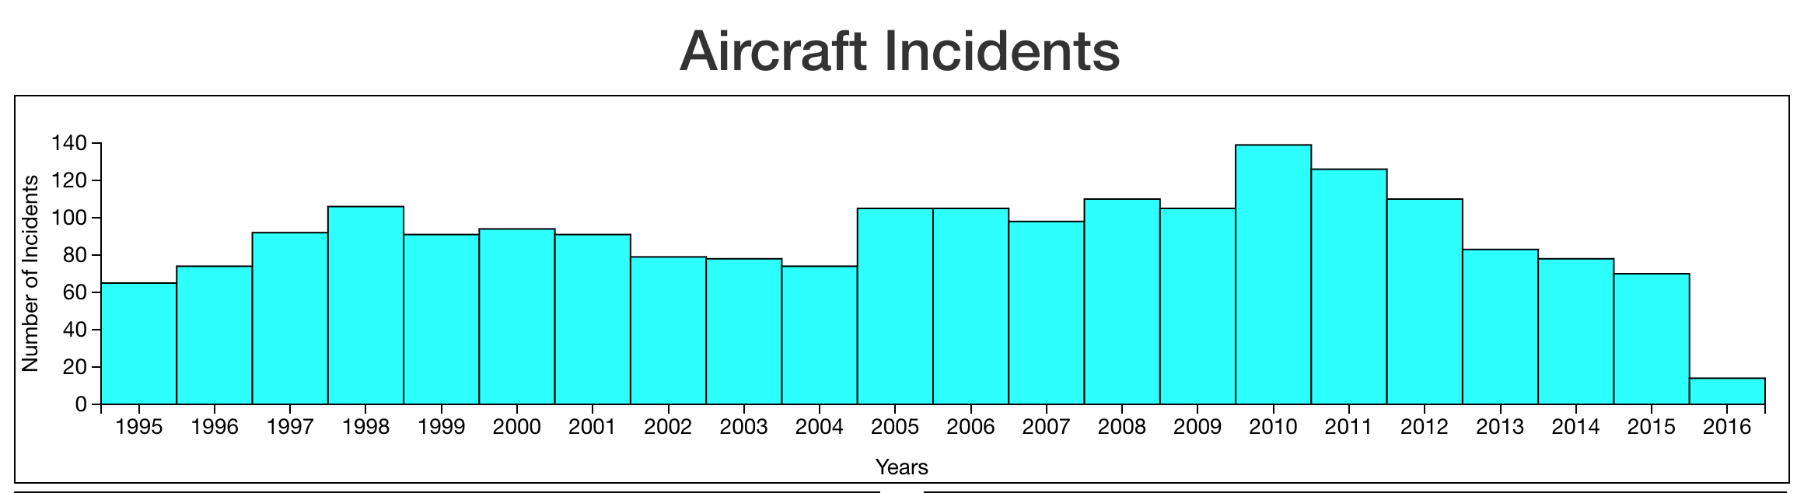

Main chart at the top. Allows the user to brush over the bars, like so:

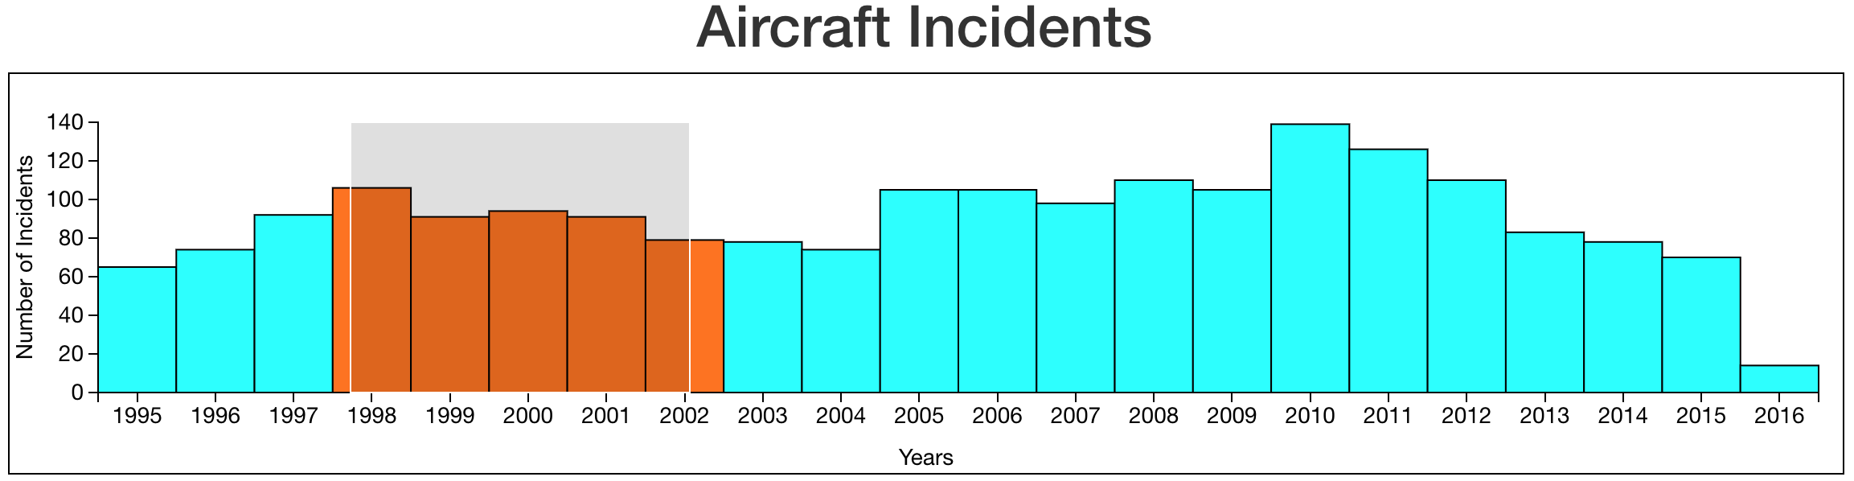

A bar is considered brushed if at least half of its area is within the brush.

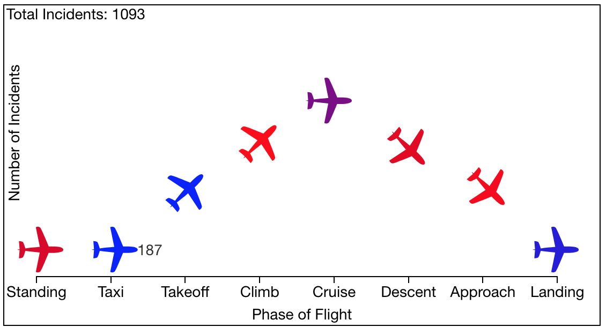

Top left chart. The planes are oriented in a way to symbolize the orientation of the plane during each phase. The color of the plane represents the number of incidents that occurred in that phase, which is deciphered using the legend on the visualization. Additionally, the user can find how many incidents occurred in a certain phase by hovering their mouse over the plane. The “Total Incidents” text and color of the planes update as the user brushes over years on the main chart.

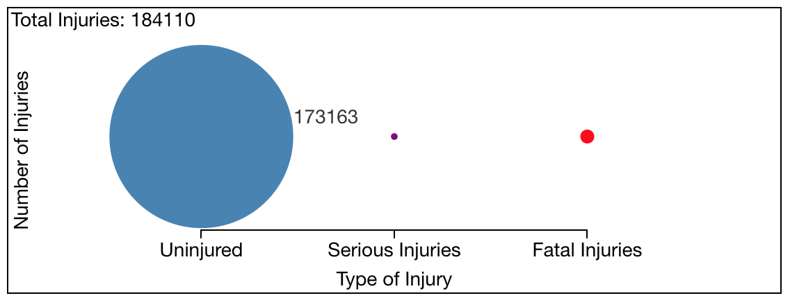

Bottom left chart. The circles represent the number of injuries that occur out of total injuries. The bigger the circle, the bigger the percentage of that type of injury. When the user hovers over a circle, its radius increases to let the know it was highlighted, and the actual number of that injury type is shown. The “Total Injuries” text and radius of the circles update as the user brushes over years on the main chart.