CS1300-Computational Linear Algebra

Professor: Dr. Terry Boult, T.A. Steve Cruz

Jacob Reichard and Daniel Lineberger

**Project 2: Eigenfaces, Facial Reconstruction, and Facial Recognition**

**Part 1**

With the first part of the assignment, there were three goals: Develop a matrix of faces and normalize said faces, Compute a facespace with a variable size provided by the user, and compute facespace coefficients for each subject. The first goal was accomplished using a dataset containing 142 pre-aligned faces. The file locations for each image was added to a text file, which was read by the program and added to a matrix of faces. These faces were normalized by subtracting the mean face from each image, resulting in a matrix for the following tasks. The second task was accomplished by taking the eigenvectors of a covariance matrix computed by taking the normalized matrix and it’s transpose. These eigenvectors were then multiplied by the normalized face to create “eigenfaces”. Three eigenfaces are pictured below for demonstration.

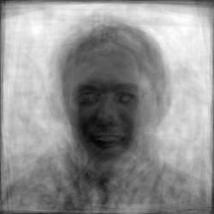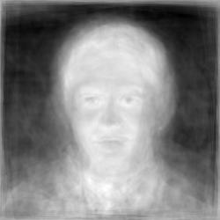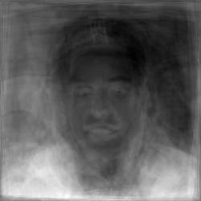

These eigenfaces were appended to a matrix to form the facespace. This facespace was saved to a file, which looked like

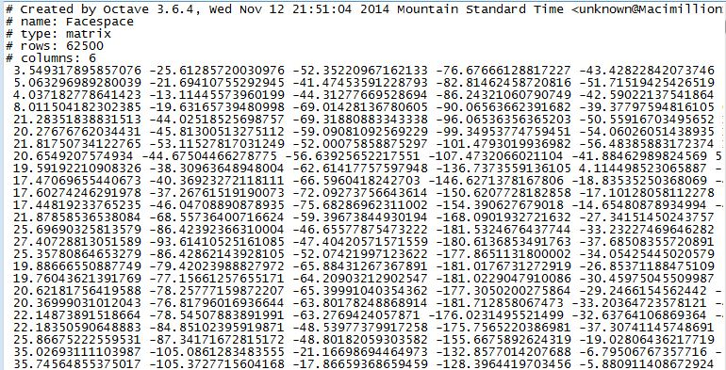

This file is stored for future use in part 2. Finally, the Facespace Coefficients were computed for each image by taking the transpose of the facespace and multiplying it by the normalized face matrix. These values were also stored, which looked like 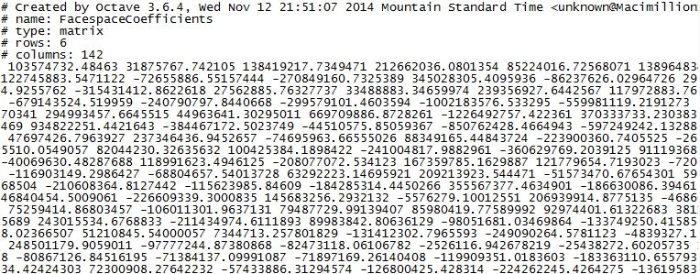

**Part 2**

In part 2 of the assignment, there were also three goals, but none were completely achieved. The first was to reconstruct a face using the stored facespace. The computations were created by calculating the weights of each eigenface (normalized face . eigenface), and these weights were used to calculate a matrix following the equation ReconstructedFace = AverageFace + (weight1 * Eigenface1) + … + (weight n * Eigenface n). An error occurred when attempting to scale and save the image, so there is not successful output. The second and third goals were to compute the mean square error and plot the results as a function of the number of eigenvectors used. The functionality relied on the first goal, and as such was not able to be accomplished. The skeleton code is included for your review, but does not completely function without the reconstructed face.

**Part 3**

Not attempted.

**Functions**

Please refer to each individual function for a detailed description, list of interacting files, and how each function accomplished it’s goal