This project is implemented to demonstrate election in democracy. It is basically based on Spring in Java along with JDBC for database connection in order to create REST web services.
Architecture:

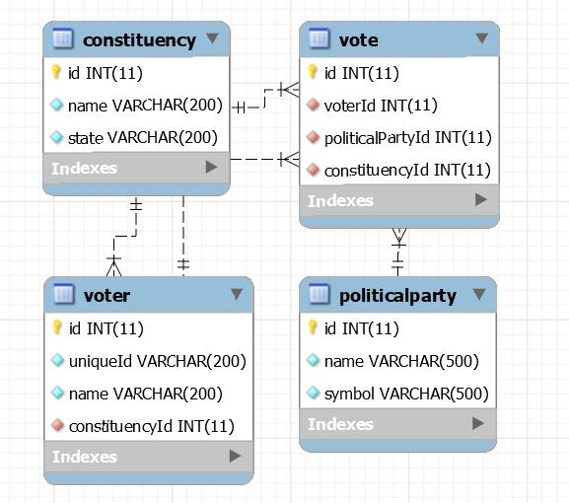
Configurable Part :

#spring.autoconfigure.exclude=org.springframework.boot.autoconfigure.jdbc.DataSourceAutoConfiguration
spring.datasource.url=jdbc:mysql://localhost:3306/electiondatabase?autoReconnect=true&useSSL=false&useOldAliasMetadataBehavior=true&useUnicode=true&characterEncoding=UTF-8
#username and password
spring.datasource.username=root
spring.datasource.password=password
server.port =7879

This is application.properties file which contains database url, server , password for connection. It also contains the server port which is 7879 for now.

private String GET_URL="http://localhost:7879/winningparty";

For load Testing , “GET_URL” variable is used to give request URL for testing inside loadTester class.

Rest web services:

- Register a voter: POST request

It’s a POST API which takes a json object with three parameter like
URL: hostname :port/registervoter

Params: {
"name" : "rohit",
"uniqueId" : "uid25",
"constituencyId" : 1
}

Return :
String containing voter Id

- Get all party Symbol : Get Request

A voter needs all party names along with symbol in order to give vote.
URL: hostname:port/allpartysymbol/{voterId}
Where voter ID is id return after getting registered.

Return:
Party symbol along with format like:

Success : Use following party symbol to cast vote for your favourite political party.

{bsp=elephant, congress=hand, bjp=lotus}

- Cast vote : POST request(as it secure than GET)

URL: hostname: port/castvote

Params :

{
"voterId" : 4,
"symbol" : "lotus"
}

Return :

String containing vote Id

- Vote Detail: GET Request
URL : hostname:port/votedetail/{voteId}
Return : Json object with parameter id, voterId,politicalPartyId
{
"id": 4,
"voterId": 4,
"politicalPartyId": 1
}
- Get Winning Party : GET request

URL : : hostname:port/winningparty
Return :
String Containing party name with seats

