Compressed Air Energy Storage Scheduling with Demand Response in Electricity Market

Aishwarya Rajendra Mulik
Department of Electrical Engineering
Rajarambapu Institute of Technology,
Shivaji University, Sakharale, Sangli
Maharasthra, India
aishwaryamulik11@gmail.com
Kailash Chand Sharma
Department of Electrical Engineering
Dr. B R Ambedkar National Institute of Technology
Jalandhar, India
sharmakc@nitj.ac.in
Pranda Prasanta Gupta
Department of Electrical Engineering
Rajarambapu Institute of Technology,
Shivaji University, Sakharale, Sangli
Maharashtra, India
prandaprasantagupta@gmail.com
Vaiju Kalkhambkar
Department of Electrical Engineering
Rajarambapu Institute of Technology,
Shivaji University, Sakharale, Sangli
Maharashtra, India
kvaijnath@gmail.com

Abstract— Due to the enormous need for electricity the power system has large integration with uncertain renewable sources. Mitigating the intermittent nature of solar power requires bulk energy storage systems (ESSs) for the fulfillment of vast energy needs in an economic way. For maintaining a balance between supplies is equal to demand the demand response (DR) programs is a tremendous option. The DR programs are ultimately used for load balance by shifting loads or load scheduling. The applied demand response theory helps in mitigating fluctuation in load and further gives a reliable and cost-effective solution. In this paper, the uncertain parameter related to solar power and the economic operation of compressed air energy storage (CAES) for large solar penetration with the DR program is deliberated. The bulk ESSs like the CAES system are a productive way for reducing irregularity of solar PV production, as it has large capacity and is environment friendly. Also, the case study is done by focusing on optimal and commercial approaches. The case study includes the IEEE six bus system along with PV modules, which offer solutions like curtailment of solar and overall cost reduction.
Keywords— Autoregressive integrated moving average, compressed air energy storage, demand response, solar uncertainty
NOMENCLATURE
A. Indices and Sets:
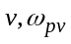 | Index and set the solar power generation
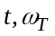 | Index and set of time in hours
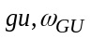 | Index and set of generation units
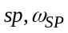 | Index and set of solar power scenarios
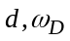 | Index and set of demand response
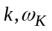 | Index and set of CAES units
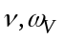 | Index and set of solar power units
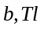 | Index of network buses and lines
B. Parameters:
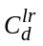 | The cost for a reduction in load of demand response program
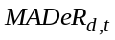 | Maximum adjustable load
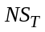 | Hours of scheduling horizon
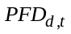 | Forecasted demand power at time
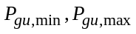 | Min/max generation limit of unit 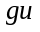
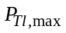 | Maximum power transmission rate of line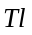
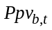 | Forecasted solar power generation at bus and time
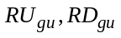 | Ramp up and down power of unit
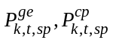 | Output power in generation and compression mode for unit at time for scenario
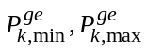 | Mini/max quantity power output of unit in generation mode
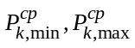 | Mini/max quantity power output of unit in compression mode
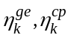 | CAES efficiency factor in generation and compression mode
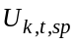 | CAES storage capacity of unit at time for scenario
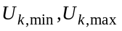 | Mini/max capacity of CAES
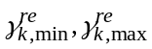 | Mini/max quantity of released air
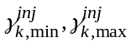 | Mini/max quantity of injected air
C. Variables:
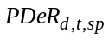 | Demand power after implementing of DR program at time for solar scenario
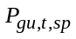 | Generated power of unit at time for solar scenario
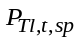 | Power flow on network line at time for solar scenario
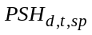 | Shiftable load at time for solar scenario
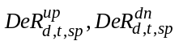 | Scheduled load up/down time at time
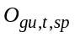 | Generator on/off status of unit at time
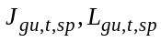 | Start-up/shut down variable of unit at time
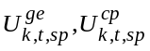 | Unit generation and compression mode status
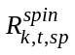 | Spinning reserve with unit at time for solar scenario
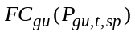 | Fuel cost of thermal unit at time for solar scenario
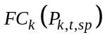 | Operating cost of CAES unit at time for solar scenario

Introduction
Nowadays, there is a huge requirement for electrical power due to growing urbanization and the usage of electricity in residential as well as in various powerful industries. To fulfill this demand there is the necessity of energy management but in an economical way. Currently, renewable energy (RE) sources like photovoltaic power generation are quite often used as fulfills enormous amounts of energy requirements. However, for mitigating the stochastic nature that comes with PV production, demand response (DR) programs are an exceptional choice along with energy storage systems. The DR programs are responsible to change energy consumption according to changes in the price of electricity for any time interval [1]. For maintaining the balance between demand and supply DR programs are being used by system operators and energy system operations. Also, the implementation of DR is beneficial for controlling demand and also mitigates wide differences in peak demand and valleys of power demand [2], [3].
For the well-founded operation of the power system, demand flexibility is a resilient solution. Due to the increasing demand for industrial and residential consumers, they are moving to become prosumers as renewable sources like solar, and wind had adopted frequently. Also, the uncertainties can be mitigated by various techniques like temperature-controlled loads for solar, etc., and provide maximum demand flexibility as it differs from user to user [5]. The time-structured way of managing energy production, transportation, and its utilization in the market considering its intermittent nature is quite challenging [6]. Nowadays, the changing demand, its price volatility, and RE intermittencies for overcrowded emerging energy systems are also studied considering correct optimal strategies and economic solutions [7]. Along with this, authors interact with both real-time and day-ahead markets and also provide different strategies for effective cost management model with combined cooling heating power taken into consideration along with the DR technique [8]. The uncertainties and problems during the integration with renewable sources can be solved with the inclusion of a thermal energy storage system also, shifting the delivery according to on\off peak hours is quite possible in this study. The algorithm proposed in the literature gives strategies for interaction with various electricity markets to control seasonal thermal energy storage systems [9]. DR programs for electric utilities also consider the management of renewable sources uncertainties. Renewable energy integration results in a reduction of consumers’ electricity bills and also helps to minimize the environmental impacts of carbon emissions [10]. According to research studies, for reducing the nature of intermittencies the various algorithms, flowcharts, and scenario-based approach is quite used [11]. Also, the scientists are motivated to do the hourly-based study for volatile nature with renewable energy sources using scenario generation and reduction techniques [12].
According to researchers, along with DR, energy storage is one of the better-option for flexible operation of power systems for the beneficial electrical market values. Due to enormous storage capacity, high efficiency, lesser operational constraint, and eco-friendly nature, the compressed air energy storage (CAES) model can deal with intermittencies of solar generation to provide reliable operation of power system [19]. In optimal function of the CAES system provides supplementary services and spinning reserve service makes the network economical [4]. However, the profitable strategies are compared and discussed in [20], giving a flexible performance of CAES in electricity markets. The detailed study CAES system including its hardware parts and operating mechanism, its various types, its interaction with the environment as well as industrial use, the applications in different fields, and developed huge projects are presented in [21], ensures CAES is one of the promising technologies. The authors also focused on cost-effective operation and surplus capacities of microgrids as they are quite enough to flatten the peak loads studied in [22]. In [23], the stochastic approach with CAES is taken into consideration for dealing with intermittencies in RE source outputs as well as price volatility.
The type of bulk ESSs infrastructure used can also impact the overall cost of the transmission network, with high-power CAES as bulk ESSs resulting in lower levels of electricity price. Moreover, user behaviours such as charging patterns in CAES with DR program can affect the loss of the network, and appropriate operation of CAES can help manage the supply, and demand and reduce network congestion.
Although there is already some research on the optimal operation of CAES with a DR program in the transmission network, there is still a need for more comprehensive analysis in this field. Therefore, the contribution of this paper can be highlighted as addressing the current gaps in research and proposing innovative solutions for the efficient utilization of ESSs infrastructure.
a) The proposed approach optimizes CAES as bulk ESS as well as uncertainties related to solar generation,
b) Stochastic approach is presented to handle the uncertain solar power generation.
c) The proposed approach superimposes the DR program on the transmission networks to smooth the load profile, reduce operational costs and handle solar power fluctuations.
Here, researchers have aimed to propose innovative solutions that consider various factors such as real-time network congestion, incentive-based DR program, network constraints, and CAES infrastructure to achieve sustainable and efficient deployment of CAES charging/discharging and solar power generation. The researcher also considered the economic feasibility and scalability of the proposed solutions to ensure their practical application in the real world.
The rest of this paper is organized as follows: Scenario generation and reduction are discussed in Section II. Section III presents the problem formulation of considering objective function, and equations for constraints related to thermal, DR program, and CAES. Section IV discusses case simulation and analysis of the results. In section V, bring a conclusion and prospect for future research.

System Model

ARIMA model
Due to the stochastic nature of the PV module and model, frequent uncertainties come along with its entire product range needed area of definite modeling. The Autoregressive integrated moving average model (ARIMA) is the appropriate method for PV forecasting. It not only predicts load data or power forecasting but is also used for the prediction of prices of electricity for market operations. This model requires stationary time series data however, the PV data is in a non-stationary format. So, before obtaining ARIMA model parameters, there is a need to convert them into stationary time series data. The ARIMA model parameters can be estimated by using equation (1) taken from reference [13].
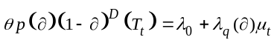 (1)
Where, is the tolerance criteria for power considering time, is the degree of differentiation, 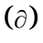is the backshift operator, 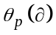is the autoregressive operator of order , 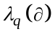is the moving average operator of order, and 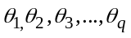is the white noise.

Scenario Generation
For obtaining accurate and optimal solutions the case studies require several scenarios. The approximation comes along with the number of repetitions for desired solutions either in any stochastic problem or any decision-based problem [12]. The algorithm for scenario generation is explained in Fig.1 and is taken from reference [13].document. Please do not revise any of the current designations.
As per Fig.1, the detailed steps for solar scenario generations are explained taken from references [12], [13].
Step 1: For scenario generation, firstly the documented data of PV radiations for any particular site is collected.
Step 2: Then, the estimation of ARIMA model parameters takes place. By using forecasted solar data, the model parameters like values of coefficients, order, and degree or white noise value can be calculated.
Step 3: The scenario generations can be initialized for getting the required number of scenarios by using an iterative process considering limited and defined time intervals.
Step 4: Also, there is a need of initializing the time counter. Here, we consider the forecasted data of 24 hours of the PV generation process.
Step 5: Identify the expression for the ARIMA model based on the particular forecasted data of solar scenarios.
Step 6: Then, PV radiations can be converted to power when the desired number of solar scenarios are generated. The value for any instant can be estimated by using a solar power curve.
Step 7: The required period counter is achieved (24 hours) then go to the subsequent step or increase the counter value.
Step 8: Similarly, get a check of scenario generations. If the desired number of scenarios is obtained then go to the next step otherwise update the scenario counter.
Step 9: Finally, after getting the required number of scenarios, assign the probability of scenarios.
Collection of data
Calibrating parameters of forecasted model
Starting of computing of scenario
Starting of time evaluation
Calculating forecasted model
PV radiation to power conversion

Check time counter
Check scenario
No
Yes
Assign scenario probability
No
Yes
Fig.1 Scenario generation algorithm

Scenario Reduction
Due to scenario generation at a huge quantity, computational operations are required for lowering its complexity to find out near-optimal solutions. Hence, after the process of scenario generation, the reduction of the scenario at desired level can give a definite solution. The algorithm for scenario reduction is explained in Fig.2 and is taken from reference [13]. Generally, the scenario reduction technique involves the elimination of scenarios having low probability and a bunch of scenarios that are close to each other. The scenario reduction technique generally involves the Kantorovich distance matrix (KD). The KD matrix considers the distance between scenarios and eliminates scenarios having low probability. The mathematical formulation obtained for the estimation of the KD matrix is taken from the reference [12].
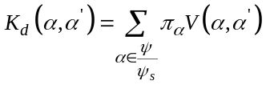 (2)
Where, 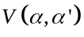 is the vector for distance considering subsets and 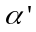. The detailed explanation for the reduction algorithm is specified stepwise is taken from reference [13].
Evaluation of distance using Kantorovich matrix
Collecting the number of scenarios
Removal of extra scenarios
Check for reduction in scenarios
End
Yes
No
Fig.2 Scenario reduction algorithm
Step 1: After obtaining a huge number of scenarios, the scenarios reduction technique uses the KD matrix for the elimination of scenarios from a bunch of scenarios.
Step 2: Then, a collection of scenarios takes place. Here, the scenario can be obtained having the lesser value of KD.
Step 3: Removal of collected scenarios having the lesser value of KD takes place. This is based on the distance of nearby scenarios.
Step 4: After getting the desired reduction of scenarios go to the next step otherwise repeat the process.

Problem Formulation
The problem statement is defined by considering thermal, CAES units along with the DR program. The objective function involves the first part is fuel cost for thermal units, the second part gives a demand response program and the last part involves the cost of a CAES.
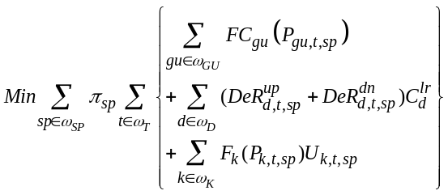 (3)
The objective function is subject to the following generator constraints: power balance constraints, ramping constraints, transmission constraints, DR constraints, and CAES constraints regarding the injection and pumping of air, power equations, and capacity of the system. Also, the spinning reserve constraints.

Thermal unit constraints
The thermal equations specified are taken from reference [14] as follows: The thermal capacity of power units is limited by constraint (4).
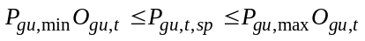 (4)
The ramping constraints are added in the model to allow operators to restrict capability in how it can increases or decreases its output level for an actual match of changing demand. The thermal unit ramp-up and down constraints are given by constraints (5) and (6). Constraints (7) and (8) describe the start-up and shutdown indicators.
(5)
(6)
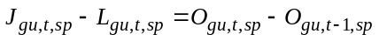 (7)
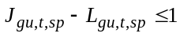 (8)

Transmission constraints
The power balance constraints described by constraint (9) for the system and the limit for power flow through the transmission line given through constraint (10) are taken from reference [14].
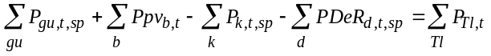(9)
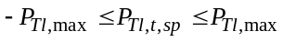 (10)

DR constraints
This study involves the DR program on the basis of incentive-based and also cost function for the DR program is defined in the objective function. After using the DR program, the net load of the power grid is given by constraint (11) and the total that can be shifted on an hourly basis is given by (12). Also, the net shifting of demand in the dispatch time interval must be equal to zero, which is given by constraint (13), and limits for hourly adjustable load are given in constraints (14) and (15).
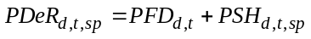 (11)
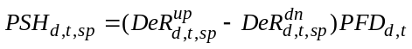 (12)
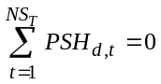 (13)
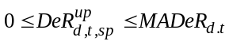 (14)
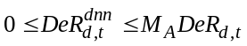 (15)

CAES constraints
Along with demand response, energy storage devices play an important role in dealing with intermittencies of RE sources. Due to vast storage capacity like pumped hydro storage, lesser operational constraints, and eco-friendly nature the CAES is quite efficient. For convenient functioning of the grid system, the CAES provides flexible operation along with the DR program. For maintaining the power system equation of supply of electricity must be equal to demand, the CAES dispense the energy sky-craping demand and reserve energy at the time of less demand. The detailed block diagram shown in Fig.3 is referred from reference[16].
During lesser demand, the need for electricity is low or medium. At this stage, the CAES system can store surplus generation. The CAES can be stored in an underground cavern or sometimes artificial caverns also be built for small-scale application. On the other hand, during on-peak hours, even the great need for electric power is satisfied by the CAES system. The pressure gets liberated by the expander making energy for use.
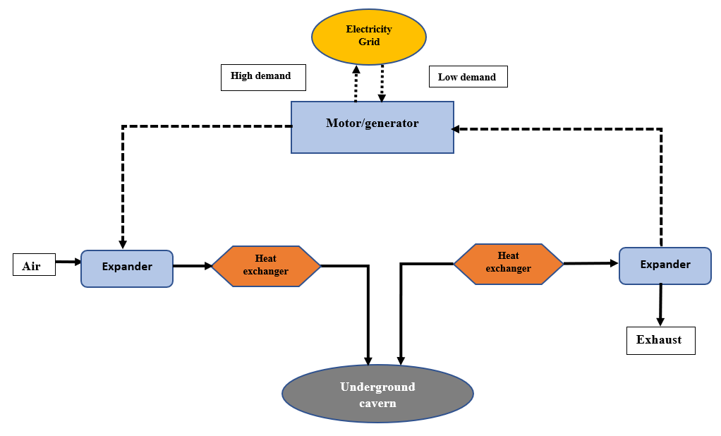
Fig.3 Schematic of Compressed air energy storage
The constraints for the CAES system are explained from equations (16)-(25). The concurrent charging and discharging of the CAES system can be restricted by constraint (16). The utilized and produced amount of power is given by constraints (17)-(18) depending upon the quantity of compressed or expanded air and efficiency. The quantity of compressed air and expanded air is bounded by constraints (19)-(20). The storage capacity for CAES is given by constraint (21) and (22) puts restrictions on it. The constraints (23)-(24) present restrictions on the utilized and produced amount of power by the CAES system. Along with this service, the CAES also can provide the spinning reserve for higher demand or emergency conditions. Also, constraint (25) provides auxiliary services [17], [18].
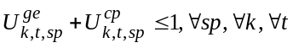 (16)
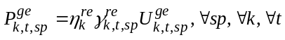 (17)
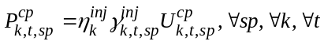 (18)
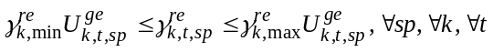 (19)
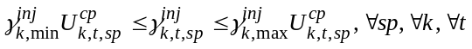 (20)
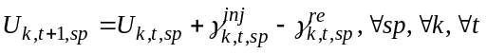 (21)
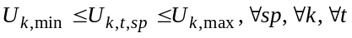 (22)
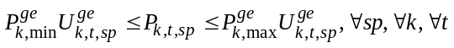 (23)
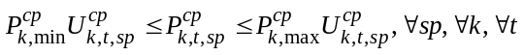 (24)
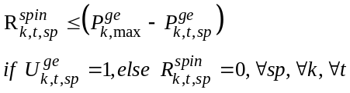 (25)

Case Study and Simulation Results
The modified IEEE six-bus system shown in Fig.4 is considered for the case study. Three thermal units, one solar farm, four gearbox lines, two tap changers and one phase shifter. The solar farm with a capacity of 75 MW is located at bus number 4. The maximum and minimum CAES capacities are 1000 and 100 MW, respectively, as are the maximum and minimum released air capacities of 100 and 5 MW, and the maximum and minimum compressed air capacities of 100 and 5 MW.
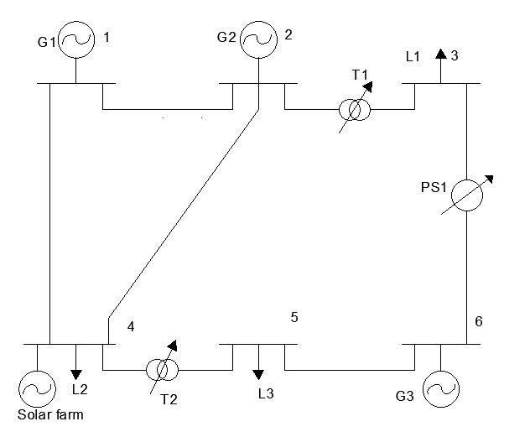
Fig.4 IEEE Six bus system
The above will be used as the base data of wind and CAES units [12]. Then GAMS software will be used to build the solar farm with the CAES model, and the simulation experiments will be performed on a computer equipped with a CPLEX solver, CPU @ 2.80GHz, and 8GB RAM.

Uncertainty modeling of solar power generation
The historical PV data was taken from the Illinois Institute of Rural Affairs, USA [11]. The PV panel area, efficiency, and performance factor considered for this study are 3.5 Km2, 15%, and 75% respectively.
The forecasted data for solar PV power and data for hourly load are given in Fig.5. The data is taken for a time of 24 hours.
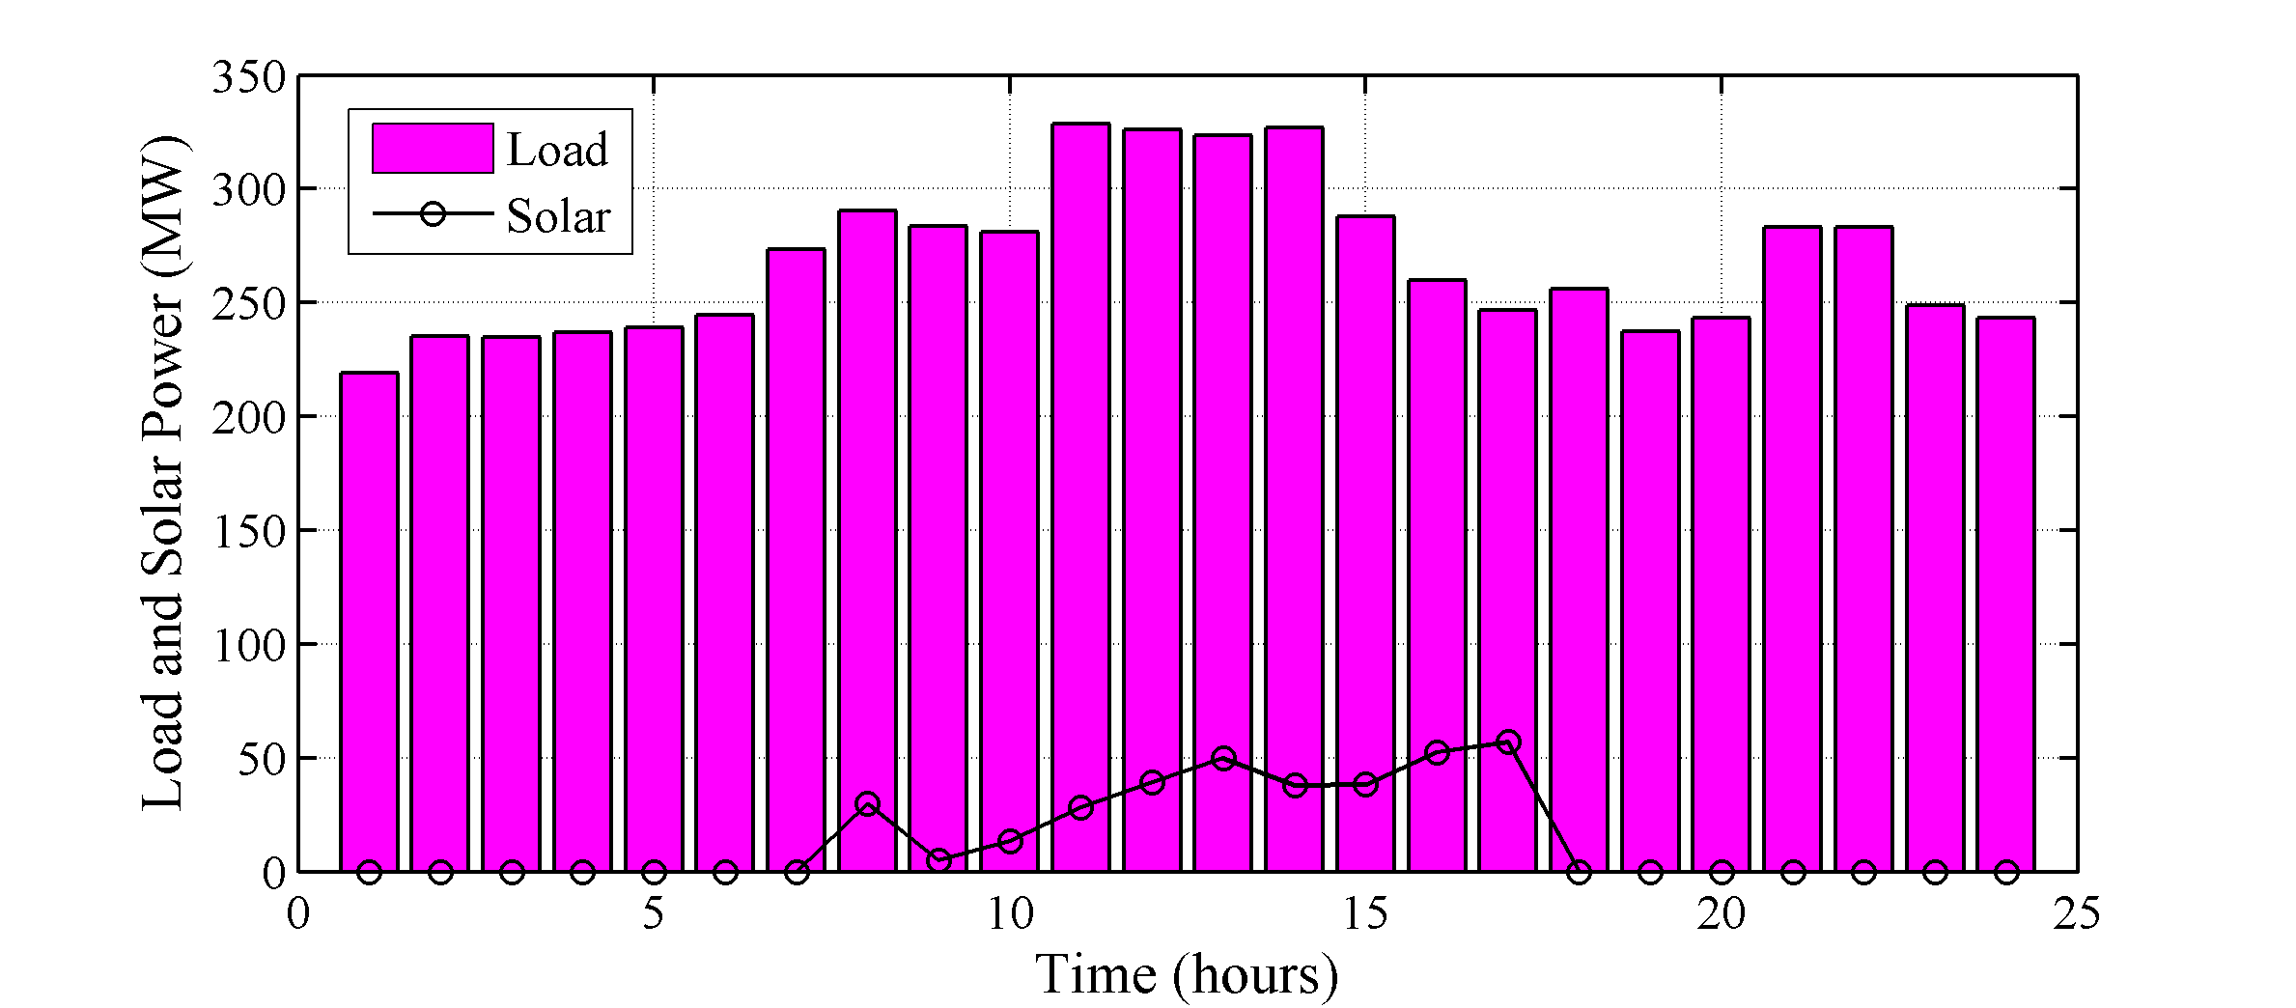
Fig.5. Forecasted PV power and Load data [15]
The modeling of PV uncertainties is done by using scenario generation and reduction algorithms. Approximately, for the time of 24 hours, there is the generation of 1000 scenarios for every hour. The generated scenarios were then reduced by using the backward algorithm method up to 12 scenarios only. The reduced number of scenarios is 10,990 Iteration.

Simulation Results
The simulation results involve dispatch for 24 hours for considering three generators G1, G2, and G3. In scheduling time interval data, the parameters of thermal units, buses, system load, and transmission lines are provided in reference [15].
Case 1: Scheduling with solar PV farms
In this case, the forecasted solar PV data is considered for 24 hours. Unit 1 is dispatched for entire 24 hours. When the system demand is large in the coming hours, this stored energy will be used. Because bus 1 is the cheapest grid unit as well as the cheapest solar PV farm, the power system tends to provide the majority of the necessities power from bus 1. However, unit 2 is dispatched for 13 to 24 hours and Unit 3 is dispatched for 11 to 24 hours as explained in Fig.6. The overall cost for Case 1 is $85432.11, which is less than the case without ESSs, which is $87562.43. Also, the 322 seconds required for operation execution.
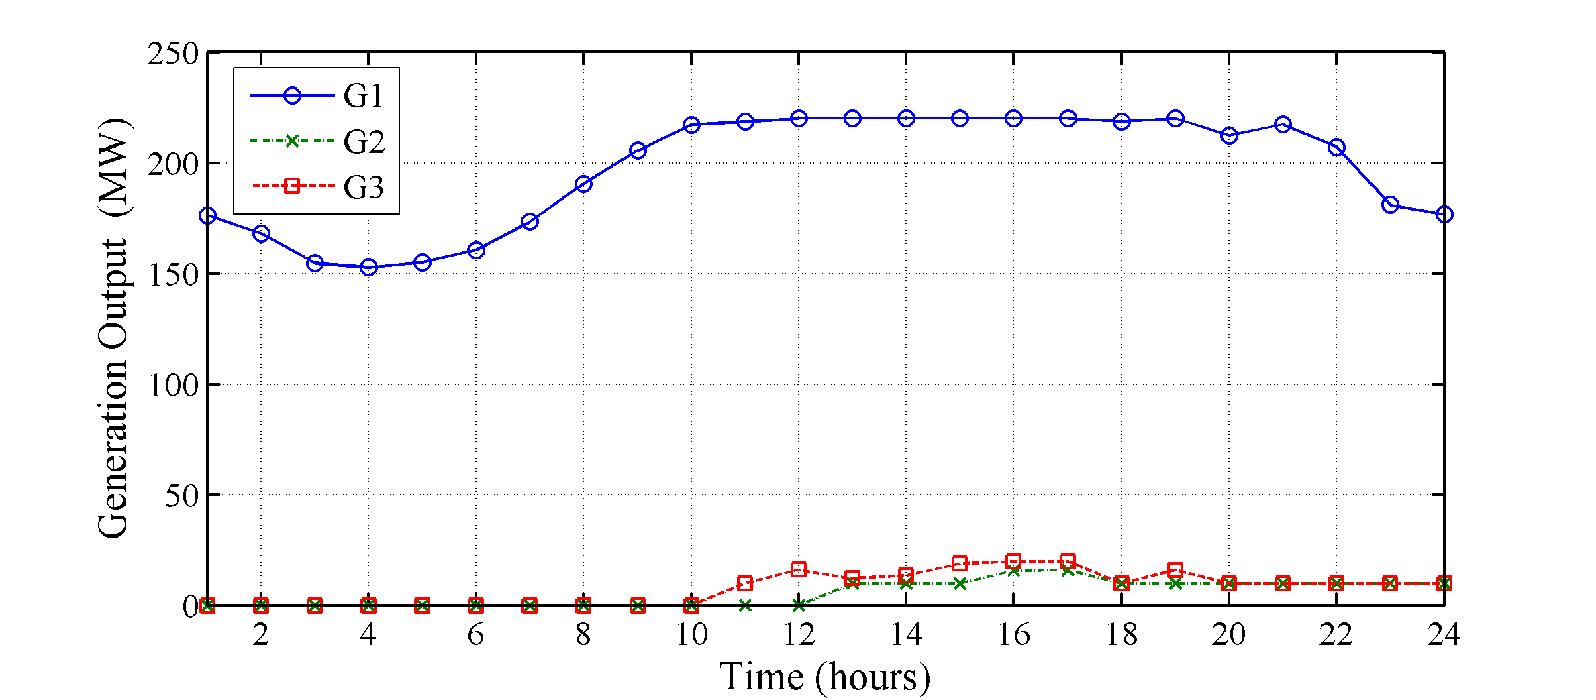
Fig. 6 Generation dispatch with solar PV farm
Case 2: Scheduling with solar power and CAES
The second case study defines the benefits of the implementation of CAES. It considers the generation dispatch (MW) with solar power and the DR program is explained in Fig.no. 7. The first unit is always dispatched for 24 hours. Unit 2 is dispatched between 2 to 24 hours and unit 3 is dispatched between 11 to 24 hours. The overall cost for case 3 is $81321.54 which shows the cost reduction due to the implementation of CAES units. Because of the effect of CAES on reducing network congestion in this case, the economical unit G1 is scheduled more frequently, while the dispatch of 2 more costly units is decreased completely. However, large power may be transmitted from bus 1 to high-load centers, which are home to the cheapest units and solar PV farms. The computational time required for case 3 is 450 seconds.
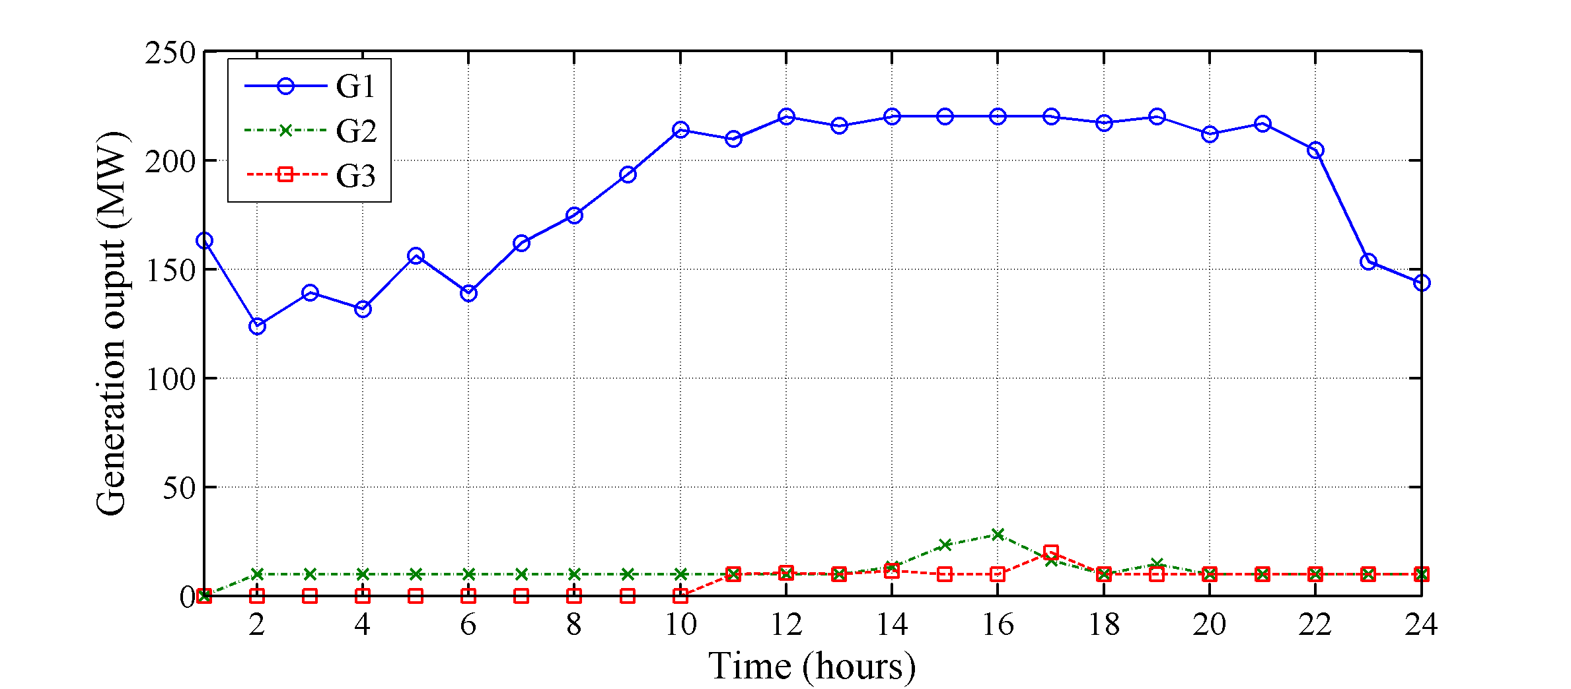
Fig. 7 Generation dispatch with solar PV power and CAES
Case 3: Scheduling with solar uncertainty, CAES, and DR program
In this section, a stochastic model in the power system with CAES, uncertain solar PV power, and a DR program is built. The stochastic optimization method with the ARIMA methodology is used to deal with solar power uncertainty. The hourly commitment of generation units is depicted in Fig. 8. This graph shows that adopting the DR program increased the generation of the cheapest unit 1 while decreasing the generation of unit 3. Furthermore, throughout the scheduling horizon, the most expensive unit 2 is turned off. In this situation, the total operating cost is $79821.54. However, the final cost is very dependent on the uncertainty modeling of anticipated solar PV power.
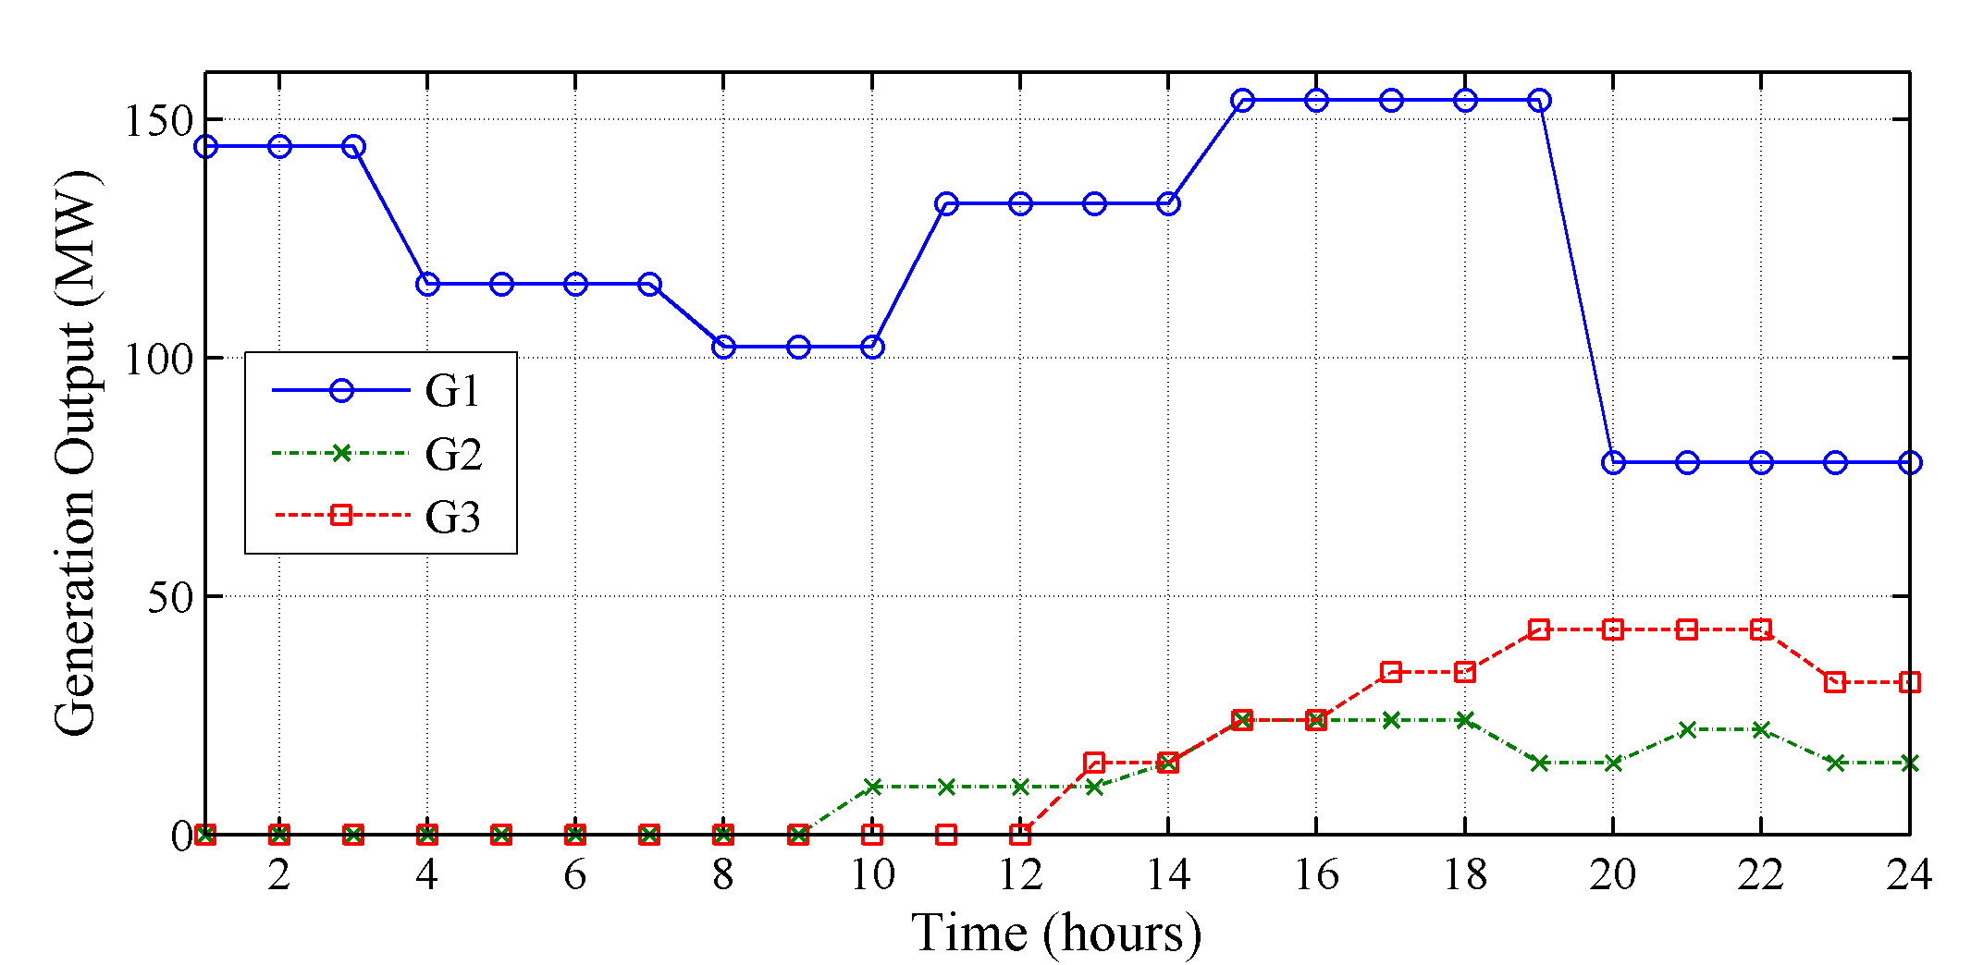
Fig. 8 Generation dispatch with CAES and DR program
The positive number in this Fig. 9 denotes discharging or generation mode, whereas the negative parts is related to CAES compressor mode. In Case 3, the producing and compressor modes of CAES are determined by the load profile and solar PV generation. When the hourly demand is low and solar PV power is enough, CAES will compress the air during off-peak hours. During peak demand, however, the CAES will provide the load to relieve the system of producing from expensive generating units such as G1. When the load falls from a higher value than the previous hour, CAES operates in compressor mode for 1 to 2 hours and 12 to 14 hours, as indicated in Fig.9. The graph also demonstrates that the generating mode of CAES is at a high value during system demand peak hours, which are 6 to 10 hours and 18 to 20 hours, respectively.
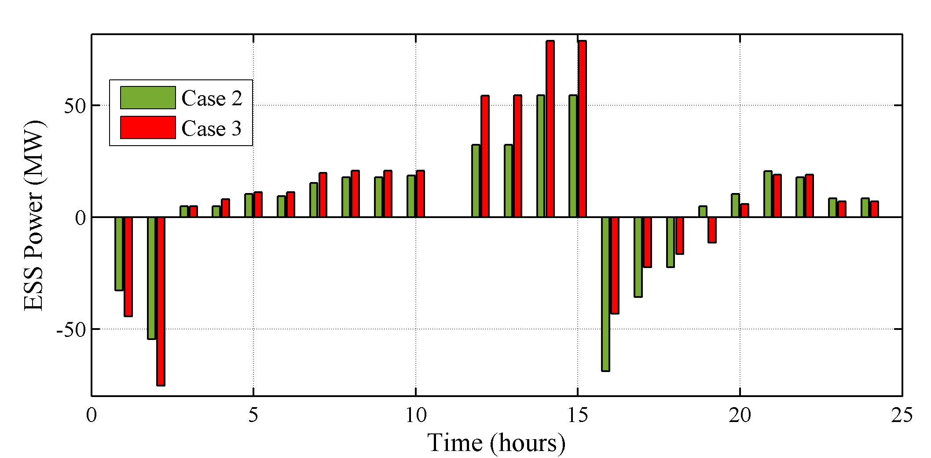
Fig. 9 Charging and discharging power of CAES

Economic Analysis

A comparative study using a DR program is done. The shifting of load from on-peak hours to off-peak hours can be done by using the DR strategies.
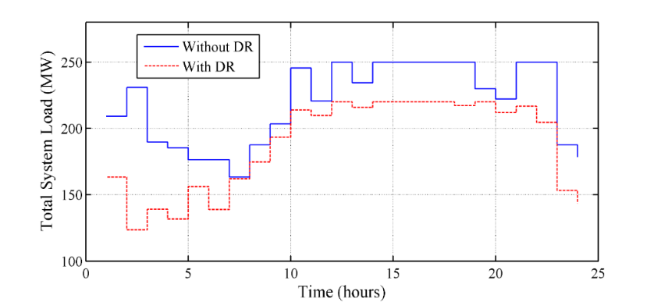
Fig.10 System load with or without DR program

As per observation, by using the DR program the load graph is gently reorganized, reshaped, and becomes very smooth in nature as compared to without the DR program as dissipated in Fig.10. Implementation of the demand response program is beneficial as shifting of load gives profit in electricity markets.

Table I displays the outcomes of a six-bus system in three cases. This work investigates the overall costs of several cases considered and deliberated in the earlier section. Table I summarizes the operational cost and CPU time for each case. The total operational cost for the first case, the solar PV units i.e., $85432.11. In Case 2, the likely operational cost is decreased by the addition of CAES, i.e., $81321.54 which has lesser marginal costs than thermal units. Case 1’s total cost is expected to be slightly higher than Case 2's due to the solar farm. Case 3 has a lower overall cost of CAES with the DR program than Case 1. The detailed comparative study is given in Table 1. It gives information about the amount of minimization in overall cost and computational time required for three cases studied on the IEEE six bus system.
- Cost Analysis on IEEE six bus system
Case | Overall Cost ($) | Computational Time (s)
Case 1 | 85432.11 | 322
Case 2 | 81321.54 | 450
Case 3 | 79821.54 | 598

Conclusions
The proposed model helps to optimize uncertainties of renewable energy sources. Demand response management reduce the grid operational cost and helps in growing electricity markets. The proposed methods prescribe an effective and economic approach for electricity markets and load management considering DR programs. Efficient energy management optimize fluctuating load parameters and provide reliable power supply. The approach considering CAES systems along with DR programs gives optimal solutions for network problems and provides cost-effective energy management. This proposed work gives way to flattening loads by reducing curtailment of RE sources and thereby gives an energy-efficient structure for the grid.
This paper can be expanded in the future to include the use of solar power generation in the energy and reserve market when DR programs are considered.

References
- Eghbali, Nazanin, et al. "Stochastic energy management for a renewable energy-based microgrid considering battery, hydrogen storage, and demand response." Sustainable Energy, Grids and Networks vol.3, pp.100652, 2022.
- Li, Chunyan, et al. "Multi -objective day-ahead scheduling of power market integrated with wind power producers considering heat and electricity trading and demand response programs." IEEE Access vol.7, pp.181213-181228, 2019
- Herath, Pramod, and Ganesh Kumar Venayagamoorthy. "Scalable Residential Demand Response Management." IEEE Access vol.9, pp. 159133-159145, 2021
- Aldaadi, Mohsen, et al. "A coordinated bidding model for wind plant and compressed air energy storage systems in the energy and ancillary service markets using a distributionally robust optimization approach." IEEE Access vol.9, pp.148599-148610, 2021
- Pathiravasam, Chirath, and Ganesh K. Venayagamoorthy. "Distributed Demand Response Management for a Virtually Connected Community with Solar Power." IEEE Access vol.10, pp.8350-8362, 2022
- Gupta, Pranda Prasanta, et al. "Battery energy storage train routing and security-constrained unit commitment under solar uncertainty." Journal of Energy Storage vol.55 pp.105811, 2022
- Jadidbonab, Mohammad, et al. "Risk‐constrained energy management of PV integrated smart energy hub in the presence of demand response program and compressed air energy storage." IET Renewable Power Generation vol.13, no.6, pp.998-1008, 2019
- Wang, Dongxiao, et al. "Optimal energy scheduling for the data center with energy nets including CCHP and demand response." IEEE Access vol.9, pp.6137-6151, 2021
- Lago, Jesus, et al. "Optimal control strategies for seasonal thermal energy storage systems with market interaction." IEEE Transactions on Control Systems Technology vol.29, no.5, pp.1891-1906, 2020
- Rehman, Ateeq Ur, et al. "An Efficient Energy Management in Smart Grid Considering Demand Response Program and Renewable Energy Sources." IEEE Access vol.9, pp.148821-148844, 2021
- Wang, Jianhui, Mohammad Shahidehpour, and Zuyi Li. "Security-constrained unit commitment with volatile wind power generation." IEEE Transactions on Power Systems vol.23, no.3, pp.1319-1327, 2008.
- Sharma, Kailash Chand, Prerna Jain, and Rohit Bhakar. "Wind power scenario generation and reduction in stochastic programming framework." Electric Power Components and Systems vol.41,no.3,pp.271-285, 2013.
- Prakash, Vivek, et al. "Modified interval‐based generator scheduling for PFR adequacy under uncertain PV generation." IET Generation, Transmission & Distribution vol.13, no.16, pp.3725-373, 2019
- Ebadi, Ramin, et al. "Coordinated power and train transportation system with transportable battery-based energy storage and demand response: A multi-objective stochastic approach." Journal of Cleaner Production vol.275, pp.123923, 2020
- Rezaei, Navid, et al. "Overview on energy storage technologies." 2018.
- Yu, Qihui, et al. "A review of compressed-air energy storage." Journal of Renewable and Sustainable Energy vol.11, no.4, pp.042702, 2019
- Gupta, Pranda Prasanta, et al. "Stochastic scheduling of compressed air energy storage in DC SCUC framework for high wind penetration." IET Generation, Transmission & Distribution vol.13, no.13 pp.2747-2760, 2019
- Moazzami, Majid, et al. "Probabilistic SCUC considering implication of compressed air energy storage on redressing intermittent load and stochastic wind generation." International Journal of Renewable Energy Research (IJRER) vol.8, no.2, pp. 767-783, 2018
- Chen, Laijun, et al. "Review and prospect of compressed air energy storage system." Journal of Modern Power Systems and Clean Energy vol4, no.4 pp.529-541, 2016
- Lund, Henrik, and Georges Salgi. "The role of compressed air energy storage (CAES) in future sustainable energy systems." Energy conversion and management vol.50 no.5, pp.1172-1179, 2009
- Wang, Jidai, et al. "Overview of compressed air energy storage and technology development." Energies vol.10, no.7, pp.991, 2017
- Bagherzadeh, Leila, et al. "A short-term energy management of microgrids considering renewable energy resources, micro-compressed air energy storage and DRPs." International Journal of Renewable Energy Research vol.9, no.4, pp.1712-1723, 2019
- Mirzapour-Kamanaj, Amir, et al. "Optimal Look-Ahead Strategic Bidding/Offering of Integrated Renewable Power Plants and CAES with Stochastic-Robust Approach." IEEE Access vol. 10, pp.107901-107912, 2022.

