Project Report

CSE0001 – Digital Literacy

Digital Literacy Portfolio
Name | Kashvi Khosla
Reg. No. | 25BAI11038
Branch | B.Tech – CSE (AI & ML)
Year | First Year
Course Code | CSE0001
Course Title | Digital Literacy

Introduction
This project report documents my work as a Student Digital Ambassador at VIT Bhopal University for the CSE0001 Digital Literacy course. The core objective of the assignment is to build a Digital Literacy Portfolio that can be shared with peers and presented to the faculty committee. The project is divided into five tasks, each aligned with one module of the course: creating an awareness infographic, building a student digital portfolio, exploring coding and collaboration platforms, practising professional email communication, and studying cybercrime awareness.
This report covers all five tasks in full. Task 1 required designing a one-page visual infographic on Digital Literacy using Canva. Task 2 involved setting up a professional student digital portfolio across LinkedIn, GitHub, and Kaggle. Task 3 required completing a HackerRank coding challenge and building a Google Form quiz. Task 4 covers a reflection on a real-world poor digital communication scenario. Task 5 focuses on cybercrime awareness — specifically UPI and online payment fraud — including what surprised me most during research and one habit I will personally change as a result.

Task 1 – Digital Literacy Awareness Infographic

1. Tool Used
For this task I used Canva (canva.com), a free, browser-based graphic design platform. Canva was chosen because it provides a large library of pre-built infographic templates, drag-and-drop editing, and free export options — all without requiring any prior design experience. No software installation was needed, which aligned perfectly with the project's browser-based workflow requirement.

2. What the Design Shows
The infographic is a single-page portrait-format poster with a clean light-blue colour scheme. It covers three prescribed topics:
- What is Digital Literacy? — The top section defines digital literacy in simple language: knowing how to use digital devices and the internet safely and effectively. A bold tagline, 'Be smart online, stay safe, and use technology wisely', reinforces the core message.
- Useful Internet Tools for Students — The middle section lists seven practical tools commonly used in academic life: Google Classroom (assignments), Zoom / Google Meet (online classes), Google Docs (note-taking), PowerPoint / Canva (presentations), YouTube (learning videos), Dictionary apps, and Calculator apps. Each entry is paired with a short description so batchmates immediately understand its purpose.
- Professional Online Presence — The bottom section explains what a professional online presence means and provides five actionable tips: use polite language online, share positive content, keep profiles clean and respectful, be responsible on social media, and build a good digital image.
The visual design uses a laptop-and-book icon in the header, illustrative character graphics to add context, and a structured file-drawer illustration in the tools section to symbolise organised digital resources. The consistent colour palette and bold headings make the poster easy to scan at a glance, which is important for an awareness resource intended for first-year students.

3. Reflection – Challenges and Observations
The most interesting part of making this infographic was realising how much thought goes into visual hierarchy — deciding what information the reader sees first and how to guide their eye down the page. I initially tried to include all five prescribed topics, but the poster quickly became cluttered. Narrowing the focus to three topics and allowing enough white space around each section was the key design decision.
The most difficult aspect was choosing appropriate illustrations that matched the tone without being distracting. Canva's free icon library is large, but finding icons that were both relevant and visually consistent required several rounds of searching and swapping. This taught me that good design is as much about curation and restraint as it is about creativity.

Infographic Preview
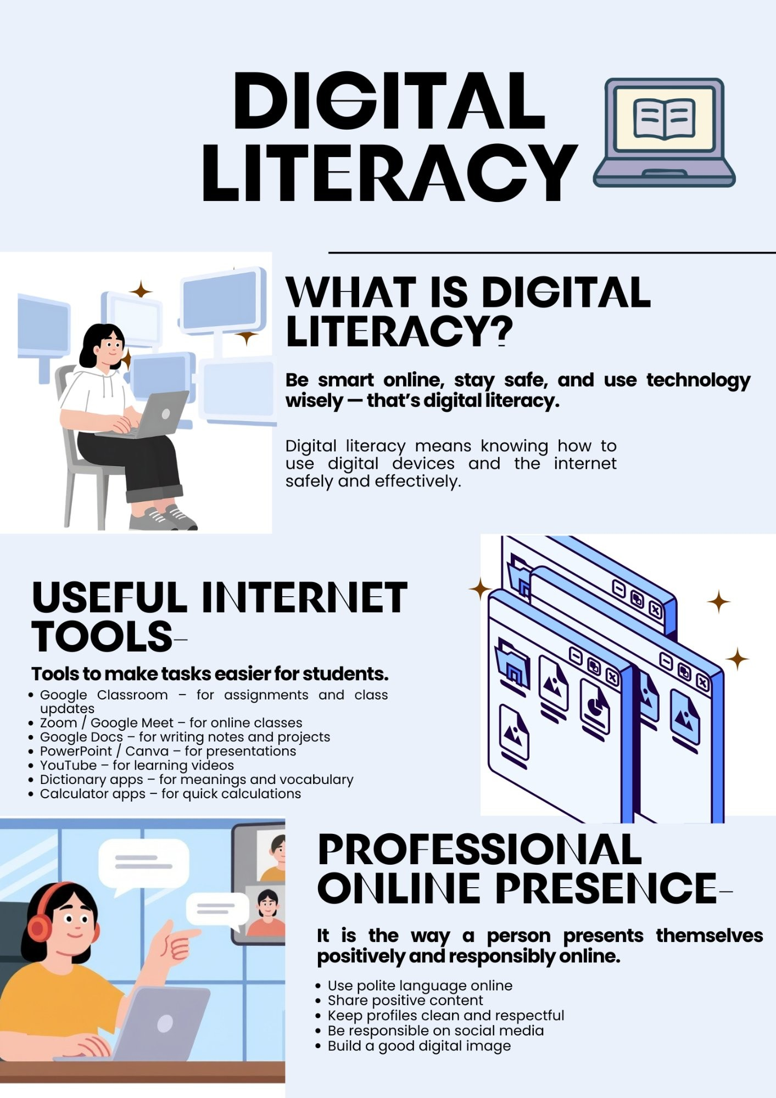
Figure 1 – Digital Literacy Awareness Infographic created using Canva

Task 2 – Build Your Student Digital Portfolio

1. Platforms Set Up
For Task 2, I created and configured accounts on three platforms — LinkedIn, GitHub, and Kaggle. Below is a brief overview of each platform and the steps taken to set it up.
Platform | What It Is Used For | What I Set Up
LinkedIn linkedin.com | LinkedIn is the world's largest professional networking platform. It is used by students, job seekers, and industry professionals to build connections, showcase qualifications, and discover internship and job opportunities. | Created a profile and filled in the Education section with my current degree, institution (VIT Bhopal University), branch, and expected graduation year. Set the profile to reflect a professional and minimal appearance.
GitHub github.com | GitHub is a cloud-based platform for hosting code repositories and collaborating on software projects. It is the industry-standard tool for version control using Git, and is widely used by developers, students, and open-source communities worldwide. | Created an account using my college email and set up a public repository named digital-literacy-project. Created a profile README with my name, branch, year, and a learning goal statement. Also created the required folder structure for all five project tasks.
Kaggle kaggle.com | Kaggle is the world's largest platform for data science and machine learning. It hosts competitions, datasets, and notebooks, and serves as a portfolio platform for aspiring data scientists and analysts to practise skills and showcase their work. | Created an account and set up a basic profile. Kaggle was chosen because it is directly relevant to the growing importance of data literacy and will be useful for exploring machine learning concepts in later semesters.

2. Purpose of Each Platform
Each platform serves a distinct purpose in a student's digital presence. LinkedIn functions as a professional identity card — it is the first place recruiters and internship coordinators look. Having an updated Education section establishes credibility even at the first-year stage. GitHub acts as a living portfolio of technical work. Every project, assignment, or experiment committed to GitHub becomes visible evidence of skills and initiative. The profile README, in particular, is a developer's first impression — it communicates who I am and what I am working towards. Kaggle is more specialised — it is a platform where data science skills are practised and benchmarked through competitions and public notebooks. Even without advanced knowledge yet, having an account and exploring the platform early builds familiarity with data-driven thinking, which is increasingly relevant across all engineering disciplines.

3. Future Plans – How I Will Use These Platforms Over Four Years
- Year 1 (Now): Keep all profiles minimal and professional. Use GitHub to host this project repository and any subsequent coursework. Use LinkedIn to connect with classmates and faculty. Explore Kaggle's beginner notebooks to understand what data science involves.
- Year 2: Begin uploading small coding projects to GitHub. Earn at least one verified skill badge on LinkedIn (e.g., Python or Excel). Attempt a beginner Kaggle competition or complete a guided dataset analysis.
- Year 3: Use GitHub to document internship projects and personal projects. Update LinkedIn with internship experience, certifications, and recommendations. Use Kaggle to participate in active competitions and build a public notebook portfolio.
- Year 4: Present a polished GitHub profile as part of campus placement preparation. Ensure LinkedIn is fully optimised with projects, skills, and at least three connections who can endorse key competencies. Kaggle rank and public notebooks serve as evidence of practical data skills for data-related roles.

4. Reflection
Before this task, I had heard of LinkedIn and GitHub but had never created accounts on either. Setting them up made me realise how early one's digital professional identity begins to form. The most surprising insight was that a GitHub profile README — a simple markdown file — is treated by the developer community in the same way a LinkedIn headline is treated by recruiters. Both require you to articulate what you do and what you are working towards, even when you are just starting out.
The most challenging part was writing the GitHub profile README concisely. It was tempting to leave it blank or write something vague, but the task pushed me to commit to a specific learning goal in writing — which, in itself, felt meaningful. Kaggle was the least familiar of the three, and exploring its interface gave me an early glimpse into what data science workflows look like, which I found genuinely interesting even at this early stage of my degree.

Task 3 – Explore Coding & Collaboration Platforms

Overview
Task 3 is divided into two parts. Part A required creating an account on a coding practice platform and completing at least one beginner-level challenge. I chose HackerRank for this. Part B required building a five-question Digital Literacy Awareness Quiz using Google Forms, with responses linked to a Google Sheet. Both parts together build familiarity with the kinds of tools used in real academic and professional environments.

Part A – Coding Practice on HackerRank
Platform: HackerRank (hackerrank.com) is one of the most widely used online platforms for coding practice and skill assessment. It is used by students to build programming skills and by companies to conduct technical screening tests during hiring. The platform offers structured problem sets categorised by language, difficulty, and domain — making it easy for beginners to find a suitable starting point.
Challenge Completed: I completed the 'Solve Me First' challenge under the Practice section. This challenge asks the user to write a function that takes two integers as input and returns their sum. While the problem itself is simple, it introduced the HackerRank environment — including how to read input, write output, and submit a solution for automated testing. The solution was accepted, marked correct, and a badge was awarded upon completion, which is now visible on my HackerRank profile.
What I Learned: Even a beginner challenge taught me something important: competitive coding platforms evaluate not just whether an answer is correct, but whether the code handles all edge cases and runs within time limits. This is different from writing code in a notebook or editor where there is no automated judge. Understanding how test cases work — including hidden ones — is a foundational skill for any technical interview or coding contest.

Part B – Google Forms: Digital Literacy Awareness Quiz
Platform: Google Forms is a free, browser-based tool from Google Workspace that allows anyone to create surveys, quizzes, and feedback forms. Responses are automatically collected into a linked Google Sheet, making it easy to view, analyse, and share results. It requires no installation and works seamlessly across devices.
What I Built: I created a five-question Digital Literacy Awareness Quiz designed to test my batchmates' basic understanding of digital tools, online safety, and professional behaviour online. The form includes the required question types — at least one multiple choice question and one short answer question. The questions are:

Q# | Question | Type
1 | Which of the following is a cloud collaboration tool? | Multiple Choice
2 | What is digital literacy? | Short Answer
3 | Which platform is commonly used for coding practice? | Multiple Choice
4 | What should you do to protect your online account? | Multiple Choice
5 | Name one benefit of using Google Forms for collaboration. | Short Answer
The form was created and is live. The link has been added to the GitHub repository README, and a screenshot of both the form and the linked Google Sheet (response view) has been saved to the task-3-platforms/ folder. Responses collected through this form can genuinely be used as part of the Digital Ambassador role — making it a real deliverable, not just an exercise.

How These Tools Will Help Academically
HackerRank will serve as my primary coding practice ground throughout my B.Tech. Most companies that visit for campus placements use HackerRank-style online assessments as the first round of selection. Getting comfortable with the platform early — understanding the interface, submission process, and test case logic — removes one barrier when it matters most. I plan to gradually work through the Python and SQL tracks as these subjects appear in my curriculum.
Google Forms, on the other hand, is a practical collaboration tool I can use immediately. From collecting peer feedback on group projects, to running quick polls in study groups, to creating quizzes for revision — it is versatile and requires zero technical setup. The integration with Google Sheets means that any data collected is automatically organised and ready to analyse, which is a skill directly relevant to data handling and research methodology in later academic years.

Reflection
The most interesting discovery from this task was how differently HackerRank evaluates code compared to simply running it on a personal computer. The automated judge tests every solution against multiple hidden inputs, which means a solution that appears to work locally can still fail if it does not handle edge cases. This shift in perspective — from 'does it run?' to 'does it always work correctly?' — is a fundamental part of thinking like a software engineer.
Designing the Google Form quiz was more thoughtful than I initially expected. Writing five clear, unambiguous questions on digital literacy — where the correct answer is not too obvious but not unfair — required me to revisit the course material and think from a quiz-taker's perspective. This exercise reinforced my own understanding of the topics more than simply reading about them would have.

Task 4 – Professional Email & Etiquette Guide

Reflection – Poor Digital Communication: Scenario & Key Learnings
In 2013, a newly hired employee at a PR firm in the United States tweeted a poorly worded joke just before boarding a flight to South Africa. Within hours, the tweet had been seen by thousands of people worldwide. By the time her plane landed, she had been dismissed from her job and her name was trending globally — all from a single carelessly written post that took seconds to publish but caused irreversible damage to her career and reputation.
The core problem was a complete failure to consider audience and consequence before posting. Social media is not a private space — even a small account can reach a massive audience within minutes if content is shared or reported. What could have been done differently is simple: pause, re-read, and ask 'Would I be comfortable if my employer or the general public saw this?' That single moment of reflection before hitting 'Post' would have prevented the entire situation. This incident is a powerful reminder that digital communication, unlike spoken words, is permanent and global.

Task 5 – Cybercrime Awareness Case Study & Prevention Guide

Reflection – What Surprised Me Most & One Habit I Will Change
While researching UPI and online payment fraud, the most surprising discovery was how ordinary and polished these scams look. I had assumed that fraud messages would be obviously suspicious — full of spelling mistakes or strange formatting. In reality, fraudsters create near-perfect replicas of official bank notifications, NPCI alerts, and government payment portals. Some even spoof verified-looking sender IDs and use urgency tactics — such as 'your account will be blocked in 24 hours' — to push victims into acting without thinking. What struck me most was learning that even educated adults fall for these scams, which made me realise that awareness, not intelligence, is the real defence.
The one habit I will personally change is how I handle unexpected payment requests. Before this research, I would have likely scanned a QR code or clicked a link if the message seemed to come from a trusted source. Going forward, I will follow a simple personal rule: receiving money never requires entering a UPI PIN. If any app, link, or person asks for my PIN to 'complete a transfer to me', I will immediately treat it as a scam, close the app, and report it to the National Cyber Crime Portal (cybercrime.gov.in) or call Helpline 1930. This single rule, if followed consistently, would prevent the majority of UPI fraud cases targeting college students in India.

Conclusion – Overall Learning from the Project
When I first read the project brief, the five tasks seemed like a checklist — create an infographic, set up some accounts, complete a coding challenge, write a couple of emails, read about cybercrime. Looking back after completing all of them, I realise that what the project actually built was something much more cohesive: a foundation for how to exist and operate in a digital world professionally, safely, and responsibly.
The most immediate shift in my thinking came from Task 2. I had never considered that a GitHub profile README or a LinkedIn Education section could matter at the first-year stage. I assumed those were things you filled in when you had something impressive to show. What I learned is that the habit of maintaining a professional digital presence has to be built early — because by the time you have something impressive to show, you want the infrastructure already in place. Starting minimal and professional now is far better than scrambling to build a profile from scratch in the final year.
Task 1 taught me that communication is design. Choosing what to include, what to leave out, and how to arrange information visually is a skill in itself — one that applies equally to a presentation, a README file, a LinkedIn summary, or an email subject line. The infographic exercise made me think about audience in a way that pure writing exercises rarely do: who is reading this, how much time do they have, and what is the single most important thing I want them to take away?
Task 3 introduced me to two types of tools I will use throughout my degree. HackerRank gave me my first real experience of automated evaluation — a system that does not care about effort or intent, only whether the output is correct for every possible input. That rigour is uncomfortable at first, but it is precisely the standard that the industry applies. Google Forms, by contrast, showed me how quickly a useful collaborative tool can be built with zero technical effort — a reminder that digital literacy is not only about coding, but also about knowing which tool is right for which problem.
Tasks 4 and 5 were, in some ways, the most personally relevant. The Task 4 reflection on the 2013 tweet incident reinforced something I intellectually knew but had never applied consciously: that digital communication is permanent and public in a way that spoken words are not. Every post, comment, or message I send is a record. The Task 5 research into UPI fraud was genuinely alarming — not because the scams are technically sophisticated, but because they are psychologically sophisticated. They exploit trust, urgency, and familiarity, and they are designed to make the victim feel that not acting immediately is the risky choice. Knowing this changes how I will respond to any unexpected financial request, however legitimate it appears.
Taken together, the five tasks of this project cover the full range of what digital literacy means in practice: creating clear and purposeful digital content, building a credible and professional online identity, using the right platforms for the right purposes, communicating with care and professionalism, and protecting yourself and others from digital threats. These are not skills that become relevant after graduation — they are relevant from the first week of college, and this project made that clear in a way that a lecture or a textbook chapter alone could not.
The GitHub repository that houses all of this work is itself a deliverable I am genuinely glad to have. It is the first entry in what I intend to build into a meaningful technical portfolio over the next four years — and it exists because a first-year course took the time to make that feel possible.

References

Tools & Platforms Used
- Canva. (2024). Free online graphic design tool. Canva Pty Ltd. Retrieved from https://www.canva.com
- GitHub, Inc. (2024). GitHub — Where the world builds software. Microsoft Corporation. Retrieved from https://github.com
- LinkedIn Corporation. (2024). LinkedIn: Professional networking platform. Microsoft
Corporation. Retrieved from https://www.linkedin.com
- Kaggle Inc. (2024). Kaggle: Your machine learning and data science community. Google LLC. Retrieved from https://www.kaggle.com
- HackerRank. (2024). HackerRank — Practice coding, prepare for interviews. HackerRank Inc. Retrieved from https://www.hackerrank.com
- Google LLC. (2024). Google Forms — Free online survey and form builder. Retrieved from https://forms.google.com

Cybercrime & Online Safety
- Ministry of Home Affairs, Government of India. (2023). Annual report on cyber crime in India.
Indian Cyber Crime Coordination Centre (I4C). Retrieved from https://www.cybercrime.gov.in
- National Payments Corporation of India. (2024). UPI safety and fraud awareness guidelines. NPCI. Retrieved from https://www.npci.org.in
- Reserve Bank of India. (2023). RBI guidelines on safe digital payments and UPI fraud prevention. RBI. Retrieved from https://www.rbi.org.in
- Press Trust of India. (2023, October 14). Cyber fraud cases involving UPI surge 45% inFY2023, says MHA report. The Hindu. Retrieved from https://www.thehindu.com

Digital Literacy & Professional Presence
- Digital Literacy Panel. (2023). What is digital literacy? A guide for students and educators.
UNESCO. Retrieved from https://www.unesco.org/en/digital-literacy
- LinkedIn Talent Solutions. (2024). How to build a student LinkedIn profile. LinkedIn Corporation. Retrieved from https://www.linkedin.com/help/linkedin
- GitHub Docs. (2024). Managing your profile README. GitHub, Inc. Retrieved from https://docs.github.com/en/account-and-profile/setting-up-and-managing-your-github-profile

Email Etiquette
- Purdue Online Writing Lab (OWL). (2024). Email etiquette for students: Writing professional emails. Purdue University. Retrieved from https://owl.purdue.edu/owl/general_writing/
- Grammarly Inc. (2024). How to write a professional email: Tips and examples. Retrieved from https://www.grammarly.com/blog/professional-email

