Practical File Of
Fundamentals of C Programming 22CS003
Submitted

in partial fulfillment for the award of the degree of

BACHELEOR OF ENGINEERING
in


COMPUTER SCIENCE & ENGINEERING

CHITKARA UNIVERSITY CHANDIGARH-PATIALA NATIONAL HIGHWAY
RAJPURA (PATIALA) PUNJAB-140401 (INDIA)

1 February, 2023
Submitted To: Submitted By:
Name: Dr. Gaganpreet Kaur Name: KASHISH
Designation: Roll No.: 2310990792
Chitkara University, Punjab 2nd Sem, 2024
Index

Sr.no | Practical Name
1. | Write a Program to show the use to input (Scanf)/output (Printf) statements and block structure of C-program by highlighting the features of "stdio.h".
2. | Write a program to add two numbers and display the sum.
3. | Write a program to calculate the area and the circumference of a circle by using radius as the input provided by the user.
4. | Write a Program to perform addition, subtraction, division and multiplication of two numbers given as input by the user.
5. | Write a program to evaluate each of the following equations.  (i) V = u + at. (ii) S = ut+1/2at² (iii) T=2*a+√b+9c (iv) H=√b²+p²
6. | Write a program to swap two variable:  a) By using temporary variable.  b) Without using temporary variable
7. | Write a Program to find the greatest among three numbers using:  - Conditional Operator  - If-Else statement
8. | Write the following programs using switch case statement:  - To check that an input alphabet is vowel or consonant  - To check whether a number is positive, negative or zero

Program 1:
Write a Program to show the use to input (Scanf)/output (Printf) statements and block structure of C-program by highlighting the features of "stdio.h".

Code:

#include <stdio.h>

int main() {

/* Input using scanf */
int age;
printf("Enter your age: ");
scanf("%d", &age);

/* Output using printf */
printf("You entered: %d\n", age);

/* If-else block */
if(age >= 18) {
printf("You are an adult!\n");
}
else {
printf("You are a minor!\n");
}

return 0;
}

OUTPUT:

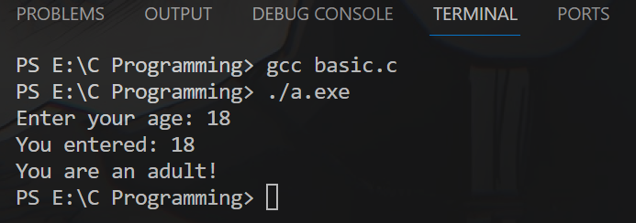
Program 2:
Write a program to add two numbers and display the sum.

Code:

#include <stdio.h>

int main() {
int num1, num2, sum;

printf("Enter first number: ");
scanf("%d", &num1);

printf("Enter second number: ");
scanf("%d", &num2);

sum = num1 + num2;

printf("Sum = %d", sum);

return 0;
}

OUTPUT:

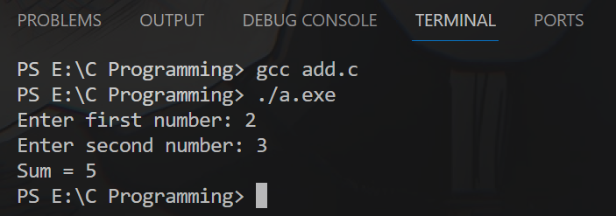

Program 3:
Write a program to calculate the area and the circumference of a circle by using radius as the input provided by the user.

Code:

#include <stdio.h>

int main() {
float radius, area, circumference;
const float PI = 3.14;

printf("Enter the radius of the circle: ");
scanf("%f", &radius);

area = PI * radius * radius;
circumference = 2 * PI * radius;

printf("Area of the circle = %.2f\n", area);
printf("Circumference of the circle = %.2f", circumference);

return 0;
}

OUTPUT:

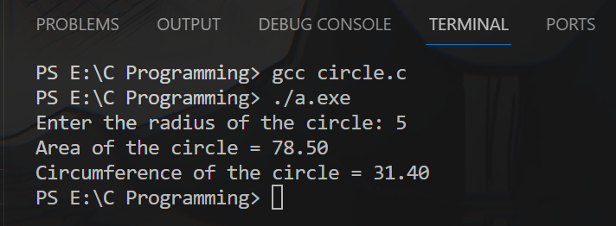

Program 4:
Write a Program to perform addition, subtraction, division and multiplication of two numbers given as input by the user.

Code:

#include <stdio.h>

int main() {
float num1, num2;
char op;

printf("Enter first number: ");
scanf("%f", &num1);

printf("Enter second number: ");
scanf("%f", &num2);

printf("Enter operation to perform (+, -, *, /): ");
scanf(" %c", &op);

if(op == '+') {
printf("%.2f + %.2f = %.2f", num1, num2, num1+num2);
}
else if(op == '-') {
printf("%.2f - %.2f = %.2f", num1, num2, num1-num2);
}
else if(op == '*') {
printf("%.2f * %.2f = %.2f", num1, num2, num1*num2);
}
else if(op == '/') {
printf("%.2f / %.2f = %.2f", num1, num2, num1/num2);
}
else {
printf("Invalid operation");
}

return 0;
}

OUTPUT:

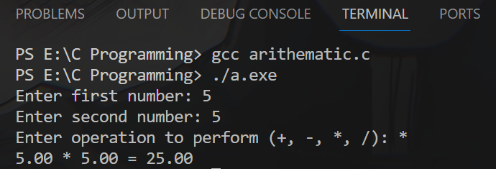

Program 5:

Write a program to evaluate each of the following equations.

(i) V = u + at. (ii) S = ut+1/2at² (iii) T=2*a+√b+9c (iv) H=√b²+p²

Code:

#include <stdio.h>
#include <math.h>

int main() {

float u, a, t, v;
float s, ut;

float a1, b, c, T;

float b2, p, H;

// Equation (i)
printf("Enter values for u, a, t: ");
scanf("%f %f %f", &u, &a, &t);

v = u + a*t;

printf("V = %.2f\n", v);

// Equation (ii)
printf("Enter values for u, t, a: ");
scanf("%f %f %f", &u, &t, &a);

s = u*t + 0.5*a*t*t;

printf("S = %.2f\n", s);

// Equation (iii)
printf("Enter values for a, b, c: ");
scanf("%f %f %f", &a1, &b, &c);

T = 2*a1 + sqrt(b) + 9*c;

printf("T = %.2f\n", T);

// Equation (iv)
printf("Enter values for b, p: ");
scanf("%f %f", &b2, &p);

H = sqrt(b2*b2 + p*p);

printf("H = %.2f", H);

return 0;
}

OUTPUT:

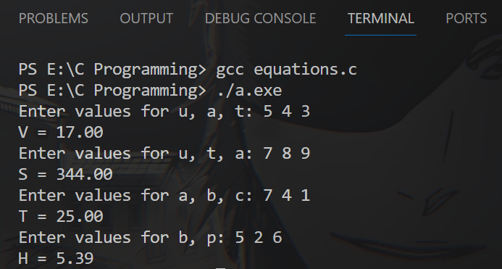

Program 6:

Write a program to swap two variable:

a) By using temporary variable.

Code:

#include <stdio.h>

int main() {
int a, b, temp;

printf("Enter value of a: ");
scanf("%d", &a);

printf("Enter value of b: ");
scanf("%d", &b);

// Swapping using temporary variable
temp = a;
a = b;
b = temp;

printf("After swapping: a = %d, b = %d", a, b);

return 0;
}

OUTPUT:

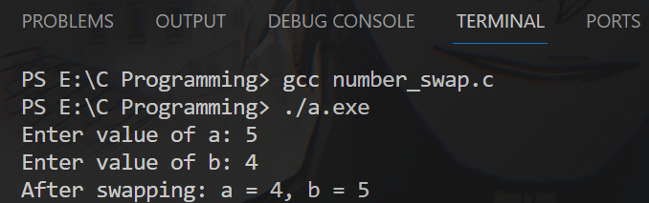

b) Without using temporary variable.

Code:

#include <stdio.h>

int main() {
int a, b;

printf("Enter value of a: ");
scanf("%d", &a);

printf("Enter value of b: ");
scanf("%d", &b);

// Swapping without temporary variable
a = a + b;
b = a - b;
a = a - b;

printf("After swapping: a = %d, b = %d", a, b);

return 0;
}

OUTPUT:

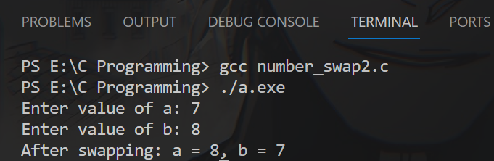

Program 7:

Write a Program to find the greatest among three numbers using:
- Conditional Operator

Code:

#include <stdio.h>

int main() {
int num1, num2, num3;

printf("Enter three numbers: ");
scanf("%d %d %d", &num1, &num2, &num3);

// Finding greatest using conditional operator
int greatest = (num1 > num2) ?
(num1 > num3 ? num1 : num3) :
(num2 > num3 ? num2 : num3);

printf("Greatest number is: %d", greatest);

return 0;
}

OUTPUT:

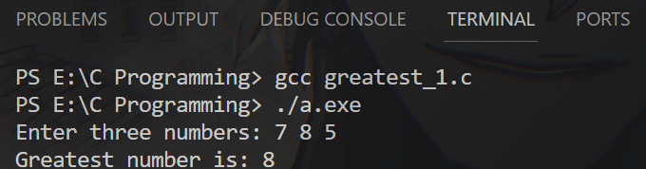

- If-Else statement

Code:

#include <stdio.h>

int main() {
int num1, num2, num3;

printf("Enter three numbers: ");
scanf("%d %d %d", &num1, &num2, &num3);

if(num1 > num2) {
if(num1 > num3) {
printf("%d is the greatest number.", num1);
}
else {
printf("%d is the greatest number.", num3);
}
}
else {
if(num2 > num3) {
printf("%d is the greatest number.", num2);
}
else {
printf("%d is the greatest number.", num3);
}
}

return 0;
}

OUTPUT:

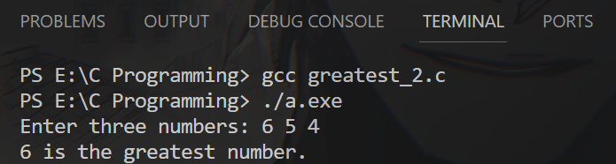

Program 8:

Write the following programs using switch case statement:
- To check that an input alphabet is vowel or consonant

Code:

#include <stdio.h>

int main() {
char ch;

printf("Enter an alphabet: ");
scanf("%c", &ch);

switch(ch) {
case 'a':
case 'e':
case 'i':
case 'o':
case 'u':
case 'A':
case 'E':
case 'I':
case 'O':
case 'U':
printf("%c is a Vowel.", ch);
break;
default:
printf("%c is a Consonant.", ch);
}

return 0;
}

OUTPUT:

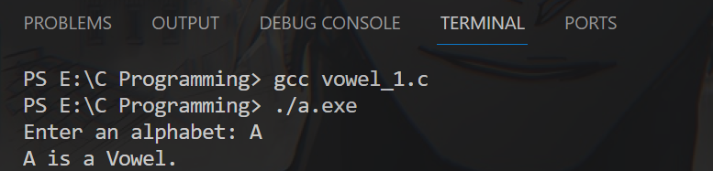

- To check whether a number is positive, negative or zero

Code:

#include <stdio.h>

int main() {
int num;

printf("Enter a number: ");
scanf("%d", &num);

switch(num > 0) {
case 1:
printf("%d is positive.", num);
break;
case 0:
if(num < 0) {
printf("%d is negative.", num);
}
else {
printf("%d is zero.", num);
}
break;
}

return 0;
}

OUTPUT:

