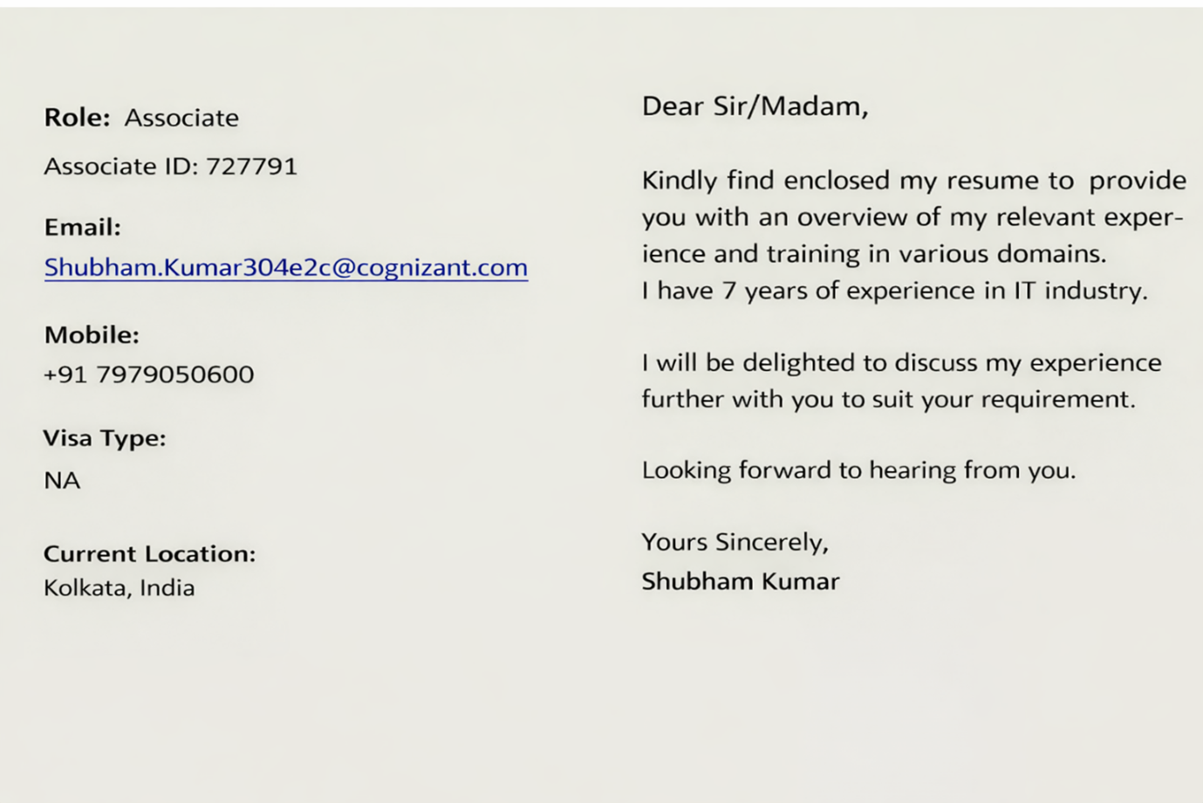

SHUBHAM KUMAR
+91-7979050600 | Shubham.Kumar304e2c@cognizant.com | LinkedIn | GitHub

Professional Summary
- Hands-on experience in AWS cloud services including IAM (users, roles, policies), VPC networking (subnets, route tables, Internet Gateway, NAT Gateway), and VPC peering
- Understanding of Oracle Cloud Infrastructure (OCI) including IAM concepts (users, groups, policies, identity domains) and networking (VCN, subnets, gateways, security rules)
- Implemented Single Sign-On (SSO) for Active Directory users using AWS IAM Identity Center, enabling authentication via external Identity Provider and role/policy-based access control
- Understanding of cloud networking concepts including private/public connectivity, routing, peering, and hybrid connectivity models (VPN, FastConnect, Direct Connect)
- Experience in configuring security controls including Security Groups, Network ACLs in AWS and Security Lists, NSGs, and IP whitelisting in OCI
- Worked on infrastructure provisioning using Terraform in AWS with remote state management in S3
- Automated patching and configuration workflows using Ansible, improving operational efficiency and reducing manual effort
- Exposure to Docker and Kubernetes for containerization and deployment (POC level)
- Experience in administering and supporting Oracle WebLogic Server in enterprise environments, including domain configuration, clustering, deployments, and troubleshooting
- Strong understanding of WebLogic architecture, server lifecycle management, and performance tuning using logs and thread dump analysis
- Proficient in installation, configuration, and patching of WebLogic and related middleware components across Linux environments
- Experience in handling production support activities including incident management, root cause analysis, and ensuring high availability of applications
- Provided 24×7 production support including weekend on-call support for critical issue resolution and system stability
- Worked extensively in Linux environments supporting middleware and infrastructure operations
- Automated repetitive tasks and health checks using WLST, Shell scripting, and basic Python scripting
- Experience with monitoring tools including Nagios, AppDynamics, SolarWinds, with prior exposure to Prometheus and Grafana
- Experience in middleware-related activities including ODI upgrades, SSL certificate management, and deployment validation
- Strong understanding of enterprise support processes using tools like ServiceNow and ITSM

TECHNICAL SKILLS
Technology
- OCI (Oracle Cloud Infrastructure): IAM, VCN, Subnets, Internet Gateway, NAT Gateway, Service Gateway, DRG, Load Balancer, Compute, Object Storage.
- AWS: EC2, S3, IAM, VPC (Subnets, Route Tables, Internet Gateway, NAT Gateway), VPC Peering
- Automation: Ansible, Terraform.
- Middleware: Oracle WebLogic Server
Monitoring Tools
- Prometheus (prior exposure), Grafana (prior exposure), Dynatrace
Scripting Languages
- WLST (Jython), Shell Scripting
Ticketing Tools
- ServiceNow
- Cherwell
Operating Systems
- Linux / Windows.

Project Experience
Cognizant Technology Solutions
Schneider National Inc. (Client Project)
Infrastructure Engineer (Automation, Cloud & DevOps Exposure) | ~3 Years
- Worked with OCI IAM concepts including users, groups, identity domains, compartments, and policy attachment/inheritance
→ Configured AWS IAM users, roles, and policies for controlled access to EC2 and other services
- Gained understanding of OCI dynamic groups and instance principals for resource-level access
→ Configured AWS IAM roles and instance profiles for secure service-to-resource access
- Basic understanding of SSO using OCI IAM federation
→ Implemented SSO for AD users using AWS IAM Identity Center, enabling federated authentication and role-based access control
- Configured OCI networking including VCN, subnets, route tables, Internet Gateway, NAT Gateway, and Service Gateway for connectivity
→ Configured AWS VPC networking including subnets, route tables, Internet Gateway, and NAT Gateway
- Applied OCI Security Lists (subnet level) and Network Security Groups (VNIC level) with IP whitelisting
→ Applied AWS Security Groups (instance level) and Network ACLs (subnet level) for traffic control
- Understanding of OCI DNS and DHCP configurations
→ Familiarity with AWS Route 53 and DHCP options within VPC
- Configured OCI Local Peering Gateway (LPG) for private connectivity between VCNs
→ Configured AWS VPC Peering for private communication between VPCs
- Understanding of OCI Dynamic Routing Gateway (DRG) for hybrid connectivity via VPN and FastConnect
→ Related with AWS Virtual Private Gateway / Transit Gateway for VPN and Direct Connect
- Automated patching and configuration workflows using Ansible (AAP) across environments
→ Leveraged automation practices in cloud-based environments for improved consistency and reduced manual effort
- Provisioned AWS infrastructure (VPC) using Terraform with remote state management in S3
- Exposure to Docker and Kubernetes for containerization and deployment (POC level)
→ Exploring container orchestration concepts applicable across cloud platforms
- Executed ODI application upgrades with validation through logs and service checks
→ Applied structured deployment validation approach in middleware environments
- Managed SSL certificate renewal using keytool for middleware applications, ensuring secure and compliant communication
- Worked extensively in Linux environments supporting middleware and infrastructure operations
→ Leveraged Linux understanding in both on-premise and cloud-based systems

Western Union (Client Project)
Middleware Engineer (WebLogic Administration & Production Support) | ~4 Years
- Developed and maintained WLST (Jython-based) health check scripts for proactive monitoring of servers, data sources, and stuck threads
- Administered Oracle WebLogic 12c environments, including managed servers, clustering, and domain configurations
- Performed installation, configuration, and patching of WebLogic and Fusion Middleware components
- Managed JDBC data sources and connection pools
- Configured and maintained JMS resources (queues, topics, connection factories)
- Supported high availability setups using clustering, load balancing, and failover mechanisms
- Configured Node Manager and supported server lifecycle operations
- Integrated Apache HTTP Server with WebLogic for routing and load balancing
- Analyzed thread dumps to identify performance issues such as high CPU and server hangs
- Participated in DR drills and environment validation
- Automated administrative tasks using WLST scripting
- Provided 24x7 production support, including monitoring and issue resolution
Key Strengths
- Strong production support and system reliability experience
- Hands-on automation using Ansible in enterprise environments
- Growing expertise in DevOps tools and cloud-native technologies
- Ability to quickly learn and apply new technologies in practical scenarios
- Solid understanding of deployment pipelines and system architecture
- Continuously improving skills through hands-on implementation and practice

Certification Information
- Oracle Cloud Infrastructure Foundations Associate Certificate – Completed
- Microsoft Azure Administrator Associate (AZ-104) Certificate – Completed
- AWS Solutions Architect Associate Certificate – Currently Preparing
- Oracle Cloud Infrastructure Architect Certificate – Currently Preparing

Education
- B. Tech in Electrical Engineering
Kalinga Institute of Industrial Technology, Bhubaneswar
CGPA: 7.5/10 | 2018
- Higher Secondary (12th – Science)
CBSE | 2013
- Secondary (10th)
CBSE | 2011

