Demystifying Machine Imagination: A Comprehensive Review of Hallucination Control in Large Language Models
1st Kashyap Barad 2nd Dr. Reena Gunjan(Professor) 3rd Dr. Ayesha Butalia(Professor)
School of Computing School of Computing School of Computing
MIT Art Design and Technology MIT Art Design and Technology MIT Art Design and Technology
University University University
Pune, India Pune, India Pune, India kashyapbarad03@gmail.com reena.gunjan@mituniversity.edu.in ayesha.butalia@mituniversity.edu.in

Abstract—Large Language Models (LLMs) are increasingly useful but sometimes produce answers that are factually incorrect or unsupported—a phenomenon known as “hallucination.” These errors undermine user trust and limit LLM deployment in high-stakes domains such as healthcare, law, and finance. Researchers have proposed diverse mitigation strategies, including retrieval-augmented generation (RAG) with external knowledge grounding, supervised fine-tuning and alignment techniques, prompt engineering, architectural innovations, advanced decoding and uncertainty-aware methods, and post-hoc verification and self-critique. Key evaluation methods involve specialized benchmarks, automated metrics including LLM-based evaluators, and human judgment. This survey reviews recent advances, citing empirical insights. No single fix suffices; hybrid approaches combining grounding, controlled prompting, consistency checks, and uncertainty estimation tend to work best. Building reliable LLMs requires integrated, multi-layered solutions combining RAG/reasoning frameworks with automated fact-checking loops.
Keywords—Large Language Models (LLMs), Hallucination Mitigation, Retrieval-Augmented Generation (RAG), Alignment and Fine-Tuning, Prompt Engineering, Chain-of-Thought (CoT), Ensemble Models, Mixture-of-Experts (MoE), Decoding Strategies, Uncertainty Estimation, Model Calibration, Post-Hoc Verification, LLM-as-Judge, Factuality Evaluation, AI Reliability, Trustworthy AI.

Introduction
Hallucinations in LLMs occur when the model generates smooth and confident answers that are actually wrong or fabricated [1]. The model “hallucinates” by producing plausible-sounding statements lacking real-world grounding. This is a critical problem: false or misleading content from an AI assistant can have severe consequences—misinformation, legal risk, medical error—and undermines public trust [1][2]. Studies find that hallucinations are prevalent even in large models and can propagate through downstream applications unless explicitly addressed [1][10]. Hallucination is frequently cited as a top barrier to deploying LLMs in high-stakes settings [1][2].
Conceptually, hallucinations arise from a combination of factors: statistical training on incomplete or biased data, probabilistic decoding priorities, and prompt design. Researchers distinguish prompt-induced hallucinations (caused by ambiguous or leading prompts) from model-internal hallucinations (stemming from pre-trained knowledge and architecture) [11]. Larger models do not automatically solve the problem; experiments with the TruthfulQA benchmark show an “inverse scaling” effect, where bigger models often imitate human misconceptions and hallucinate more than smaller ones [10].
This survey first reviews mitigation strategies (ways to prevent or correct hallucinations) and then covers evaluation methods (how hallucinations are measured). It draws on recent surveys and empirical studies for evidence of what works [8][3]. The goal is comprehensive coverage of both well-established techniques and emerging trends, concluding with open problems and future directions for more robust LLM design.

Related Work and Mitigation Strategies
Recent work emphasizes that no single technique eliminates hallucinations; multiple mechanisms are typically combined. Key strategies include retrieval and knowledge grounding, supervised alignment, prompt and control techniques, architectural changes, post-hoc checking, and uncertainty modeling [5][6]. The following subsections summarize the major themes.

A. Retrieval-Augmented Generation (RAG)
RAG integrates external knowledge into generation by retrieving relevant documents and conditioning the LLM on them. In a RAG pipeline, the model first queries an external corpus (e.g., Wikipedia) to fetch supporting text, then generates responses grounded in that text [5]. This effectively extends the model’s knowledge beyond its training data. Variants such as REPLUG and Retrieval in Decoder incorporate retrieval at decoding time [16]. Empirically, RAG raises factual accuracy (FactScore) substantially by providing explicit evidence [6][7]. However, RAG’s effectiveness depends on retrieval quality: noisy or irrelevant documents can mislead the model [6]. Extensions include self-reflective loops (e.g., SELF-RAG) and dynamic retrieval [8].
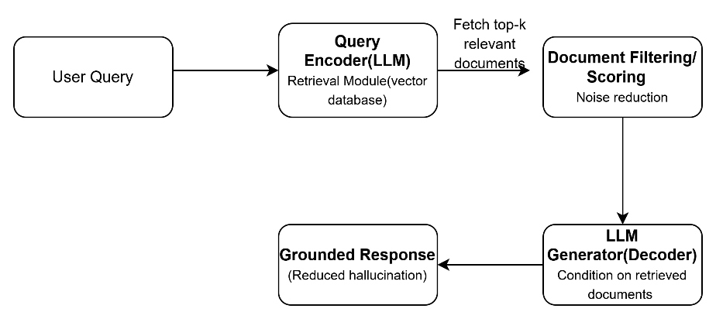
- Fig. 1. Retrieval-Augmented Generation (RAG) Framework

B. Fine-Tuning and Alignment
Fine-tuning adapts the model via supervised or reinforcement learning to prefer truthful answers. This includes training on curated factual datasets, alignment with human preferences, and contrastive or adversarial training. Approaches such as FactPEGASUS and FAVA fine-tune models on ranked factual summaries or synthetic hallucinated examples [3]. Reinforcement Learning from Human Feedback (RLHF) encourages models to value truthfulness, with Li et al. reporting that RLHF “improves accuracy and encourages models to acknowledge uncertainty” [9]. While powerful, these methods require significant labeled data and risk overfitting to specific domains.
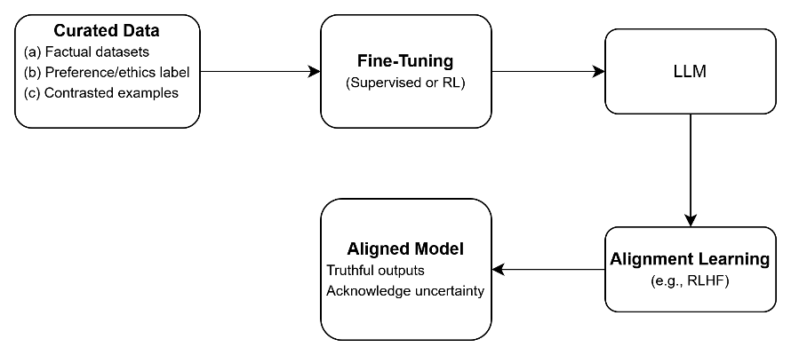
- Fig. 2. Fine-Tuning and Alignment Process

C. Prompt Engineering and Reasoning Aids
Crafting prompts to steer the model or elicit intermediate reasoning can reduce errors. Chain-of-Thought (CoT) prompting allows the model to break reasoning into steps, catching logical gaps that lead to hallucinations. Structured prompts such as “Think step-by-step” significantly improve factuality in sensitive questions [12]. Another tactic is self-critique: asking the model to justify or verify its own answer. However, prompt methods have limits and may only address certain hallucination types [11].
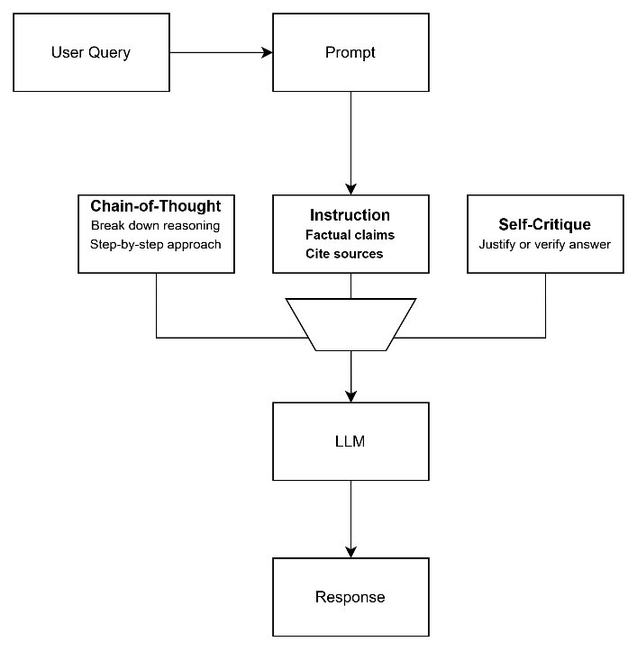
- Fig. 3. Chain-of-Thought (CoT) Prompting Strategy

D. Architectural and Ensemble Models
Mixture-of-Experts (MoE) architectures gate only relevant domain experts, reducing cross-talk and hallucination [4]. Dual-model systems use one model to generate and another to monitor output, providing an explicit validation layer. Modular pipelines with separate reasoning and tool-using modules decompose tasks and invoke sub-models for each reasoning step. While promising, such systems can be complex and require careful interface design.
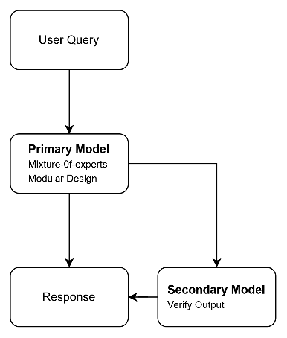
- Fig. 4. Mixture-of-Experts (MoE) Architecture

E. Decoding Strategies and Calibration
Confidence-aware decoding techniques downweight hallucination-prone tokens by measuring entropy or layer-wise agreement [6][7]. Beam search variants prune candidate continuations below a confidence threshold. Factuality Nucleus Sampling dynamically adjusts randomness so that more certain tokens are favored [8][7]. By making decoding aware of model certainty, one can avoid generation in “hallucination mode.” These methods are often combined with RAG-based decoding.
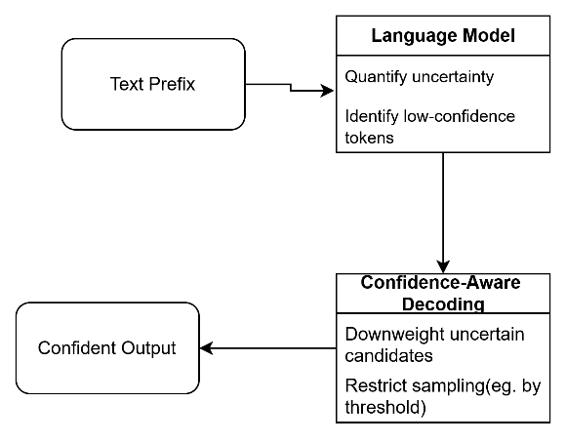
- Fig. 5. Confidence-Aware Decoding Process

F. Post-Hoc Verification and Critique
Critic-Driven Decoding uses a trained classifier or NLI model to score each candidate completion and steer the generator away from implausible answers [4]. “Generate-then-verify” approaches retrieve supporting evidence for each claim and revise if necessary. Self-consistency methods take multiple reasoning chains and choose the most consistent answer. LLM-as-a-judge schemes have one LLM evaluate another’s output, though care is needed since the critic can itself hallucinate [3]. Integrating these checks involves trade-offs between latency and accuracy.
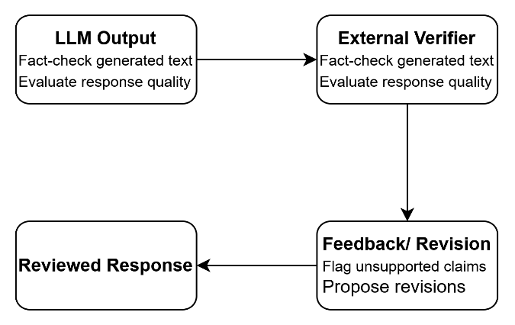
- Fig. 6. Post-Hoc Verification Pipeline

G. Uncertainty Estimation and Calibration
Models can be trained or prompted to express uncertainty (e.g., “I’m not sure”) when facts are unclear [11]. Techniques include entropy-based scores, Bayesian dropout, and sampling multiple answers to measure divergence [4]. Semantic entropy clusters possible answers and computes uncertainty over interpretations [3]. A confidence threshold allows the model to abstain or defer to a fallback when uncertain. High uncertainty empirically correlates with hallucination risk [7][3], making these signals useful early warnings.
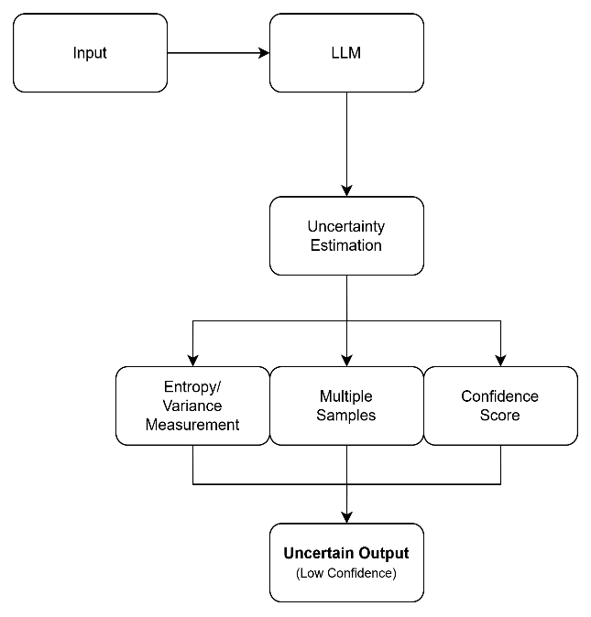
- Fig. 7. Uncertainty Estimation Framework
Each strategy above can be combined: RAG-grounded generation followed by a self-verification step and uncertainty gating is one such hybrid. Surveys agree that hybrid frameworks are most effective [4][5]. Layering retrieval, alignment, and verification yields substantially more reliable models [8].

Methods for Measuring Hallucinations
To evaluate mitigation techniques, robust measurement of hallucination is essential. Researchers have developed specialized benchmarks and metrics spanning three broad categories.

A. Benchmark Datasets
The TruthfulQA benchmark is widely used for measuring truthfulness [3][5]. It consists of difficult trivia and common-sense questions designed to trigger human-like falsehoods. Lin et al. demonstrated that TruthfulQA reveals larger models often mimic popular misconceptions, and provides an automated scoring metric correlating highly with human judgment [3]. Other benchmarks include HallucinationEval and domain-specific sets such as medical knowledge tests.

B. Automated Metrics and LLM-Based Evaluation
LLMs can be prompted to score the factuality of another model’s answer. Lin et al. showed that a fine-tuned GPT-3 classifier could predict human truthfulness judgments with over 90% accuracy [3]. However, LLM evaluators can also hallucinate, so cross-verifying them against external knowledge is advisable [3]. Other metrics include entailment scores and token-level consistency checks.

C. Human Evaluation
Despite automation advances, human judgment remains the gold standard for factuality. Crowdworkers or experts rate whether outputs are correct [3]. Human evaluation is necessary to catch subtle or contextual errors that benchmarks miss. Hybrid methods combining automated pre-filtering with human final checks are common [4].

D. Hybrid and Structural Evaluation
Newer approaches create rich evaluation tasks asking the model to justify each answer or identify unsupported parts of its response. RAGTruth provides human-annotated grounding labels for each response [8]. Standardized metrics are still emerging, and debate continues over the best way to judge LLM truthfulness [3][11].

Discussion: Gaps and Open Problems
Despite the progress outlined above, several open problems remain in LLM hallucination research. First, composability and trade-offs are not fully understood: many mitigation techniques sacrifice fluency or creativity. Aggressively grounding LLMs in data can reduce creativity and increase latency [4].
Second, there is no consistent evaluation framework. Li et al. note that retrieval and reasoning components lack a common structure, making it hard to compare different RAG methods fairly [7]. No single benchmark captures all facets of hallucination, and high-quality human judgments are expensive [3][9].
Third, robustness to adversaries and context changes is an open challenge. Hallucination spikes when prompts are adversarial or when the task requires knowledge outside training data [4][3]. Fourth, LLM-as-judge has limitations: evaluators can exhibit the same biases as generation models [3], so cross-model validation is needed. Finally, some researchers argue that hallucination may be inherent to probabilistic LLMs, suggesting a pragmatic shift toward managing rather than eliminating hallucinations.
- TABLE I. Open Problems and Research Gaps in LLM Hallucination Mitigation
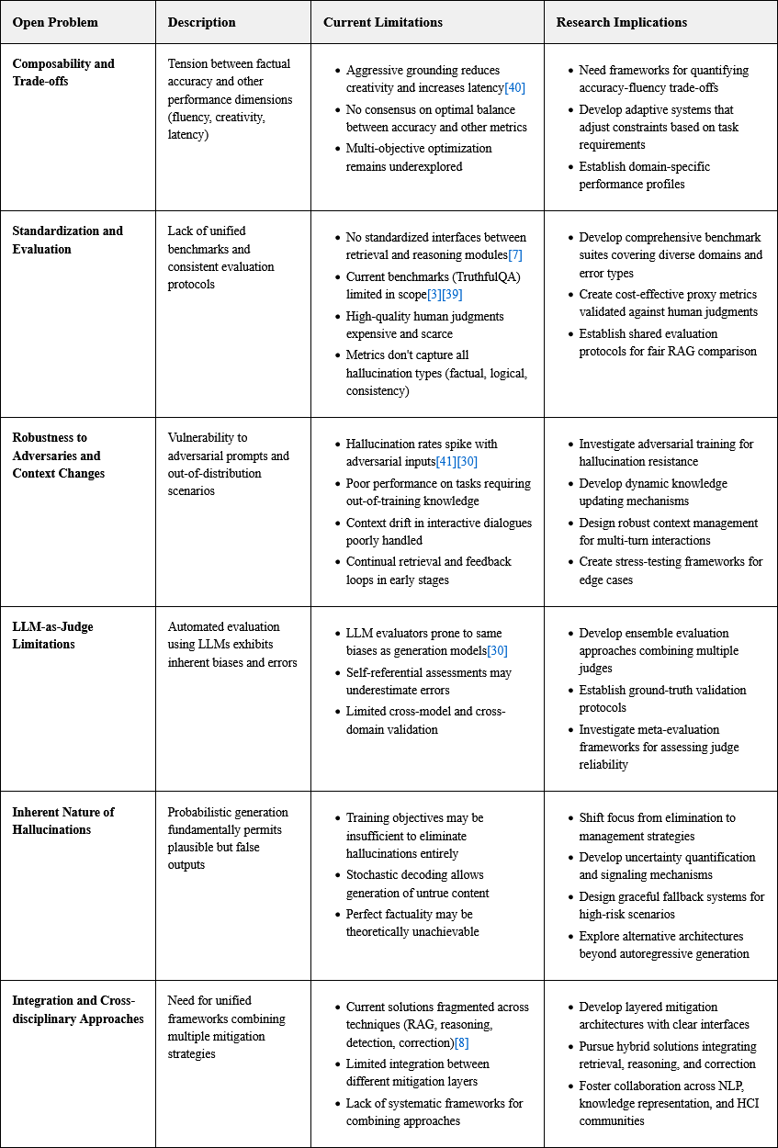

Conclusion
Mitigating hallucinations in LLMs is a multifaceted challenge. This paper surveyed a broad array of techniques: grounding with external knowledge (RAG), alignment and fine-tuning to instill factuality, smart prompting to guide reasoning, architectural designs incorporating checking modules, decoding rules that favor confidence, and post-generation verification. No single strategy suffices; layered approaches combining retrieval, logical reasoning, and self-critique perform best.
Future work must develop standardized evaluation frameworks and robust multi-stage pipelines. Techniques to dynamically estimate and express uncertainty are promising for more trustworthy models. Research should also explore how to make mitigation efficient and scalable, since many methods (e.g., RAG, RLHF) are computationally expensive. The next generation of LLMs will likely rely on a synthesis of retrieval, reasoning, critique, and uncertainty management—creating self-policing language agents that flag or correct their own errors.

Acknowledgment
[Acknowledgments to be added by the authors. This section may include funding sources, institutional support, and contributions from colleagues not listed as co-authors.]

References
- [1] Y. Li, X. Fu, G. Verma, P. Buitelaar, and M. Liu, “Mitigating Hallucination in Large Language Models (LLMs): An Application-Oriented Survey on RAG, Reasoning, and Agentic Systems,” arXiv:2510.24476, Oct. 2024.
- [2] S. Lin et al., “TruthfulQA: Measuring How Models Mimic Human Falsehoods,” in Proc. ACL, 2022, pp. 2724–2744.
- [3] A.-H. Dang, V. Tran, and L.-M. Nguyen, “Survey and analysis of hallucinations in large language models,” Front. Artif. Intell., vol. 8, Sep. 2025, doi: 10.3389/frai.2025.1622292.
- [4] I. Kazlaris, E. Antoniou, K. Diamantaras, and C. Bratsas, “From Illusion to Insight: A Taxonomic Survey of Hallucination Mitigation Techniques in LLMs,” AI, vol. 6, no. 10, p. 260, 2025.
- [5] F. A. Senel and H. B. Ozmen, “A comparative review of hallucination mitigation and performance improvement techniques in Small Language Models,” Res. Des., vol. 2, no. 1, pp. 45–65, 2025.
- [6] H. Li et al., “LLMs-as-Judges: A Comprehensive Survey on LLM-based Evaluation Methods,” arXiv:2412.05579, Dec. 2024.
- [7] Z. Ji et al., “Survey of hallucination in natural language generation,” ACM Comput. Surveys, vol. 55, no. 12, pp. 1–38, 2023.
- [8] P. Manakul et al., “SelfCheckGPT: Zero-Resource Black-Box Hallucination Detection for Generative Large Language Models,” in Proc. EMNLP, 2023.
- [9] S. Maheshwari, R. Gunjan, V. Laxmi, and M. S. Gaur, “Robust multi-modal watermarking using visually encrypted watermark,” in Proc. IWSSIP, Vienna, 2012, pp. 72–75.
- [10] P. Lewis et al., “Retrieval-Augmented Generation for Knowledge-Intensive NLP Tasks,” in Proc. NeurIPS, 2020.
- [11] J. Ouyang et al., “Training language models to follow instructions with human feedback,” in Proc. NeurIPS, 2022.
- [12] S. Ji et al., “Survey of hallucination in natural language generation,” ACM Comput. Surveys, vol. 55, no. 12, pp. 1–38, 2023.
- [13] A. Butalia, R. Pandey, and N. Dahale, “Synergistic Integration of Rough Set Theory and Fuzzy Metric Spaces for Enhanced Decision-Making,” in Proc. IEEE ICTBIG-2024, Indore, India, pp. 91–96, Dec. 2024.

